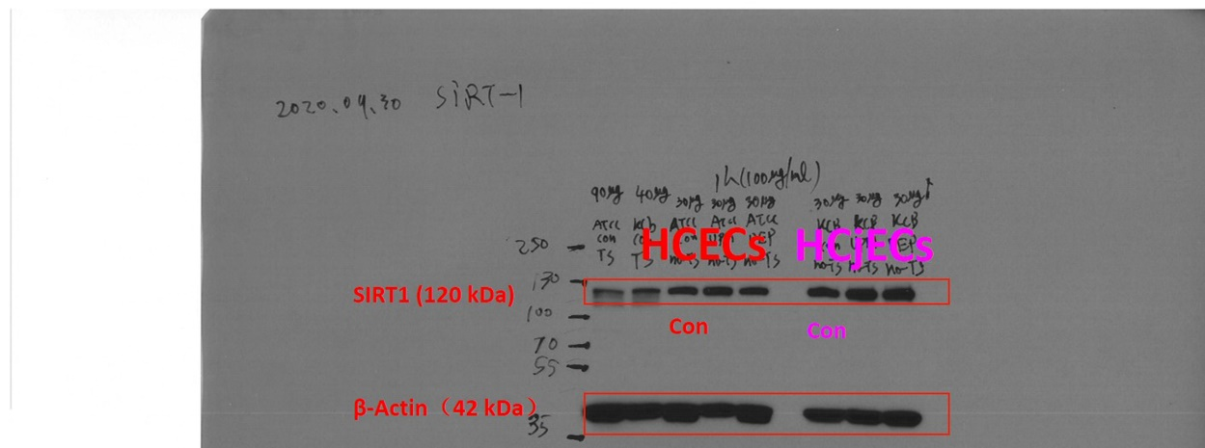
Supplementary Fig.1 Validation of SIRT1 protein levels in human corneal epithelial cells (HCECs) and human conjunctival epithelial cells (HCjECs) in our preliminary experiment. β-actin and SIRT1 shown their bands of western Blot analysis around 42kDa and 120kDa, respectively.

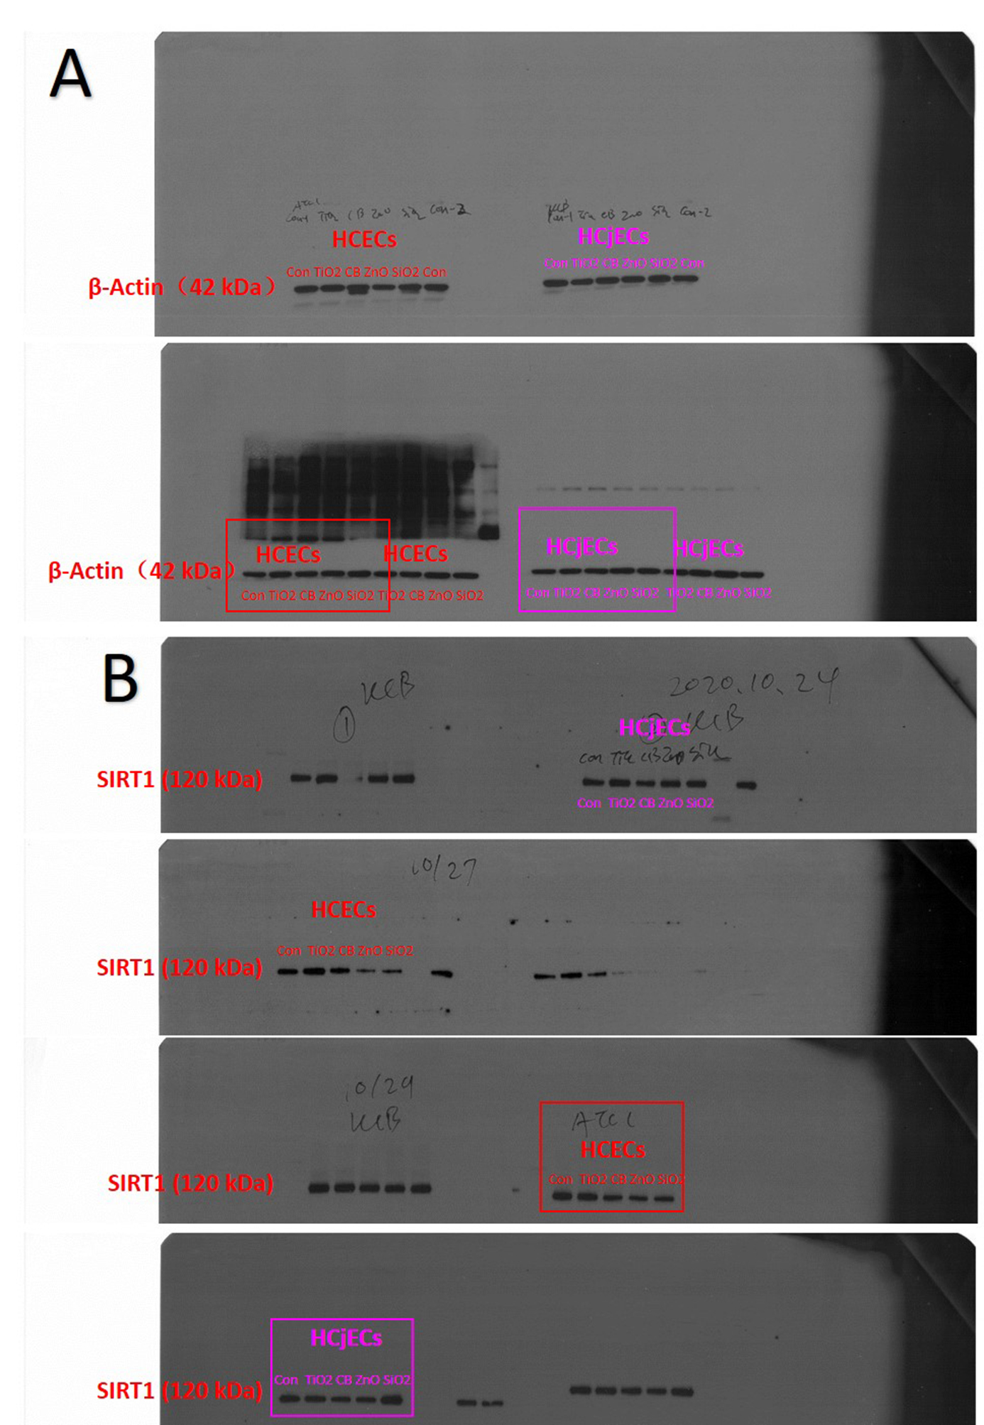

Supplementary Fig.2 Validation of SIRT1 protein levels in HCECs and HCjECs following 6 hours of NPs exposure. Protein lysates (30μg) of cells were applied to SDS-PAGE. After gel electrophoresis and protein transferring, we cut the membrane as two parts according to molecular size. β-actin (1:10,000 dilution) (A) and SIRT1 monoclonal antibody (1:1,000 dilution) (B) were incubated. β-actin served as a loading control.

