Repurposing the Pathogen Box compounds for identification of potent anti-malarials against blood stages of Plasmodium falciparum with PfUCHL3 inhibitory activity.
Hina Bharti ¹, Aakriti Singal ¹, Manisha Saini ¹, Pradeep Singh Cheema ¹, Mohsin Raza ¹ , Suman Kundu ¹ and Alo Nag ¹*
¹Department of Biochemistry, University of Delhi South Campus, Benito Juarez Road, New
Delhi-110021, India.
Phone: +91-11-24117363, 24112503, Fax: 91-11-24115270.
* Corresponding author (Email id: anag@south.du.ac.in)

Supplementary Tables
SupplementaryTable S1: Table depicting binding energies of all 400 Pathogen Box compounds against PfUCHL3 (2WE6) and HsUCHL3 (1XD3). Top 100 compounds with comparative score greater than -3kcal/mol (cells colored in blue) were taken for further assessment.
S.No. | Compound | △G (kcal/mol) against PfUCHL3  (PDB ID:2WE6) | △G (kcal/mol) against HsUCHL3  (PDB ID:1XD3) | Comparative △G (kcal/mol)
 | MMV688508 | -3.57 | 5.86 | -9.43
 | MMV687700 | -7.37 | 1.83 | -9.2
 | MMV022029 | -7.24 | 1.75 | -8.99
 | MMV688362 | -4.85 | 3.92 | -8.77
 | MMV688990 | -3.83 | 4.55 | -8.38
 | MMV688509 | -7.2 | 1.05 | -8.25
 | MMV024937 | -5.91 | 2.31 | -8.22
 | MMV020512 | -4.41 | 3.6 | -8.01
 | MMV676380 | -6.15 | 1.79 | -7.94
 | MMV687798 | -5.95 | 1.92 | -7.87
 | MMV085499 | -5.21 | 2.54 | -7.75
 | MMV688552 | -5.4 | 2.1 | -7.5
 | MMV676603 | -7.23 | 0.18 | -7.41
 | MMV688762 | -4.72 | 2.5 | -7.22
 | MMV688180 | -5.46 | 1.7 | -7.16
 | MMV688407 | -5.33 | 1.83 | -7.16
 | MMV687813 | -3.96 | 2.97 | -6.93
 | MMV688271 | -4.04 | 2.85 | -6.89
 | MMV688474 | -5.17 | 1.68 | -6.85
 | MMV001493 | -4.7 | 2.15 | -6.85
 | MMV689029 | -4.75 | 1.98 | -6.73
 | MMV023949 | -0.17 | 6.54 | -6.71
 | MMV020591 | -5.76 | 0.87 | -6.63
 | MMV007638 | -6.32 | 0.18 | -6.5
 | MMV676597 | -5.31 | 1.12 | -6.43
 | MMV007133 | -5.63 | 0.76 | -6.39
 | MMV688262 | -5.33 | 1.01 | -6.34
 | MMV676539 | -6.94 | -0.67 | -6.27
 | MMV676602 | -4.39 | 1.86 | -6.25
 | MMV020136 | -5.34 | 0.89 | -6.23
 | MMV676478 | -4.09 | 2.08 | -6.17
 | MMV634140 | -5.99 | 0.17 | -6.16
 | MMV687729 | -4.69 | 1.43 | -6.12
 | MMV687172 | -5.49 | 0.61 | -6.1
 | MMV688472 | -5.58 | 0.47 | -6.05
 | MMV688466 | -4.14 | 1.91 | -6.05
 | MMV688361 | -6.26 | -0.24 | -6.02
 | MMV024406 | -5.12 | 0.78 | -5.9
 | MMV007471 | -6.2 | -0.42 | -5.78
 | MMV024114 | -7.76 | -2.02 | -5.74
 | MMV020982 | -4.29 | 1.35 | -5.64
 | MMV688270 | -2.29 | 3.34 | -5.63
 | MMV022478 | -3.99 | 1.59 | -5.58
 | MMV023860 | -8.57 | -3 | -5.57
 | MMV688471 | -4.93 | 0.61 | -5.54
 | MMV688178 | -5.72 | -0.2 | -5.52
 | MMV026490 | -2.82 | 2.69 | -5.51
 | MMV023953 | -6.9 | -1.53 | -5.37
 | MMV020289 | -6.89 | -1.53 | -5.36
 | MMV024829 | -4.17 | 1.18 | -5.35
 | MMV1029203 | -5.15 | 0.15 | -5.3
 | MMV658993 | -6.77 | -1.48 | -5.29
 | MMV407539 | -3.29 | 1.95 | -5.24
 | MMV688844 | -3.52 | 1.64 | -5.16
 | MMV676509 | -5.11 | 0.03 | -5.14
 | MMV688364 | -3.86 | 1.28 | -5.14
 | MMV671636 | -2.6 | 2.53 | -5.13
 | MMV688283 | -3.65 | 1.43 | -5.08
 | MMV030734 | -4.72 | 0.33 | -5.05
 | MMV085071 | -6.97 | -2.06 | -4.91
 | MMV024397 | -5.11 | -0.35 | -4.76
 | MMV687239 | -6.45 | -1.76 | -4.69
 | MMV676476 | -5.59 | -0.91 | -4.68
 | MMV099637 | -4.02 | 0.64 | -4.66
 | MMV659004 | -5.54 | -0.92 | -4.62
 | MMV020165 | -4.46 | 0.16 | -4.62
 | MMV688704 | -6.15 | -1.6 | -4.55
 | MMV688991 | -5.53 | -1.01 | -4.52
 | MMV688179 | -3.93 | 0.57 | -4.5
 | MMV090930 | -4.89 | -0.4 | -4.49
 | MMV668727 | -3.8 | 0.67 | -4.47
 | MMV689061 | -4.8 | -0.46 | -4.34
 | MMV032967 | -4.57 | -0.24 | -4.33
 | MMV019742 | -4.03 | 0.24 | -4.27
 | MMV688845 | -3.53 | 0.61 | -4.14
 | MMV004168 | -4.17 | -0.05 | -4.12
 | MMV687246 | -2.43 | 1.65 | -4.08
 | MMV688327 | -3.68 | 0.3 | -3.98
 | MMV675997 | -3.28 | 0.69 | -3.97
 | MMV687189 | -4.88 | -1.05 | -3.83
 | MMV688550 | -2.33 | 1.49 | -3.82
 | MMV010576 | -6.03 | -2.23 | -3.8
 | MMV688796 | -5.87 | -2.15 | -3.72
 | MMV020623 | -2.04 | 1.47 | -3.51
 | MMV008439 | -4.37 | -0.89 | -3.48
 | MMV019189 | -4.09 | -0.65 | -3.44
 | MMV689028 | -3.28 | 0.14 | -3.42
 | MMV675998 | -5 | -1.63 | -3.37
 | MMV687775 | -4.67 | -1.3 | -3.37
 | MMV1198433 | -3.51 | -0.16 | -3.35
 | MMV019087 | -4.83 | -1.51 | -3.32
 | MMV000858 | -7.18 | -3.9 | -3.28
 | MMV676528 | -6.6 | -3.35 | -3.25
 | MMV688761 | -5.96 | -2.71 | -3.25
 | MMV560185 | -4.99 | -1.78 | -3.21
 | MMV687794 | -4.65 | -1.44 | -3.21
 | MMV688768 | -4.73 | -1.53 | -3.2
 | MMV688921 | -4.28 | -1.08 | -3.2
 | MMV688350 | -1.32 | 1.69 | -3.01
 | MMV676555 | -5.05 | -2.05 | -3
 | MMV024035 | -1.15 | 1.8 | -2.95
 | MMV019790 | -5.73 | -2.82 | -2.91
 | MMV676536 | -4.39 | -1.5 | -2.89
 | MMV676554 | -3.39 | -0.57 | -2.82
 | MMV687703 | -2.35 | 0.46 | -2.81
 | MMV023233 | -4.8 | -2 | -2.8
 | MMV688936 | -3.97 | -1.18 | -2.79
 | MMV006901 | -6.4 | -3.62 | -2.78
 | MMV688942 | -4.67 | -1.89 | -2.78
 | MMV687812 | -1.79 | 0.97 | -2.76
 | MMV690102 | -1.58 | 1.15 | -2.73
 | MMV676558 | -6.39 | -3.66 | -2.73
 | MMV407834 | -1.3 | 1.42 | -2.72
 | MMV007625 | -2.13 | 0.54 | -2.67
 | MMV675968 | -4.82 | -2.2 | -2.62
 | MMV020291 | -7.54 | -4.94 | -2.6
 | MMV085210 | -3.68 | -1.1 | -2.58
 | MMV688854 | -2.52 | 0.02 | -2.54
 | MMV011691 | -0.5 | 2.01 | -2.51
 | MMV676571 | -1.61 | 0.86 | -2.47
 | MMV667494 | -4.66 | -2.3 | -2.36
 | MMV020320 | -3.85 | -1.5 | -2.35
 | MMV676260 | -5.84 | -3.53 | -2.31
 | MMV676064 | -2.54 | -0.26 | -2.28
 | MMV688766 | -4.36 | -2.09 | -2.27
 | MMV006741 | -5.41 | -3.15 | -2.26
 | MMV020537 | -4.06 | -1.8 | -2.26
 | MMV020670 | -0.99 | 1.24 | -2.23
 | MMV024443 | -4.86 | -2.64 | -2.22
 | MMV010764 | -4.2 | -2 | -2.2
 | MMV688547 | -4.82 | -2.66 | -2.16
 | MMV026020 | -1.54 | 0.59 | -2.13
 | MMV687762 | -6 | -3.89 | -2.11
 | MMV007920 | -3.65 | -1.55 | -2.1
 | MMV676480 | -5.08 | -3.04 | -2.04
 | MMV688703 | -6.05 | -4.05 | -2
 | MMV028694 | -3.78 | -1.78 | -2
 | MMV019807 | -5.98 | -4.02 | -1.96
 | MMV688360 | -5.03 | -3.07 | -1.96
 | MMV676600 | -0.44 | 1.5 | -1.94
 | MMV020520 | -0.31 | 1.61 | -1.92
 | MMV661713 | -2.99 | -1.1 | -1.89
 | MMV687800 | 1.01 | 2.9 | -1.89
 | MMV000063 | -4.38 | -2.61 | -1.77
 | MMV021013 | -4.38 | -2.61 | -1.77
 | MMV392832 | -4.6 | -2.86 | -1.74
 | MMV687696 | 0.05 | 1.78 | -1.73
 | MMV689243 | -4.35 | -2.66 | -1.69
 | MMV687188 | -4.73 | -3.1 | -1.63
 | MMV200748 | -6.74 | -5.11 | -1.63
 | MMV676589 | -4.53 | -2.93 | -1.6
 | MMV687180 | -3.67 | -2.07 | -1.6
 | MMV676159 | -3.78 | -2.18 | -1.6
 | MMV024195 | 0.04 | 1.63 | -1.59
 | MMV676182 | -3.35 | -1.77 | -1.58
 | MMV023969 | -0.96 | 0.62 | -1.58
 | MMV688371 | -4.72 | -3.15 | -1.57
 | MMV021660 | -3.54 | -2.03 | -1.51
 | MMV000062 | -3.12 | -1.61 | -1.51
 | MMV1037162 | -3.14 | -1.66 | -1.48
 | MMV688798 | -4.71 | -3.23 | -1.48
 | MMV023370 | -5.8 | -4.32 | -1.48
 | MMV001561 | -3.38 | -1.91 | -1.47
 | MMV676411 | -5.27 | -3.81 | -1.46
 | MMV663250 | -3.78 | -2.33 | -1.45
 | MMV019993 | -3.21 | -1.77 | -1.44
 | MMV020710 | -3.9 | -2.5 | -1.4
 | MMV102872 | -5.62 | -4.24 | -1.38
 | MMV188296 | -5.27 | -3.91 | -1.36
 | MMV228911 | -0.53 | 0.81 | -1.34
 | MMV689758 | -4.13 | -2.79 | -1.34
 | MMV688124 | -1.25 | 0.08 | -1.33
 | MMV676605 | -0.66 | 0.66 | -1.32
 | MMV007803 | -0.83 | 0.48 | -1.31
 | MMV020517 | -4.19 | -2.89 | -1.3
 | MMV688795 | -6.13 | -4.84 | -1.29
 | MMV676401 | -5.77 | -4.48 | -1.29
 | MMV019721 | -3.57 | -2.3 | -1.27
 | MMV676162 | -0.94 | 0.31 | -1.25
 | MMV393144 | -5.8 | -4.56 | -1.24
 | MMV687248 | -4.65 | -3.45 | -1.2
 | MMV676599 | -3.54 | -2.35 | -1.19
 | MMV688994 | 0.17 | 1.35 | -1.18
 | MMV676186 | 1.76 | 2.93 | -1.17
 | MMV688775 | -3.68 | -2.54 | -1.14
 | MMV676057 | -0.68 | 0.44 | -1.12
 | MMV688774 | 0.41 | 1.51 | -1.1
 | MMV688793 | -5.09 | -3.99 | -1.1
 | MMV676472 | 0.01 | 1.1 | -1.09
 | MMV688555 | -4.93 | -3.84 | -1.09
 | MMV652003 | -4.09 | -3.03 | -1.06
 | MMV690103 | -2.47 | -1.44 | -1.03
 | MMV687776 | -4.05 | -3.02 | -1.03
 | MMV688889 | -7.09 | -6.09 | -1
 | MMV676461 | -6.41 | -5.45 | -0.96
 | MMV016136 | -4.29 | -3.35 | -0.94
 | MMV054312 | -3.97 | -3.05 | -0.92
 | MMV687254 | -4 | -3.09 | -0.91
 | MMV688776 | -4.22 | -3.36 | -0.86
 | MMV676412 | -4.11 | -3.3 | -0.81
 | MMV676191 | -6.55 | -5.74 | -0.81
 | MMV595321 | 2.13 | 2.91 | -0.78
 | MMV688313 | 0.17 | 0.94 | -0.77
 | MMV676442 | -1.06 | -0.31 | -0.75
 | MMV676444 | -6.6 | -5.87 | -0.73
 | MMV637953 | 0.9 | 1.59 | -0.69
 | MMV688514 | -5.77 | -5.11 | -0.66
 | MMV063404 | -4.42 | -3.79 | -0.63
 | MMV006833 | -4.65 | -4.04 | -0.61
 | MMV011903 | -0.38 | 0.23 | -0.61
 | MMV676377 | -6.09 | -5.48 | -0.61
 | MMV407539 | 0.68 | 1.23 | -0.55
 | MMV676398 | -5.27 | -4.74 | -0.53
 | MMV689437 | -2.87 | -2.37 | -0.5
 | MMV676350 | -4.33 | -3.84 | -0.49
 | MMV023183 | -5.97 | -5.52 | -0.45
 | MMV688470 | -1.88 | -1.43 | -0.45
 | MMV023985 | -3.88 | -3.45 | -0.43
 | MMV1088520 | -3.4 | -3 | -0.4
 | MMV009135 | -3.25 | -2.85 | -0.4
 | MMV689709 | -6.32 | -5.93 | -0.39
 | MMV688980 | -3.27 | -2.88 | -0.39
 | MMV688279 | -3.34 | -2.99 | -0.35
 | MMV020321 | -5.97 | -5.66 | -0.31
 | MMV688274 | 2.87 | 3.14 | -0.27
 | MMV675996 | -3.45 | -3.19 | -0.26
 | MMV676409 | -5.67 | -5.43 | -0.24
 | MMV020391 | -5.28 | -5.06 | -0.22
 | MMV688416 | 0.04 | 0.26 | -0.22
 | MMV687796 | 1.37 | 1.59 | -0.22
 | MMV689000 | 0.7 | 0.89 | -0.19
 | MMV202553 | -4.96 | -4.79 | -0.17
 | MMV688763 | -6.63 | -6.47 | -0.16
 | MMV026468 | -5.39 | -5.23 | -0.16
 | MMV689255 | -3.54 | -3.39 | -0.15
 | MMV019234 | 0.79 | 0.9 | -0.11
 | MMV676063 | 0.38 | 0.47 | -0.09
 | MMV676382 | -7.19 | -7.14 | -0.05
 | MMV006372 | -5.86 | -5.82 | -0.04
 | MMV062221 | -3.68 | -3.64 | -0.04
 | MMV689244 | 0.24 | 0.25 | -0.01
 | MMV676050 | -3.89 | -3.9 | 0.01
 | MMV053220 | -5.24 | -5.28 | 0.04
 | MMV085230 | -5.69 | -5.74 | 0.05
 | MMV676204 | -2.95 | -3.01 | 0.06
 | MMV688888 | 0.92 | 0.85 | 0.07
 | MMV676386 | -6.37 | -6.44 | 0.07
 | MMV676526 | -5.45 | -5.54 | 0.09
 | MMV1110498 | -3.8 | -3.9 | 0.1
 | MMV045105 | -4.88 | -5 | 0.12
 | MMV688934 | -3.98 | -4.12 | 0.14
 | MMV687170 | -3.26 | -3.4 | 0.14
 | MMV024311 | -4.88 | -5.09 | 0.21
 | MMV000011 | 1.1 | 0.85 | 0.25
 | MMV676474 | -5.83 | -6.09 | 0.26
 | MMV002816 | -5.54 | -5.82 | 0.28
 | MMV675993 | -3.98 | -4.27 | 0.29
 | MMV019838 | -4.75 | -5.05 | 0.3
 | MMV675995 | 0.61 | 0.31 | 0.3
 | MMV020388 | -3.38 | -3.68 | 0.3
 | MMV006239 | -5.6 | -5.9 | 0.3
 | MMV010545 | -5.29 | -5.6 | 0.31
 | MMV676358 | -5.72 | -6.04 | 0.32
 | MMV688125 | -3.87 | -4.23 | 0.36
 | MMV000016 | -3.61 | -4.02 | 0.41
 | MMV003270 | -5.83 | -6.24 | 0.41
 | MMV687138 | -5.91 | -6.35 | 0.44
 | MMV676008 | 1.13 | 0.66 | 0.47
 | MMV1019989 | -4.39 | -4.87 | 0.48
 | MMV084603 | -4.14 | -4.62 | 0.48
 | MMV688557 | -4.67 | -5.17 | 0.5
 | MMV688273 | -3.68 | -4.2 | 0.52
 | MMV676406 | 1.65 | 1.12 | 0.53
 | MMV688891 | -5.15 | -5.69 | 0.54
 | MMV687146 | -6.12 | -6.67 | 0.55
 | MMV658988 | -3.64 | -4.19 | 0.55
 | MMV011511 | -2.94 | -3.5 | 0.56
 | MMV687706 | -6 | -6.58 | 0.58
 | MMV011765 | -5.25 | -5.83 | 0.58
 | MMV1028806 | -5.15 | -5.73 | 0.58
 | MMV069458 | -4.84 | -5.42 | 0.58
 | MMV016838 | 0.65 | 0.06 | 0.59
 | MMV1236379 | -5.96 | -6.56 | 0.6
 | MMV690027 | 1.17 | 0.56 | 0.61
 | MMV553002 | -6.87 | -7.48 | 0.61
 | MMV676384 | -5.81 | -6.42 | 0.61
 | MMV687730 | -3.45 | -4.08 | 0.63
 | MMV688543 | -6.26 | -6.9 | 0.64
 | MMV676588 | -4.91 | -5.56 | 0.65
 | MMV687273 | -7.05 | -7.71 | 0.66
 | MMV019551 | -4.42 | -5.08 | 0.66
 | MMV020120 | -6.81 | -7.48 | 0.67
 | MMV688548 | -6.15 | -6.83 | 0.68
 | MMV002529 | -5.03 | -5.71 | 0.68
 | MMV676584 | -4.48 | -5.18 | 0.7
 | MMV1030799 | -6.27 | -6.97 | 0.7
 | MMV659010 | -6.13 | -6.83 | 0.7
 | MMV001625 | -6.58 | -7.31 | 0.73
 | MMV676477 | 1.72 | 0.99 | 0.73
 | MMV676468 | -5.31 | -6.05 | 0.74
 | MMV676395 | -5.04 | -5.79 | 0.75
 | MMV688553 | -5.66 | -6.42 | 0.76
 | MMV676439 | -6.4 | -7.17 | 0.77
 | MMV000023 | -3.28 | -4.06 | 0.78
 | MMV690028 | 1.66 | 0.86 | 0.8
 | MMV676379 | -3.18 | -3.99 | 0.81
 | MMV023227 | -5.97 | -6.81 | 0.84
 | MMV020152 | -5.47 | -6.31 | 0.84
 | MMV495543 | -5.73 | -6.6 | 0.87
 | MMV021375 | -4.42 | -5.33 | 0.91
 | MMV688852 | -4.28 | -5.2 | 0.92
 | MMV688978 | -3.78 | -4.7 | 0.92
 | MMV676383 | -6.06 | -6.98 | 0.92
 | MMV688853 | -5.1 | -6.07 | 0.97
 | MMV688958 | -6.04 | -7.05 | 1.01
 | MMV687803 | -5.77 | -6.78 | 1.01
 | MMV676520 | -5.54 | -6.56 | 1.02
 | MMV024101 | -4.58 | -5.6 | 1.02
 | MMV047015 | -3.18 | -4.21 | 1.03
 | MMV020081 | -4.74 | -5.78 | 1.04
 | MMV272144 | -3.92 | -4.99 | 1.07
 | MMV676161 | -6.73 | -7.83 | 1.1
 | MMV153413 | -3.89 | -5 | 1.11
 | MMV393995 | -4.89 | -6.02 | 1.13
 | MMV688756 | -5.14 | -6.28 | 1.14
 | MMV084864 | -3.29 | -4.44 | 1.15
 | MMV687807 | -4.42 | -5.6 | 1.18
 | MMV688411 | -1.59 | -2.8 | 1.21
 | MMV676524 | -4.96 | -6.21 | 1.25
 | MMV026356 | -3.25 | -4.5 | 1.25
 | MMV688797 | -5.67 | -6.98 | 1.31
 | MMV688352 | 1.97 | 0.62 | 1.35
 | MMV688122 | -4.25 | -5.62 | 1.37
 | MMV688943 | -5.36 | -6.77 | 1.41
 | MMV001499 | -5.91 | -7.32 | 1.41
 | MMV611037 | -5.12 | -6.53 | 1.41
 | MMV688955 | -4.19 | -5.61 | 1.42
 | MMV002817 | -5.69 | -7.12 | 1.43
 | MMV687747 | -6.15 | -7.61 | 1.46
 | MMV023388 | -5.17 | -6.63 | 1.46
 | MMV676431 | -6.69 | -8.19 | 1.5
 | MMV687699 | -5.08 | -6.58 | 1.5
 | MMV687251 | -4.48 | -5.98 | 1.5
 | MMV009054 | -2.99 | -4.5 | 1.51
 | MMV688330 | -2.98 | -4.5 | 1.52
 | MMV676048 | -2.66 | -4.19 | 1.53
 | MMV688469 | -5.29 | -6.83 | 1.54
 | MMV687801 | -3.74 | -5.29 | 1.55
 | MMV688410 | -2.57 | -4.12 | 1.55
 | MMV011229 | -3.94 | -5.51 | 1.57
 | MMV026313 | -5.31 | -6.88 | 1.57
 | MMV687765 | 3.45 | 1.83 | 1.62
 | MMV689060 | -5.36 | -6.99 | 1.63
 | MMV146306 | -5.25 | -6.88 | 1.63
 | MMV031011 | -3.33 | -5 | 1.67
 | MMV687749 | 3.22 | 1.54 | 1.68
 | MMV003152 | -4.41 | -6.1 | 1.69
 | MMV676492 | -3.25 | -4.96 | 1.71
 | MMV688938 | -5.13 | -6.92 | 1.79
 | MMV676445 | -4.28 | -6.1 | 1.82
 | MMV676470 | -5.62 | -7.45 | 1.83
 | MMV637229 | -3.85 | -5.76 | 1.91
 | MMV022236 | -2.3 | -4.22 | 1.92
 | MMV688554 | -5.47 | -7.45 | 1.98
 | MMV687243 | -6.65 | -8.67 | 2.02
 | MMV161996 | -3.22 | -5.26 | 2.04
 | MMV676881 | -3.36 | -5.4 | 2.04
 | MMV000907 | -4.07 | -6.12 | 2.05
 | MMV676269 | -5.58 | -7.75 | 2.17
 | MMV688417 | -4.22 | -6.39 | 2.17
 | MMV688846 | -6.22 | -8.39 | 2.17
 | MMV688755 | -3.77 | -5.99 | 2.22
 | MMV676388 | -5.73 | -8.01 | 2.28
 | MMV676877 | -4.24 | -6.55 | 2.31
 | MMV012074 | -5.12 | -7.44 | 2.32
 | MMV687145 | -6.39 | -8.72 | 2.33
 | MMV688773 | -3.53 | -5.9 | 2.37
 | MMV676449 | -4.98 | -7.4 | 2.42
 | MMV688771 | -5.38 | -7.91 | 2.53
 | MMV675994 | -6.27 | -8.8 | 2.53
 | MMV026550 | -4.9 | -7.5 | 2.6
 | MMV688415 | -2.95 | -5.6 | 2.65
 | MMV676270 | -5.3 | -8.01 | 2.71
 | MMV032995 | -4.18 | -6.93 | 2.75
 | MMV689480 | -4.3 | -7.06 | 2.76
 | MMV461553 | -3.68 | -6.45 | 2.77
 | MMV676389 | -6.85 | -9.66 | 2.81
 | MMV021057 | -3.65 | -6.5 | 2.85
 | MMV688345 | -4.04 | -6.93 | 2.89
 | MMV676501 | -3.85 | -6.98 | 3.13
 | MMV688939 | -4.15 | -7.3 | 3.15
 | MMV675969 | -5.57 | -8.73 | 3.16
 | MMV001059 | -5.48 | -8.67 | 3.19
 | MMV676053 | -5.38 | -8.7 | 3.32
 | MMV688941 | -5.76 | -9.23 | 3.47
 | MMV676604 | -4.7 | -8.21 | 3.51
 | MMV688754 | 0.16 | -3.55 | 3.71
 | MMV676512 | -4.27 | -8.15 | 3.88
 | MMV202458 | -4.27 | -8.76 | 4.49
 | MMV688467 | 2.52 | -4.29 | 6.81
Supplementary Table S2: Predicted ADME properties of top hundred compounds identified from initial in-silico screening. The compounds fulfilling the criteria of drug likeliness by falling completely in the pink zone of bioavailability radar are considered as drug-like molecule and these are further evaluated for their activity against recombinant PfUCHL3 in-vitro. Cells representing the compounds that accord with drug-likeness criteria are highlighted in light grey and potential hits identified in this study are presented in red font.
S.No | Name | Bioavailability Radar | Log P_{o/w} | Log S | Log K_{p} (cm/s) | Lipinski | GI absorption | PAINS
 | MMV023860 |  | 2.27 | -3.33 | -5.54 | Yes  0 violation | High | 0  alert
 | MMV024114 | 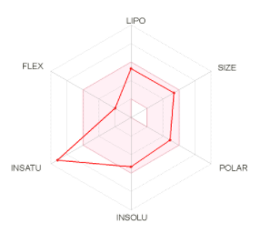 | 2.61 | -5.33 | -6.33 | Yes  0 violation | High | 0  alert
 | MMV687700 | 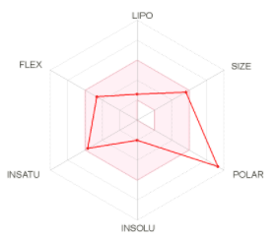 | 1.47 | -2.02 | -9.82 | No, 1 violation | Low | 0  alert
 | MMV022029 | 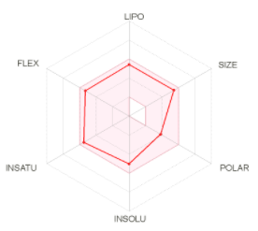 | 3.77 | -5.02 | -6.22 | Yes  0 violation | High | 0  alert
 | MMV676603 |  | 2.88 | -4.41 | -6.87 | Yes  0 violation | High | 0  alert
 | MMV688509 | 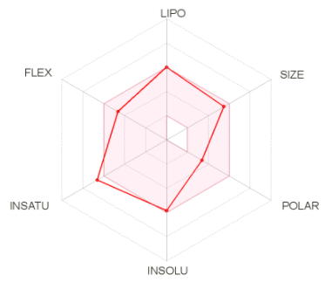 | 4.14 | -5.85 | -5.53 | Yes  0 violation | High | 0  alert
 | MMV000858 |  | 2.87 | -3.50 | -7.33 | Yes  0 violation | High | 0  alert
 | MMV085071 | 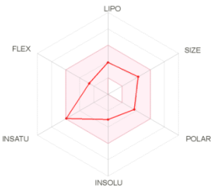 | 2.44 | -3.08 | -7.49 | Yes  0 violation | High | 0  alert
 | MMV676539 | 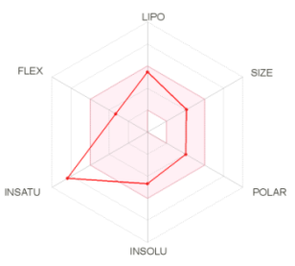 | 2.67 | -4.67 | -5.47 | Yes  0 violation | High | 0  alert
 | MMV023953 | 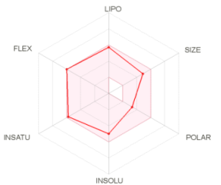 | 3.71 | -5.01 | -5.54 | Yes  0 violation | High | 0  alert
 | MMV020289 | 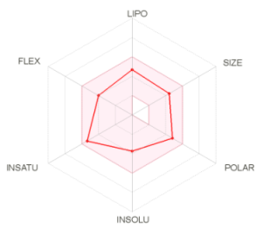 | 2.60 | -3.74 | -6.59 | Yes  0 violation | High | 0  alert
 | MMV658993 | 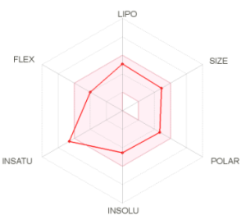 | 2.97 | -4.56 | -6.36 | Yes  0 violation | High | 0  alert
 | MMV676528 | 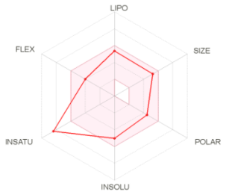 | 2.54 | -5.03 | -6.21 | Yes  0 violation | High | 0  alert
 | MMV687239 | 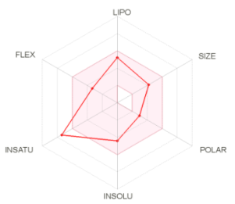 | 2.89 | -4.43 | -5.79 | Yes  0 violation | High | 0  alert
 | MMV007638 |  | 2.35 | -5.10 | -5.73 | Yes  0 violation | High | 0  alert
 | MMV688361 | 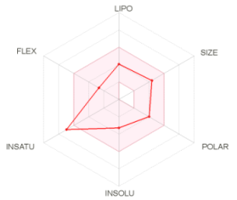 | 2.89 | -3.27 | -7.34 | Yes  0 violation | High | 0  alert
 | MMV007471 | 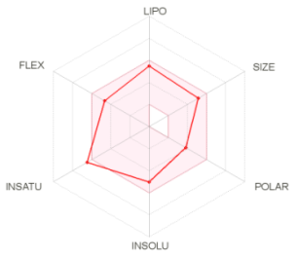 | 3.80 | -5.03 | -5.99 | Yes  0 violation | High | 0  alert
 | MMV676380 | 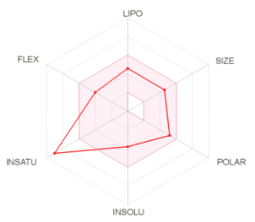 | 1.45 | -3.80 | -6.79 | Yes  0 violation | High | 0  alert
 | MMV688704 | 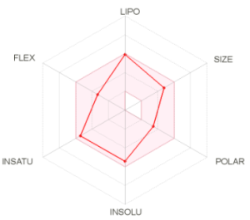 | 3.57 | -5.42 | -5.24 | Yes  0 violation | High | 0  alert
 | MMV010576 | 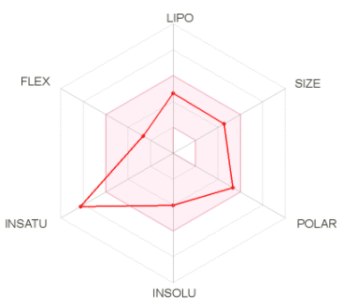 | 2.28 | -4.03 | -6.71 | Yes  0 violation | High | 0  alert
 | MMV634140 | 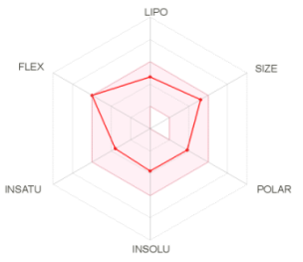 | 4.03 | -3.81 | -7.09 | Yes  0 violation | High | 0  alert
 | MMV688761 | 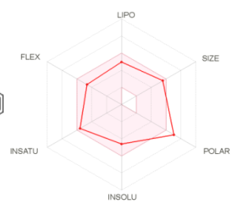 | 2.70 | -4.61 | -6.84 | Yes  0 violation | Low | 0  alert
 | MMV687798 | 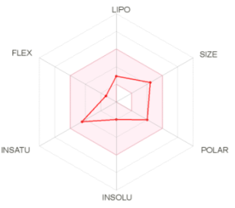 | 2.25 | -1.99 | -8.78 | Yes  0 violation | High | 0  alert
 | MMV024937 | 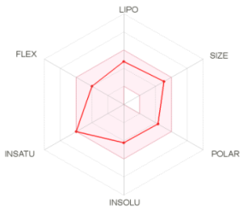 | 3.13 | -4.23 | -6.84 | Yes  0 violation | High | 0  alert
 | MMV688796 | 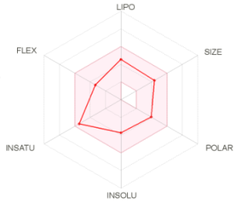 | 3.04 | -3.72 | -6.71 | Yes  0 violation | High | 0  alert
 | MMV020591 | 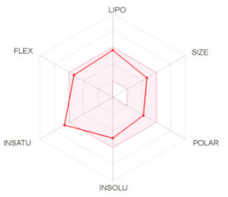 | 2.50 | -4.86 | -5.55 | Yes  0 violation | High | 0  alert
 | MMV688178 | 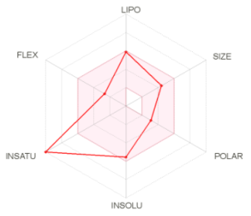 | 3.31 | -5.54 | -5.14 | Yes  0 violation | High | 0  alert
 | MMV007133 | 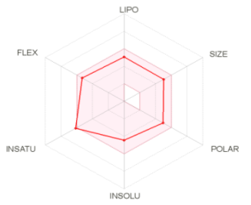 | 2.39 | -4.44 | -6.42 | Yes  0 violation | High | 0  alert
 | MMV676476 | 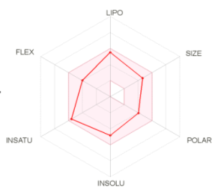 | 3.39 | -4.84 | -5.67 | Yes  0 violation | High | 0  alert
 | MMV688472 | 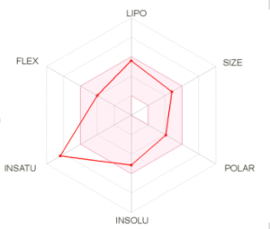 | 3.43 | -5.12 | -5.68 | Yes  0 violation | High | 0  alert
 | MMV659004 | 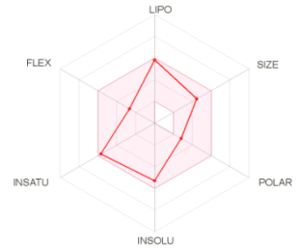 | 3.67 | -5.29 | -5.22 | Yes  0 violation | High | 0  alert
 | MMV688991 | 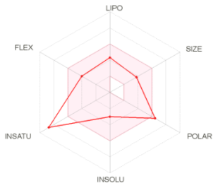 | 0.90 | -3.02 | -6.73 | Yes  0 violation | Low | 0  alert
 | MMV687172 | 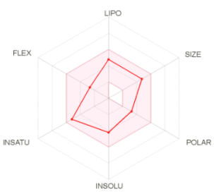 | 3.52 | -4.22 | -6.63 | Yes  0 violation | High | 0  alert
 | MMV688180 | 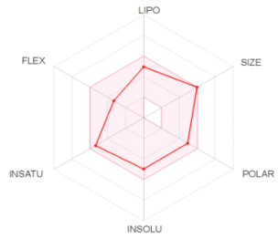 | 2.73 | -4.97 | -7.07 | Yes  0 violation | High | 0  alert
 | MMV688552 | 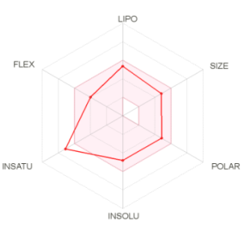 | 3.41 | -4.79 | -5.95 | Yes  0 violation | High | 0  alert
 | MMV020136 | 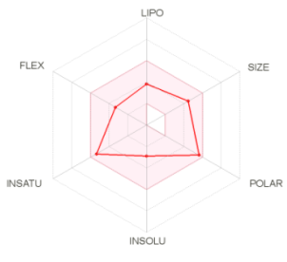 | 2.41 | -2.89 | -7.67 | Yes  0 violation | High | 0  alert
 | MMV688407 | 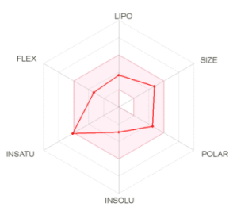 | 2.96 | -2.91 | -8.02 | Yes  0 violation | High | 0  alert
 | MMV688262 | 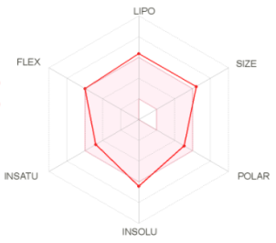 | 3.81 | -6.44 | -5.56 | No, 1 violation | Low | 1  alert
 | MMV676597 | 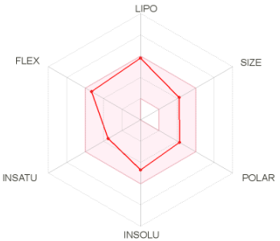 | 2.97 | -4.72 | -5.06 | Yes  0 violation | High | 0  alert
 | MMV085499 | 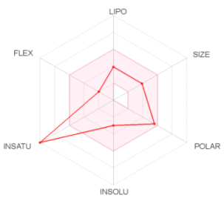 | 1.76 | -3.00 | -7.27 | Yes  0 violation | High | 0  alert
 | MMV688474 | 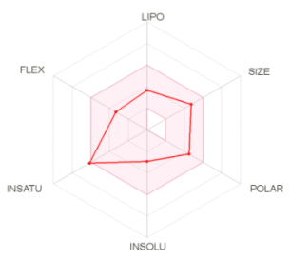 | 2.74 | -2.91 | -8.02 | Yes  0 violation | High | 0  alert
 | MMV1029203 | 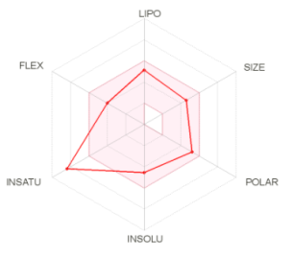 | 3.22 | -4.53 | -6.13 | Yes  0 violation | High | 0  alert
 | MMV024406 | 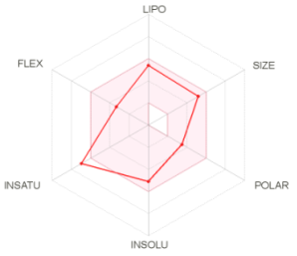 | 2.89 | -5.09 | -6.13 | Yes  0 violation | High | 0  alert
 | MMV676509 | 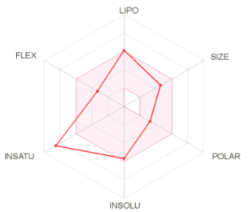 | 3.42 | -5.69 | -4.91 | Yes  0 violation | High | 0  alert
 | MMV024397 | 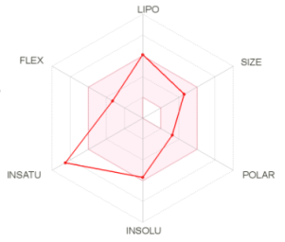 | 3.10 | -4.30 | -5.62 | Yes  0 violation | High | 0  alert
 | MMV676555 | 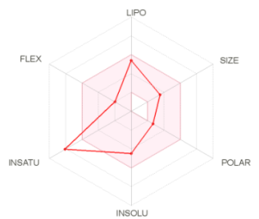 | 2.99 | -4.47 | -5.24 | Yes  0 violation | High | 0  alert
 | MMV675998 | 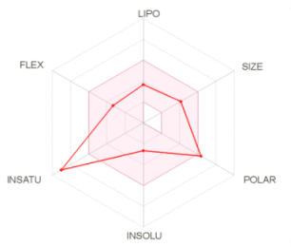 | 1.34 | -2.67 | -7.70 | Yes  0 violation | High | 0  alert
 | MMV560185 | 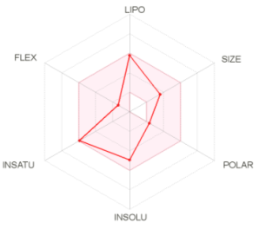 | 3.35 | -4.95 | -4.78 | Yes  0 violation | High | 0  alert
 | MMV688471 | 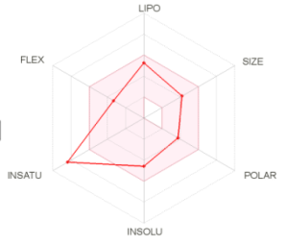 | 2.83 | -4.57 | -5.77 | Yes  0 violation | High | 0  alert
 | MMV090930 | 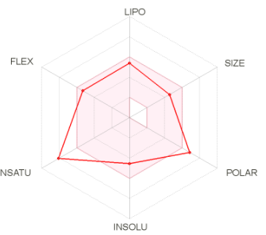 | 1.81 | -4.54 | -5.79 | Yes  0 violation | Low | 0  alert
 | MMV687189 | 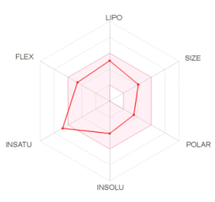 | 2.98 | -4.06 | -5.96 | Yes  0 violation | High | 0  alert
 | MMV688362 | 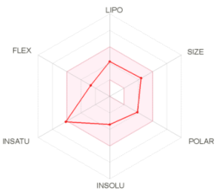 | 3.01 | -3.41 | -7.16 | Yes  0 violation | High | 0  alert
 | MMV019087 | 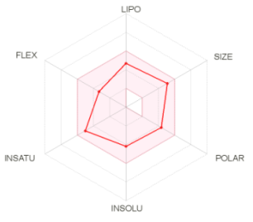 | 2.79 | -4.19 | -6.95 | Yes  0 violation | High | 0  alert
 | MMV689061 | 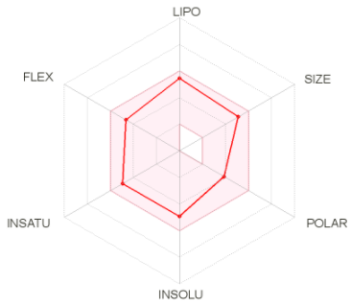 | 3.87 | -4.94 | -6.02 | Yes  0 violation | High | 0  alert
 | MMV689029 | 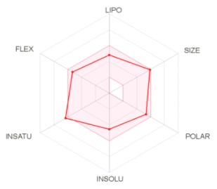 | 3.32 | -4.56 | -7.23 | Yes  0 violation | High | 0  alert
 | MMV688768 | 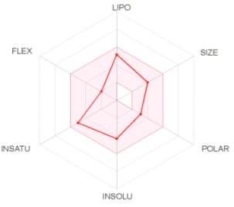 | 3.18 | -4.32 | -5.79 | Yes  0 violation | High | 1 alert
 | MMV688762 | 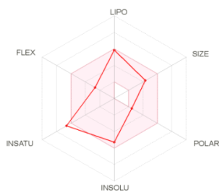 | 3.10 | -5.30 | -5.12 | Yes  0 violation | High | 0  alert
 | MMV030734 | 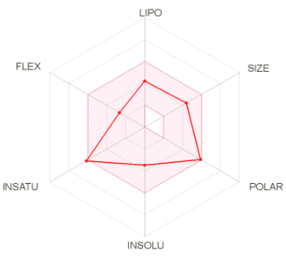 | 1.83 | -3.48 | -7.17 | Yes  0 violation | High | 0  alert
 | MMV001493 | 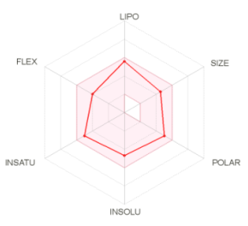 | 3.46 | -4.69 | -5.53 | Yes  0 violation | High | 0  alert
 | MMV687729 | 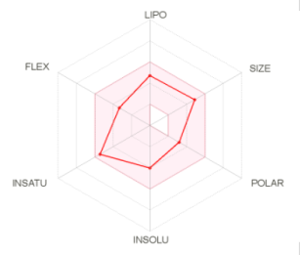 | 3.46 | -4.03 | -6.79 | Yes  0 violation | High | 0  alert
 | MMV687775 | 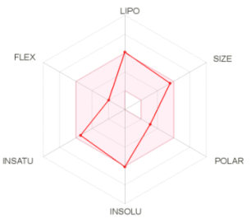 | 0.00 | -6.08 | -5.42 | Yes  0 violation | High | 0  alert
 | MMV687794 | 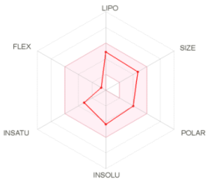 | 3.30 | -4.35 | -6.51 | Yes  0 violation | High | 0  alert
 | MMV032967 | 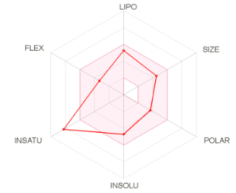 | 2.32 | -4.71 | -5.92 | Yes  0 violation | High | 0  alert
 | MMV020165 | 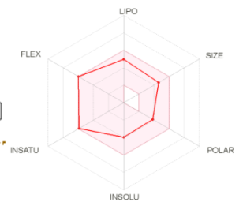 | 2.83 | -3.96 | -6.33 | Yes  0 violation | High | 0  alert
 | MMV020512 | 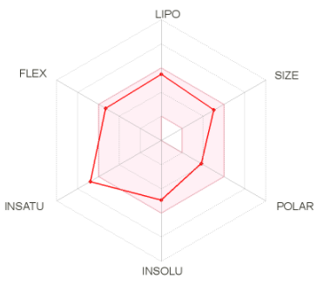 | 3.70 | -4.92 | -5.90 | Yes  0 violation | High | 0  alert
 | MMV676602 | 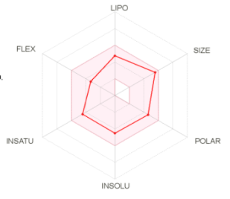 | 3.73 | -4.50 | -7.12 | Yes  0 violation | High | 1  alert
 | MMV008439 | 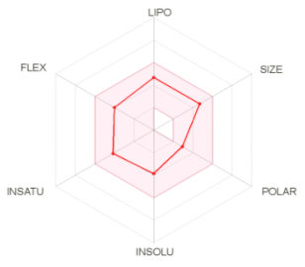 | 4.14 | -3.85 | -6.72 | Yes  0 violation | High | 0  alert
 | MMV020982 | 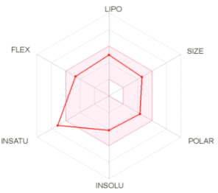 | 2.59 | -4.14 | -6.37 | Yes  0 violation | High | 0  alert
 | MMV688921 | 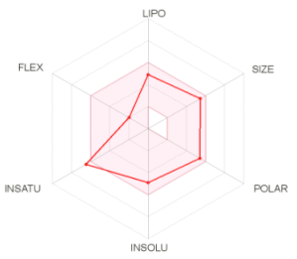 | 3.19 | -4.89 | -6.86 | Yes  0 violation | High | 0  alert
 | MMV024829 | 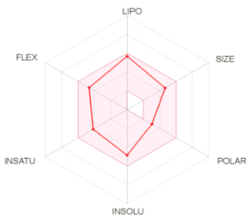 | 3.79 | -4.85 | -5.48 | Yes  0 violation | High | 0  alert
 | MMV004168 | 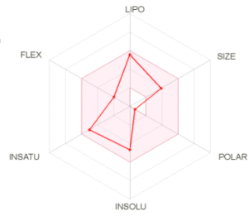 | 3.65 | -4.68 | -5.20 | Yes  0 violation | High | 0  alert
 | MMV688466 | 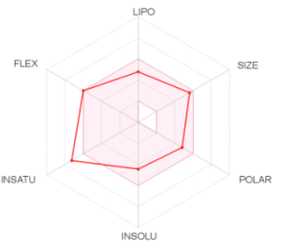 | 3.10 | -4.46 | -7.10 | Yes  0 violation | High | 0  alert
 | MMV676478 | 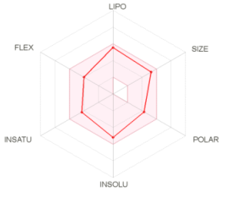 | 4.11 | -5.18 | -5.97 | Yes  0 violation | High | 0  alert
 | MMV019189 | 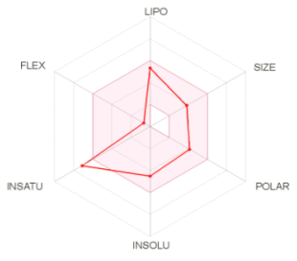 | 2.53 | -4.50 | -5.48 | Yes  0 violation | High | 1 alert
 | MMV688271 | 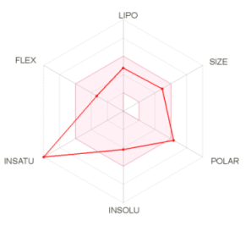 | 1.68 | -4.20 | -6.81 | Yes  0 violation | Low | 0  alert
 | MMV019742 | 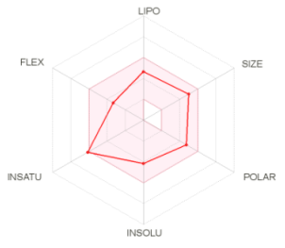 | 2.62 | -4.16 | -6.92 | Yes  0 violation | High | 0  alert
 | MMV099637 | 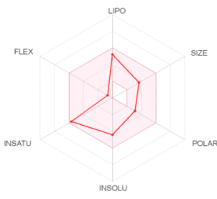 | 3.05 | -4.43 | -5.52 | Yes  0 violation | High | 0  alert
 | MMV022478 | 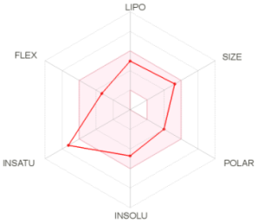 | 2.96 | -4.72 | -6.65 | Yes  0 violation | High | 1 alert
 | MMV687813 | 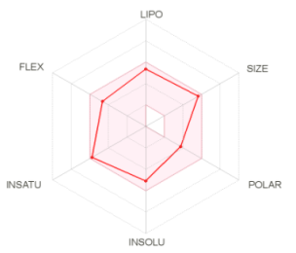 | 4.05 | -5.09 | -6.40 | Yes  0 violation | High | 0  alert
 | MMV688179 | 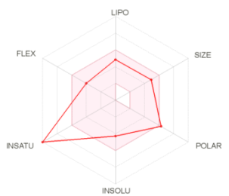 | 1.74 | -4.27 | -6.67 | No, 1 violation | Low | 0  alert
 | MMV688364 | 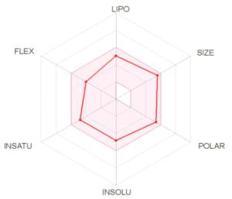 | 4.00 | -4.80 | -6.74 | Yes  0 violation | High | 0  alert
 | MMV688990 | 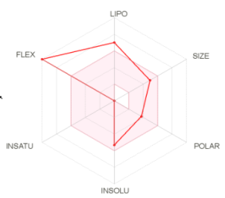 | 0.26 | -5.32 | -3.97 | Yes  0 violation | Low | 0  alert
 | MMV668727 | 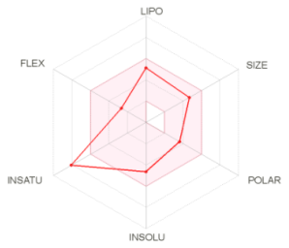 | 2.22 | -4.63 | -6.19 | Yes  0 violation | Low | 0  alert
 | MMV688327 | 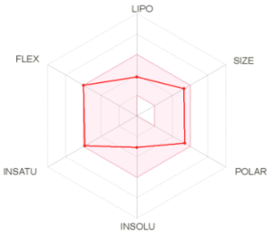 | 2.1 | -3.08 | -8.17 | Yes  0 violation | High | 0  alert
 | MMV688283 | 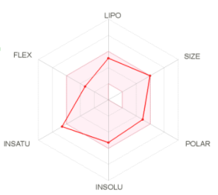 | 3.76 | -5.30 | -6.79 | Yes  0 violation | High | 0  alert
 | MMV688508 | 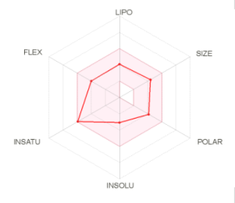 | 2.56 | -3.07 | -7.29 | Yes  0 violation | High | 0  alert
 | MMV688845 | 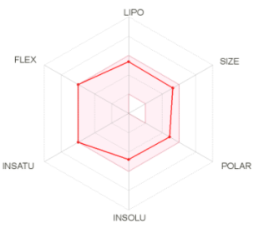 | 3.36 | -4.78 | -6.22 | Yes  0 violation | High | 0  alert
 | MMV688844 | 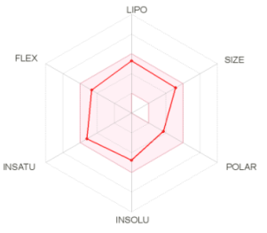 | 4.21 | -4.78 | -6.22 | Yes  0 violation | High | 0  alert
 | MMV1198433 | 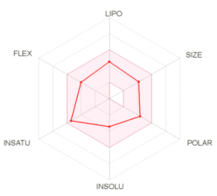 | 3.08 | -3.44 | -6.64 | Yes  0 violation | High | 0  alert
 | MMV407539 | 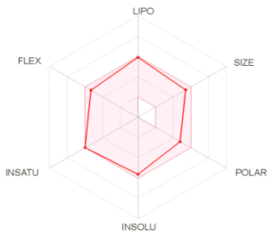 | 3.65 | -5.61 | -5.59 | Yes  0 violation | High | 0  alert
 | MMV675997 | 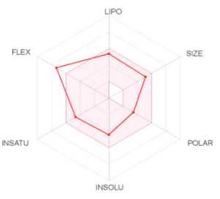 | 4.00 | -4.46 | -6.16 | Yes  0 violation | High | 0  alert
 | MMV689028 | 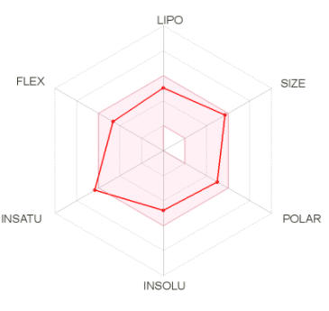 | 3.31 | -4.78 | -6.86 | Yes  0 violation | High | 0  alert
 | MMV026490 | 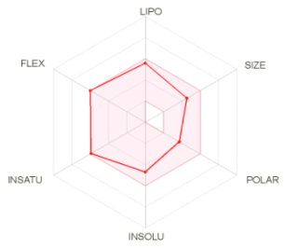 | 2.86 | -4.71 | -5.55 | Yes  0 violation | High | 0  alert
 | MMV671636 | 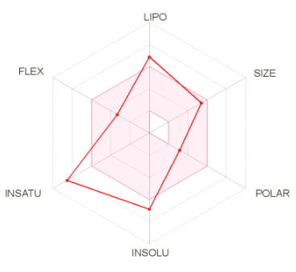 | 3.72 | -6.87 | -4.43 | Yes  0 violation | Low | 0  alert
 | MMV687246 | 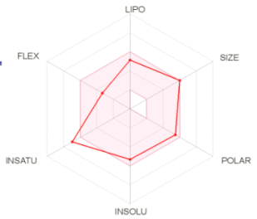 | 2.91 | -5.32 | -6.87 | Yes  0 violation | High | 0  alert
 | MMV688550 | 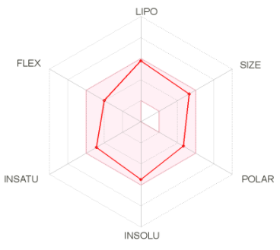 | 4.21 | -5.48 | -5.69 | Yes  0 violation | High | 0  alert
 | MMV688270 | 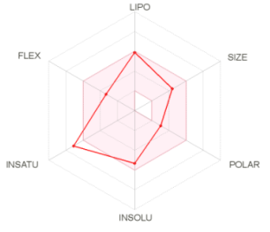 | 3.83 | -5.31 | -5.11 | Yes  0 violation | High | 0  alert
 | MMV020623 | 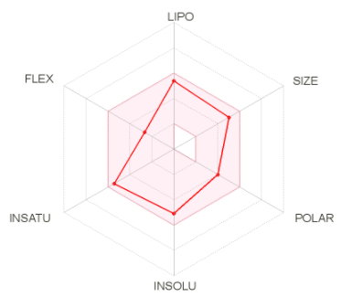 | 3.34 | -5.11 | -6.02 | Yes  0 violation | High | 0  alert
 | MMV688350 | 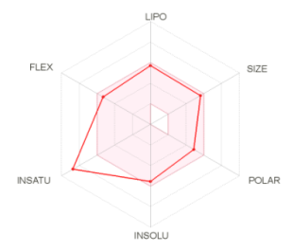 | 3.11 | -5.54 | -5.96 | Yes  0 violation | High | 0  alert
 | MMV023949 | 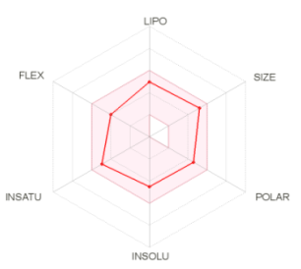 | 3.08 | -4.50 | -6.67 | Yes  0 violation | High | 0  alert

*The Bioavailability Radar envisages the drug-likeness of a molecule. The pink area represents the optimal range.
*Predicted octanol/water partition coefficient log Po/w (acceptable range: -0.7 to 5.0).
*Predicted solubility log S (acceptable range below 6).
*Predicted skin permeability coefficient log Kp in cm/s.

Supplementary Figures
Supplementary Figure S1: Uncropped gel images for Figure 2a-b, d-e
Figure S1: Full length gel images for commaassie stained SDS gel shown in a) Figure 2a, b) Figure 2b, c) Figure 2d and d) Figure 2e.
Supplementary Figure S2: Uncropped images of immunoblotting in Figure 9:
Figure S2: Full length images of blot probed with a) anti-ubiquitin and (b) anti-β-acttin. The box indicates the cropped position of membrane in the figure.

Supplementary Figure S3: Assessing the cytoxicity of MMV676603 and MMV688704 against mammalian cell lines.
Figure S3: Cell viability evaluation using MTT assay: Graphical representation of the percent cell viability of HEK-293T (green) and HepG2 (orange) cells treated with varied concentration of a) MMV676603 and b) MMV688704.

