Supplementary Information:

Top-emitting 940-nm thin-film VCSELs
transferred onto aluminum heatsinks

Sunghyun Moon¹, Yeojun Yun¹, Minhyung Lee¹, Donghwan Kim³, Wonjin Choi³, Ji-Yong Park² and Jaejin Lee^{1,*}
¹Department of Electrical and Computer Engineering, Ajou University, Suwon, 16499, South Korea
² Department of Physics and Department of Energy Systems Research, Ajou University, Suwon, 16499, South Korea
³RayIR Corporation, LTD, 156 Gwanggyo-ro, Yeongtong-gu, Suwon, 16506, South Korea
*Corresponding author: jaejin@ajou.ac.kr
Surface roughness of the fabricated top-emitting thin-film VCSELs
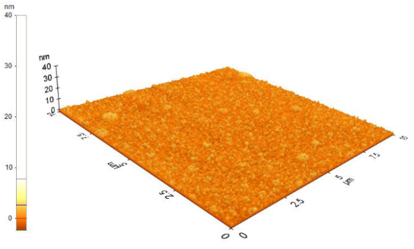
Supplementary Figure S1 shows 10 × 10-μm² atomic force microscopy (AFM) image of the fabricated thin-film VCSEL onto an aluminum heatsink. The fabricated thin-film VCSEL exhibited smooth surface with a root-mean-square (RMS) value of 0.774 nm.

Supplementary Figure S1. The 10 × 10-μm² AFM image of the fabricated thin-film VCSEL onto an aluminum substrate. The fabricated thin-film VCSEL showed smooth surface with a RMS value of 0.774 nm.

Reflectance spectrum of 940-nm thin-film VCSELs
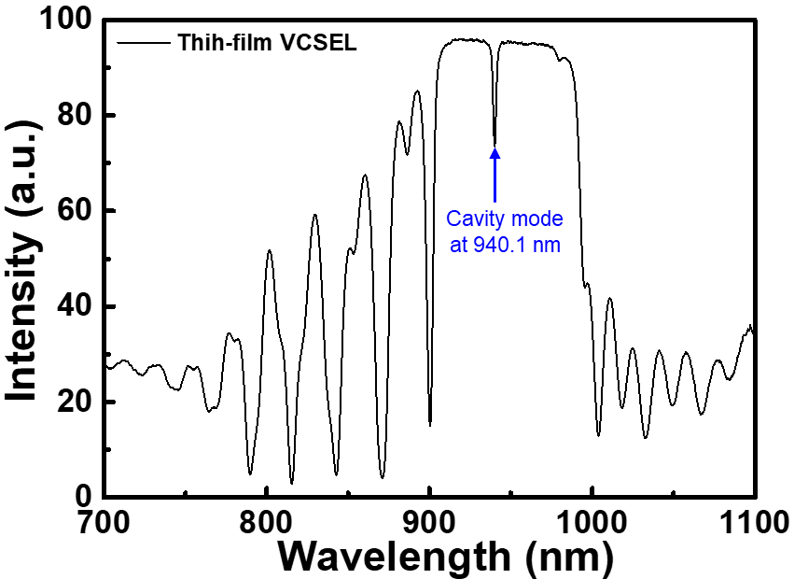
The reflectance spectrum of 940-nm thin-film VCSELs with p-on-n structures, including 38-pair n-DBRs, 18-pair p-type DBRs, and 3-pair MQWs, is shown in Fig. S2. The bottom n-DBRs with 38 pairs exhibited maximal reflectivity, whereas the top p-DBRs with lower numbers than n-DBRs were designed to ensure the light emission of the thin-film VCSELs. The cavity mode (CM) dip in the reflectance spectrum of thin-film VCSELs was centered at 940.1 nm.

Supplementary Figure S2. Reflectance spectrum of 940-nm thin-film VCSELs with p-on-n structures. The epitaxial structures of thin-film VCSELs consist of top p-DBR and bottom n-DBR mirrors as well as an active gain region with InGaAs−AlGaAs MQWs.

