Supplementary Information to:
Advances in automatic identification of flying insects using optical sensors and machine learning

Carsten Kirkeby^{*1,2}, Klas Rydhmer^{2*}, Samantha M. Cook ³, Alfred Strand², Martin T. Torrance³, Jennifer L. Swain³, Jord Prangsma², Andreas Johnen⁴, Mikkel Jensen², Mikkel Brydegaard^{2,5} and Kaare Græsbøll⁶

* These authors contributed equally to this work
¹Section for Animal Welfare and Disease Control, Department of Veterinary and Animal Sciences, Faculty of Health and Medical Sciences, University of Copenhagen, 1870 Frederiksberg, Denmark
²FaunaPhotonics APS, Ole Maaløes Vej 3, DK-2200 Copenhagen N, Denmark.
³Department of Biointeractions and Crop protection, Rothamsted Research, Harpenden, UK
⁴Xarvio Digital Farming Solutions, BASF Digital Farming GmbH, Albrecht-Thaer-Strasse 34, Münster, Germany
⁵Lund laser Centre, Department of Physics, Lund University, Sölvegatan 14, SE-223 62 Lund, Sweden.
⁶DTU Compute, Technical University of Denmark, 2800 Kongens Lyngby, Denmark.

Corresponding author: Carsten Kirkeby, ckir@sund.ku.dk

Supplementary Information

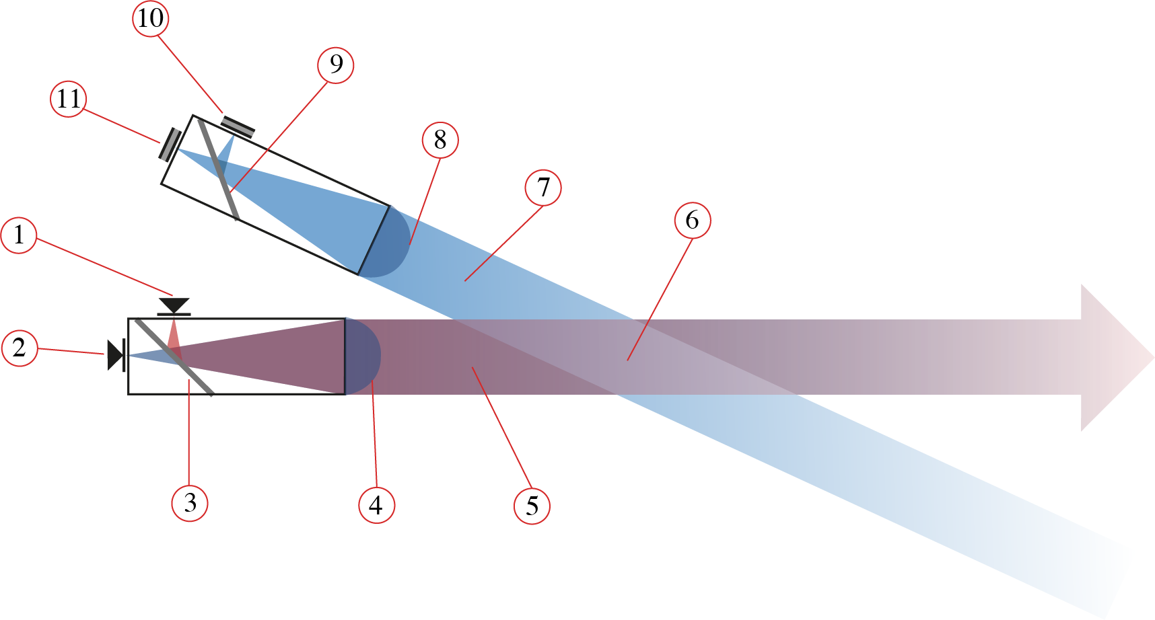
Supplementary Figure 1: Optical sensor setup viewed from above: 1: Laser diode 808 nm, 2: Laser diode 1320 nm, 3: Dichroic mirror, 4: Expander lens, 5: Emitted laser beam, 6: Probe volume, 7: Observed field of view, 8: Focusing lens, 9: Polarizing beam splitter, 10: Sandwich detector (808 nm & 1320 nm, co-polarized signal), 11: Sandwich detector (808 nm & 1320 nm, de-polarized signal). Drawing by Maja Olofsson.

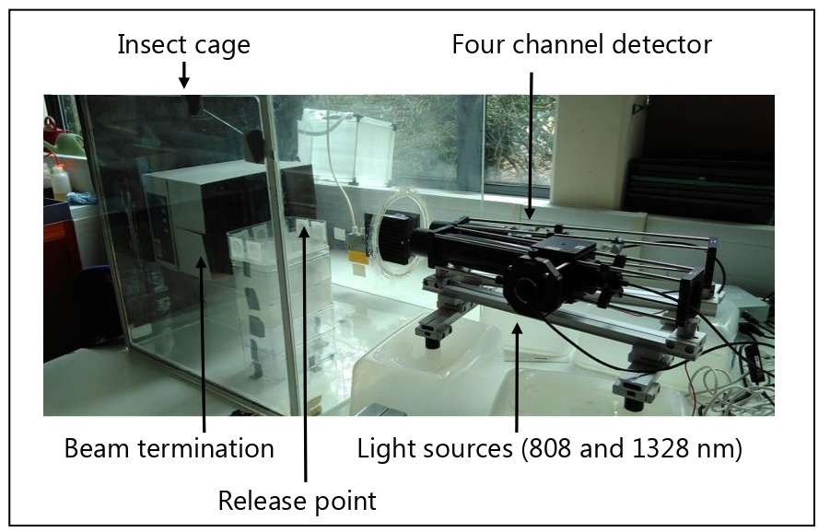
Supplementary Figure 2: Experimental setup of the prototype optical sensor. Photo: Klas Rydhmer.

Supplementary Table 1. The features used in the “Features” method in this study.

Fundamental frequency
Frequency of first harmonic
Frequency of second harmonic
Amplitude of the fundamental frequency in the Fourier transform
Amplitude of the first harmonic
Amplitude of the second harmonic
Full width-half maximum of the fundamental frequency peak in the Fourier transform
Full width-half maximum of the first harmonic peak in the Fourier transform
Full width-half maximum of the second harmonic peak in the Fourier transform
Ratio between amplitude of the fundamental harmonic and the amplitude of the first harmonic,
Ratio between amplitude of the fundamental harmonic and the amplitude of the second harmonic,
Ratio between amplitude of the first harmonic and the amplitude of the second harmonic,
Average amplitude of the body signal,
Median amplitude of body signal,
Average amplitude of wing signal,
Median amplitude of wing signal,
Wing mean/wing median,
Average of body signal /(body signal + wing signal),
Length of the event
Maximum amplitude of event,
Average amplitude of the event, and
Median amplitude of the event.

