Supplementary Materials for

Muscle metabolic remodelling patterns in Duchenne muscular dystrophy revealed by ultra-high resolution mass spectrometry imaging

Ivana Dabaj^{1,2#}, Justine Ferey^{3#}, Florent Marguet^{2,4}, Vianney Gilard^{3,5}, Carole Basset⁴, Youssef Bahri⁶, Anne-Claire Brehin⁷, Catherine Vanhulle¹, France Leturcq⁸, Stéphane Marret^{1,2}, Annie Laquerrière^{2,4}, Isabelle Schmitz-Afonso⁶, Carlos Afonso⁶, Soumeya Bekri^{2,3*}, Abdellah Tebani³

¹ Rouen University Hospital, Department of Neonatal Pediatrics, Intensive Care and Neuropediatrics, Rouen, 76031, France
² Normandie Univ, UNIROUEN, CHU Rouen, INSERM U1245, 76000 Rouen, France
³ Rouen University Hospital, Metabolic Biochemistry Department, Rouen, 76031, France.
⁴ Rouen University Hospital, Department of Pathology, Rouen, France.
⁵ Rouen University Hospital, Department of Neurosurgery, Rouen, France.
⁶ Normandie Univ, COBRA UMR 6014 et FR 3038 Univ Rouen; INSA Rouen; CNRS IRCOF, 1 Rue TesnieÌre, 76821 Mont-Saint-Aignan Cedex France
⁷ Normandie Univ, UNIROUEN, Inserm U1245 and Rouen University Hospital, Department of Genetics and Reference Center for Developmental Disorders, F 76000, Normandy Center for Genomic and Personalized Medicine, Rouen, France
⁸ APHP, Laboratoire de Génétique et Biologie moléculaire, HUPC Cochin, Paris, France.

#these authors contributed equally to this work

*Corresponding author:
Prof. Soumeya BEKRI
Department of Metabolic Biochemistry,
Rouen University Hospital 76031 ROUEN Cedex France
soumeya.bekri@chu-rouen.fr
Tel 00 33 2 32 88 81 24
Fax 00 33 2 32 88 83 41

Other Supplementary Material provided as an Excel file for this manuscript includes the following:

Supplementary Table 1. Clinical data for 9 Duchenne patients included in this study.
Supplementary Table 2. Descriptive statistics of the clinical data.
Supplementary Table 3. Complete intensity table of the annotated metabolites in the analysis’s biopsies.
Supplementary Table 4. Complete statistical and annotation metrics of the included metabolites.
Supplementary Table 5. Metabolite comparison with reported literature.

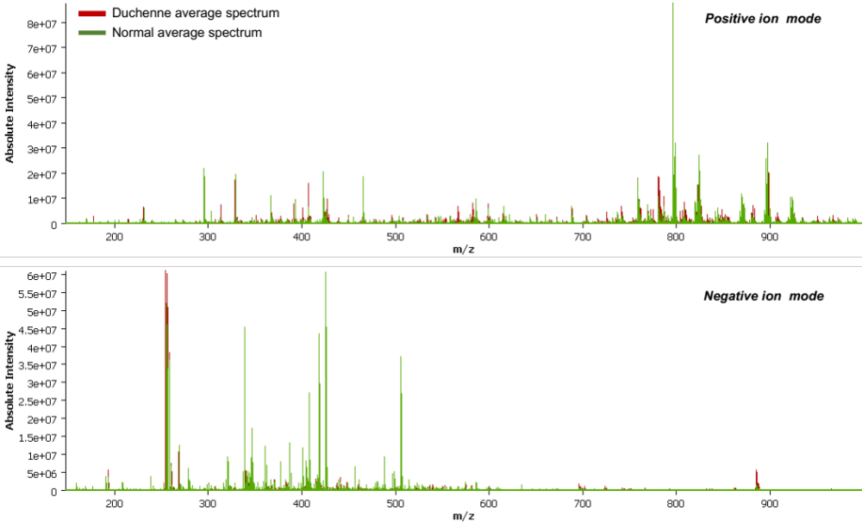

Supplementary Figure 1. Average spectra from Duchenne and Control samples in both Positive and Negative ionization mode.

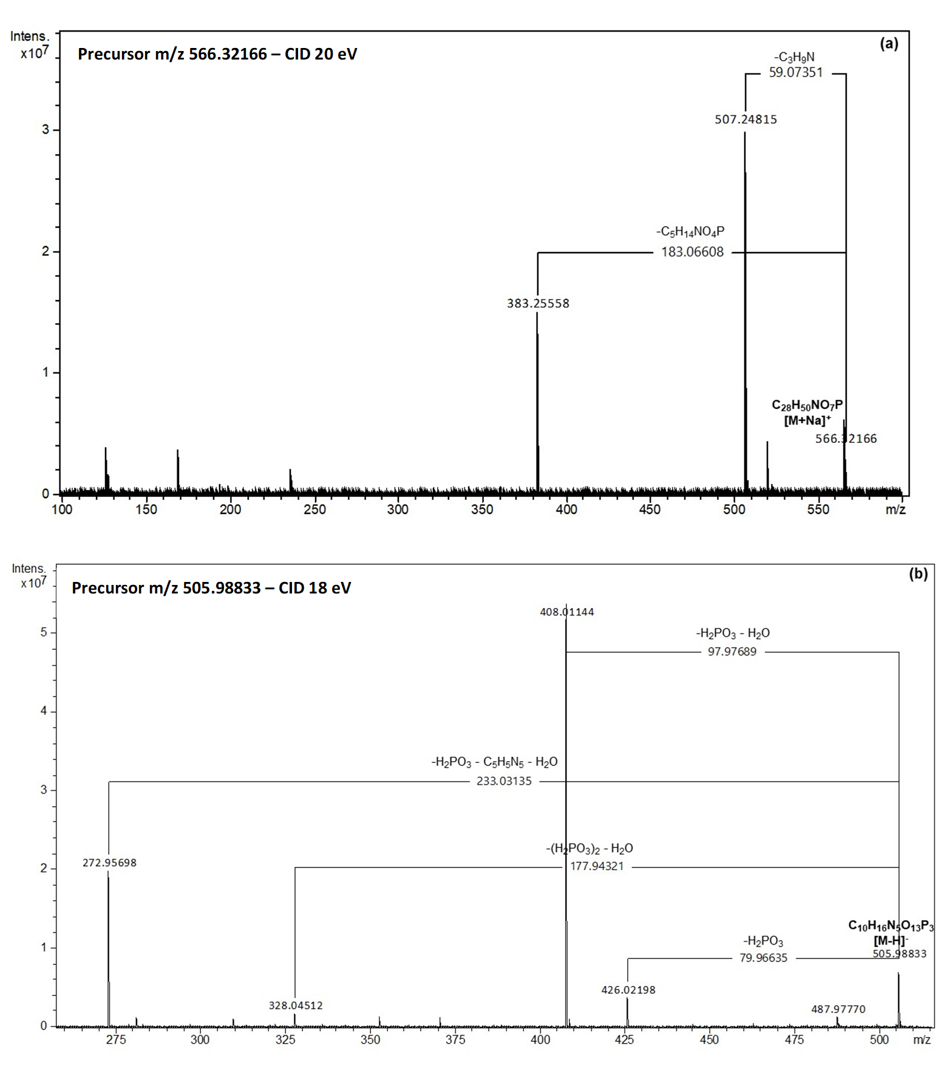
Supplementary Figure 2. MALDI-MS/MS spectra obtained from a) lysoPC(20:4) analyzed in positive ion mode by using DHB as a matrix and (b) Adenosine triphosphate (ATP) analyzed in negative ion mode by using 9-AA as a matrix. Spectra obtained using a Bruker SolariX MALDI-FTICR MS 12 Tesla. Collision induced dissociation (CID) was used for acquiring the MS/MS spectra.

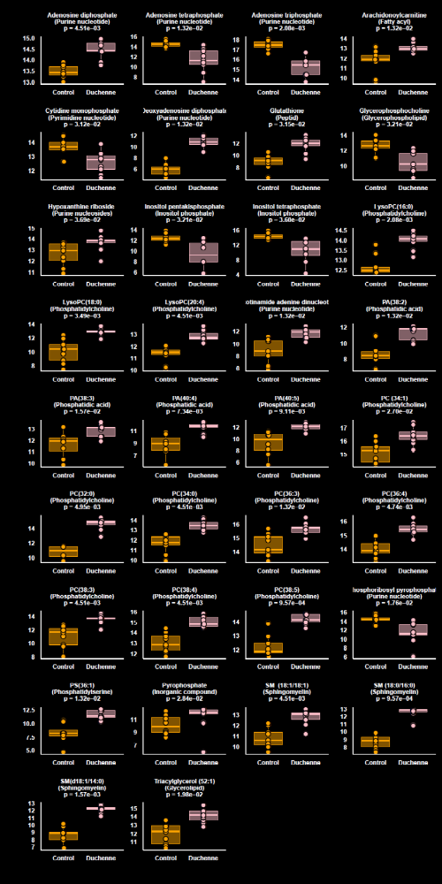
Supplementary Figure 3. Boxplots of the differentially expressed metabolites between Duchenne and control biopsies.

Supplementary Figure 4. MALDI-MS/MS spectra obtained from adenosine diphosphate (ADP, precursor m/z 426.02209, [M-H]⁻) analyzed in negative ion mode by using 9-AA as a matrix Spectra obtained using a Bruker solariX MALDI-FTICR MS 12 Tesla. Collision induced dissociation (CID) at 15 eV was used for acquiring the MS/MS spectra.

Supplementary Figure 5. MALDI-MS/MS spectra obtained from phosphatidylcholine 34:1 (PC 34:1, precursor m/z 782.56728, [M+Na]⁺) analyzed in positive ion mode by using DHB as a matrix Spectra obtained using a Bruker solariX MALDI-FTICR MS 12 Tesla. Collision induced dissociation (CID) at 25 eV was used for acquiring the MS/MS spectra.

Supplementary Figure 6. MALDI-MS/MS spectra obtained from phosphatidylcholine 32:0 (PC 32:0, precursor m/z 756.55138, [M+Na]⁺) analyzed in positive ion mode by using DHB as a matrix Spectra obtained using a Bruker solariX MALDI-FTICR MS 12 Tesla. Collision induced dissociation (CID) at 20 eV was used for acquiring the MS/MS spectra.

Supplementary Figure 7. MALDI-MS/MS spectra obtained from phosphatidylcholine 32:0 (PC 32:0, precursor m/z 756.55138, [M+Na]⁺) analyzed in positive ion mode by using DHB as a matrix Spectra obtained using a Bruker solariX MALDI-FTICR MS 12 Tesla. Collision induced dissociation (CID) at 20 eV was used for acquiring the MS/MS spectra.

Supplementary Figure 8. MALDI-MS/MS spectra obtained from phosphatidylcholine 36:4 (PC 36:4, precursor m/z 804.55255, [M+Na]⁺) analyzed in positive ion mode by using DHB as a matrix Spectra obtained using a Bruker solariX MALDI-FTICR MS 12 Tesla. Collision induced dissociation (CID) at 25 eV was used for acquiring the MS/MS spectra.

Supplementary Figure 9. MALDI-MS/MS spectra obtained from phosphatidylcholine 38:4 (PC 38:4, precursor m/z 832.58306, [M+Na]⁺) analyzed in positive ion mode by using DHB as a matrix Spectra obtained using a Bruker solariX MALDI-FTICR MS 12 Tesla. Collision induced dissociation (CID) at 25 eV was used for acquiring the MS/MS spectra.

Supplementary Figure 10. MALDI-MS/MS spectra obtained from phosphatidylcholine 38:4 (PC 38:4, precursor m/z 832.58306, [M+Na]⁺) analyzed in positive ion mode by using DHB as a matrix Spectra obtained using a Bruker solariX MALDI-FTICR MS 12 Tesla. Collision induced dissociation (CID) at 25 eV was used for acquiring the MS/MS spectra.

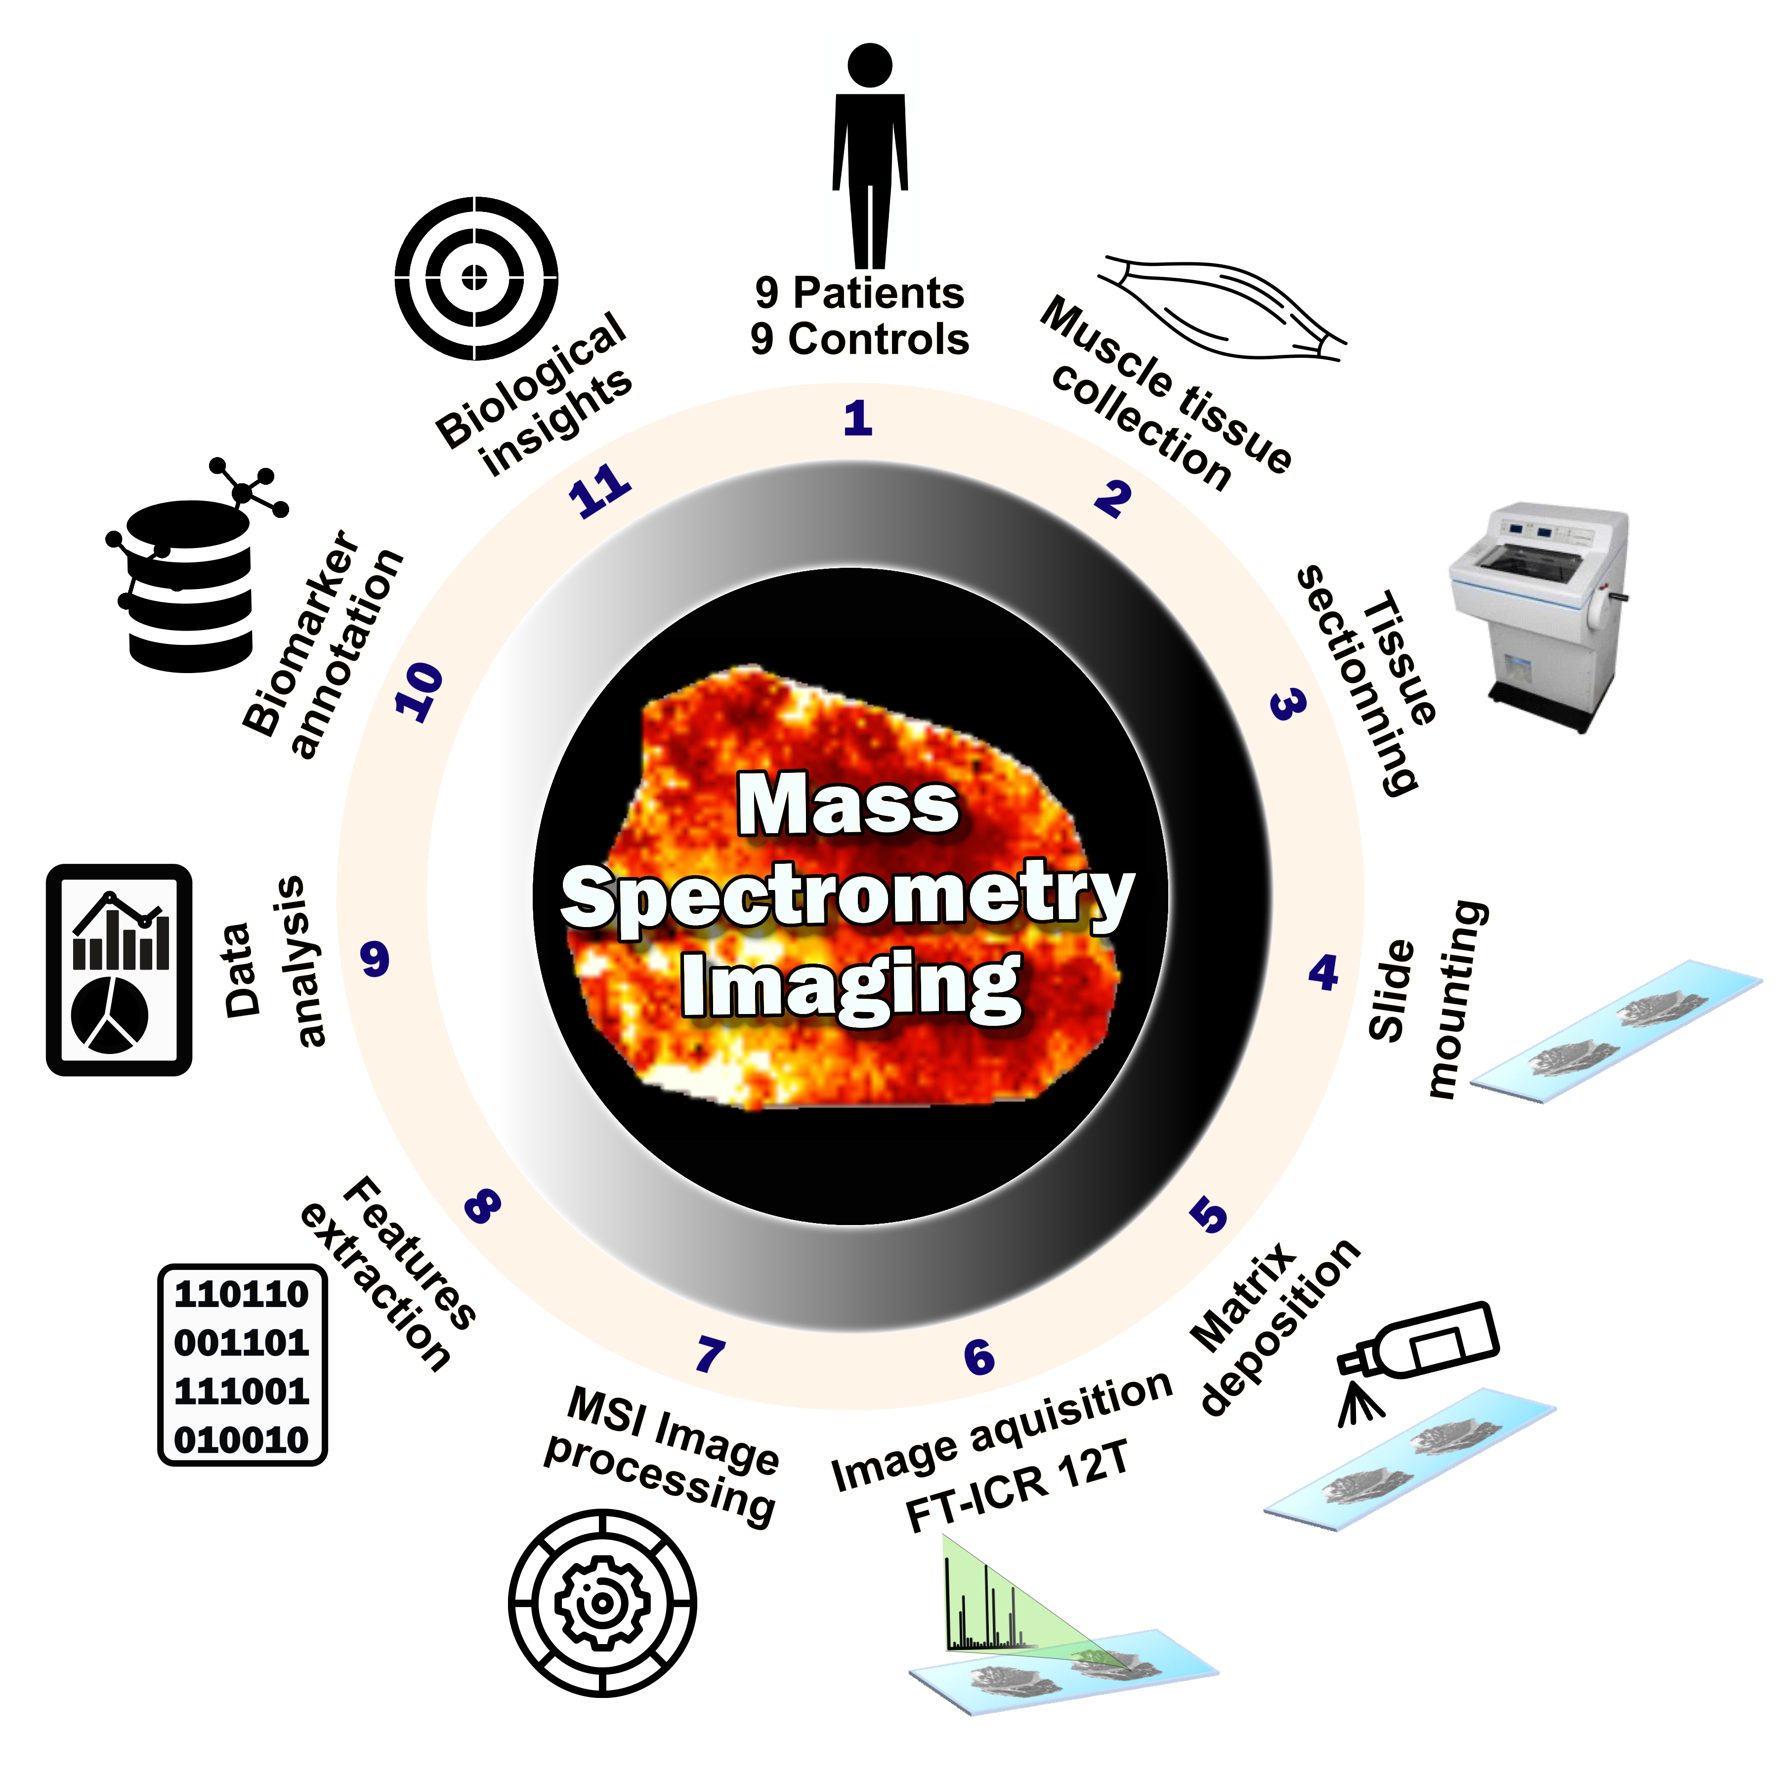

Supplementary Figure 11. General overview of mass spectrometry imaging workflow. (1) Patient selection; (2) Tissue sampling; (3) Tissue sectioning using a cryomicrotome; (4) Tissue section fixed to the sample probe; (5) Homogenous deposition of matrices using an automatic sprayer; (6) MSI data acquisition using an FT-ICR 12T Solarix Bruker; (7) Mass spectrometry imaging datasets (raw data files) were processed; (8) Raw data were converted into data matrices, including ion mass-to-charge ratios (m/z), spatial localization and relative intensity for each ion image, were generated using SCiLs Lab software; (9) Data analysis workflow for comparative analysis to extract the differential metabolic patterns; (10) Annotation of the discriminant features by interrogation mass spectrometry databases; (11) Interpretation of the data according to clinical and biological contexts.

