Analyzing the G3BP-like gene family of Arabidopsis thaliana in early turnip mosaic virus infection Hendrik Reuper, Khalid Amari and Björn Krenz

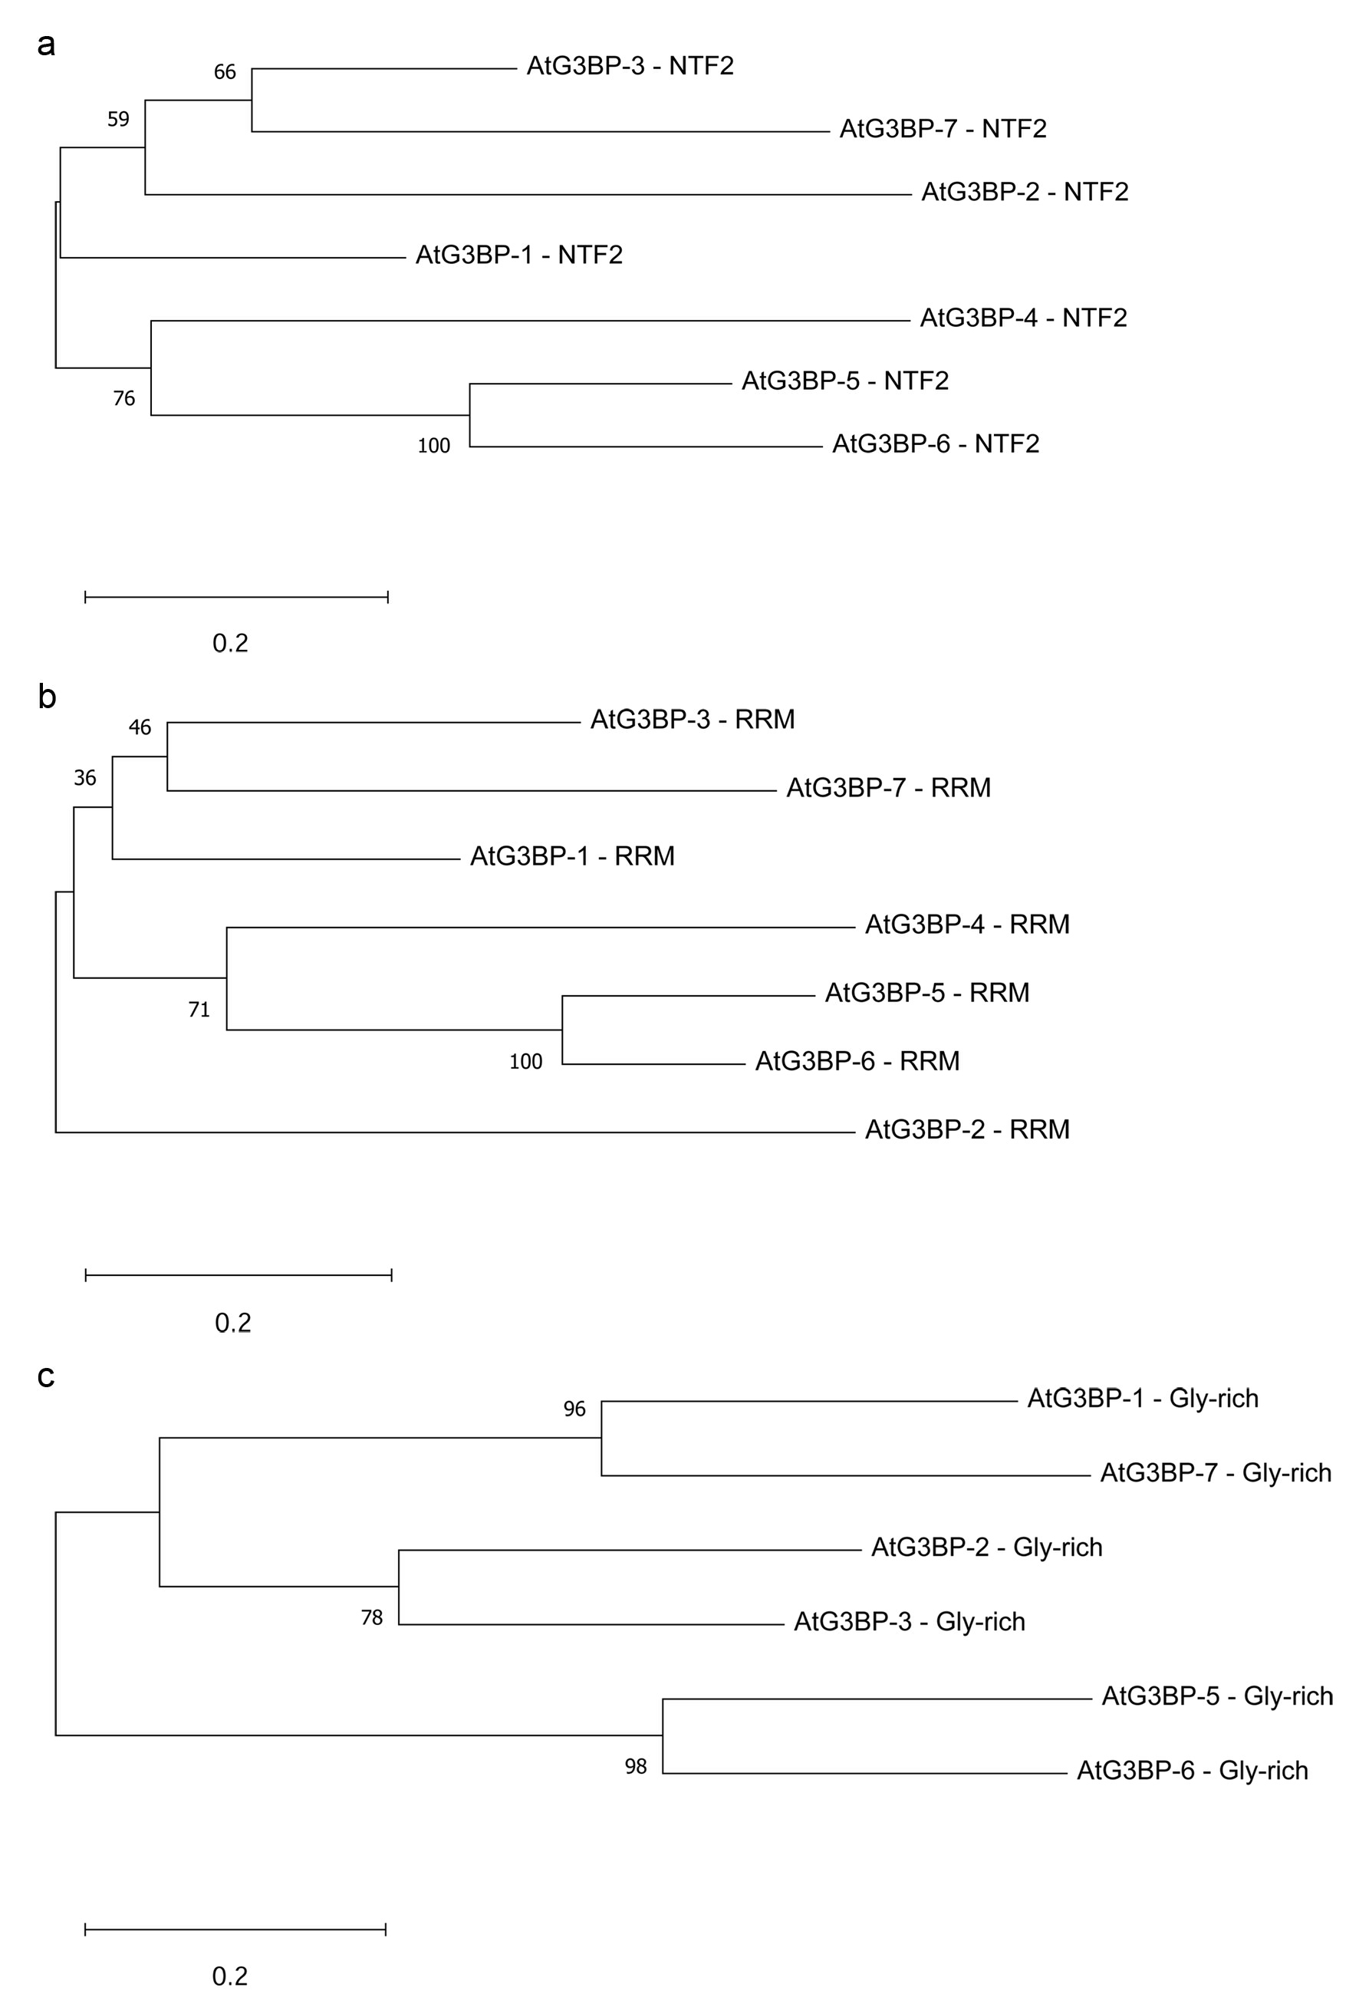
Supplementary Figure S1 Phylogenetic analysis of the different domains of the AtG3BP family.
The optimal tree with the sum of branch length of (a) 2.60190885 for the NTF2-like domain, (b) 2.49910748 for the RRM domain and (c) 2.64850966 for the Gly-rich region is shown. Evolutionary analyses were carried out as described in the methods section.

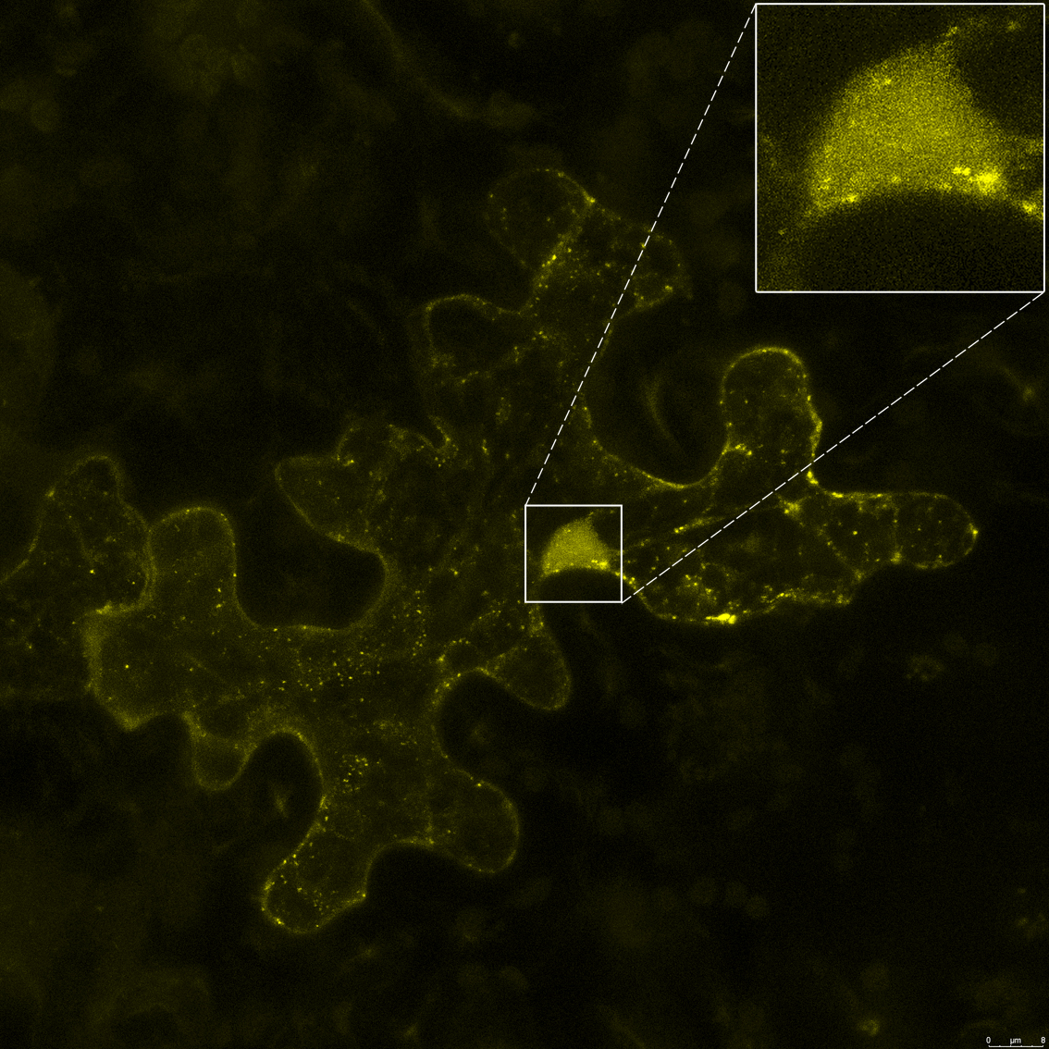
Supplementary Figure S2 Sub-cellular localization of AtG3BP-6::EYFP transient expressed in N. benthamiana leaves after heat shock. The enlarged area highlights the nuclear localization of AtG3BP-6. The picture is a maximum projection of a z-stack obtained by confocal laser scanning microscopy and was taken 2 dpai. The picture corresponds to a size of 145 x 145 µm.

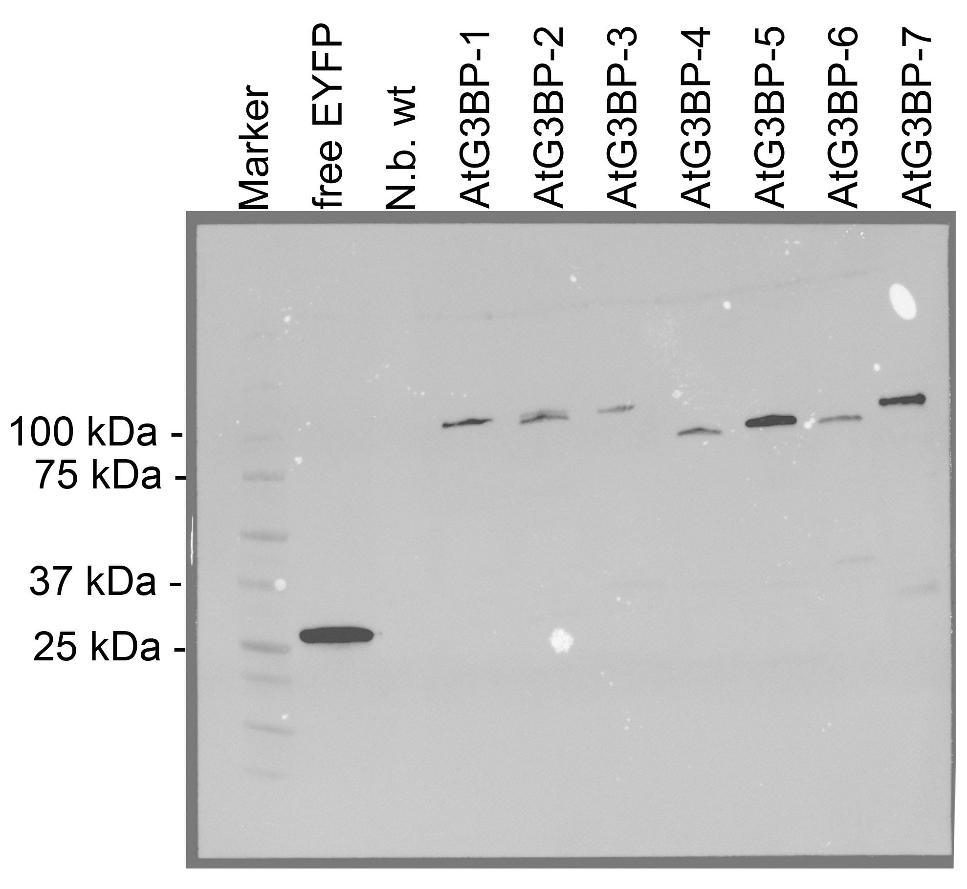
Supplementary Figure S3 Expression control of AtG3BP::EYFP fusion proteins. Protein extracts from infiltrated N. benthamiana leaves were separated via PAGE and immunoblotted against EYFP with a mouse anti-GFP antibody as described in the methods section. N. benthamiana leaves transiently expressing free EYFP were used as positive control, un-infiltrated leaves as negative control.

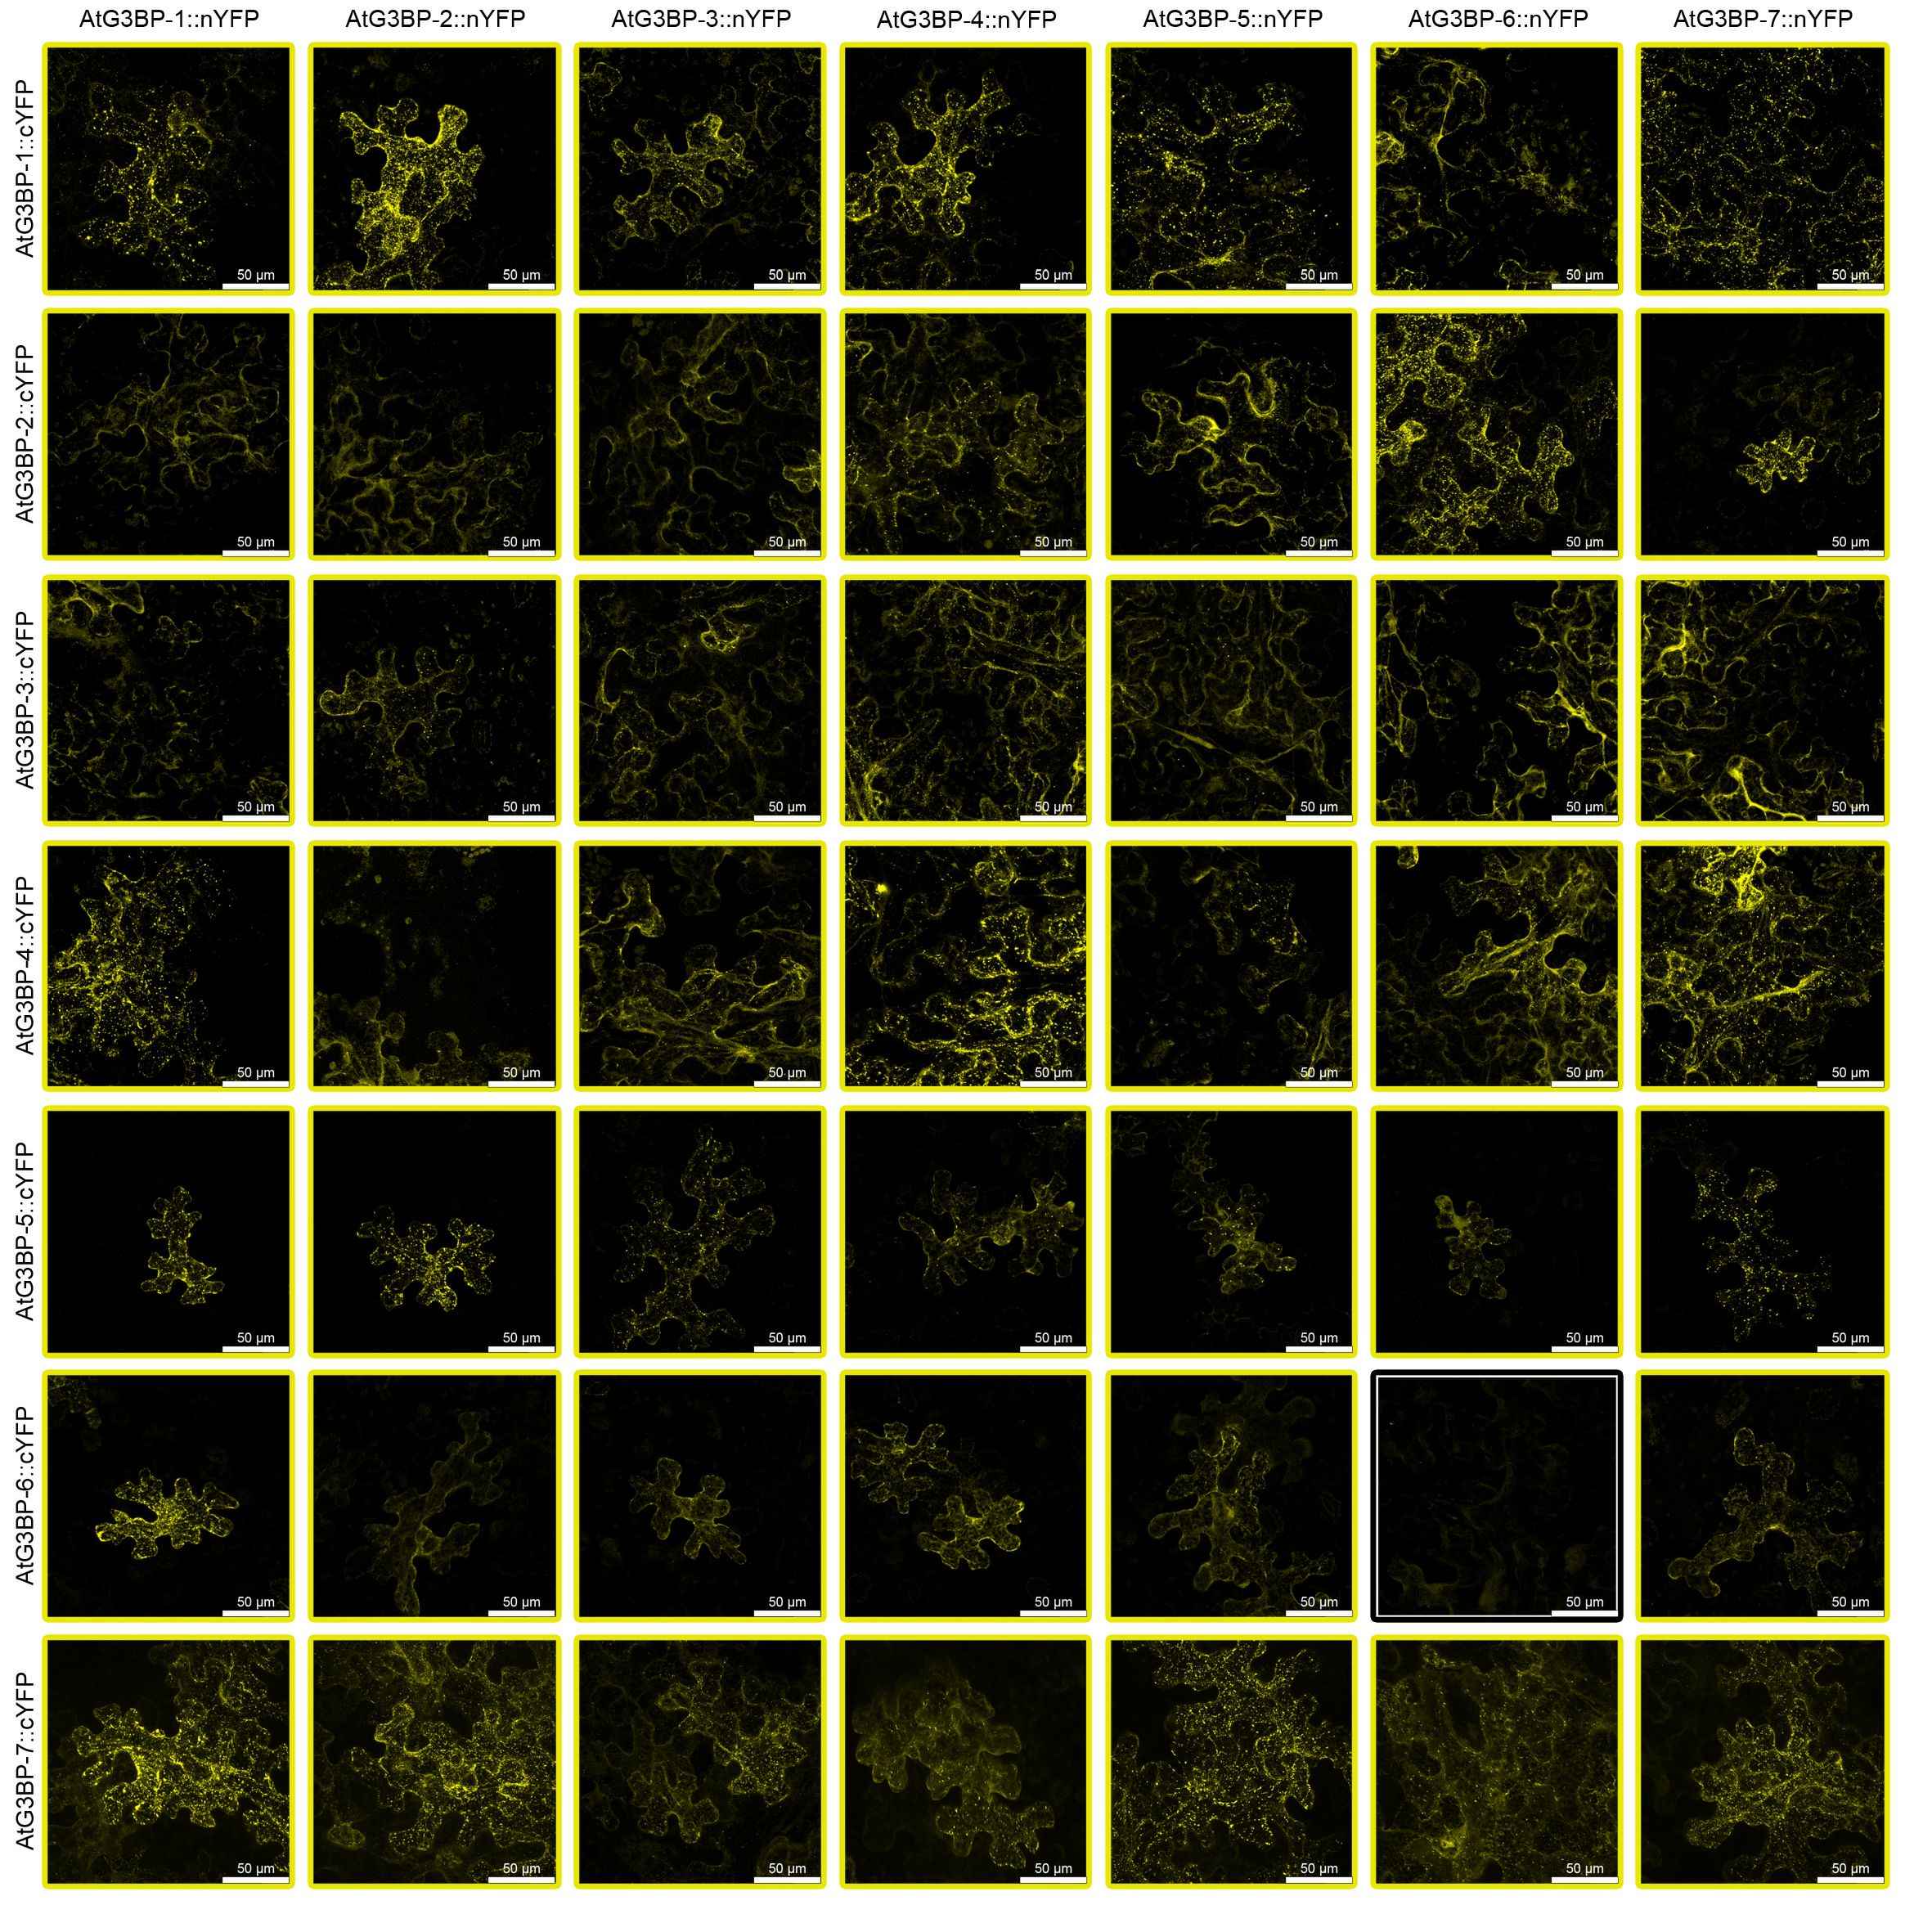
Supplementary Figure S4 BiFC analysis of AtG3BPs C-terminally fused to splitYFP under ambient conditions. Yellow frames indicate interaction, black frames no interaction. Possible yellow spots in the black framed panels are due to increased gain of the detector to detect even very low signals. The images displaying the self-interaction of the respective AtG3BP::splitYFP constructs are the same as in Figure 3A.

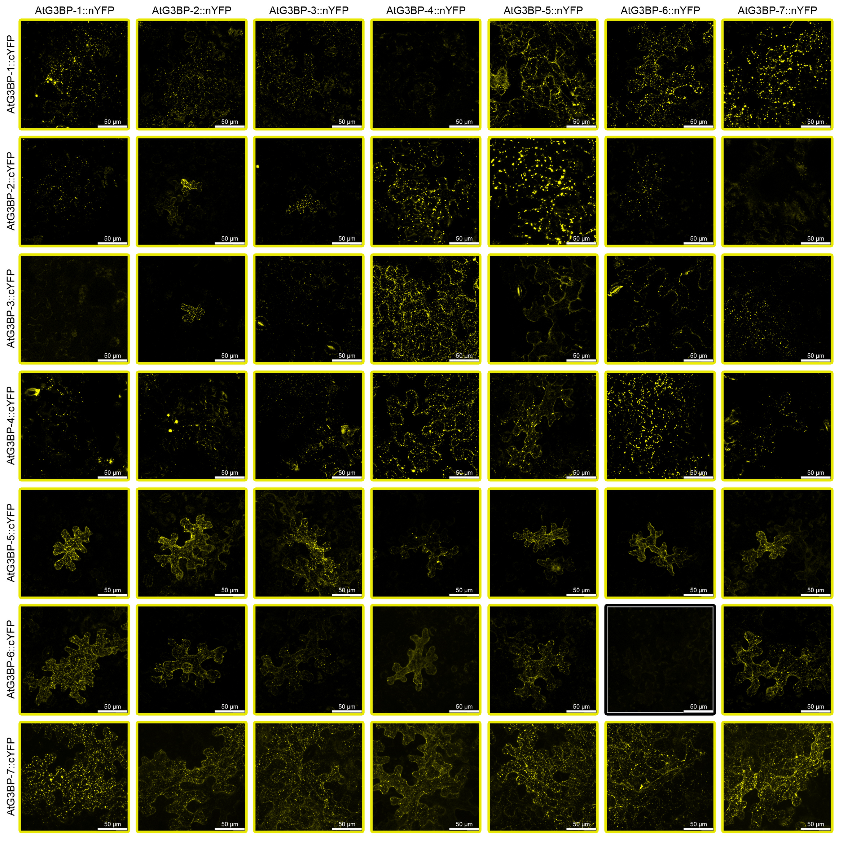
Supplementary Figure S5 BiFC analysis of AtG3BPs C-terminally fused to splitYFP after heat shock. Yellow frames indicate interaction, black frames no interaction. Possible yellow spots in the black framed panels are due to increased gain of the detector to detect even very low signals. The images displaying the self-interaction of the respective AtG3BP::splitYFP constructs are the same as in Figure 3A.

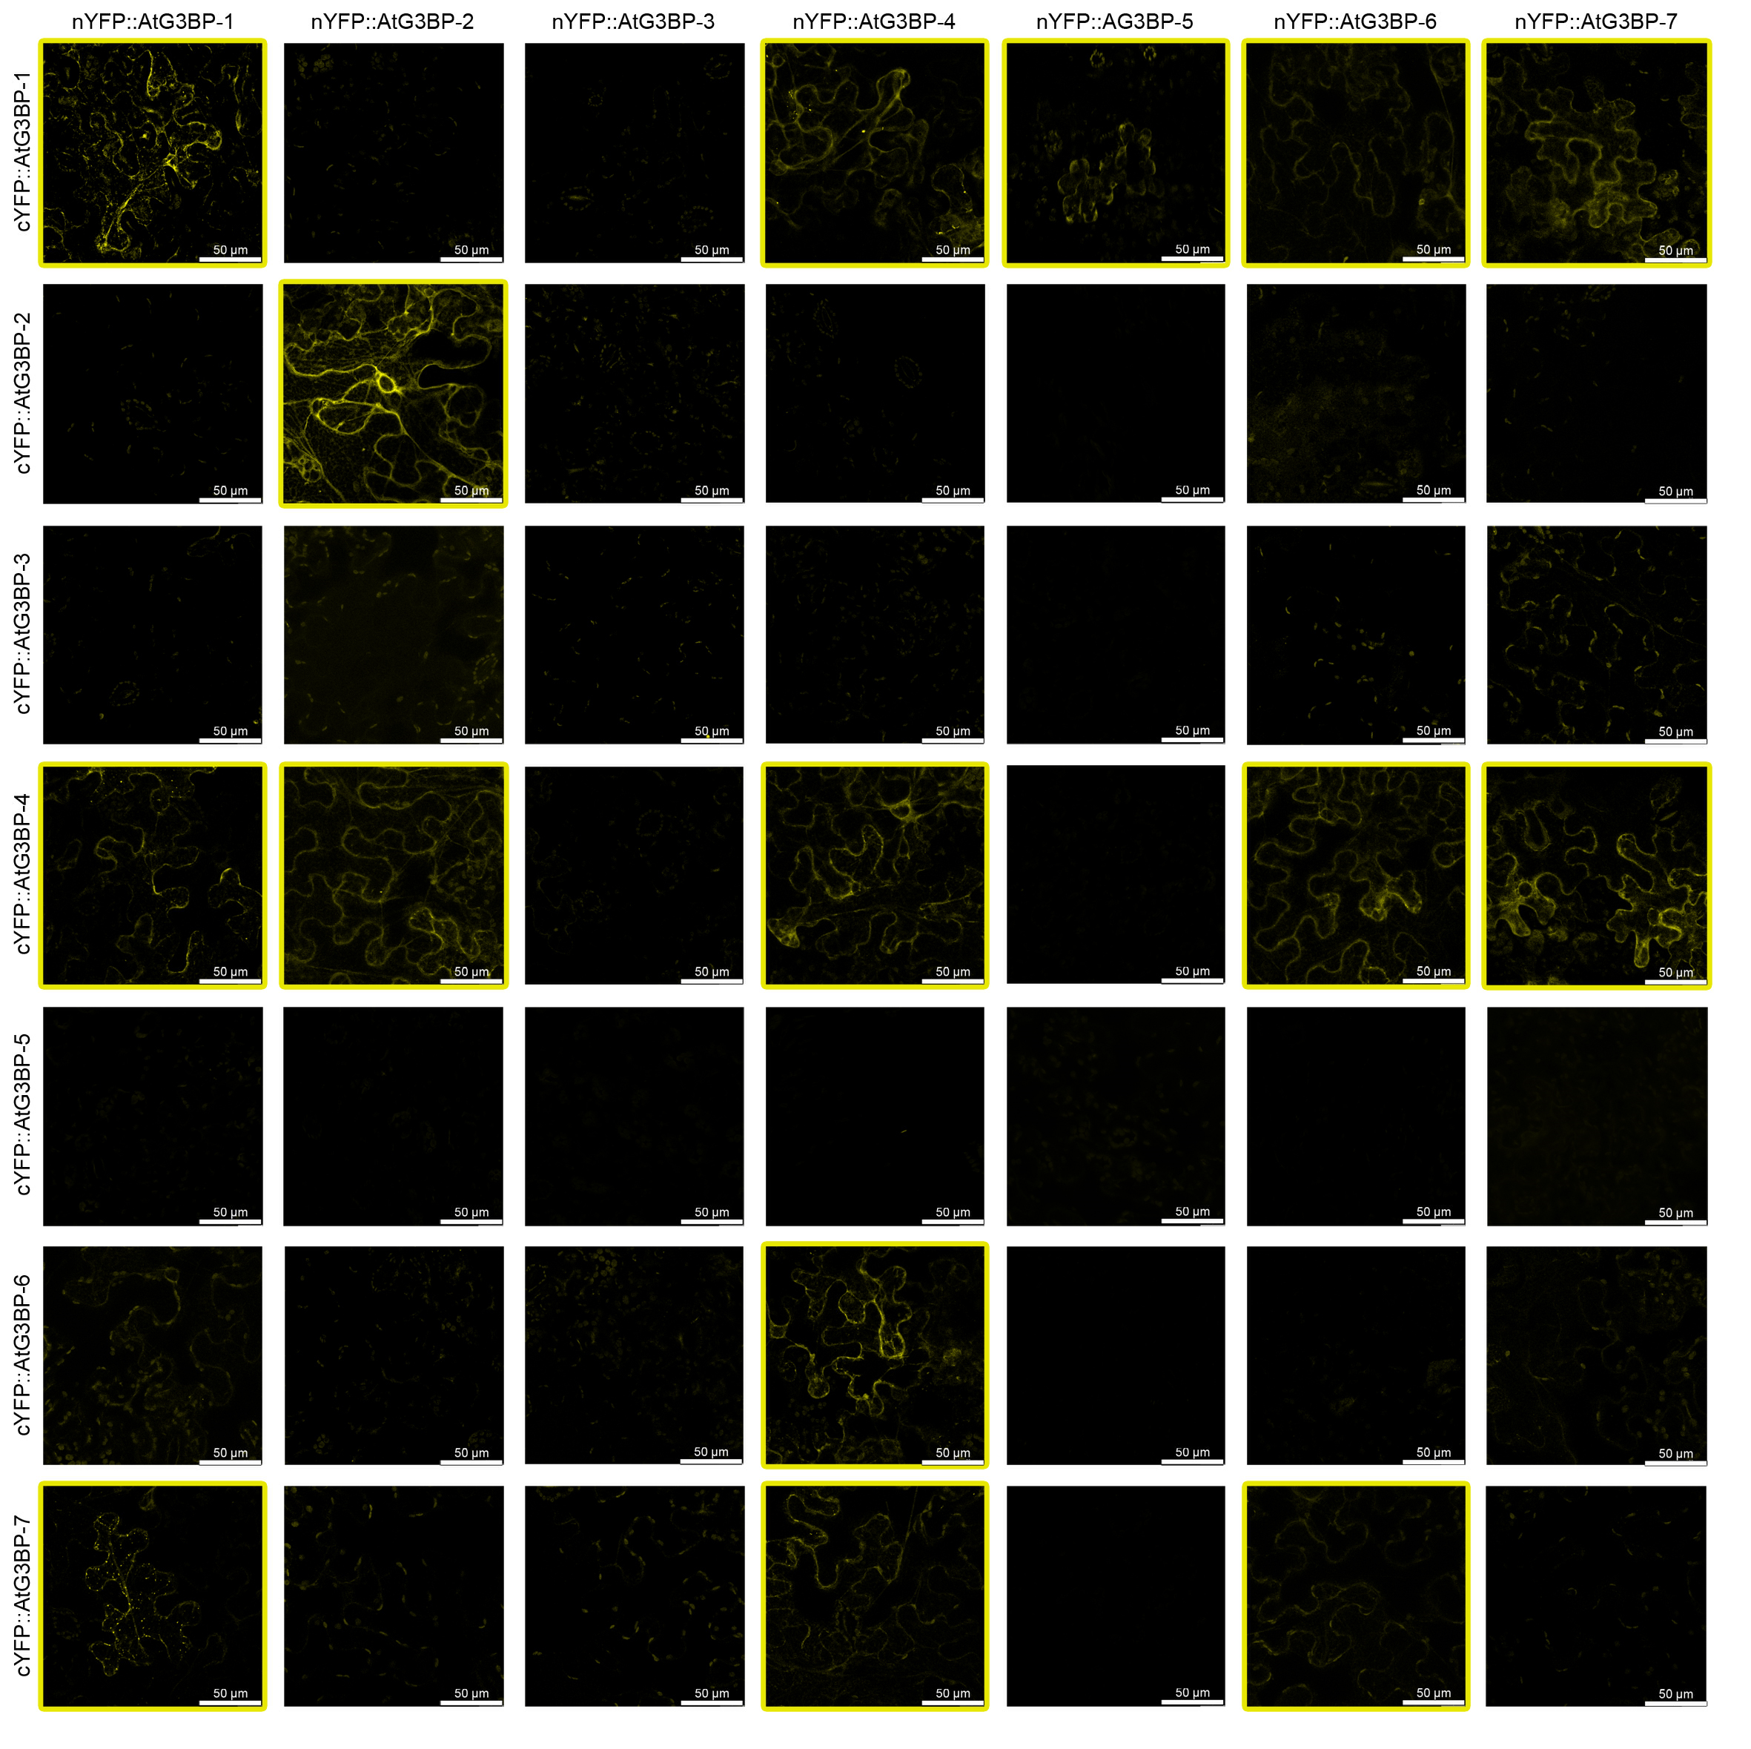
Supplementary Figure S6 BiFC analysis of AtG3BPs N-terminally fused to splitYFP under ambient conditions. Yellow frames indicate interaction. Possible yellow spots in the none-framed panels are due to increased gain of the detector to detect even very low signals. The images displaying the self-interaction of the respective splitYFP::AtG3BPs are the same as in Figure 3B.

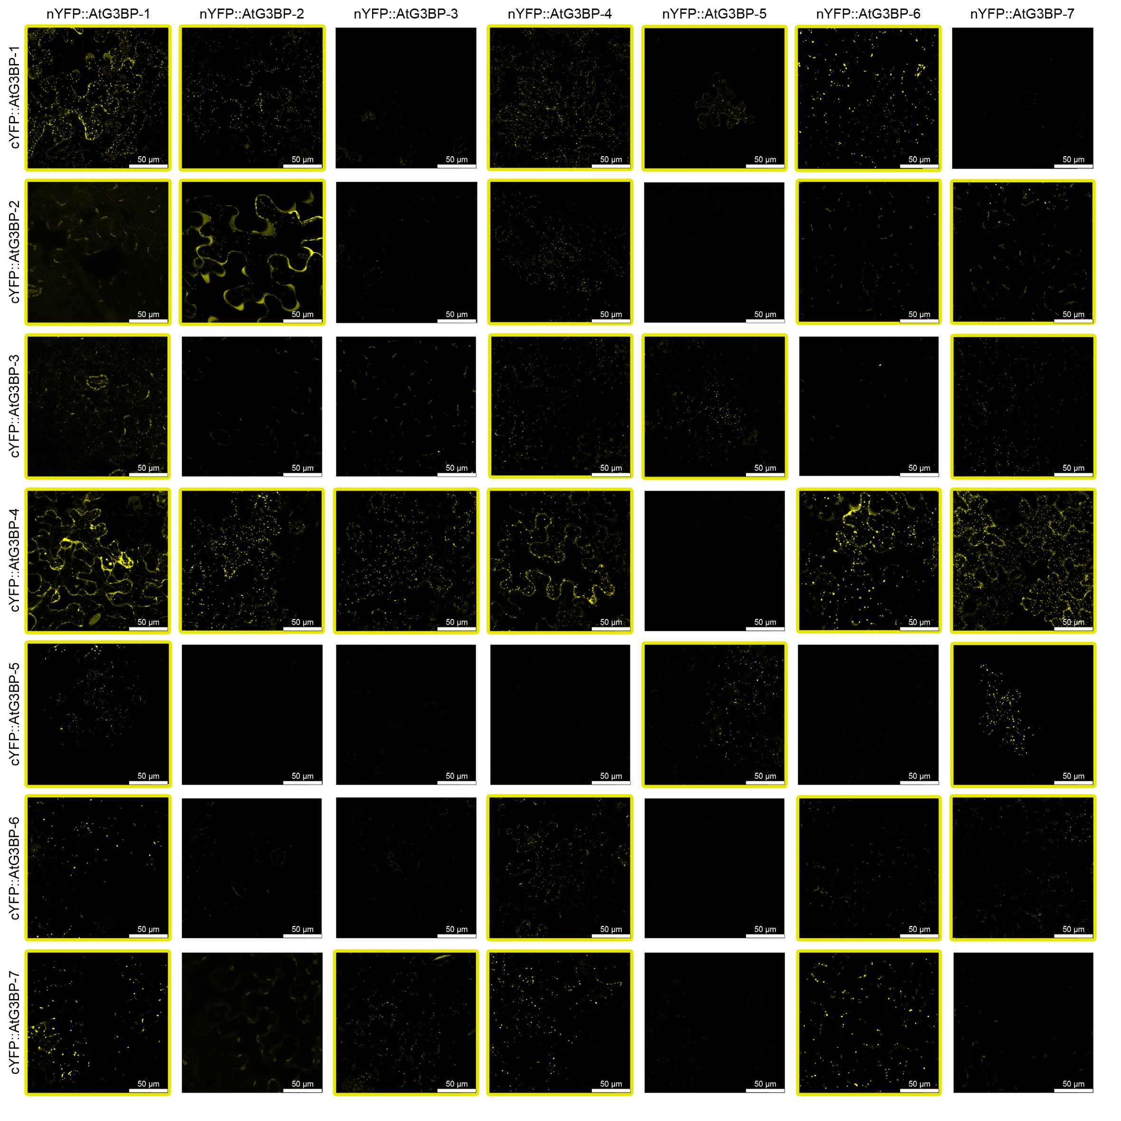
Supplementary Figure S7 BiFC analysis of AtG3BPs N-terminally fused to splitYFP after heat shock. Yellow frames indicate interaction. Possible yellow spots in the none-framed panels are due to increased gain of the detector to detect even very low signals. The images displaying the self-interaction of the respective splitYFP::AtG3BPs are the same as in Figure 3B.

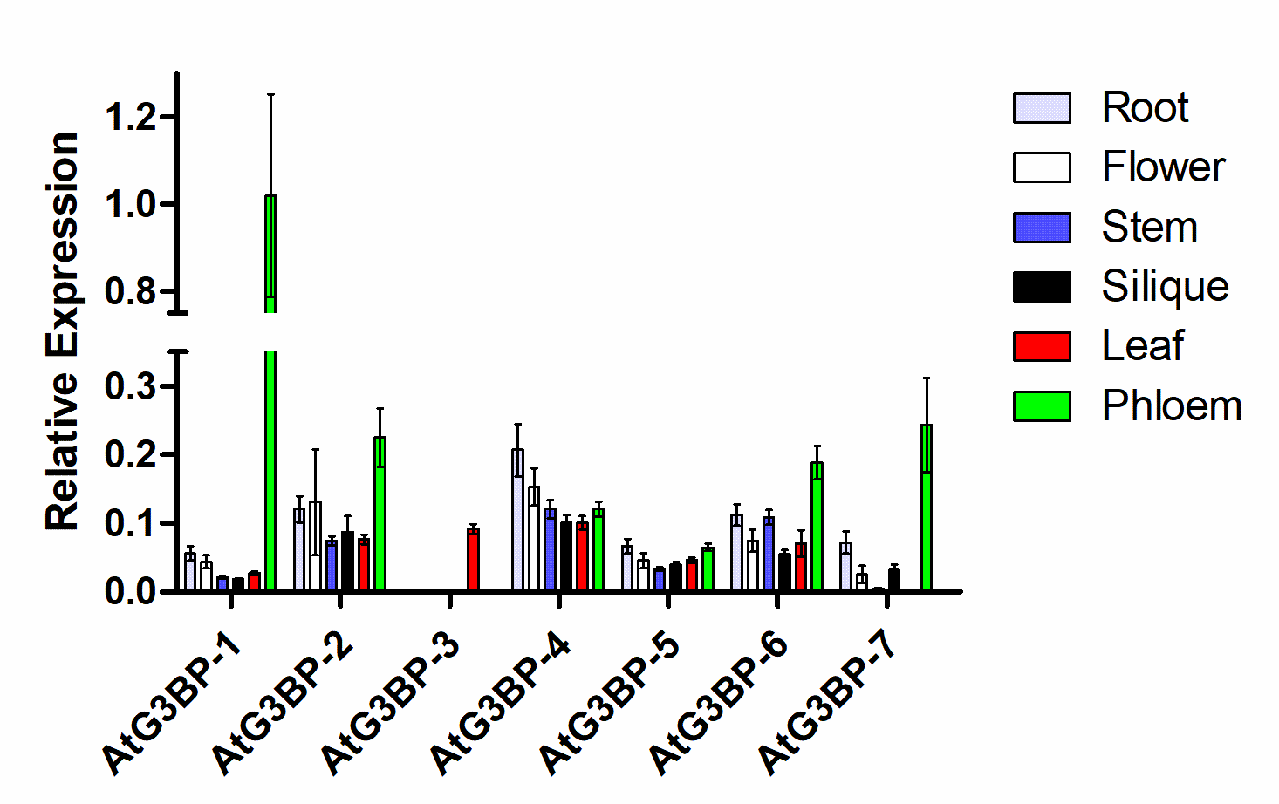
Supplementary Figure S8 Expression level analysis. (a) qRT-PCR was used to measure the relative gene expression of all AtG3BPs in roots, stem, flower, silique, leaves and laser dissected phloem tissue. Transcript levels were calculated using the 2^{-∆Ct} method with AtActin-2 as the endogenous control. The error bar represents the standard error. The different extraction method for phloem tissue and therefore limited comparability must be noted here.

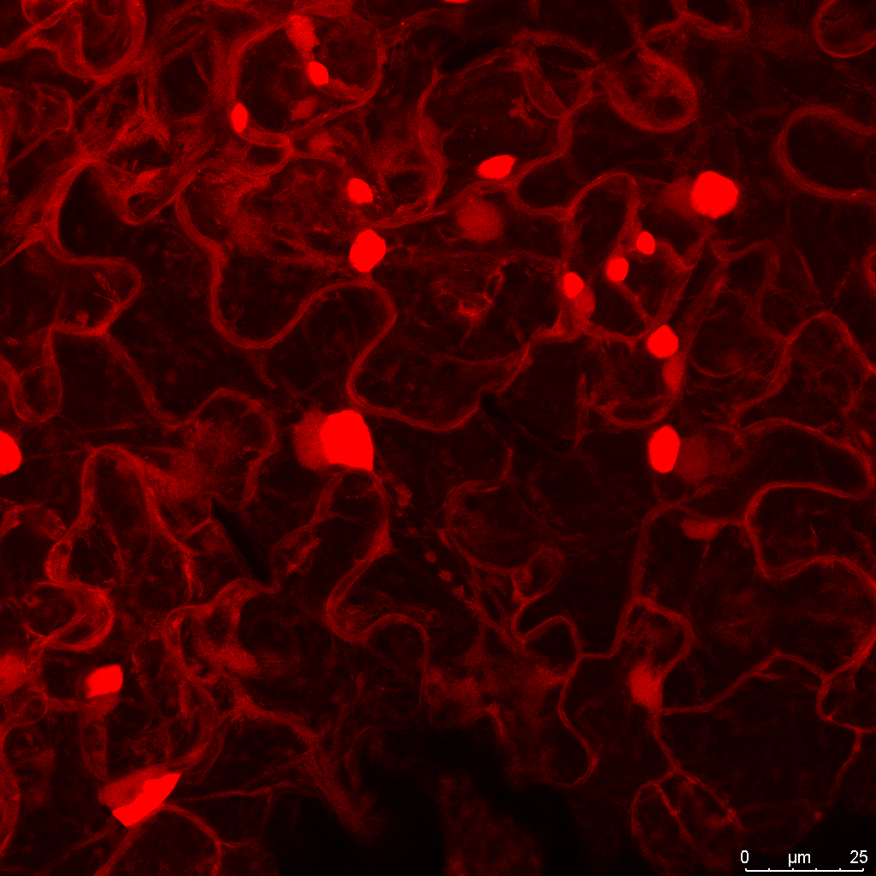
Supplementary Figure S9 Systemic TuMV-RFP infection in Arabidopsis thaliana. The picture was obtained 14 dpi by confocal laser scanning microscopy and is a projection of a z-stack.

Supplementary Table S1 List of used Gateway destination vectors
Gateway destination vectors | Reporter | Antibiotic resistance | Reference
pRB35S-C-Venus^{N173}-GW | C-terminal Venus^{N173} | Spectinomycin and Streptomycin | Nietzsche et al., 2014
pRB35S-C-Venus^{C155}-GW | C-terminal Venus^{C155} | Spectinomycin and Streptomycin | Nietzsche et al., 2014
pB4nYGW | N-terminal nYFP | Spectinomycin | Kamigaki et al., 2016
pB4cYGW | N-terminal cYFP | Spectinomycin | Kamigaki et al., 2016
pB4GWnY | C-terminal nYFP | Spectinomycin | Kamigaki et al., 2016
pB4GWcY | C-terminal cYFP | Spectinomycin | Kamigaki et al., 2016
pGWB 441 | C-terminal EYFP | Spectinomycin | Nakagawa et al., 2007

Supplementary Table S2 List of used Oligonucleotides
Primer | Gene | Sequence 5'-3'
G3BP-1-fw | AtG3BP-1 (AT5G60980) | CACCATGGCACAGCAGGAA
G3BP-1-rev | AtG3BP-1 (AT5G60980) | TCAAGATGAACCACCACCTCGAG
G3BP-1-rev-nS | AtG3BP-1 (AT5G60980) | AGATGAACCACCACCTCGAG
G3BP-2-fw | AtG3BP-2 (AT5G43960) | CACCATGGCGACTCCTTATCCT
G3BP-2-rev | AtG3BP-2 (AT5G43960) | TTAGCGACCACCACCGCG
G3BP-2-rev-nS | AtG3BP-2 (AT5G43960) | GCGACCACCACCGCGGTA
G3BP-3-fw | AtG3BP-3 (AT3G25150) | CACCATGGCGATGTTAGGTGCACAGCAAGTT
G3BP-3-rev | AtG3BP-3 (AT3G25150) | TTACGCAGCAACAGACACACG
G3BP-3-rev-nS | AtG3BP-3 (AT3G25150) | CGCAGCAACAGACACACGG
G3BP-4-fw | AtG3BP-4 (AT1G69250) | CACCATGGCTACCGAGGGAG
G3BP-4-rev | AtG3BP-4 (AT1G69250) | TCAATGTGCGGCTTCACTTTTT
G3BP-4-rev-nS | AtG3BP-4 (AT1G69250) | ATGTGCGGCTTCACTTTTTTTCC
G3BP-5-fw | AtG3BP-5 (AT1G13730) | CACCATGGCACTTGAATCAAATGCT
G3BP-5-rev | AtG3BP-5 (AT1G13730) | TTAACGGCTAGCTTCTACCGTACC
G3BP-5-rev-nS | AtG3BP-5 (AT1G13730) | ACGGCTAGCTTCTACCGTACC
G3BP-6-fw | AtG3BP-6 (AT2G03640) | CACCATGACACCTGAATCAAACGC
G3BP-6-rev | AtG3BP-6 (AT2G03640) | CTAGTTTTTGGCCTCAGTATTGCC
G3BP-6-rev-nS | AtG3BP-6 (AT2G03640) | GTTTTTGGCCTCAGTATTGCCATG
G3BP-7-fw | AtG3BP-7 (AT5G48650) | CACCATGGATTCTACTGCTGCAAC
G3BP-7-rev | AtG3BP-7 (AT5G48650) | CTAGTACGAGTTGATGCTGGCGA
G3BP-7-rev-nS | AtG3BP-7 (AT5G48650) | GAGTTGATGCTGGCGACGTA
UBP24-fw | AtUBP-24 (AT4G30890) | CACCATGAGTGAAAAGAAGGTATTTGTGTTTG
UBP24-rev-nS | AtUBP-24 (AT4G30890) | CACTTGCTTGTAGAAGAGGACATAGGC
qAt-Actin2-fw | AtActin-2 (AT3G18780) | CACCACAACAGCAGAGCGGGA
qAt-Actin2-rev | AtActin-2 (AT3G18780) | TCCCACAAACGAGGGCTGGA
qAtG3BP1-fw | AtG3BP-1 (AT5G60980) | TTCACCAATCTCCCGGTTTAG
qAtG3BP1-rev | AtG3BP-1 (AT5G60980) | CGTTGATCGCTTGCATAGTTG
qAtG3BP2-fw | AtG3BP-2 (AT5G43960) | TCTGCAAGAGGACCAACATC
qAtG3BP2-rev | AtG3BP-2 (AT5G43960) | CCACATCAACTGCAACTTCTTC
qAtG3BP3-fw | AtG3BP-3 (AT3G25150) | CAGTGTCAGGAGGACGTTTAG
qAtG3BP3-rev | AtG3BP-3 (AT3G25150) | TGTACGACAGTGCCTTCATC
qAtG3BP4-fw | AtG3BP-4 (AT1G69250) | AGACCGTAAGCTTCGTGTAAAG
qAtG3BP4-rev | AtG3BP-4 (AT1G69250) | TGCTATCTGCAGAGCCATTC
qAtG3BP5-fw | AtG3BP-5 (AT1G13730) | GTTACAGGCTCAAGGGAAACT
qAtG3BP5-rev | AtG3BP-5 (AT1G13730) | CCGATTCTGATGGCTGATTCT
qAtG3BP6-fw | AtG3BP-6 (AT2G03640) | CTGTATTGGGTTTGTGGCATTC
qAtG3BP6-rev | AtG3BP-6 (AT2G03640) | GCTCTTCGGTTTCCGATTCT
qAtG3BP7-fw | AtG3BP-7 (AT5G48650) | GTGAAGATTGGTGGACTGAGAG
qAtG3BP7-rev | AtG3BP-7 (AT5G48650) | CCCACTCCCACATTCCTATTT

