Supplementary Information

Title: Predictors for bronchoalveolar lavage recovery failure in diffuse parenchymal lung disease

Authors’ full names:
Keigo Koda, MD^{1 ‡}, Hironao Hozumi, MD, PhD^{1 ‡ *}, Hideki Yasui, MD, PhD¹, Yuzo Suzuki, MD, PhD¹, Masato Karayama, MD, PhD¹, Kazuki Furuhashi, MD, PhD¹, Noriyuki Enomoto, MD, PhD¹, Tomoyuki Fujisawa, MD, PhD¹, Naoki Inui, MD, PhD^{1, 2}, Yutaro Nakamura, MD, Ph.D.¹, Takafumi Suda, MD, PhD¹
‡ Dr Keigo Koda and Dr Hironao Hozumi contributed equally to this paper

Authors’ affiliations:
¹ Second Division, Department of Internal Medicine, Hamamatsu University School of Medicine, Hamamatsu, 1-20-1 Handayama Higashiku, Hamamatsu 431-3192, Japan
² Department of Clinical Pharmacology and Therapeutics, Hamamatsu University School of Medicine, Hamamatsu, 1-20-1 Handayama Higashiku, Hamamatsu 431-3192, Japan
Supplementary Table S1. Post-BAL diagnosis and gender
Disease category | Men, n = 258 | Women, n = 143 | P-value
IIP other than IPF | 62 (24.0) | 31 (21.7) | 0.62
Connective tissue disease-associated ILD | 25 (9.7) | 45 (31.5) | <0.01*
IPF | 41 (15.9) | 3 (2.1) | <0.01*
Sarcoidosis | 14 (5.4) | 18 (12.6) | 0.02*
Drug-induced pneumonitis | 17 (6.6) | 4 (2.8) | 0.16
Cryptogenic organizing pneumonia | 14 (5.4) | 4 (2.8) | 0.32
Hypersensitivity pneumonitis | 12 (4.7) | 2 (1.4) | 0.15
Chronic eosinophilic pneumonia | 5 (1.9) | 3 (2.1) | 0.99
Pleuroparenchymal fibroelastosis | 5 (1.9) | 2 (1.4) | 0.99
Others | 63 (24.4) | 31 (21.7) | 0.62
Data are presented as number (%).
*P < 0.05

BAL, bronchoalveolar lavage; IIP, idiopathic interstitial pneumonia; IPF, idiopathic pulmonary fibrosis; ILD, interstitial lung disease.

Supplementary Table S2. Results of logistic regression analysis for BALF recovery failure in derivation cohort; disease adjustment
Multivariate |  | Model 1 |  |  | Model 2 |  |  | Model 3 |  |  | Model 4
 | OR | 95% CI | P-value | OR | 95% CI | P-value | OR | 95% CI | P-value | OR | 95% CI | P-value
Men (vs. women) | 4.94 | 1.86–13.1 | <0.01* | 5.25 | 1.95–14.1 | <0.01* | 5.18 | 1.95–13.8 | <0.01* | 5.08 | 1.92–13.5 | <0.01*
Smoking,  per 1 pack-years increase | 1.01 | 0.99–1.02 | 0.19 | 1.01 | 0.99–1.02 | 0.22 | 1.01 | 0.99–1.02 | 0.23 | 1.01 | 0.99–1.02 | 0.23
FVC,  per 100mL increase | 0.96 | 0.91–1.02 | 0.15 | 0.96 | 0.91–1.01 | 0.14 | 0.96 | 0.91–1.01 | 0.14 | 0.96 | 0.91–1.01 | 0.15
FEV_{1.0}/FVC,  per 1% increase | 0.97 | 0.94–0.99 | 0.02* | 0.97 | 0.94–0.99 | 0.03* | 0.97 | 0.94–0.99 | 0.03* | 0.97 | 0.94–0.99 | 0.03*
BAL target site, other than  RM/LL (vs. RM/LL) | 2.78 | 1.28–5.88 | 0.01* | 2.78 | 1.27–5.88 | 0.01* | 2.78 | 1.28–6.25 | 0.01* | 2.70 | 1.25–5.88 | 0.01*
Lung volume of BAL side,  100mL increase | 1.05 | 0.98–1.12 | 0.17 | 1.04 | 0.98–1.12 | 0.18 | 1.04 | 0.98–1.12 | 0.18 | 1.05 | 0.98–1.12 | 0.17
Post-BAL diagnosis
IIP other than IPF | 1.32 | 0.72–2.41 | 0.38
CTD-ILD |  |  |  | 0.98 | 0.41–2.34 | 0.97
IPF |  |  |  |  |  |  | 1.14 | 0.49–2.63 | 0.76
Sarcoidosis |  |  |  |  |  |  |  |  |  | 0.67 | 0.18–2.48 | 0.55
*P < 0.05
BAL, bronchoalveolar lavage; BALF, BAL fluid; OR, odds ratio; CI, confidence interval; FVC, forced vital capacity; %FVC, percent predicted FVC; FEV_{1.0}, forced expiratory volume in one second; %FEV_{1.0}, percent predicted FEV_{1.0}; RM/LL, right middle lobe or left lingula; LAA, low attenuation area. IIP, idiopathic interstitial pneumonia; IPF, idiopathic pulmonary fibrosis; CTD, connective tissue disease; ILD, interstitial lung disease.
Supplementary Table S3. Characteristics of the validation cohort
 | n = 234
Age (years) | 66 (57–72)
Men/women | 143 (61.1)/ 91 (38.9)
Smoking, never/ex/current/unknown | 98 (41.9)/ 96 (41.0)/ 24 (10.3)/ 16 (6.8)
Smoking (pack years) | 11 (0–35)
Pulmonary function
FVC (mL) | 2530 (1990–3200)
%FVC (%) | 82.5 (69.5–96.8)
FEV_{1.0} (mL) | 2070 (1630–2490)
%FEV_{1.0} (%) | 84.6 (70.3–92.7)
FEV_{1.0}/ FVC (%) | 81.1 (76.1–86.3)
BAL target site
Right upper lobe | 11 (4.7)
Right middle lobe | 170 (72.7)
Right lower lobe | 7 (3.0)
Left upper lobe other than the lingula | 3 (1.3)
Lingula | 41 (17.5)
Left lower lobe | 2 (0.9)
BALF recovery failure, yes | 39 (16.7)
BALF recovery failure prediction score
Model 1, 0/1/2/3 | 72 (30.8)/ 109 (46.6)/ 50 (21.4)/ 3 (1.3)
Model 2, 0/1/2 | 76 (32.5)/ 121 (51.7)/ 37 (15.8)
Data are presented as median (IQR) or number (%)
FVC, forced vital capacity; %FVC, percent predicted FVC; FEV_{1.0}, forced expiratory volume in one second; %FEV_{1.0}, percent predicted FEV_{1.0}; BAL, bronchoalveolar lavage; BALF, BAL fluid
Supplementary Figure S1. Receiver operating characteristic curve
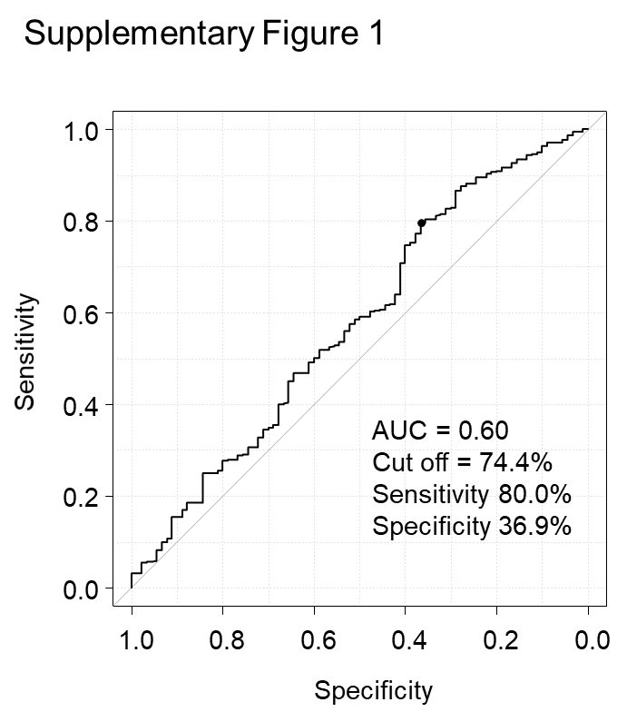
The receiver operating characteristic analysis was performed to identify the optimal cut-off value of FEV_{1.0}/FVC for predicting BALF recovery failure in the derivation cohort. The area under the curve (c-index) was 0.60 (95% CI 0.52–0.676). Using 74.4% as the cut-off value of FEV_{1.0}/FVC, the sensitivity and specificity were 80.0% and 36.9%, respectively.
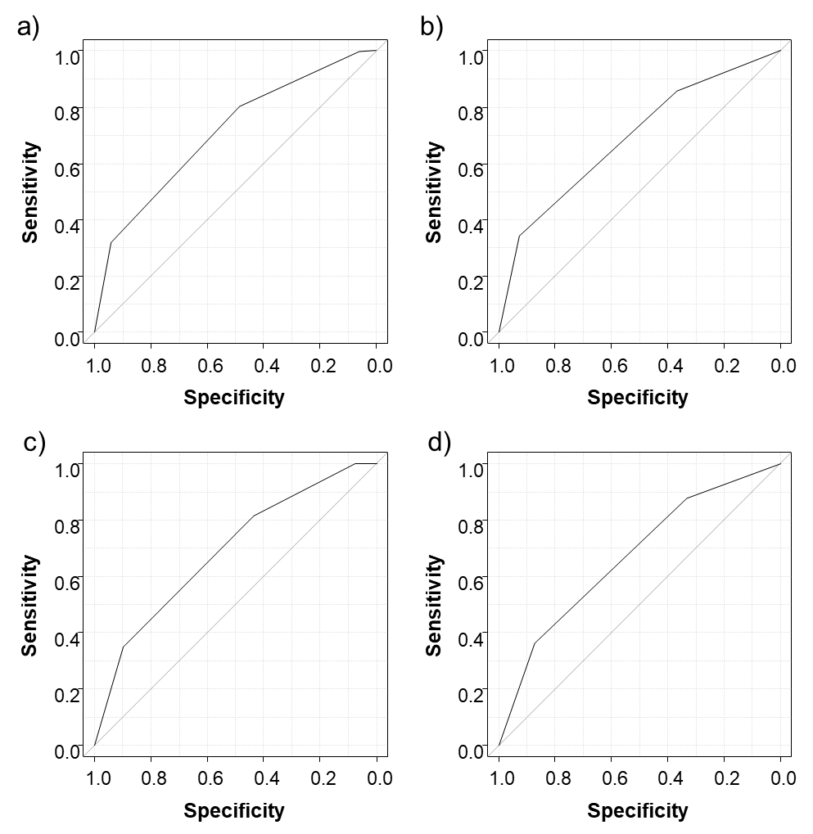Supplementary Figure S2. Receiver-operating characteristic curves of the prediction score models of BALF recovery failure
- Model 1 in the derivation cohort
- Model 2 in the derivation cohort
- Model 1 in the validation cohort
- Model 2 in the validation cohort

