Supplementary Information

Early warnings of COVID-19 outbreaks across Europe from social media

Milena Lopreite, Pietro Panzarasa, Michelangelo Puliga, Massimo Riccaboni

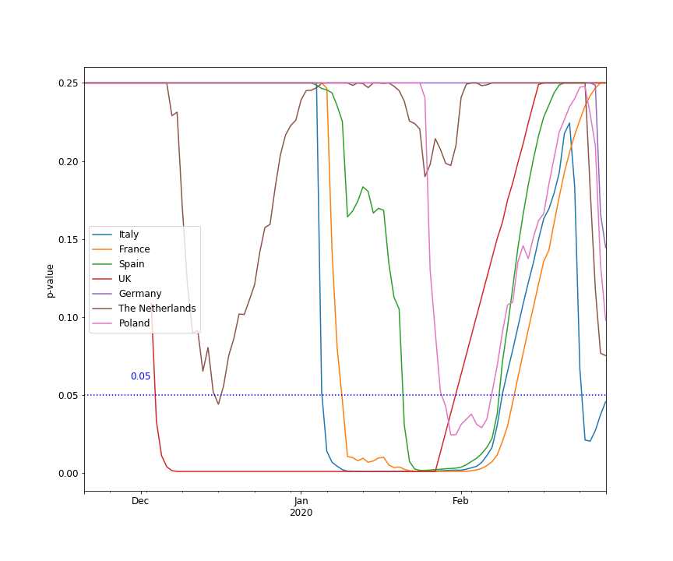

Fig. S1 Two-sample Anderson-Darling test of the difference between cumulative distributions of number of tweets citing pneumonia and posted in two corresponding winter seasonal periods (2018-2019 and 2019-2020) for each of the 7 European countries. The graph reports the average p-values over moving window widths w $ϵ [50, 70]$ computed with daily frequency.

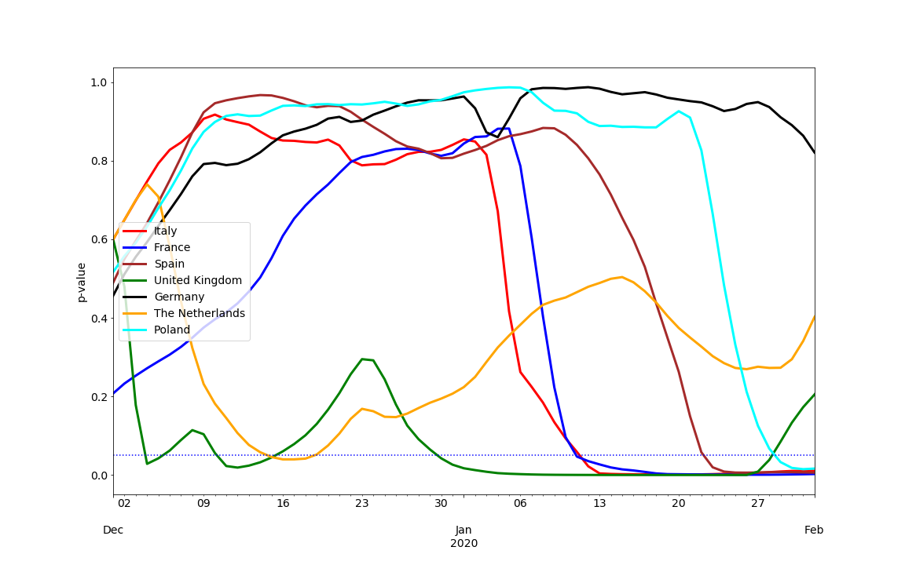

Fig. S2 Two-sample Kolmogorov-Smirnov test of the difference between cumulative distributions of number of tweets citing pneumonia and posted in the winter seasonal period 2019-2020 and in the corresponding five preceding periods since 2014-2015 for each of the 7 European countries. The graph reports the average of the p-values obtained using each of the five preceding winter seasons. In turn, the p-values related to each individual season are averages over moving window widths w $ϵ [50, 70]$ computed with daily frequency.

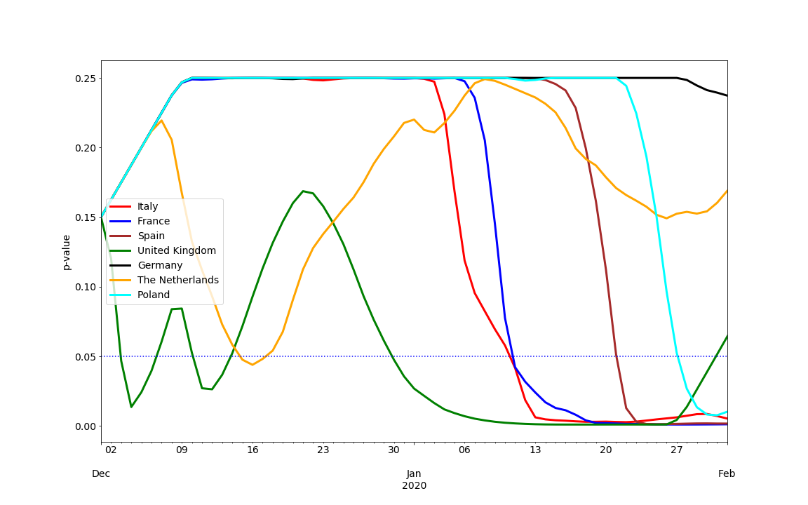

Fig. S3 Two-sample Anderson-Darling test of the difference between cumulative distributions of number of tweets citing pneumonia and posted in the winter seasonal period 2019-2020 and in the corresponding five preceding periods since 2014-2015 for each of the 7 European countries. The graph reports the average of the p-values obtained using each of the five preceding winter seasons. In turn, the p-values related to each individual season are averages over moving window widths w $ϵ [50, 70]$ computed with daily frequency.

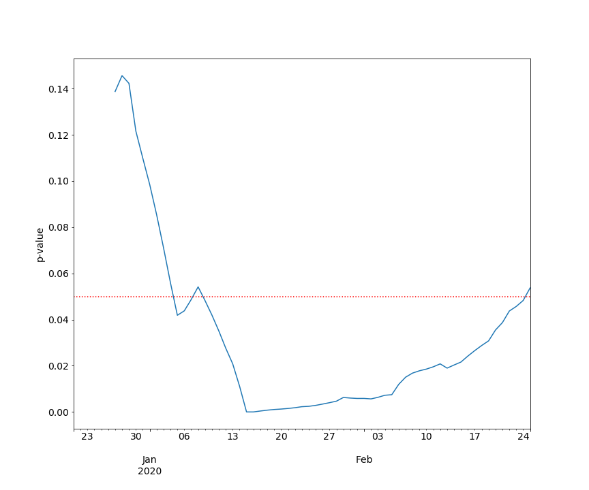

Fig. S4 Two-sample Kolmogorov-Smirnov test of the difference between cumulative distributions of number of tweets citing dry cough and posted in two corresponding winter seasonal periods (2018-2019 and 2019-2020) in 7 European countries. The graph reports the average p-values over moving window widths w $ϵ [50, 70]$ computed with daily frequency.

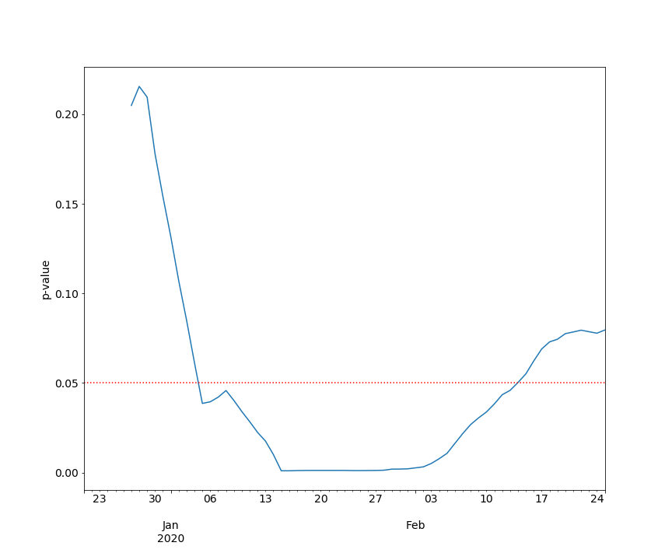

Fig. S5 Two-sample Anderson-Darling test of the difference between cumulative distributions of number of tweets citing dry cough and posted in two corresponding winter seasonal periods (2018-2019 and 2019-2020) in 7 European countries. The graph reports the average p-values over moving window widths w $ϵ [50, 70]$ computed with daily frequency.

Countries | Periods
Italy | 2020/01/06 - 2020/02/07
France | 2020/01/10 - 2020/02/08
Spain | 2020/01/22 - 2020/02/06
UK | 2019/12/05 - 2020/01/28
The Netherlands | 2019/12/15 - 2019/12/18
Poland | 2020/02/05 - 2020/02/06
Table S1 Countries and time periods in the 2019-2020 winter season characterized by excess posting on pneumonia according to the Kolmogorov-Smirnov tests. In these periods the cumulative distributions of pneumonia-related tweets differ from the distributions in the corresponding time periods in the 2018-2019 season (K-S tests at the 0.05 level of significance).

Country | Period
Italy | 2020/01/06 – 2020/02/29
France | 2020/01/09 – 2020/02/11
Spain | 2020/01/21 – 2020/02/08
UK | 2019/12/04 – 2020/01/30
The Netherlands | 2019/12/16 – 2019/12/16
Poland | 2020/01/29 – 2020/02/06

Table S2 Countries and time periods in the 2019-2020 winter season characterized by excess posting on pneumonia according to Anderson-Darling tests. These are the periods in which the cumulative distributions of dry cough-related tweets differ from the distributions in the corresponding time periods in the 2018-2019 season (A-D tests at the 0.05 level of significance).

Country | 2014-2015 | 2015-2016 | 2016-2017 | 2017-2018 | 2018-2019
France | 0.36066  (0.00064) | 0.39344  (0.00013) | 0.36066  (0.00064) | 0.44262  (0.00001) | 0.40984  (0.00006)
Germany | 0.09836  (0.93268) | 0.06530  (0.99742) | 0.08197  (0.98783) | 0.14754  (0.52379) | 0.06557  (0.99956)
Italy | 0.34426  (0.00133) | 0.39344  (0.00013) | 0.34426  (0.00133) | 0.34426  (0.00133) | 0.45902  (0.00000)
The Netherlands | 0.26230  (0.02967) | 0.18033  (0.27603) | 0.27869  (0.01712) | 0.21173  (0.11129) | 0.22812  (0.07130)
Poland | 0.37324  (0.00036) | 0.36548  (0.00075) | 0.31064  (0.00452) | 0.27581  (0.01716) | 0.26202  (0.02566)
Spain | 0.34426  (0.00133) | 0.32787  (0.00266) | 0.32787  (0.00266) | 0.32787  (0.00266) | 0.31148  (0.00512)
UK | 0.37705  (0.00030) | 0.37705  (0.00030) | 0.42623  (0.00002) | 0.37705  (0.00030) | 0.36066  (0.00064)
Table S3 Two-sample Kolmogorov-Smirnov test of the difference between cumulative distributions of number of tweets citing pneumonia posted in the winter seasonal period 2019-2020 and in each of the corresponding five periods since 2014-2015 for each of the 7 European countries. For each country and winter seasonal period, the table reports the values of the statistical test (corresponding p-values are shown in parentheses).

Country | 2014-2015 | 2015-2016 | 2016-2017 | 2017-2018 | 2018-2019
France | 9.39622  (0.00100) | 10.05256  0.00100) | 7.00257  (0.00100) | 14.51323  (0.00100) | 9.64127  (0.00100)
Germany | -0.82499  (0.25000) | -1.13954  (0.25000) | -1.05783  (0.25000) | 0.62221  (0.18304) | -1.09790  (0.25000)
Italy | 8.17272  (0.00100) | 11.00139  (0.00100) | 5.74394  (0.00189) | 5.05182  (0.00332) | 12.30459  (0.00100)
The Netherlands | 2.77755  (0.02381) | 1.01411  (0.12474) | 2.39161  (0.03388) | 0.52939  (0.20061) | 1.64154  (0.06830)
Poland | 8.38603  (0.00100) | 6.24365  (0.00128) | 4.13372  (0.00719) | 3.03733  (0.01883) | 3.73690  (0.01014)
Spain | 7.95646  (0.00100) | 7.28634  (0.00100) | 7.26826  (0.00100) | 6.87016  (0.00100) | 6.12392  (0.00140)
UK | 5.28041  (0.00276) | 5.36497  (0.00257) | 7.49829  (0.00100) | 5.45749  (0.00239) | 4.34225  (0.00602)
Table S4 Two-sample Anderson-Darling test of the difference between cumulative distributions of number of tweets citing pneumonia posted in the winter seasonal period 2019-2020 and in each of the corresponding five periods since 2014-2015 for each of the 7 European countries. For each country and winter seasonal period, the table reports the values of the statistical test (corresponding p-values are shown in parentheses).

Country/Region | Users 2020 | Users 2019 | Relative variation  2020-2019 | Absolute variation  2020-2019
Germany
Total number of tweets = 452

Rheinland-Pfalz | 14 | 4 | 2.50 | 10
Hessen | 28 | 9 | 2.11 | 19
Baden-Württemberg* | 27 | 11 | 1.45 | 16
Nordrhein-Westfalen* | 46 | 19 | 1.42 | 27
Schleswig-Holstein | 14 | 6 | 1.33 | 8
Hamburg | 18 | 8 | 1.25 | 10
Berlin | 56 | 30 | 0.87 | 26
Bayern* | 26 | 20 | 0.30 | 6
Niedersachsen | 14 | 12 | 0.17 | 2
Total number of users | 243 | 119 | 1.04 | 124
Spain
Total number of tweets = 2,245

Castilla-La Mancha* | 11 | 1 | 10.00 | 10
Comunidad de Madrid* | 203 | 52 | 2.90 | 151
Cataluña | 122 | 34 | 2.59 | 88
Aragón | 11 | 4 | 1.75 | 7
Extremadura | 158 | 68 | 1.32 | 90
Islas Canarias | 13 | 6 | 1.17 | 7
Andalucía | 83 | 42 | 0.98 | 41
Galicia | 15 | 8 | 0.88 | 7
Comunidad Valenciana | 38 | 24 | 0.58 | 14
País Vasco | 11 | 7 | 0.57 | 4
Total number of users | 665 | 246 | 1.70 | 419
France
Total number of tweets = 2,112

Provence-Alpes-Côte d'Azur | 57 | 11 | 4.18 | 46
Bretagne | 24 | 6 | 3.00 | 18
Centre-Val de Loire | 30 | 8 | 2.75 | 22
Grand Est* | 54 | 15 | 2.60 | 39
Auvergne-Rhône-Alpes | 67 | 19 | 2.53 | 48
Île-de-France* | 361 | 105 | 2.44 | 256
Normandie | 32 | 10 | 2.20 | 22
Nouvelle-Aquitaine | 42 | 14 | 2.00 | 28
Hauts-de-France | 49 | 20 | 1.45 | 29
Pays de la Loire | 36 | 15 | 1.40 | 21
Occitanie | 43 | 19 | 1.26 | 24
Bourgogne-Franche-Comté | 21 | 12 | 0.75 | 9
Total number of users | 816 | 254 | 2.21 | 562
Italy
Total number of tweets = 1,097

Friuli-Venezia Giulia | 11 | 2 | 4.50 | 9
Piemonte* | 20 | 7 | 1.86 | 13
Emilia-Romagna* | 19 | 7 | 1.71 | 12
Umbria | 87 | 44 | 0.98 | 43
Lazio | 61 | 32 | 0.91 | 29
Veneto | 20 | 12 | 0.67 | 8
Campania | 16 | 10 | 0.60 | 6
Sicily | 19 | 12 | 0.58 | 7
Toscana | 23 | 16 | 0.44 | 7
Lombardia* | 201 | 151 | 0.33 | 50
Total number of users | 477 | 293 | 0.63 | 184
The Netherlands
Total number of tweets = 380

Noord-Brabant* | 16 | 8 | 1.00 | 8
Zuid-Holland | 33 | 17 | 0.94 | 16
Gelderland | 17 | 9 | 0.89 | 8
Noord-Holland | 52 | 30 | 0.73 | 22
Total number of users | 118 | 64 | 0.84 | 54
Poland
Total number of tweets = 244

Mazowieckie* | 25 | 10 | 1.50 | 15
Łódzkie | 31 | 17 | 0.82 | 14
Total number of users | 56 | 27 | 1.07 | 29
United Kingdom
Total number of tweets = 4,451

England* | 1,462 | 484 | 2.02 | 978
Wales* | 66 | 22 | 2.00 | 44
Northern Ireland | 36 | 14 | 1.57 | 22
Scotland | 192 | 83 | 1.31 | 109
Total number of users | 1,756 | 603 | 1.91 | 1,153

Table S5 European regions associated with an excess number of unique users discussing pneumonia, after filtering out press releases and news accounts. Highlighted in red are the regions that, based on the Wikipedia pages that summarize the statistics on COVID-19 per each country, reported active local cases of COVID-19 in the initial period between 15 February and 7 March 2020. Marked with a star (*) are the regions with the highest number of COVID-19 cases per capita (Source: Wikipedia, 20 April 2020).

European region | Number of unique users
England | 96
Comunidad de Madrid | 35
Île-de-France | 27
Centre-Val de Loire | 26
Andalucía | 23
Cataluña | 17
Comunidad Valenciana | 14
Hauts-de-France | 8
Lombardia | 8
Umbria | 7
Thüringen | 6
Pays de la Loire | 6
Auvergne-Rhône-Alpes | 6
Occitanie | 6
Región de Murcia | 5
Emilia-Romagna | 5
Provence-Alpes-Côte d'Azur | 4
Castilla-La Mancha | 4
Scotland | 3
Noord-Holland | 3
Aragón | 3
Łódzkie | 3
Castilla y León | 3
Gelderland | 3
Berlin | 3
Islas Baleares | 2
Wales | 2
Overijssel | 2
Nouvelle-Aquitaine | 2
Utrecht | 2
Veneto | 2
Friuli-Venezia Giulia | 2
Zuid-Holland | 2
Galicia | 2
Grand Est | 2
Campania | 2
Bretagne | 1
Baden-Württemberg | 1
Trentino-Alto Adige | 1
Toscana | 1
Groningen | 1
Cantabria | 1
Hamburg | 1
Extremadura | 1
Northern Ireland | 1
Normandie | 1
Nordrhein-Westfalen | 1
Niedersachsen | 1
Kujawsko-Pomorskie | 1
Ceuta y Melilla | 1
Table S6 European regions and number of unique users discussing dry cough between 1 December 2019 and 30 January 2020. Usual adjustments have been made to filter out messages related to press releases and news account.

