Predictive Modeling of Depression and Anxiety using Electronic Health Records and a Novel Machine Learning Approach with Artificial Intelligence

Matthew D. Nemesure, BS*^{1,2}; Michael V. Heinz, MD ^{1,3}; Raphael Huang¹, and Nicholas C. Jacobson; PhD^{1,2,4,5}

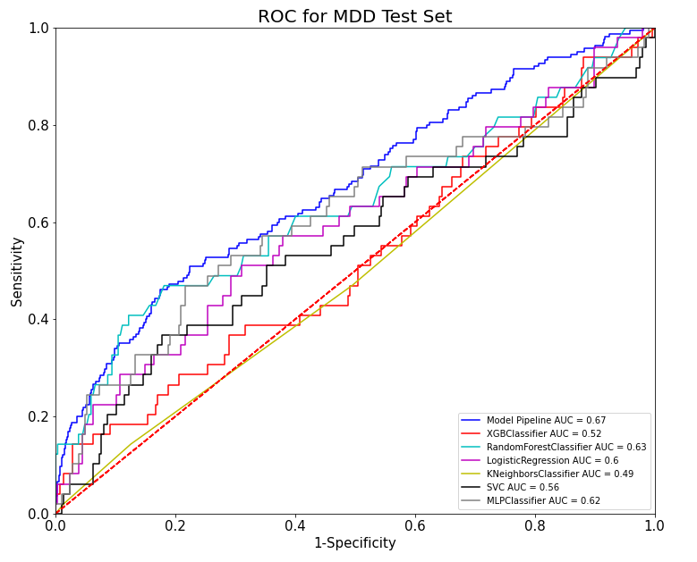
Figure 1

Figure 1: Final AUC for predicting MDD in the held out test set for each individual model and the ensemble model.

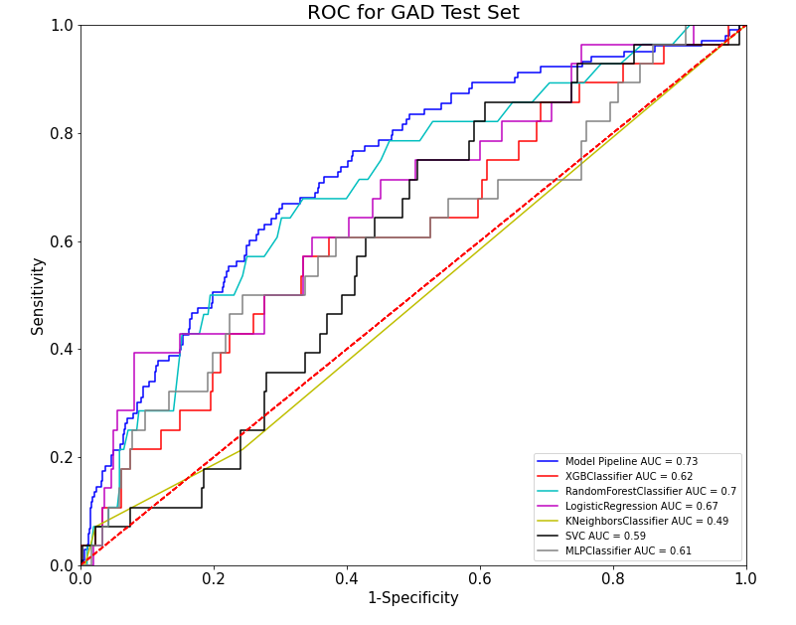
Figure 2

Figure 2: Final AUC for predicting GAD in the held out test set for each individual model and the ensemble model.

Github link: https://github.com/mnemesure/MDD_GAD_EHR

Matplotlib:

Matplotlib: Thomas A Caswell, Michael Droettboom, Antony Lee, John Hunter, Elliott Sales de Andrade, Eric Firing, … Paul Ivanov. (2020, November 12). matplotlib/matplotlib: REL: v3.3.3 (Version v3.3.3). Zenodo. http://doi.org/10.5281/zenodo.4268928

Seaborn: Michael Waskom, Olga Botvinnik, Maoz Gelbart, Joel Ostblom, Paul Hobson, Saulius Lukauskas, … Thomas Brunner. (2020, September 8). mwaskom/seaborn: v0.11.0 (Sepetmber 2020) (Version v0.11.0). Zenodo. http://doi.org/10.5281/zenodo.4019146

