A dynamic prediction model for prognosis of acute-on-chronic liver failure based on the trend of clinical indicators
Zhenjun Yu^{#1}, Yu Zhang^{#1}, Yingying Cao¹, Manman Xu², Shaoli You³, Yu Chen², Bing Zhu³, Ming Kong², Fangjiao Song³, Shaojie Xin*³, Zhongping Duan*², Tao Han*¹⁴⁵

Supplementary Tables:
Table S1. Training Set, Baseline clinical characteristics of patients on admission.
Baseline Characteristics | Overall (n=541)
Age(years) | 50 (43-59)
Sex (male) | 414 (76.5%)
Compensated Cirrhosis | 219 (40.5%)
Decompensated Cirrhosis | 234 (43.3%)
Etiology
Hepatitis B virus infection | 303 (56.1%)
Alcoholism | 102 (18.9%)
Hepatitis B virus infection and Alcoholism | 45 (8.3%)
Others | 91 (16.8%)
Precipitant event
Hepatitis B virus reactivation | 39 (7.2%)
Alcoholism | 14 (2.6%)
Bacterial Infections | 96 (17.7%)
Drugs or Poisons | 46 (8.5%)
Others | 50 (9.2%)
Unknow | 296 (54.7%)
Complication
Hepatic encephalopathy | 112 (20.7%)
Gastrointestinal bleeding | 99 (18.3%)
Ascites | 418 (77.3%)
Abdominal infection | 218 (40.3%)
Pulmonary infection | 128 (23.7%)
Biliary infection | 20 (3.7%)
Intestinal infection | 21 (3.9%)
Laboratory
White blood cell (×10⁹/L) | 6.7 (4.7-9.1)
Neutrophil ratio (%) | 72.0 (63.1-79.8)
Hemoglobin (g/L) (n=535) | 118 (102-136)
Platelet (×10⁹/L) | 87 (56-126)
C-reactive protein (mg/L) (n=190) | 14.4 (9.2-25.0)
Alanine aminotransferase (U/L) (n=539) | 132.0 (43.0-461.0)
Aspartate aminotransferase (U/L) (n=532) | 180.5 (90.5-471.8)
Alkaline phosphatase (U/L) | 142.0 (111.5-185.5)
Glutamate transpeptidase (U/L) | 87.0 (53.0-151.0)
Cholinesterase (IU/L) | 2599.5 (1788.8-3507.5)
Albumin (g/L) | 28.7 (25.0-32.0)
Globulin (g/L) | 30.9 (25.7-36.5)
Total Bilirubin (mg/dL) | 13.9 (8.7-20.4)
Blood urea nitrogen (mmol/L) | 5.1 (3.6-9.0)
Creatinine (mg/dL) | 0.9 (0.7-1.1)
Serum sodium (mmol/L) | 135.0 (131.4-137.7)
Serum potassium (mmol/L) | 3.9 (3.5-4.3)
Serum chloride (mmol/L) (n=538) | 99.9 (95.7-103.1)
Triglyceride (mmol/L) (n=288) | 1.0 (0.7-1.4)
Total cholesterol (mmol/L) (n=291) | 1.7 (1.1-2.4)
Prothrombin Activity (%) | 36 (29-45)
Alpha-fetoprotein (ng/mL) (n=296) | 32.5 (5.5-121.0)
Serum ammonia (mmol/L) (n=418) | 61 (42-84)
Organ failures#
Liver | 343 (63.4%)
Kidneys | 25 (4.6%)
Brain | 27 (5.0%)
Coagulation | 138 (25.5%)
Lungs | 20 (3.7%)
Circulation | 3 (0.6%)
Organ support
Artificial liver support system | 205 (37.9%)
Prognostic score
CTP | 11 (10-12)
MELD | 22 (18-26)
MELD-Na | 25 (19-31)
CLIF-SOFA | 7 (7-9)
CLIF-C ACLF | 40 (35-46)
COSSH-ACLF | 5.3 (4.8-5.8)
#Organ failures were judged by reference to the CLIF-SOFA definition of organ failure¹.

Table S2. Stratified analysis of the impact of artificial liver support system (ALSS) treatment on the short-term prognosis of ACLF in the training set.
Variable |  | With ALSS treatment (n) (Non-survivor (n)), % | Without ALSS treatment (n) (Non-survivor (n)), % | χ² value | p value
Age (years) | ≥60 | 47 (18), 38.3% | 80 (34), 42.5% | 0.216 | 0.642
Age (years) | <60 | 158 (56), 35.4% | 256 (75), 29.3% | 1.706 | 0.191
Sex | male | 159 (59), 37.1% | 255 (78), 30.6% | 1.880 | 0.170
Sex | female | 46 (15), 32.6% | 81 (31), 38.3% | 0.407 | 0.523
WGO type | Type A | 45 (13), 28.9% | 43 (9), 20.9% | 0.743 | 0.389
WGO type | Type B | 89 (25), 28.1% | 130 (32), 24.6% | 0.331 | 0.565
WGO type | Type C | 71 (36), 50.7% | 163 (68), 41.7% | 1.618 | 0.203
Etiology | Alcoholic | 38 (10), 26.3% | 64 (13), 20.3% | 0.492 | 0.483
Etiology | HBV | 116 (46), 39.7% | 186 (66), 35.5% | 0.533 | 0.465
Etiology | HBV and Alcoholic | 19 (10), 52.6% | 26 (10), 38.5% | 0.893 | 0.345
Combined infection | Yes | 144 (56), 38.9% | 196 (70), 35.7% | 0.359 | 0.549
Combined infection | No | 61 (18), 29.5% | 140 (39), 27.9% | 0.057 | 0.811
MELD  score | >30 | 22 (12), 54.5% | 39 (26), 66.7% | 0.880 | 0.348
MELD  score | ≤30 | 183 (62), 33.9% | 297 (83), 27.9% | 1.891 | 0.169

Table S3. The third-day variation range of Total Bilirubin, Creatinine, Prothrombin Activity and Hepatic Encephalopathy was set at 10-50%, with Univariate Cox regression analysis to determine the survival model fit.
The 3rd day | Group setting | p value | Hazard ratio (95%CI) | Harrell’s C (95%CI)
Total Bilirubin trend | Boundary setting (10%) | p <0.001 | 1.735(1.32-2.282) | 0.560(0.532-0.588)
Total Bilirubin trend | Boundary setting (20%) | p <0.001 | 1.725(1.389-2.144) | 0.586(0.554-0.618)
Total Bilirubin trend | Boundary setting (30%) | p <0.001 | 1.673(1.395-2.007) | 0.606(0.571-0.641)
Total Bilirubin trend | Boundary setting (40%) | p <0.001 | 1.824(1.303-2.553) | 0.543(0.519-0.567)
Total Bilirubin trend | Boundary setting (50%) | p =0.002 | 1.882(1.264-2.804) | 0.532(0.511-0.554)
Creatinine trend | Boundary setting (10%) | p =0.002 | 1.386(1.132-1.697) | 0.562(0.527-0.599)
Creatinine trend | Boundary setting (20%) | p <0.001 | 1.622(1.259-2.088) | 0.564(0.531-0.598)
Creatinine trend | Boundary setting (30%) | p <0.001 | 1.649(1.218-2.231) | 0.557(0.528-0.586)
Creatinine trend | Boundary setting (40%) | p =0.010 | 1.626(1.121-2.359) | 0.531(0.505-0.555)
Creatinine trend | Boundary setting (50%) | p =0.002 | 1.933(1.288-2.901) | 0.533(0.510-0.556)
Prothrombin Activity trend | Boundary setting (10%) | p =0.003 | 1.677(1.195-2.354) | 0.542(0.514-0.570)
Prothrombin Activity trend | Boundary setting (20%) | p <0.001 | 1.596(1.247-2.043) | 0.565(0.532-0.597)
Prothrombin Activity trend | Boundary setting (30%) | p <0.001 | 1.387(1.157-1.662) | 0.567(0.531-0.604)
Prothrombin Activity trend | Boundary setting (40%) | p =0.09 | 1.472(0.939-2.309) | 0.520(0.499-0.541)
Prothrombin Activity trend | Boundary setting (50%) | p =0.25 | 1.366(0.801-2.331) | 0.512(0.496-0.529)
Hepatic Encephalopathy trend (West Haven stage) | Boundary setting (1 level) | p =0.002 | 2.345 (1.363-4.034) | 0.521(0.503-0.538)
Hepatic Encephalopathy trend (West Haven stage) | Boundary setting (2 level) | p =0.611 | 1.293 (0.481-3.478) | 0.501(0.493-0.510)
Hepatic Encephalopathy trend (West Haven stage) | Boundary setting (3 level) | p =0.097 | 5.307 (0.741-38.001) | 0.502(0.498-0.506)

Table S4. The first-week variation range of Total Bilirubin, Creatinine, Prothrombin Activity and Hepatic Encephalopathy was set at 10-50%, with Univariate Cox regression analysis to determine the survival model fit.
The 1st week | Group setting | p value | Hazard ratio (95%CI) | Harrell’s C (95%CI)
Total Bilirubin trend | Boundary setting (10%) | p <0.001 | 1.905(1.596-2.274) | 0.650(0.613-0.686)
Total Bilirubin trend | Boundary setting (20%) | p <0.001 | 2.096(1.713-2.564) | 0.651(0.615-0.686)
Total Bilirubin trend | Boundary setting (30%) | p <0.001 | 2.2(1.749-2.767) | 0.649(0.609-0.685)
Total Bilirubin trend | Boundary setting (40%) | p <0.001 | 2.214(1.712-2.862) | 0.627(0.598-0.658)
Total Bilirubin trend | Boundary setting (50%) | p <0.001 | 1.988(1.462-2.703) | 0.585(0.557-0.614)
Creatinine trend | Boundary setting (10%) | p =0.003 | 1.327(1.101-1.6) | 0.569(0.529-0.609)
Creatinine trend | Boundary setting (20%) | p <0.001 | 1.752(1.378-2.227) | 0.597(0.558-0.636)
Creatinine trend | Boundary setting (30%) | p <0.001 | 1.942(1.461-2.582) | 0.593(0.556-0.629)
Creatinine trend | Boundary setting (40%) | p <0.001 | 1.975(1.433-2.723) | 0.565(0.530-0.599)
Creatinine trend | Boundary setting (50%) | p <0.001 | 2.54(1.811-3.563) | 0.571(0.540-0.603)
Prothrombin Activity trend | Boundary setting (10%) | p <0.001 | 1.965(1.487-2.597) | 0.590(0.553-0.625)
Prothrombin Activity trend | Boundary setting (20%) | p <0.001 | 1.668(1.334-2.086) | 0.595(0.556-0.634)
Prothrombin Activity trend | Boundary setting (30%) | p <0.001 | 1.582(1.319-1.897) | 0.597(0.556-0.638)
Prothrombin Activity trend | Boundary setting (40%) | p =0.002 | 1.837(1.272-2.652) | 0.558(0.528-0.589)
Prothrombin Activity trend | Boundary setting (50%) | p =0.102 | 1.412(0.934-2.135) | 0.523(0.509-0.547)
Hepatic Encephalopathy trend (West Haven stage) | Boundary setting (1 level) | p =0.044 | 1.695(0.999-2.874) | 0.519(0.498-0.541)
Hepatic Encephalopathy trend (West Haven stage) | Boundary setting (2 level) | p =0.600 | 2.066(0.971-4.398) | 0.511(0.496-0.525)
Hepatic Encephalopathy trend (West Haven stage) | Boundary setting (3 level) | p =0.052 | 3.991(0.99-16.093) | 0.505(0.497-0.512)

Table S5. The second-week variation range of Total Bilirubin, Creatinine, Prothrombin Activity and Hepatic Encephalopathy was set at 10-50%, with Univariate Cox regression analysis to determine the survival model fit.
The 2nd week | Group setting | p value | Hazard ratio (95%CI) | Harrell’s C (95%CI)
Total Bilirubin trend | Boundary setting (10%) | p <0.001 | 2.004(1.64-2.449) | 0.643(0.611-0.677)
Total Bilirubin trend | Boundary setting (20%) | p <0.001 | 1.867(1.58-2.206) | 0.654(0.620-0.688)
Total Bilirubin trend | Boundary setting (30%) | p <0.001 | 2.01(1.671-2.418) | 0.656(0.623-0.691)
Total Bilirubin trend | Boundary setting (40%) | p <0.001 | 2.216(1.767-2.78) | 0.636(0.605-0.667)
Total Bilirubin trend | Boundary setting (10%) | p <0.001 | 2.004(1.64-2.449) | 0.643(0.611-0.677)
Creatinine trend | Boundary setting (10%) | p <0.001 | 2.033(1.545-2.676) | 0.592(0.556-0.628)
Creatinine trend | Boundary setting (20%) | p <0.001 | 1.746(1.384-2.202) | 0.599(0.561-0.634)
Creatinine trend | Boundary setting (30%) | p <0.001 | 1.628(1.334-1.987) | 0.604(0.566-0.642)
Creatinine trend | Boundary setting (40%) | p <0.001 | 2.162(1.598-2.925) | 0.581(0.546-0.615)
Creatinine trend | Boundary setting (50%) | p <0.001 | 2.514(1.816-3.48) | 0.580(0.546-0.613)
Prothrombin Activity trend | Boundary setting (10%) | p <0.001 | 1.871(1.537-2.277) | 0.625(0.587-0.662)
Prothrombin Activity trend | Boundary setting (20%) | p <0.001 | 2.292(1.802-2.914) | 0.625(0.589-0.660)
Prothrombin Activity trend | Boundary setting (30%) | p <0.001 | 1.772(1.495-2.1) | 0.630(0.592-0.666)
Prothrombin Activity trend | Boundary setting (40%) | p <0.001 | 2.193(1.634-2.944) | 0.587(0.555-0.620)
Prothrombin Activity trend | Boundary setting (50%) | p <0.001 | 2.024(1.422-2.879) | 0.560(0.533-0.589)
Hepatic Encephalopathy trend (West Haven stage) | Boundary setting (1 level) | p <0.001 | 2.078 (1.503-2.878) | 0.564(0.533-0.595)
Hepatic Encephalopathy trend (West Haven stage) | Boundary setting (2 level) | p <0.001 | 2.445 (1.617-3.698) | 0.542(0.518-0.565)
Hepatic Encephalopathy trend (West Haven stage) | Boundary setting (3 level) | p <0.001 | 4.703 (2.773-7.976) | 0.533(0.515-0.551)

Table S6. Validation Set, Baseline clinical characteristics of patients on admission.
Baseline Characteristics | Overall (n=130)
Age(years) | 44 (37-52)
Sex (male) | 115 (88.5%)
Compensated Cirrhosis | 82 (63.1%)
Decompensated Cirrhosis | 18 (13.8%)
Etiology
Hepatitis B virus infection | 99 (76.2%)
Alcoholism | 20 (15.4%)
Hepatitis B virus infection and Alcoholism | 4 (3.1%)
Others | 7 (5.4%)
Precipitant event
Hepatitis B virus reactivation | 18 (13.8%)
Alcoholism | 12 (9.2%)
Bacterial Infections | 9 (6.9%)
Drugs or poisons | 12 (9.2%)
Others | 3 (2.3%)
Unknow | 76 (58.5%)
Complication
Hepatic encephalopathy | 51 (39.2%)
Gastrointestinal bleeding | 8 (6.2%)
Ascites | 93 (71.5%)
Abdominal infection | 114 (87.7%)
Pulmonary infection | 41 (31.5%)
Biliary infection | 0 (0%)
Intestinal infection | 0 (0%)
Laboratory
White blood cell (×10⁹/L) | 6.8 (4.6-10.1)
Neutrophil ratio (%) | 70.0 (60.8-79.6)
Hemoglobin (g/L) | 122 (103-136)
Platelet (×10⁹/L) | 102.5 (69.8-144.3)
C-reactive protein (mg/L) (n=89) | 12.0 (6.0-23.0)
Alanine aminotransferase (U/L) | 150.1 (65.1-369.9)
Aspartate aminotransferase (U/L) | 150.0 (94.2-305.0)
Alkaline phosphatase (U/L) (n=120) | 133.1 (102.2-168.3)
Glutamate transpeptidase (U/L) | 85.9 (51.3-146.7)
Cholinesterase (IU/L) (n=119) | 2950 (1903-4164)
Albumin (g/L) | 30.4 (26.8-33.8)
Globulin (g/L) | 32.3 (27.3-38.5)
Total Bilirubin (mg/dL) | 20.9 (12.9-27.3)
Blood urea nitrogen (mmol/L) | 4.6 (3.4-6.3)
Creatinine (mg/dL) | 0.7 (0.5-0.9)
Serum sodium (mmol/L) | 135.6 (131.9-138.2)
Serum potassium (mmol/L) | 3.9 (3.5-4.2)
Serum chloride (mmol/L) (n=93) | 101.0 (96.4-103.1)
Triglyceride (mmol/L) (n=61) | 1.2 (0.8-1.5)
Total cholesterol (mmol/L) (n=91) | 2.6 (2.3-3.2)
Prothrombin Activity (%) | 33 (26-41)
Alpha-fetoprotein (ng/mL) (n=125) | 51.0 (7.2-169.1)
Serum ammonia (mmol/L) (n=117) | 80 (51-112)
Organ failures#
Liver | 103 (79.2%)
Kidneys | 2 (1.5%)
Brain | 2 (1.5%)
Coagulation | 44 (33.8%)
Lungs | 2 (1.5%)
Circulation | 1 (0.8%)
Organ support
Artificial liver support system | 50 (38.5%)
Prognostic score
CTP | 11 (10-12)
MELD | 23 (20-28)
MELD-Na | 25 (20-35)
CLIF-SOFA | 8 (7-9)
CLIF-C ACLF | 42 (36-46)
COSSH-ACLF | 5.3 (4.8-6.1)
#Organ failures were judged by reference to the CLIF-SOFA definition of organ failure¹.

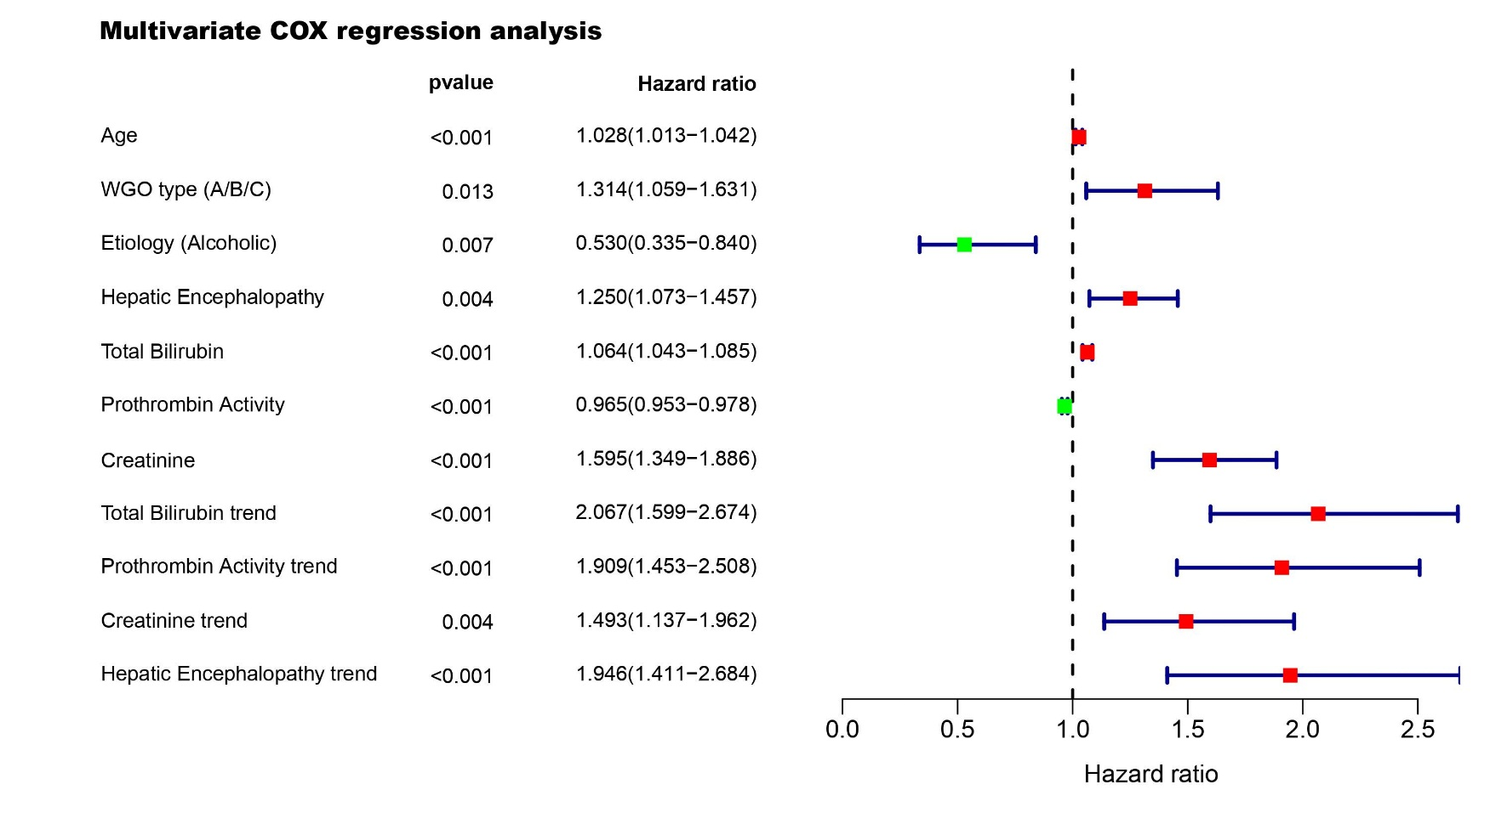
Supplementary Figures:

Figure S1. Multivariate Cox Regression analysis showed that the dynamic trend scores of Total Bilirubin, Creatinine, Prothrombin Activity and Hepatic Encephalopathy were all independent prognostic factors of ACLF.

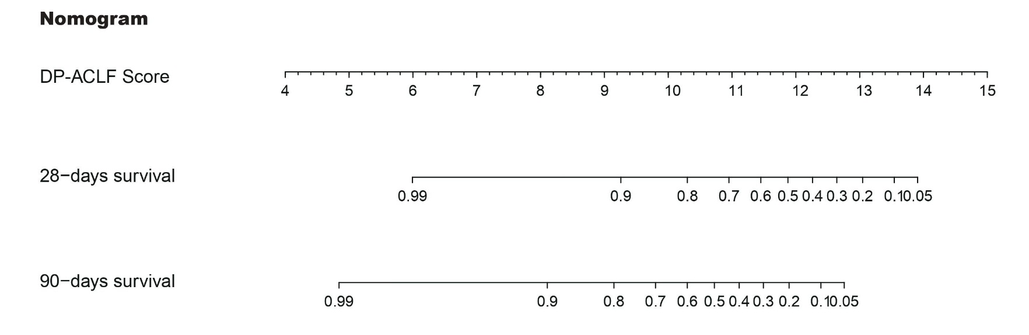
Figure S2. Nomogram showed the 28- and 90-day survival rates of ACLF with different DP-ACLF scores.

Supplementary materials 1:
Details of the prognostic scoring systems for patients with ACLF in this study.

1. Child-Turcotte-Pugh (CTP)²
CTP score | 1 | 2 | 3
HE grade (West-Haven) | 0 | I~II | III~IV
Ascites | no | Mild | Moderate or Severe
TB(umol/L) | <34 | 34~51 | >51
PT prolonged(s) | <4 | 4~6 | >6
ALB(g/L) | >35 | 28~35 | <28

2. Chronic Liver Failure Sequential Organ Failure Assessment score (CLIF-SOFA) ¹
Organ/System | 0 | 1 | 2 | 3 | 4
Liver (TB mg/dL) | <1.2 | 1.2~2.0 | 2.0~6.0 | 6.0~12.0 | >=12.0
Kidney (Cr mg/dL) | <1.2 | 1.2~2.0 | 2.0~3.5 | 3.5~5.0 or Renal replacement therapy | >=5.0
Nervous system (HE grade) | 0 | I | II | III | IV
Coagulation system (INR) | <1.1 | 1.1~1.25 | 1.25~1.5 | 1.5~2.5 | >=2.5 or PLT <=20×10⁹/L
Circulatory system (MAP mmHg or Antihypertensive drugs | >=70 | <70 | Dopamine <=5 or dobutamine or triopressin | Dopamine >5 or epinephrine<=0.1 or norepinephrine<=0.1 | Dopamine >15 or epinephrine>0.1 or norepinephrine>0.1
Respiratory system (PaO₂/FiO₂ or SPO₂/FiO₂) | >400  >512 | 300~400  375~512 | 200~300  214~357 | 100~200  89~214 | <=100  <=89

3. Chronic Liver Failure Consortium Organ Function (CLIF-OF) ³
Organ/System | 1 | 2 | 3
Liver (TB mg/dL) | <6 | 6~12 | >12
Kidney (Cr mg/dL) | <2 | 2~3.5 | >=3.5 or Renal replacement therapy
Nervous system (HE grade) | 0 | I~II | III~IV
Coagulation system (INR) | <2 | 2~2.5 | >=2.5
Circulatory system (MAP mmHg) | >=70 | <70 | Antihypertensive drugs
Respiratory system (PaO₂/FiO₂  or SPO₂/FiO₂) | >300  >357 | 201~300  215~357 | <=200  <=214

4. Hepatitis B virus related Sequential Organ Failure Assessment score (HBV-SOFA)⁴
Organ/System | 1 | 2 | 3
Kidney (Cr umol/L) | <103 | 104~206 | >206
Nervous system (HE grade) | 0 | I~II | III~IV
Circulatory system (MAP mmHg) | >=70 | <70 | Antihypertensive drugs
Respiratory system (PaO₂/FiO₂  or SPO₂/FiO₂) | >300  >357 | 201~300  215~357 | <=200  <=214

5. The formula of MELD⁵ and MELD-sodium (MELD-Na)⁶ score: MELD = 3.78 × ln(TB (mg/dL)) + 11.2 × ln(INR) + 9.57 × ln(serum creatinine (mg/dL)) + 6.43× Etiology (the etiology was 0 for cholegenic or alcoholic, and 1 for others); MELD-Na = MELD+1.59 × (135-Na(mmol/L)).

6. The CLIF-SOFA score sums the severity grades of organ failures; and the CLIF-C ACLF score is a modification of the CLIF Consortium Organ Function (CLIF-OF) score: CLIF-C ACLF = 10 × (0.33 × CLIF-OF + 0.04 × age + 0.63 × ln(white blood cell(10⁹/L) – 2)^{1,3}.

7. The formula of COOSH-ACLF score: 0.741 × INR + 0.523 × HBV-SOFA + 0.026 × age + 0.003 × TB(mg/dL)⁴.

References:
1 Moreau, R. et al. Acute-on-chronic liver failure is a distinct syndrome that develops in patients with acute decompensation of cirrhosis. Gastroenterology 144, 1426-1437. e1429 (2013).
2 Pugh, R., Murray‐Lyon, I., Dawson, J., Pietroni, M. & Williams, R. Transection of the oesophagus for bleeding oesophageal varices. British journal of surgery 60, 646-649 (1973).
3 Jalan, R. et al. Development and validation of a prognostic score to predict mortality in patients with acute-on-chronic liver failure. Journal of hepatology 61, 1038-1047 (2014).
4 Wu, T. et al. Development of diagnostic criteria and a prognostic score for hepatitis B virus-related acute-on-chronic liver failure. Gut 67, 2181-2191 (2018).
5 Kamath, P. S. & Kim, W. R. The model for end‐stage liver disease (MELD). Hepatology (Baltimore, Md.) 45, 797-805 (2007).
6 Biggins, S. W. et al. Evidence-based incorporation of serum sodium concentration into MELD. Gastroenterology 130, 1652-1660, doi:10.1053/j.gastro.2006.02.010 (2006).

