Supporting Information

Non pharmacological high-intensity ultrasound treatment of human dermal fibroblasts to accelerate wound healing
Jeong Yu Lee^{1,*}, Daejin Min¹, Wanil Kim¹, Bum Ho Bin¹, Kyu Han Kim¹, Eun-Gyung Cho^{1, *}

¹Basic Research & Innovation Division, R&D Unit, AmorePacific Corporation, 1920 Yonggu-daero, Giheung-gu, Yongin-si, Gyeonggi-do, Republic of Korea

*To whom all correspondence should be addressed. E-mail: jeongyu@amorepacific.com or egcho@amorepacific.com

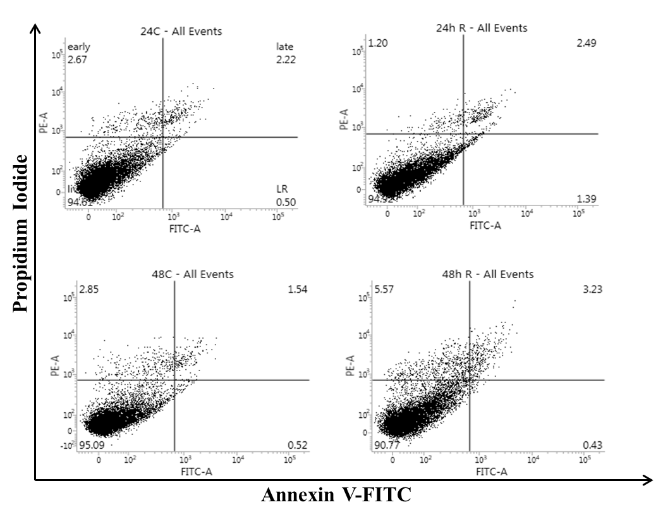
Figure S1. Flow cytometric analysis using Annexain V-FITC/PI staining for apoptosis.

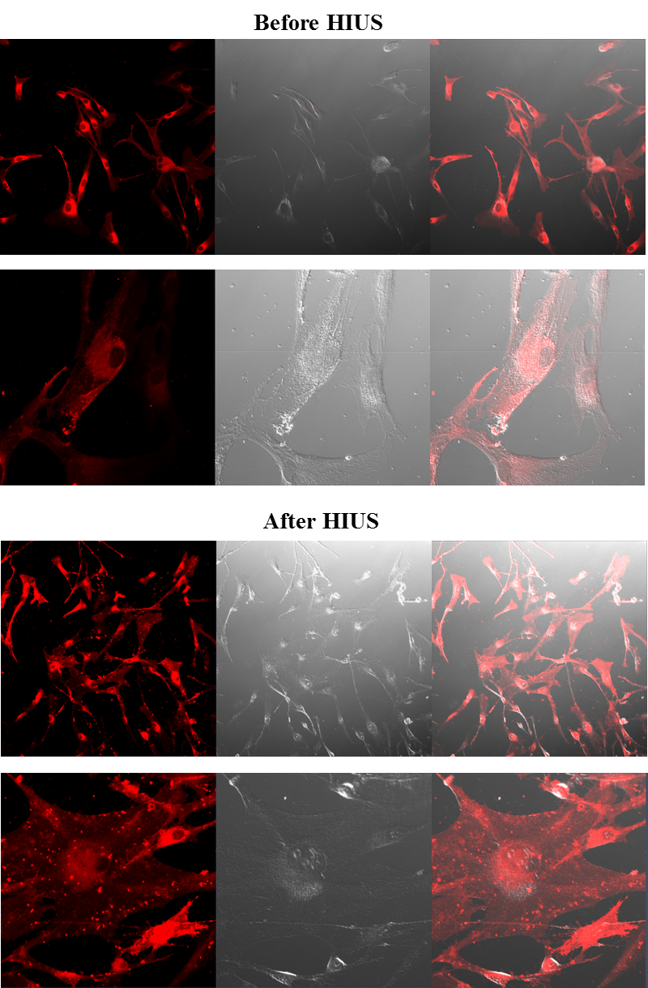
Figure S2. Confocal fluorescence microscopic images of fibroblast stained with PI. Images were taken at before and 24 h after treatment.

Table S1. The list of upregulated DEGs.
Term | Genes
Phagocytosis | LRP1, ADORA2A, F2RL1, ABCA1, CD14
Regulation of signal transduction | IRAK2, ICAM1, LRP1, ADORA2A, RNF152, RGS4, EPM2A, F2RL1, ABCA1, PMEPA1, CD14, TRIB2
Cytokine production | CD274, F2RL1, ABCA1, CD14, TRIB2
Apoptotic process | ICAM1, LRP1, ADORA2A, RNF152, CD274, BCL2A1, CD14, DHCR24
Regulation of MAPK cascade | IRAK2, ICAM1, RGS4, F2RL1, TRIB2
Regulation of cytokine secretion | CD274, F2RL1, CD14
Protein phosphorylation | ST3GAL1, IRAK2, ICAM1, ADORA2A, RGS4, F2RL1, PMEPA1, TRIB2
MAPK cascade | IRAK2, ICAM1, RGS4, F2RL1, TRIB2
Cell proliferation | EDNRA, LRP1, ADORA2A, PTGES, CD274, F2RL1, DHCR24
Regulation of cell migration | ICAM1, LRP1, CD274, F2RL1

Table S2. The list of downregulated DEGs.
Term | Genes
RNA metabolic process | NFKBID, TRPV1, EZH1, RBM6, INTS3, NSUN5P1, FOS, OSR2, DDX11, HMOX1, SRRM2, MEG3, MYC, CYR61, RFX8, EGR1, ZFP36, PAN2, UCN, EGR2, CREBZF, NR4A1, FOSB, SNAI1, CAPN3, CCNL2, STAT2, SUGP2, BTG2, ID2, ZNF692, HES4, ZGLP1, HOXD4, VGLL3, KLF2, CRYM
Transcription,  DNA-templated | NFKBID, TRPV1, EZH1, INTS3, FOS, OSR2, DDX11, HMOX1, MEG3, MYC, CYR61, RFX8, EGR1, ZFP36, UCN, EGR2, CREBZF, NR4A1, FOSB, SNAI1, CAPN3, CCNL2, STAT2, BTG2, ID2, ZNF692, HES4, ZGLP1, HOXD4, VGLL3, KLF2, CRYM
Cell death | ZFP36, EGR1, UCN, NFKBID, GSDMB, TRPV1, NR4A1, SNAI1, CAPN3, DHRS2, CCR7, BTG2, DUSP1, HMOX1, GADD45B, MYC, CYR61
Apoptotic process | ZFP36, UCN, NFKBID, TRPV1, NR4A1, SNAI1, CAPN3, DHRS2, CCR7, BTG2, DUSP1, HMOX1, GADD45B, MYC, CYR61
Inflammatory response | ZFP36, FOS, UCN, CCR7, NFKBID, TRPV1, HMOX1, CXCL2, PLA2G4B
Immune system development | ZFP36, EGR1, DHRS2, FOS, CCR7, ID2, NFKBID, KLF2, MYC
Regulation of cell cycle | DUSP1, BTG2, ID2, DDX11, NR4A1, INTS3, GADD45B, MYC, CCNL2
Cellular response to stress | ZFP36, EGR1, TRPV1, INTS3, SNAI1, CAPN3, DHRS2, FOS, CCR7, DDX11, ID2, BTG2, HMOX1, KLF2, GADD45B, PLA2G4B, MYC
Cell activation | EGR1, DHRS2, CCR7, ID2, NFKBID, TRPV1, HMOX1, CAPN3
Epithelial cell proliferation | ZFP36, OSR2, ID2, HMOX1, IQGAP3, NR4A1, MYC

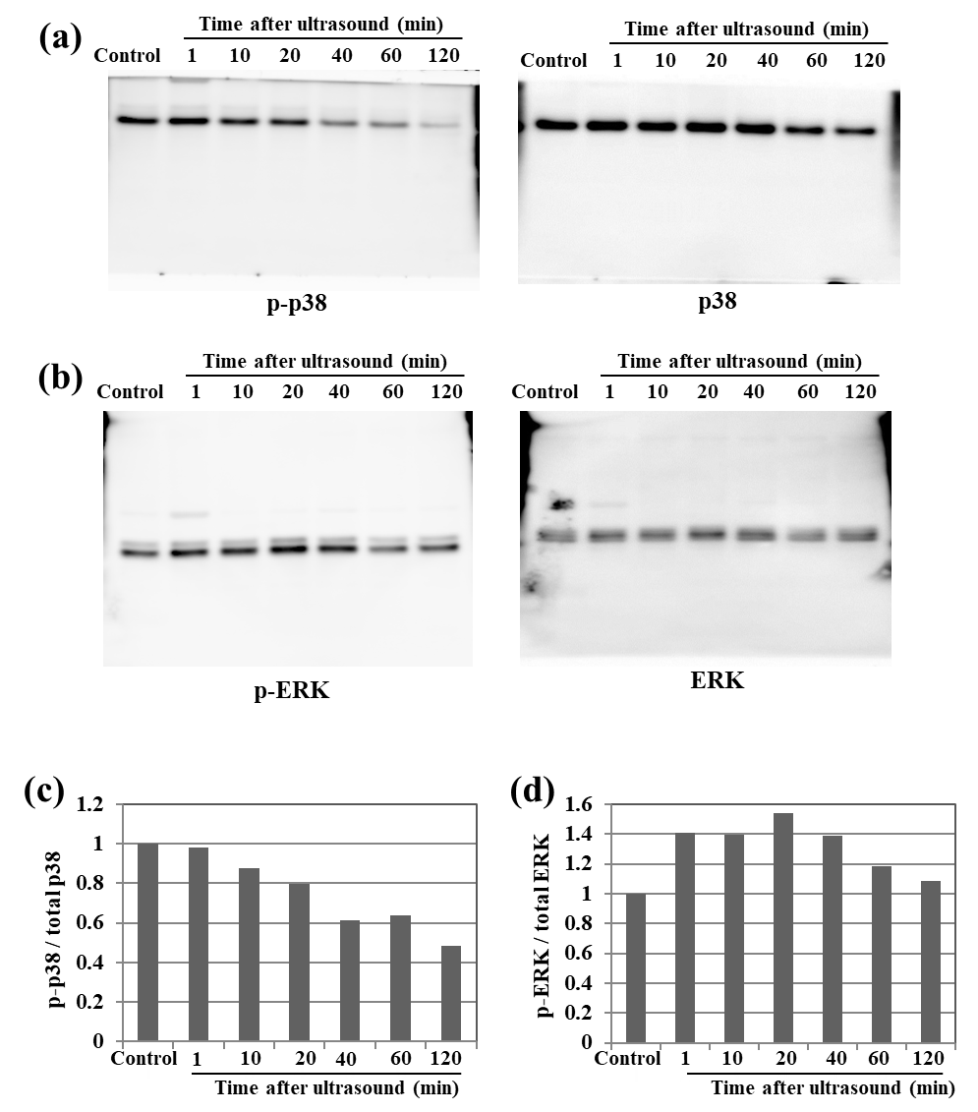
Figure S3. Full-length images of phosphorylated or total protein levels of p38 (a) and ERK1/2 (b) at the indicated time points (minutes) were determined by western blot analysis. All images were analyzed under the same condition. Ratio of phospho-p38 and total p38 (c) and phospho-ERK and total ERK (d) in absolute values.

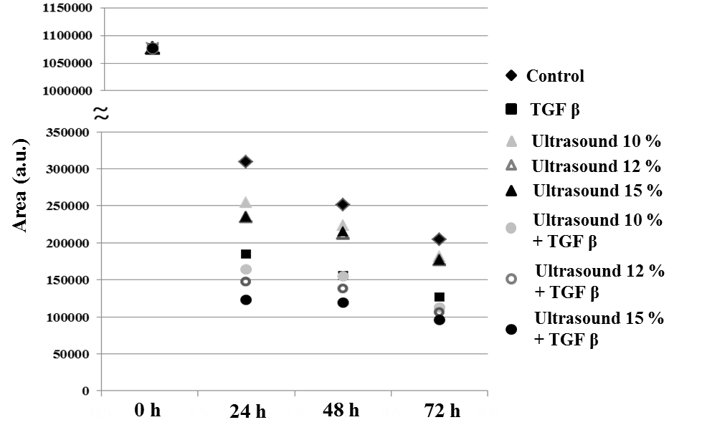
Figure S4. Change of the area contracted by fibroblast in 3D collagen matrix.

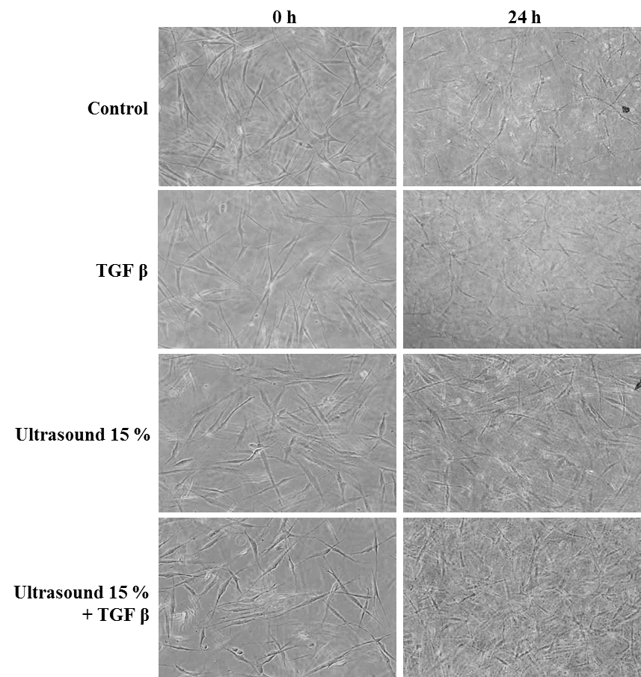
Figure S5. Optical microscope images of fibroblast in 3D collagen matrix. Images were taken at 0 and 24 h after HIUS treatment.

