Gene Co-Expression Network Analysis Reveals Immune Cell Infiltration as a Favorable Prognostic Marker in Non-Uterine Leiomyosarcoma
Mohammad Darzi ¹, Saeid Gorgin ^{1*}, Keivan Majidzadeh-A ² & Rezvan Esmaeili ^{2*}
¹ Department of Electrical Engineering and Information Technology, Iranian Research Organization for Science and Technology (IROST), Tehran, Iran; modarzi@irost.ir , gorgin@irost.ir
² Genetics Department, Breast Cancer Research Center, Motamed Cancer Institute, ACECR, Tehran, Iran; kmajidzadeh@acecr.ac.ir , esmaeili.rezvan@gmail.com
* Correspondence: esmaeili.rezvan@gmail.com, gorgin@irost.ir (Tel: (+98) 9125191902, (+9821) 56276020)

Suplementary Figure S3: The Kaplan–Meier plot. The left plot belongs to green modules, and the right one is for the red.
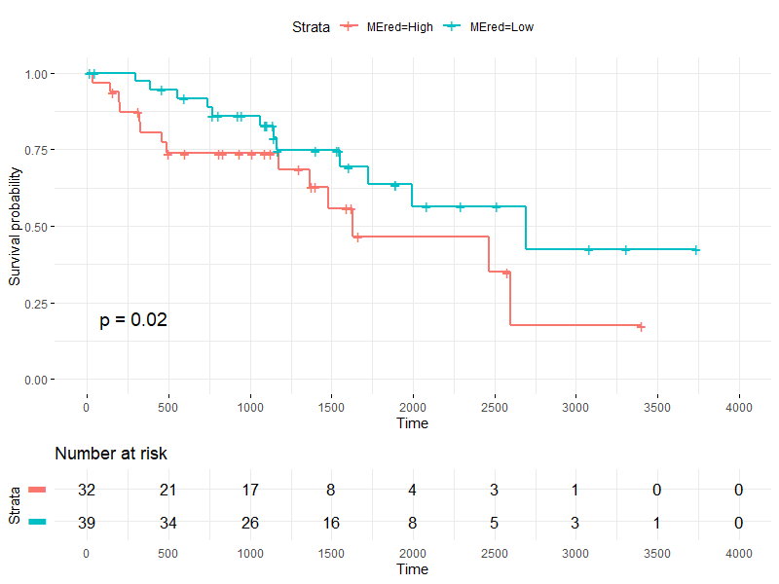
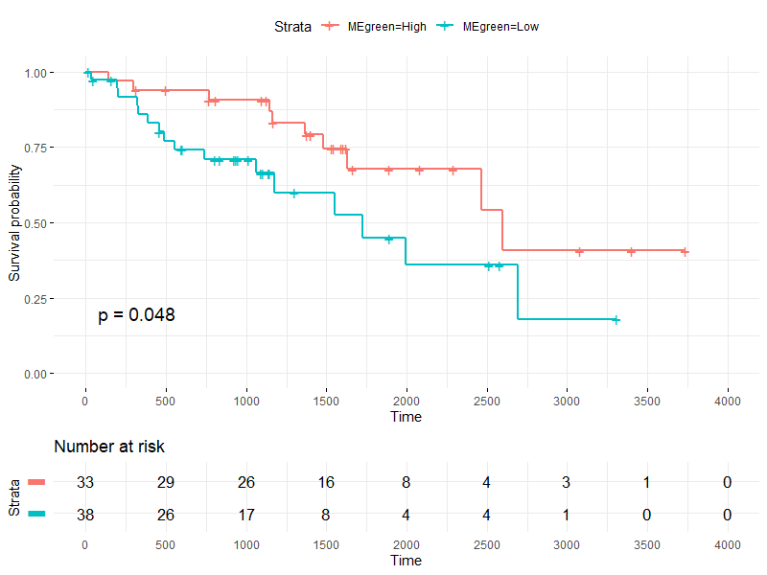
K-M plot for red module
K-M plot for green module

