SUPPLEMENTARY MATERIALS FOR
Comparison of DNA sequencing and morphological identification techniques to characterize environmental fungal communities
Naohide Shinohara^{a*}, Cheolwoon Woo^{b}, Naomichi Yamamoto^{b}, Kazuhiro Hashimoto^{c}, Hiroko Yoshida-Ohuchi^{d}, Yuji Kawakami^{c}

ª Research Institute of Science for Safety and Sustainability (RISS), National Institute of Advanced Industrial Science and Technology (AIST), 16-1 Onogawa, Tsukuba, Ibaraki 305-8569, Japan
^{b} Department of Environmental Health Sciences, Graduate School of Public Health, Seoul National University, Seoul 08826, Republic of Korea
^{c} Laboratory of Integrated Pest Management, FCG Research Institute Inc., 1-1-20, Aomi, Koto-ku, Tokyo 135-0064, Japan
^{d} Graduate School of Pharmaceutical Sciences, Tohoku University, 6-3 Aramaki-Aoba, Aoba-ku, Sendai, Miyagi 980-8578, Japan
* Correspondence to: Naohide Shinohara; e-mail: n-shinohara@aist.go.jp; TEL: +81-29-861-8030, FAX: +81-29-861-8411

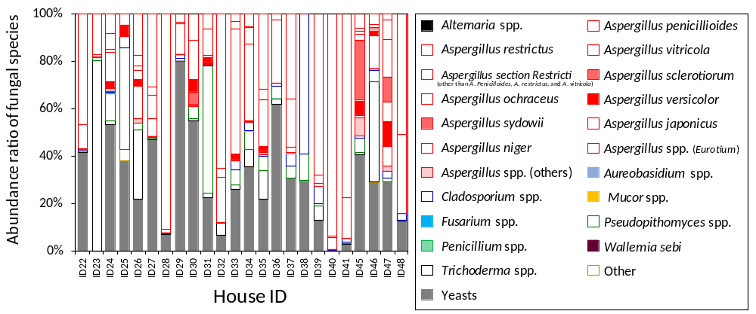
Fig. S1 Relative abundances of fungal species based on the culture method.

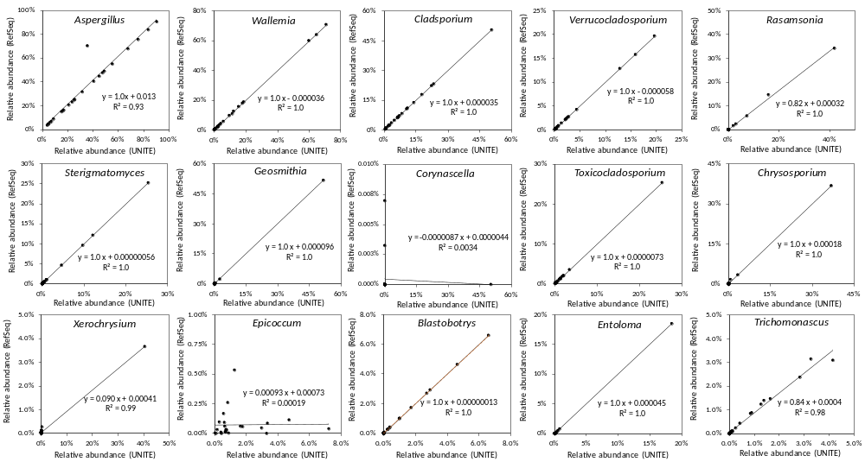
Fig. S2. Correlation of relative abundances based on the UNITE and RefSeq databases.

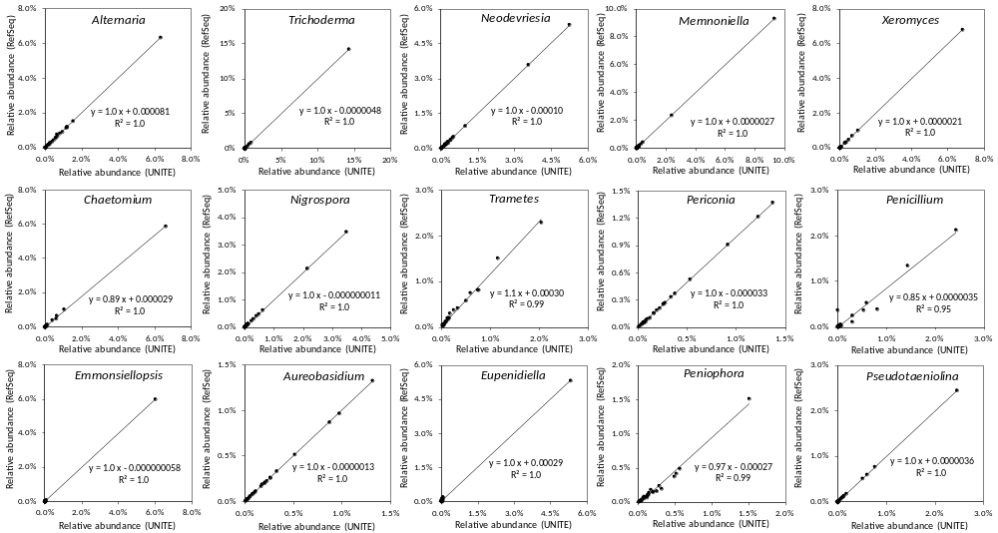
Fig. S2. (cont.)

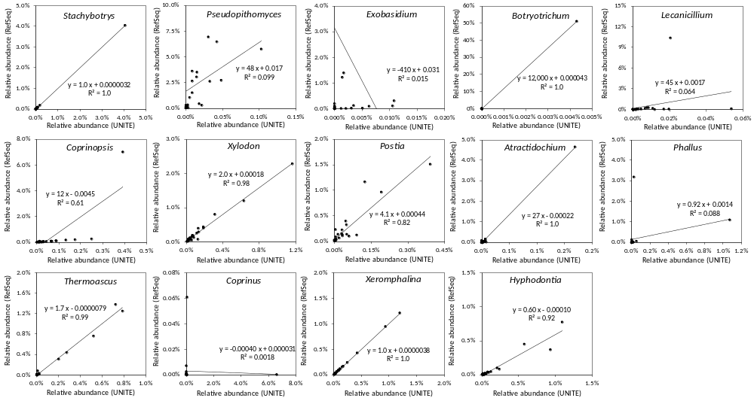
Fig. S2. (cont.)

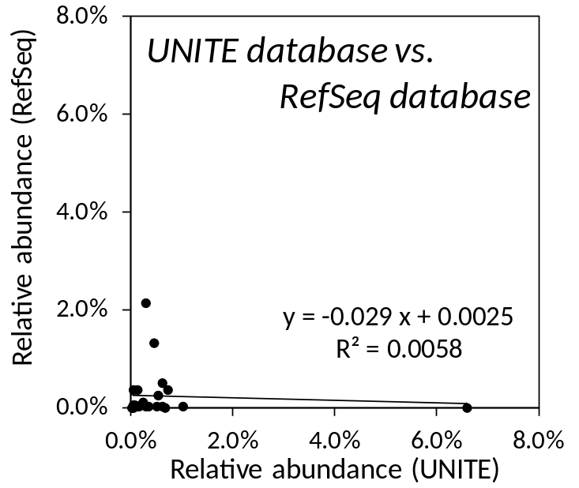
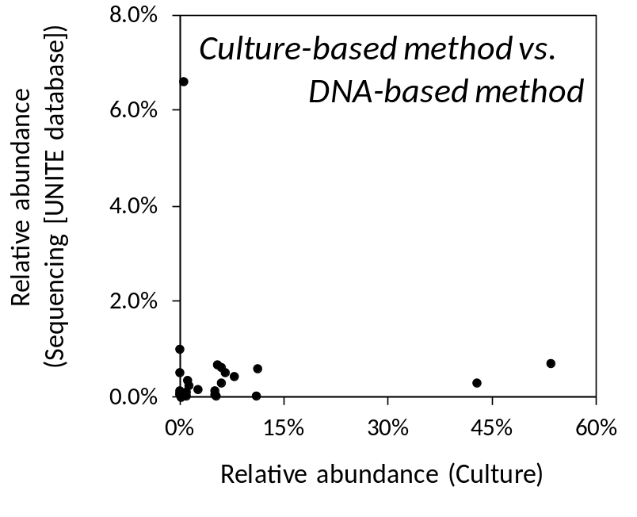

Fig. S3. Correlation of the results from Culture based method and DNA-based method in the previous database (Left) and Correlation of relative abundances based on the UNITE and RefSeq databases in the previous database (Right).

Table S1. Most abundant fungal genera. Fungal genera with the highest 12 and 40 relative abundance levels in house dust (20–63 μm), based on culture and sequencing methods, in 24 Japanese houses.
