SUPPLEMENTARY DATA
MicroRNA‑331 inhibits isoproterenol‑induced expression of profibrotic genes in cardiac myofibroblasts via the TGFβ/smad3 signaling pathway

Fatemeh Yousefi¹, Bahram M. Soltani^{1*}, Shahram Rabbani^{2*}
1 Department of Genetics, Faculty of Biological Sciences, Tarbiat Modares University, Tehran, Iran
2 Research Center for Advanced Technologies in Cardiovascular Medicine, Cardiovascular Diseases Research Institute, Tehran University of Medical Sciences, Tehran, Iran
*Corresponding author e-mail: soltanib@modares.ac.ir
*Corresponding author e-mail: sh-rabbani@tums.ac.ir
Tel.: +98-02182884703
Fax: +98-2182884717
P.O. Box: 14115-154

Supplementary Figure 1: Western blot analysis of (A) Col1A1, (B) Smad3, and (C) GAPDH protein, following overexpression of miR-331 and C1-Mock in mouse cardiac myofibroblast cells (MCMyoFbs). GAPDH served as loading control. Protein load: 40 µg/lane. Unlabeled lines belong to another study.
A
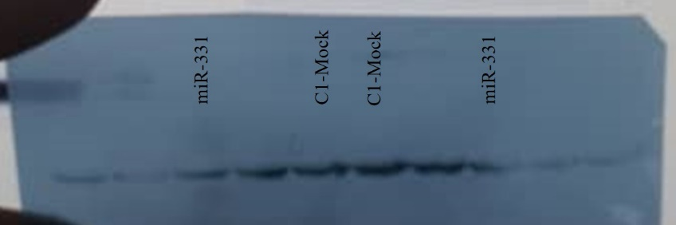
B
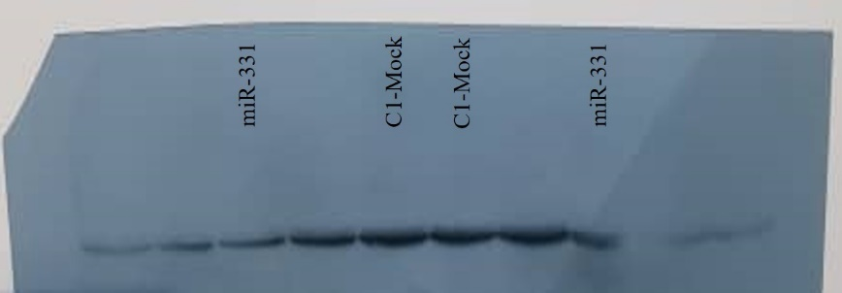
C
