Detecting Neurodevelopmental Trajectories in Congenital Heart Diseases with a Machine-Learning Approach
Elisa Cainelli^{1*}, Patrizia S Bisiacchi^{1,2*}, Paola Cogo³, Massimo Padalino⁴, Manuela Simonato ⁵, Michela Vergine³, Corrado Lanera ⁶, Luca Vedovelli⁶
¹ Department of General Psychology, University of Padova, Padova, Italy.
² Padova Neuroscience Centre, PNC, Padova, Italy
³ Clinica Pediatrica, Department of Medicine and University Hospital S Maria della Misericordia, University of Udine, Udine, Italy.
⁴ Pediatric and Congenital Cardiovascular Surgery Unit, Department of Cardiac, Thoracic and Vascular Sciences, Padova University Hospital, Padova, Italy.
⁵ PCare Laboratory, Fondazione Istituto di Ricerca Pediatrica “Citta della Speranza”, Padova, Italy
⁶ Unit of Biostatistics, Epidemiology, and Public Health, Department of Cardiac, Thoracic, Vascular Sciences, and Public Health, University of Padova, Padova, Italy.
Table S1
Boruta full numeric results for neuropsychology variables. Imp: importance, decision: if the variable is important to differentiate the CHD and controls groups.
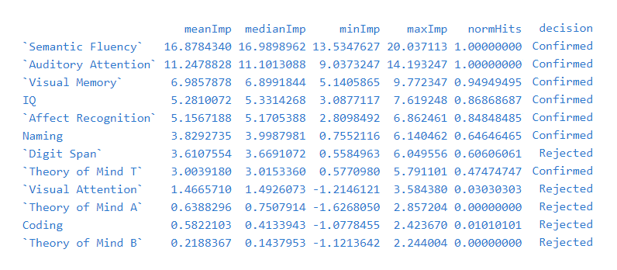

Table S2
Boruta full numeric results for psychopatology variables. Imp: importance, decision: if the variable is important to differentiate the CHD and controls groups.
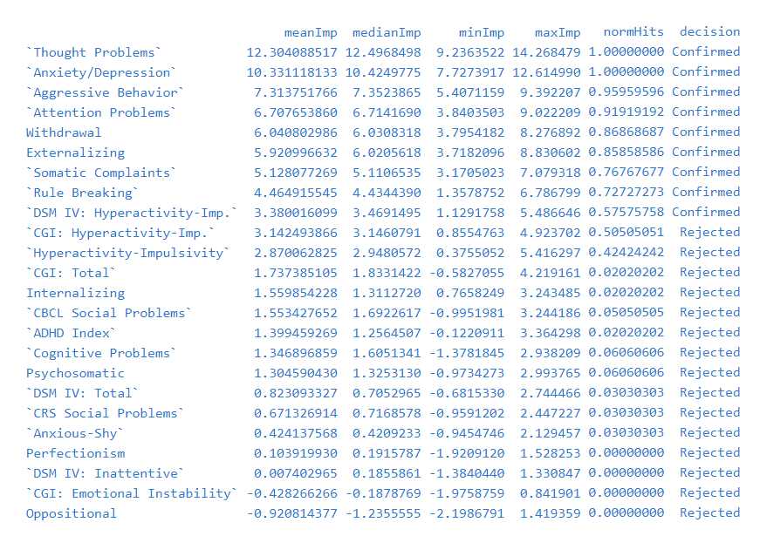

Table S3.
Neuropsychology and clinical variables comparisons after clustering.
Clinical variables were not included in the clustering but evaluated a posteriori. Results are presented in Z-scores for neuropsychology variables and in the original scales for clinical variables. P-values are adjusted for false discovery rate.

Cluster | 1 (N=9) | 2 (N=20) | 3 (N=5) | p value
IQ |  |  |  | < 0.001
- Median | -1.2 | -0.1 | 1.9
- Q1,Q3 | -1.3, -0.8 | -0.2, 0.5 | 1.5, 1.9
- Mean | -1.2 (0.4) | 0.1 (0.4) | 1.8 (0.3)
Coding |  |  |  | 0.064
- Median | -0.4 | 0.1 | 0.7
- Q1,Q3 | -0.8, -0.4 | -0.8, 0.8 | 0.3, 1.7
- Mean | -0.6 (0.5) | 0.0 (1.0) | 1.0 (0.9)
Digit Span |  |  |  | 0.021
- Median | -0.9 | -0.1 | 1.0
- Q1,Q3 | -1.3, -0.6 | -0.3, 1.0 | 0.3, 1.7
- Mean | -0.9 (0.5) | 0.2 (0.8) | 1.1 (1.4)
Naming |  |  |  | 0.718
- Median | -0.1 | -0.0 | 0.4
- Q1,Q3 | -1.0, 0.6 | -0.5, 0.5 | -0.3, 0.7
- Mean | -0.3 (1.1) | -0.0 (0.9) | 0.6 (1.3)
Semantic Fluency |  |  |  | 0.109
- Median | -0.9 | 0.2 | 1.0
- Q1,Q3 | -1.0, -0.2 | -0.8, 0.8 | 0.1, 1.8
- Mean | -0.7 (0.6) | 0.1 (0.9) | 0.8 (1.4)
Visual Attention |  |  |  | 0.671
- Median | 0.3 | 0.0 | 0.6
- Q1,Q3 | -1.2, 0.6 | -0.6, 0.4 | 0.3, 0.9
- Mean | -0.2 (1.3) | -0.1 (0.9) | 0.6 (0.9)
Theory of Mind A |  |  |  | 0.015
- Median | -0.4 | 0.3 | 0.9
- Q1,Q3 | -1.6, -0.1 | -0.4, 0.7 | 0.8, 1.2
- Mean | -0.8 (1.2) | 0.1 (0.7) | 1.0 (0.2)
Theory of Mind B |  |  |  | 0.829
- Median | 0.2 | -0.3 | 1.0
- Q1,Q3 | -0.6, 0.4 | -0.8, 0.5 | -0.8, 1.4
- Mean | -0.0 (0.8) | -0.1 (1.0) | 0.4 (1.4)
Theory of Mind T |  |  |  | 0.017
- Median | -0.5 | 0.1 | 1.5
- Q1,Q3 | -1.0, -0.2 | -0.2, 0.4 | 0.6, 1.5
- Mean | -0.7 (0.9) | 0.0 (0.8) | 1.2 (0.8)
Affect Recognition |  |  |  | 0.155
- Median | -1.3 | 0.2 | 0.8
- Q1,Q3 | -1.6, 0.6 | -0.5, 0.6 | 0.6, 0.8
- Mean | -0.6 (1.1) | 0.1 (0.9) | 0.6 (0.4)
Auditory Attention |  |  |  | 0.492
- Median | -0.3 | 0.4 | 0.4
- Q1,Q3 | -0.9, -0.3 | -0.3, 1.2 | 0.1, 0.8
- Mean | -0.6 (0.8) | 0.2 (1.1) | 0.4 (0.8)
Visual Memory |  |  |  | 0.854
- Median | -0.0 | 0.2 | 0.1
- Q1,Q3 | -0.7, 0.3 | -0.3, 0.7 | -0.3, 0.5
- Mean | -0.2 (0.9) | 0.1 (1.1) | 0.1 (1.0)
Clinical Variables
STAT category |  |  |  | 0.788
- 1 | 2 (22.2%) | 1 (5.0%) | 2 (40.0%)
- 2 | 2 (22.2%) | 9 (45.0%) | 2 (40.0%)
- 3 | 2 (22.2%) | 4 (20.0%) | 0 (0.0%)
- 4 | 2 (22.2%) | 4 (20.0%) | 1 (20.0%)
- 5 | 1 (11.1%) | 2 (10.0%) | 0 (0.0%)
Age at sugery (m) |  |  |  | 0.718
- Median | 6.9 | 3.0 | 25.3
- Q1,Q3 | 4.5, 11.2 | 0.3, 21.6 | 6.2, 44.0
- Mean | 16.1 (22.1) | 14.1 (20.5) | 25.1 (22.1)
Pre-surgery  Oxy. Sat. (%) |  |  |  | 0.785
- Median | 88.0 | 90.0 | 98.0
- Q1,Q3 | 84.0, 96.0 | 85.8, 97.2 | 87.5, 99.0
- Mean | 88.9 (9.2) | 90.9 (6.7) | 93.7 (7.4)
Surgery  Temp. Nadir (°C) |  |  |  | 0.677
- Median | 31.0 | 31.2 | 34.0
- Q1,Q3 | 27.0, 32.7 | 28.0, 32.2 | 32.0, 34.0
- Mean | 29.1 (5.3) | 30.1 (3.4) | 31.7 (4.1)
Cardiopulmonary  Bypass time (min) |  |  |  | 0.718
- Median | 143.0 | 125.0 | 84.0
- Q1,Q3 | 90.0, 158.0 | 100.5, 144.5 | 57.0, 130.0
- Mean | 132.9 (62.7) | 128.4 (45.5) | 99.2 (52.7)
Time at cerebral  Sat. <45%, NIRS (min) |  |  |  | 0.829
- Median | 2.2 | 12.9 | 5.0
- Q1,Q3 | 0.0, 25.0 | 0.0, 19.7 | 0.0, 7.1
- Mean | 18.7 (27.0) | 22.0 (31.7) | 6.5 (8.4)
Mean surgery lactates  (mmol/L) |  |  |  | 0.854
- Median | 1.7 | 2.7 | 2.0
- Q1,Q3 | 1.5, 2.9 | 1.4, 3.7 | 1.4, 2.4
- Mean | 2.3 (1.3) | 2.9 (1.8) | 2.3 (1.3)
Days in intensive care |  |  |  | 0.718
- Median | 3.0 | 5.0 | 2.0
- Q1,Q3 | 2.0, 7.0 | 2.5, 5.0 | 1.0, 5.0
- Mean | 11.1 (19.5) | 5.7 (6.0) | 2.8 (2.0)

Table S4.
Psychopathology and clinical variables comparisons after clustering.
Clinical variables were not included in the clustering but evaluated a posteriori. Results are presented in Z-scores for psychopathology variables and in the original scales for clinical variables. P-values are adjusted for false discovery rate.
Cluster | 1 (N=14) | 2 (N=4) | 3 (N=16) | p value
Oppositional |  |  |  | < 0.001
Median | 52.5 | 66.0 | 43.0
Q1,Q3 | 47.2, 55.8 | 63.0, 69.2 | 38.8, 44.2
Mean | 56.0 (15.0) | 66.2 (3.8) | 42.8 (4.7)
Cognitive Problems |  |  |  | < 0.001
Median | 54.0 | 74.5 | 42.0
Q1,Q3 | 52.0, 60.5 | 63.8, 82.0 | 40.0, 46.0
Mean | 57.2 (9.2) | 71.2 (13.5) | 42.9 (4.1)
Hyperactivity-Impulsivity |  |  |  | < 0.001
Median | 55.5 | 73.5 | 40.5
Q1,Q3 | 54.2, 60.5 | 69.5, 75.0 | 40.0, 43.2
Mean | 56.9 (6.7) | 71.0 (6.2) | 41.4 (2.3)
Anxious-Shy |  |  |  | 0.009
Median | 48.0 | 72.0 | 44.0
Q1,Q3 | 41.5, 48.0 | 61.8, 82.0 | 36.0, 51.5
Mean | 45.6 (4.9) | 71.8 (11.8) | 44.3 (7.9)
Perfectionism |  |  |  | 0.002
Median | 48.0 | 64.0 | 39.5
Q1,Q3 | 42.2, 51.5 | 61.0, 70.0 | 37.0, 43.8
Mean | 48.9 (7.7) | 67.0 (15.1) | 42.1 (7.0)
CRS Social Problems |  |  |  | 0.015
Median | 44.0 | 65.0 | 43.0
Q1,Q3 | 43.2, 44.0 | 52.8, 76.0 | 43.0, 44.0
Mean | 45.4 (5.0) | 63.8 (14.3) | 44.6 (6.4)
Psychosomatic |  |  |  | 0.012
Median | 44.0 | 84.0 | 44.0
Q1,Q3 | 43.0, 47.8 | 79.2, 87.2 | 43.0, 48.0
Mean | 47.0 (7.0) | 82.5 (13.2) | 48.9 (9.9)
ADHD Index |  |  |  | < 0.001
Median | 57.0 | 72.0 | 42.0
Q1,Q3 | 49.5, 64.5 | 71.0, 72.0 | 40.0, 45.5
Mean | 58.3 (11.3) | 71.0 (2.0) | 43.1 (4.1)
CGI: Hyperactivity-Imp. |  |  |  | < 0.001
Median | 59.5 | 68.0 | 42.0
Q1,Q3 | 53.0, 62.5 | 67.0, 68.5 | 39.0, 43.0
Mean | 59.9 (10.7) | 67.5 (2.5) | 41.9 (3.5)
CGI: Emotional Instability |  |  |  | 0.002
Median | 45.0 | 76.0 | 41.5
Q1,Q3 | 42.0, 55.0 | 70.2, 81.0 | 41.0, 42.0
Mean | 50.4 (12.8) | 75.2 (6.8) | 41.9 (2.6)
DSM IV: Inattentive |  |  |  | < 0.001
Median | 55.0 | 72.0 | 42.0
Q1,Q3 | 52.0, 64.0 | 63.8, 77.0 | 40.0, 44.2
Mean | 58.0 (10.3) | 68.8 (10.9) | 42.7 (3.0)
DSM IV: Hyperactivity-Imp. |  |  |  | < 0.001
Median | 59.0 | 62.0 | 41.0
Q1,Q3 | 53.5, 61.0 | 61.0, 66.0 | 38.0, 43.5
Mean | 58.4 (7.6) | 65.0 (6.7) | 41.4 (4.3)
Withdrawal |  |  |  | 0.019
Median | 51.5 | 66.0 | 50.0
Q1,Q3 | 50.2, 57.5 | 63.5, 68.5 | 50.0, 53.0
Mean | 54.0 (4.8) | 66.0 (8.2) | 53.2 (5.1)
Somatic Complaints |  |  |  | 0.011
Median | 50.0 | 71.0 | 53.0
Q1,Q3 | 50.0, 56.8 | 68.8, 72.0 | 50.0, 57.0
Mean | 53.7 (5.6) | 69.8 (3.3) | 54.8 (6.2)
Anxiety/Depression |  |  |  | 0.005
Median | 52.0 | 70.0 | 51.0
Q1,Q3 | 51.2, 55.2 | 68.2, 70.5 | 50.0, 52.0
Mean | 53.9 (4.3) | 68.8 (3.9) | 53.0 (5.0)
CBCL Social Problems |  |  |  | 0.040
Median | 52.0 | 62.0 | 52.0
Q1,Q3 | 51.0, 58.0 | 62.0, 64.5 | 50.0, 53.0
Mean | 54.1 (4.0) | 63.7 (2.9) | 52.5 (3.6)
Thought Problems |  |  |  | 0.010
Median | 51.0 | 66.0 | 50.0
Q1,Q3 | 51.0, 58.0 | 66.0, 69.5 | 50.0, 51.0
Mean | 53.9 (3.9) | 68.3 (4.0) | 51.2 (1.7)
Attention Problems |  |  |  | 0.001
Median | 59.0 | 65.5 | 50.0
Q1,Q3 | 53.0, 67.0 | 64.0, 68.0 | 50.0, 53.0
Mean | 60.4 (8.3) | 66.5 (3.3) | 51.8 (3.1)
Rule Breaking |  |  |  | 0.021
Median | 57.0 | 55.0 | 50.0
Q1,Q3 | 51.5, 58.0 | 55.0, 62.5 | 50.0, 52.0
Mean | 55.6 (4.8) | 60.0 (8.7) | 51.3 (2.3)
Aggressive Behavior |  |  |  | 0.002
Median | 52.0 | 56.0 | 50.0
Q1,Q3 | 51.0, 59.0 | 55.0, 59.2 | 50.0, 50.2
Mean | 57.2 (10.7) | 58.2 (7.4) | 51.0 (3.0)
STAT category |  |  |  | 0.274
1 | 3 (21.4%) | 1 (25.0%) | 0 (0.0%)
2 | 7 (50.0%) | 1 (25.0%) | 6 (37.5%)
3 | 2 (14.3%) | 0 (0.0%) | 4 (25.0%)
4 | 2 (14.3%) | 2 (50.0%) | 3 (18.8%)
5 | 0 (0.0%) | 0 (0.0%) | 3 (18.8%)
Age at sugery (m) |  |  |  | 0.614
Median | 4.7 | 2.4 | 6.0
Q1,Q3 | 2.0, 10.6 | 0.2, 6.2 | 0.4, 30.6
Mean | 12.3 (18.1) | 4.0 (5.2) | 17.5 (22.5)
Pre-surgery  Oxy. Sat. (%) |  |  |  | 0.485
Median | 91.0 | 96.0 | 87.5
Q1,Q3 | 86.0, 96.8 | 93.1, 97.8 | 84.8, 96.5
Mean | 90.6 (7.5) | 94.9 (5.3) | 89.0 (8.0)
Surgery  Temp. Nadir (°C) |  |  |  | 0.553
Median | 32.0 | 30.0 | 29.6
Q1,Q3 | 31.1, 32.7 | 27.1, 32.0 | 27.8, 33.0
Mean | 30.6 (4.4) | 29.1 (3.6) | 29.6 (3.8)
Cardiopulmonary  Bypass time (min) |  |  |  | 0.830
Median | 125.0 | 143.5 | 136.0
Q1,Q3 | 102.0, 154.5 | 129.8, 151.8 | 92.2, 149.0
Mean | 127.4 (54.6) | 138.0 (35.3) | 128.9 (50.7)
Time at cerebral  Sat. <45%, NIRS (min) |  |  |  | 0.648
Median | 13.7 | 5.0 | 7.7
Q1,Q3 | 0.0, 30.1 | 0.0, 10.7 | 0.0, 21.0
Mean | 21.6 (27.5) | 5.7 (6.6) | 21.8 (33.5)
Mean surgery lactates  (mmol/L) |  |  |  | 0.963
Median | 2.0 | 2.5 | 2.4
Q1,Q3 | 1.5, 3.6 | 1.6, 3.5 | 1.4, 4.5
Mean | 2.3 (1.1) | 2.6 (1.5) | 3.0 (2.0)
Days in intensive care |  |  |  | 0.553
Median | 4.5 | 4.5 | 5.0
Q1,Q3 | 2.0, 5.0 | 3.2, 5.0 | 2.5, 7.0
Mean | 7.7 (15.7) | 3.8 (1.9) | 7.0 (6.9)

