Supporting Information

New machine learning and physics-based scoring functions for drug discovery
Isabella A. Guedes^{1,3}, André M. S. Barreto¹, Diogo Marinho¹, Eduardo Krempser², Mélaine A. Kuenemann³, Olivier Sperandio^{3,4}, Laurent E. Dardenne¹* and Maria A. Miteva^{3,5}*
¹ Laboratório Nacional de Computação Científica, Petrópolis 25651-075, Brazil;
² Fundação Oswaldo Cruz, Rio de Janeiro 21040-361, Brazil;
³ Inserm U973, Université Paris Diderot, France;
⁴ Structural Bioinformatics Unit, CNRS UMR3528, Institut Pasteur, 75015 Paris, France;
⁵ Inserm U1268 “Medicinal Chemistry and Translational Research”, CiTCoM UMR 8038, CNRS, Université de Paris, Paris 75006, France.
* Corresponding authors
E-mail addresses: maria.mitev@inserm.fr, dardenne@lncc.br

Table S1. Composition of training and testing sets for general and target-specific scoring functions. The general scoring function was also evaluated using the test set v2013 core set as independent test set.
Target class | Source | Total | Training | Random Test Set | Core Set
General::random | PDBbind v2013 | 2764 | 2073 | 691 | 195
General::all | PDBbind v2013 | 2764 | 2764 | - | 195
Proteases | PDBbind v2013 | 783 | 587 | 196 | -
PPIs | iPPI X-ray | 60 | 45 | 15 | -

Table S2. Performances of the basic scoring functions composed of MMFF94S force-field terms trained with PDBbind v2013 refined set minus random test set and core set (N = 2073) evaluated in cross-validation experiments.
van der Waals | Electrostatic | R_crossª | RMSE^{b}
original Buf-14-7 | Coulomb $ε(r)→1$ | 0.057 | 2.975
original Buf-14-7 | Coulomb $ε(r)→4$ | 0.068 | 2.936
softened Buf-14-7 | Coulomb $ε(r)→1$ | 0.491 | 2.349
softened Buf-14-7 | Coulomb $ε(r)→4$ | 0.493 | 2.346
ª R is the Pearson correlation coefficient on 10-fold cross-validation (R_cross). ^{b} RMSE is the root mean squared error (in kcal mol⁻¹).
Table S3. Performances of the linear scoring functions composed of the MMFF94S force-field terms E_{coul4} and E_{vdWS} and the lipophilic term trained with PDBbind v2013 refined set minus random test set and core set (N = 2073) evaluated in cross-validation experiments.
Lipophilic term | Carbon atoms |  | Partial chargeª
Lipophilic term | R_cross^{b} | RMSE^{d} | R_cross^{b} | RMSE^{c}
ChemScore | 0.519 | 2.306 | 0.538 | 2.274
X-Score | 0.507 | 2.324 | 0.526 | 2.294
ª All atoms with a partial charge (q) in the interval -0.4 < q < +0.4. ^{b} R is the Pearson correlation coefficient on 10-fold cross-validation (R_cross). ^{c}RMSE is the root mean squared error (in kcal mol⁻¹).
Table S4. Evaluation of the contribution of individual terms when associated with the basic scoring function composed of MMFF94S force-field terms (F_{MMFF}), trained with PDBbind v2013 refined set minus random test set and core set (N = 2073).
Basic function | Feature | Variations | Rª | RMSE^{b}
F_{MMFF}  R = 0.493  RMSE = 2.346 | Lipophilic | ChemScore functional form, nonpolar atoms defined by atomic number | 0.519 | 2.306
F_{MMFF}  R = 0.493  RMSE = 2.346 | Lipophilic | ChemScore functional form, nonpolar atoms defined according to partial charges | 0.538 | 2.274
F_{MMFF}  R = 0.493  RMSE = 2.346 | Lipophilic | X-Score functional form, nonpolar atoms defined by atomic number | 0.507 | 2.324
F_{MMFF}  R = 0.493  RMSE = 2.346 | Lipophilic | X-Score functional form, nonpolar atoms defined according to partial charges | 0.526 | 2.294
F_{MMFF}  R = 0.493  RMSE = 2.346 | Entropy | Number of “frozen” rotatable bonds based on ΔSAS | 0.507 | 2.325
F_{MMFF}  R = 0.493  RMSE = 2.346 | Polar solvation | Number of charged atoms buried after binding and not interacting with a ligand charged atom. | 0.514 | 2.313
F_{MMFF}  R = 0.493  RMSE = 2.346 | Nonpolar solvation | Total loss of the solvent-accessible surface area (SAS) of the protein and the ligand nonpolar atoms due to the binding. | 0.502 | 2.332
ª R is the Pearson correlation coefficient on 10-fold cross-validation (R_cross). ^{b} RMSE is the root mean squared error (in kcal/mol).

Table S5. Evaluated parameters of the SVM and RF algorithms.
Algorithm | Parameter | Values tested | N models
SMOReg | Complexity (C) | {1, 2, …, 9, 10} | 3000
SMOReg | epsilon (ε) | {0.00001, 0.0001, 0.001, 0.01, 0.1} | 3000
SMOReg | Kernel | puk, rbf | 3000
SMOReg | puk: sigma (σ) | {0.01, 0.05, 0.1, 0.5, 1} | 3000
SMOReg | puk: omega (ω) | {0.01, 0.05, 0.1, 0.5, 1} | 3000
SMOReg | rbf: gamma (γ) | {0.01, 0.05, 0.1, 0.5, 1} | 3000
RF | numTrees | {10, 15, 25, 50, 100, …, 450, 500} | 39
RF | numFeatures | {0, 1, 2, 3} | 39
Table S6. Optimal parameters of SVM for general and target-specific scoring functions.
Algorithm | Parameter | General | Protease | PPI
SMOReg | Complexity | 2 | 1 | 2
SMOReg | epsilon | 0.00001 | 0.0001 | 0.0001
SMOReg | Kernel | puk | puk | puk
SMOReg | puk: sigma | 0.1 | 1.0 | 1.0
SMOReg | puk: omega | 0.1 | 0.1 | 0.1
RF | numTrees | 200 | 100 | 15
RF | numFeatures | 2 | 3 | 3

Table S7. Performances of the linear and nonlinear scoring functions trained with MLR, SMOReg and RF. The target-specific scoring functions were validated on their respective independent test sets.
Algorithm | Scoring functions | Rª training | R cross | R test | RMSE^{b}
MLR | General::random | 0.553 | 0.548 | 0.602^{c} (0.494^{d}) | 2.470^{c} (2.311^{d})
MLR | General::all | 0.539 | 0.536 | 0.601^{c} | 2.478^{c}
MLR | Proteases | 0.629 | 0.614 | 0.653 | 2.086
MLR | iPPIs_oneSolv | 0.693 | 0.552 | 0.442 | 2.011
SMOReg | General::random | 1.000 | 0.653 | 0.668^{c} (0.598)^{d} | 2.338^{c} (2.130^{d})
SMOReg | General::all | 1.000 | 0.647 | 0.687^{c} | 2.303^{c}
SMOReg | Proteases | 0.996 | 0.749 | 0.730 | 1.886
SMOReg | iPPIs_oneSolv | 1.000 | 0.600 | 0.613 | 1.412
RF | General::random | 0.975 | 0.655 | 0.678^{c} (0.613) ^{d} | 2.325^{c} (2.103)^{d}
RF | General::all | 0.974 | 0.656 | 0.705^{c} | 2.256^{c}
RF | Proteases | 0.974 | 0.735 | 0.723 | 1.901
RF | iPPIs_oneSolv | 0.946 | 0.666 | 0.478 | 1.813
ª R is the Pearson’s correlation coefficient on training set (R training), 10-fold cross-validation (R cross), test set (R test). ^{b} RMSE is the root mean squared error (in kcal mol⁻¹). ^{c} Performance on the curated core set (N = 195). ^{d} Performance on the random test set (N = 691).

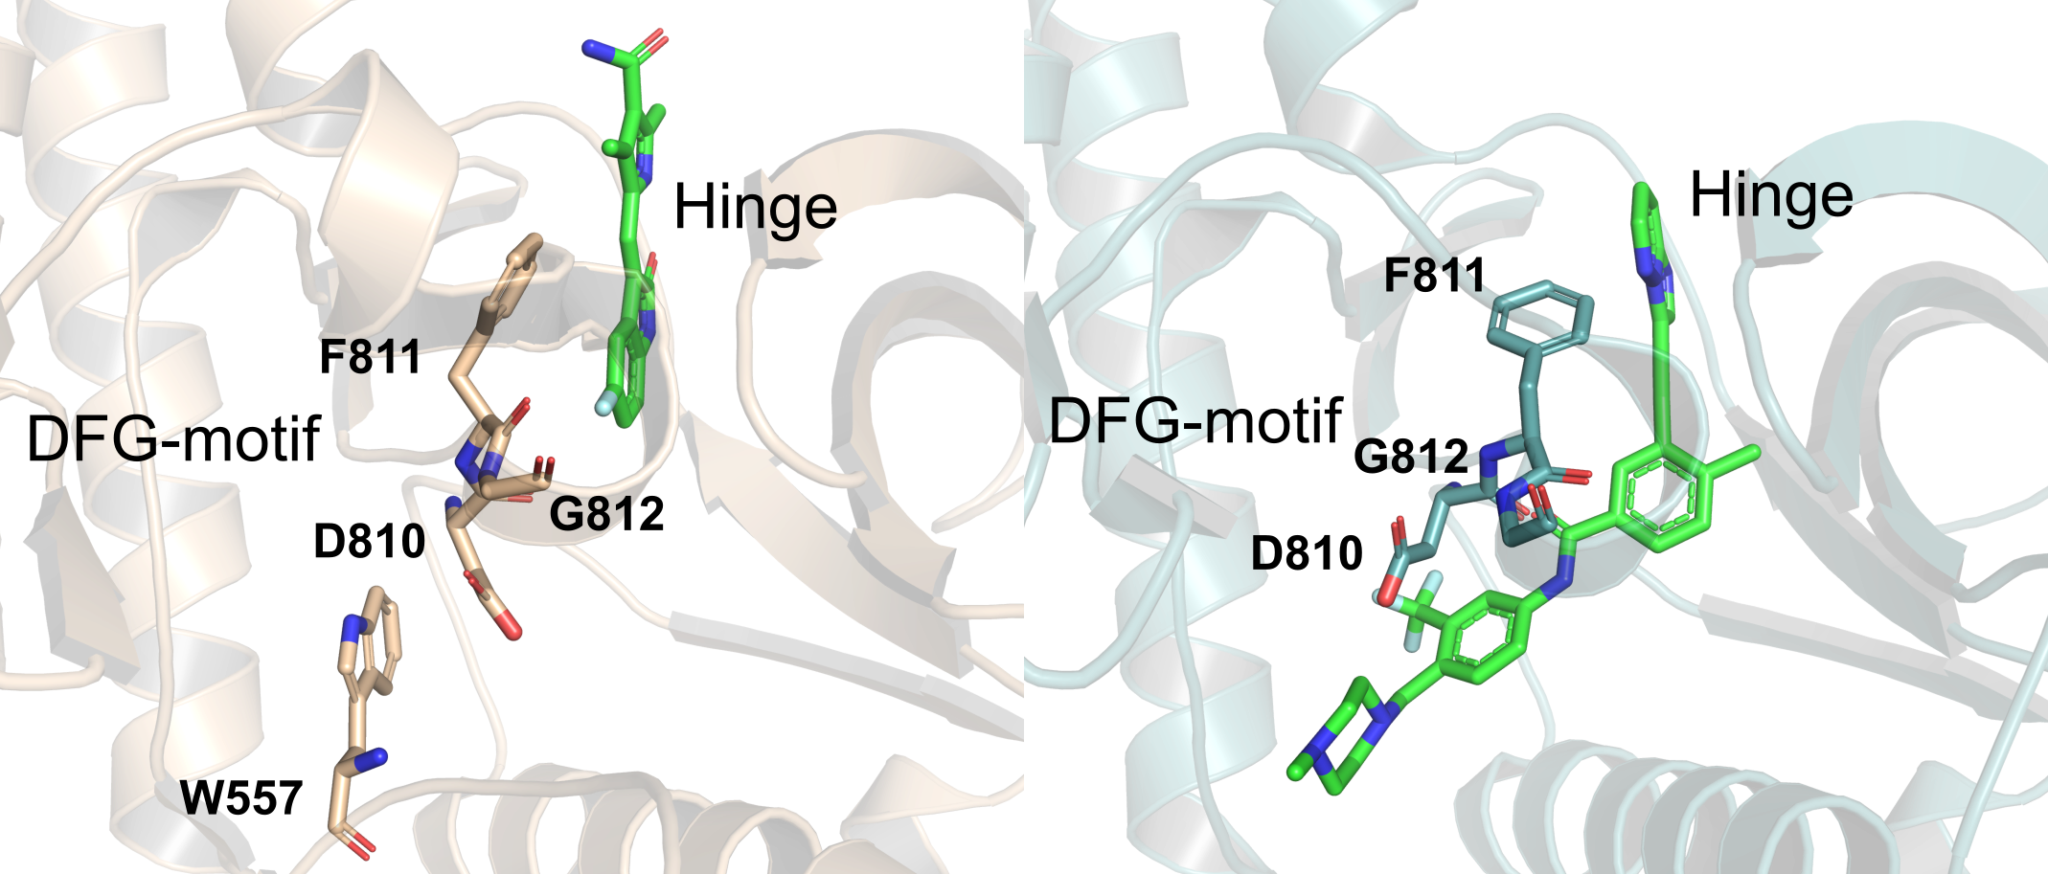
Figure S1. Experimental structures of KIT autoinhibited complexed with sunitinib (PDB code 3G0E, left) and ponatinib complex (PDB code 4U0I), which is larger than sunitinib and induces the inactive DFG-out conformation of the enzyme (right). The co-crystallized ligands are represented as green carbon sticks. The key regions for interaction of the most potent inhibitors, hinge and DFG-motif, are highlighted in the picture.

