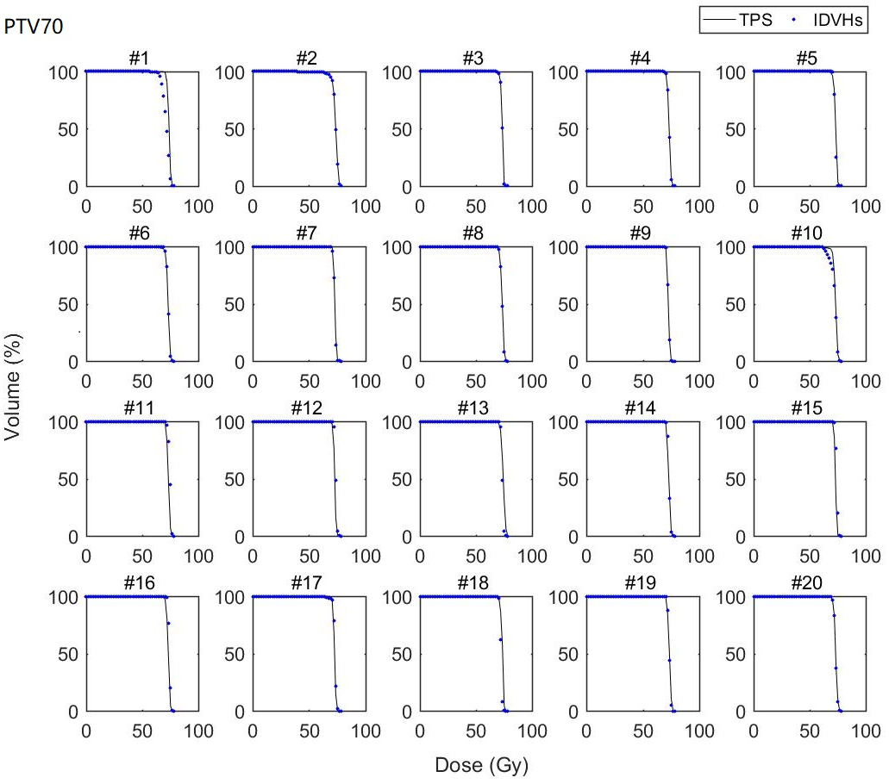
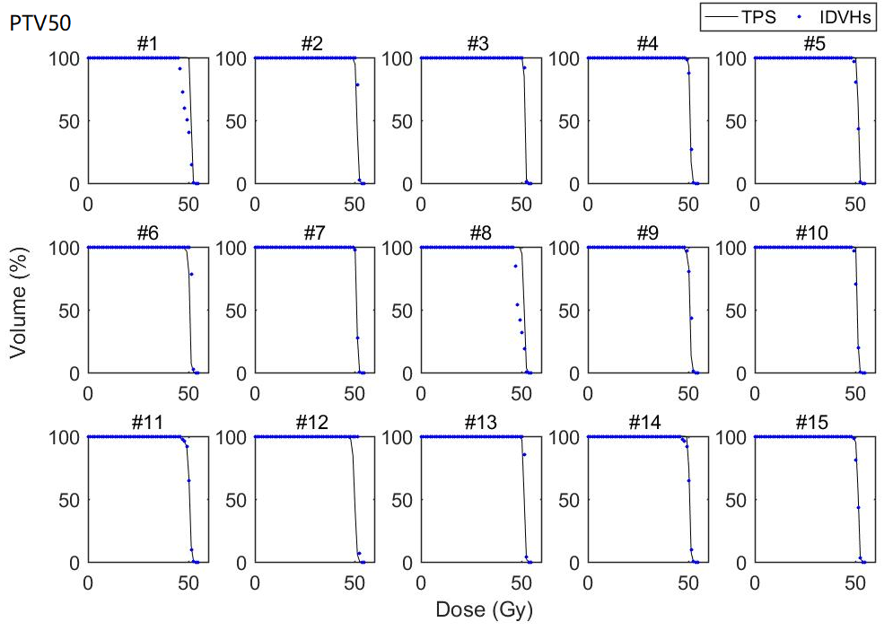
Supplemental Figure 1. Comparison between the PTVs DVHs predicted by the IDVHs method (blue scatter) and the PTVs DVHs achieved by the TPS (black solid line). The PTV70 of nasopharyngeal cancer and the PTV50 of rectal cancer are displayed in detail.

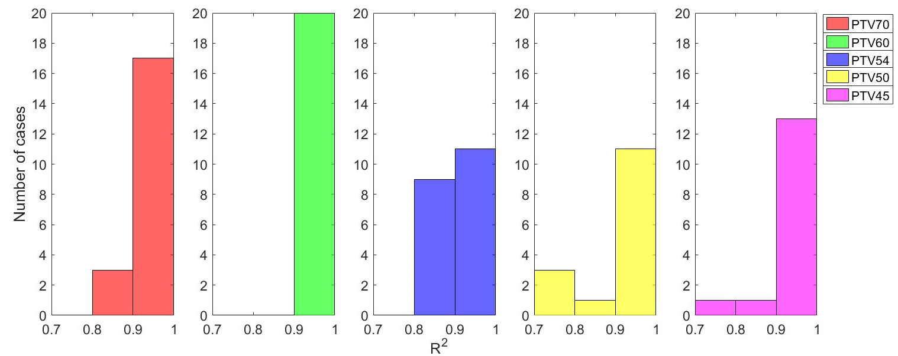
Supplemental Figure 2. PTV R² values for the IDVHs prediction method.

