Supplementary Information for the publication:

Assessment of common housekeeping genes as reference for gene expression studies using RT-qPCR in mouse choroid plexus
Kim Hoa Ho^{1,2}, Annarita Patrizi^{1,*}
¹Schaller Research Group, German Cancer Research Center (DKFZ), Heidelberg, Germany
²Faculty of Biosciences, Heidelberg University, Heidelberg, Germany

*Corresponding author:
Annarita Patrizi, PhD
a.patrizi@dkfz-heidelberg.de

Table S1. Overview of experimental conditions, biological and technical replicates
Condition | Pooled samples per biological replicate | Biological replicate | Technical replicate
Developmental panel
P0 | 2 | 5 | 3
P15 | 2 | 5 | 3
P30 | 1 | 5 | 3
P60 | 1 | 5 | 3
Light/Dark rearing panel
Ctrl | 1 | 5 | 3
D | 1 | 5 | 3
D-1hL | 1 | 5 | 3
D-4hL | 1 | 5 | 3
D-24hL | 1 | 5 | 3

Table S2. Comparison of geNorm and NormFinder results calculated with original software and RefFinder.
Developmental panel
Ranking | geNorm |  |  |  | NormFinder
Ranking | Original software |  | RefFinder |  | Original software |  | RefFinder
Ranking | Gene | Stability value | Gene | Stability value | Gene | Stability value | Gene | Stability value
1 | Rpl27 | 0.098 | Rpl27 | 0.07 | Gapdh | 0.161 | Gapdh | 0.125
2 | Rpl13a | 0.104 | Rpl13a | 0.07 | Rer1 | 0.207 | Rer1 | 0.162
3 | Actb | 0.115 | Actb | 0.115 | Ubc | 0.248 | Ubc | 0.231
4 | Tbp | 0.156 | Tbp | 0.156 | Atp5f1 | 0.261 | Atp5f1 | 0.245
5 | Rer1 | 0.216 | Rer1 | 0.216 | B2m | 0.278 | B2m | 0.272
6 | Ubc | 0.258 | Ubc | 0.258 | Rpl13a | 0.309 | Rpl13a | 0.361
7 | Gapdh | 0.312 | Gapdh | 0.312 | Rpl27 | 0.314 | Rpl27 | 0.366
8 | Atp5f1 | 0.349 | Atp5f1 | 0.349 | Actb | 0.351 | Actb | 0.386
9 | B2m | 0.376 | B2m | 0.376 | Pgk1 | 0.363 | Pgk1 | 0.399
10 | Pgk1 | 0.41 | Pgk1 | 0.41 | Tbp | 0.438 | Tbp | 0.492
11 | Sdha | 0.452 | Sdha | 0.452 | Sdha | 0.469 | Sdha | 0.54
12 | Hprt1 | 0.48 | Hprt1 | 0.48 | Hprt1 | 0.473 | Hprt1 | 0.568
Light/Dark rearing panel
Ranking | geNorm |  |  |  | NormFinder
Ranking | Original software |  | RefFinder |  | Original software |  | RefFinder
Ranking | Gene | Stability value | Gene | Stability value | Gene | Stability value | Gene | Stability value
1 | Hprt1 | 0.115 | Hprt1 | 0.113 | Hprt1 | 0.121 | Hprt1 | 0.139
2 | Rpl13a | 0.115 | Rpl13a | 0.113 | Atp5f1 | 0.123 | Tbp | 0.149
3 | Rpl27 | 0.121 | Rpl27 | 0.127 | Tbp | 0.132 | Gapdh | 0.154
4 | Rer1 | 0.135 | Rer1 | 0.14 | Rpl27 | 0.135 | Rpl27 | 0.154
5 | Gapdh | 0.182 | Tbp | 0.184 | Gapdh | 0.151 | Atp5f1 | 0.179
6 | Tbp | 0.205 | Gapdh | 0.206 | Rpl13a | 0.157 | Rpl13a | 0.185
7 | Atp5f1 | 0.22 | Atp5f1 | 0.22 | Pgk1 | 0.163 | Pgk1 | 0.198
8 | Ubc | 0.231 | Ubc | 0.232 | Ubc | 0.164 | Ubc | 0.211
9 | Pgk1 | 0.24 | Pgk1 | 0.24 | Actb | 0.166 | Rer1 | 0.224
10 | Actb | 0.253 | Actb | 0.253 | Rer1 | 0.189 | Actb | 0.231
11 | Sdha | 0.264 | Sdha | 0.264 | Sdha | 0.19 | Sdha | 0.25
12 | B2m | 0.279 | B2m | 0.278 | B2m | 0.212 | B2m | 0.294

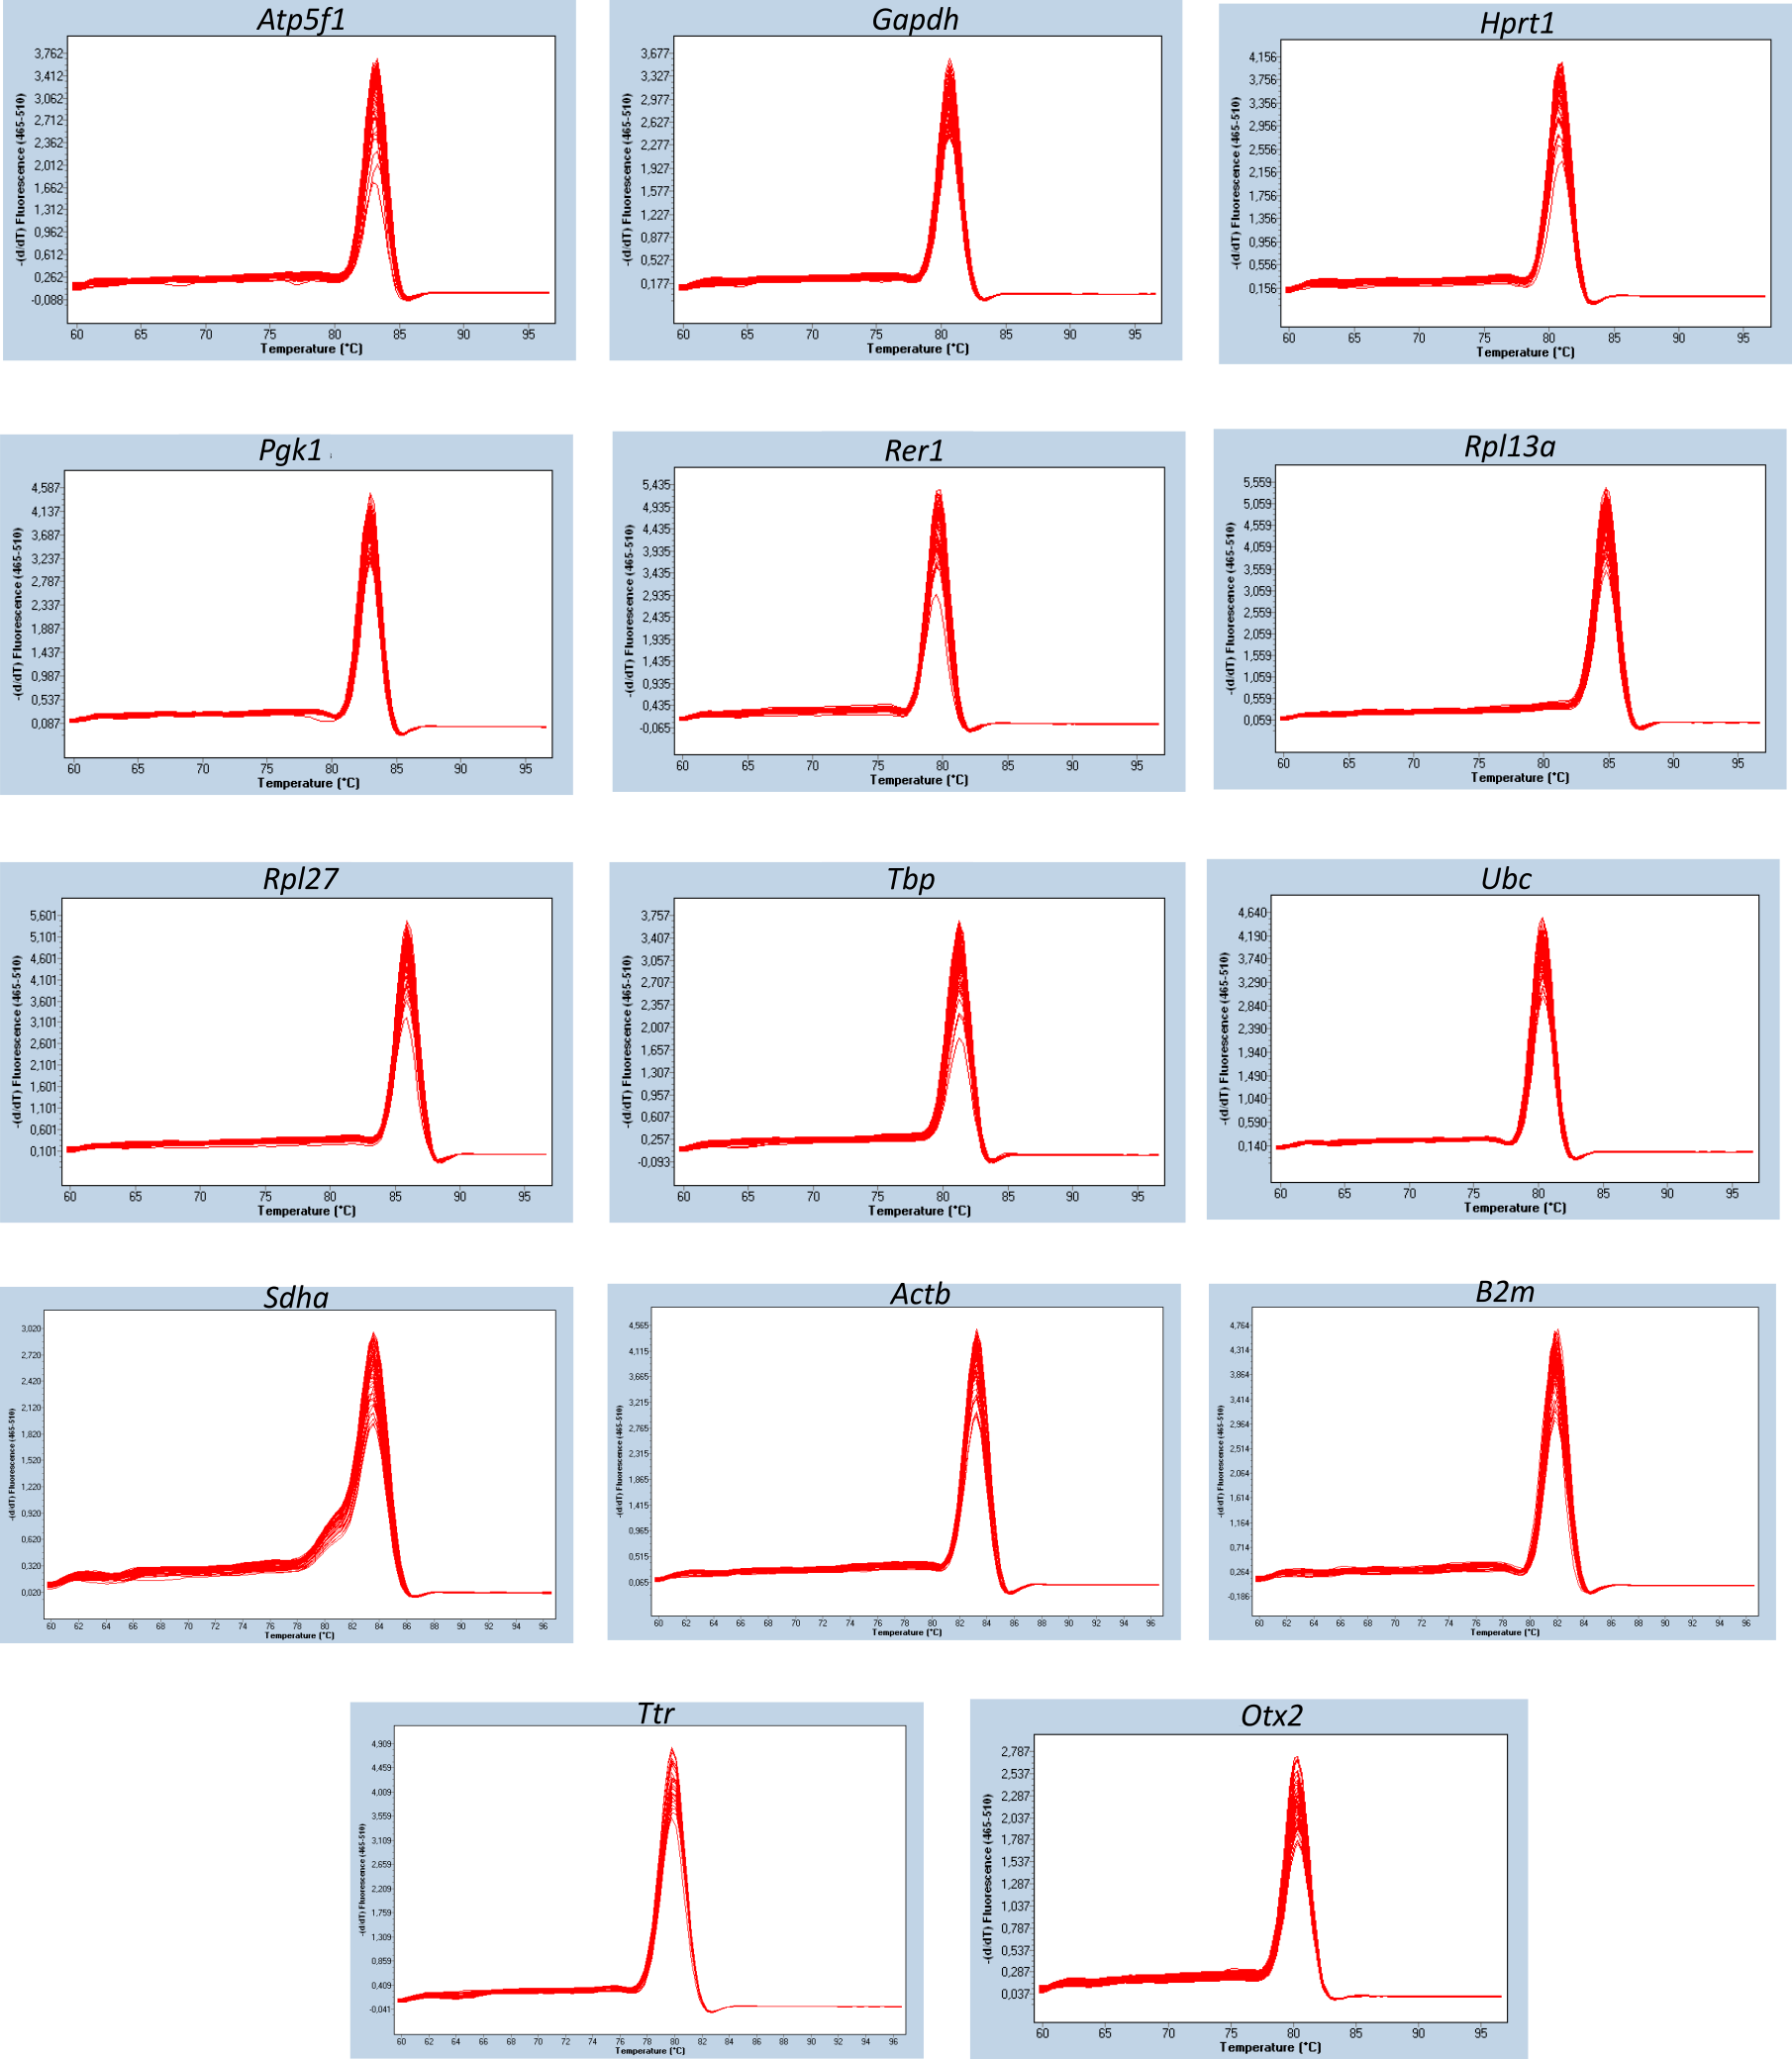
Figure S1.

qPCR melting curve analysis. The primers specificity for 12 candidate reference genes and 2 target genes was determined by melting-curve analysis. Data generated by Roche LightCycler® 480.

Figure S2.
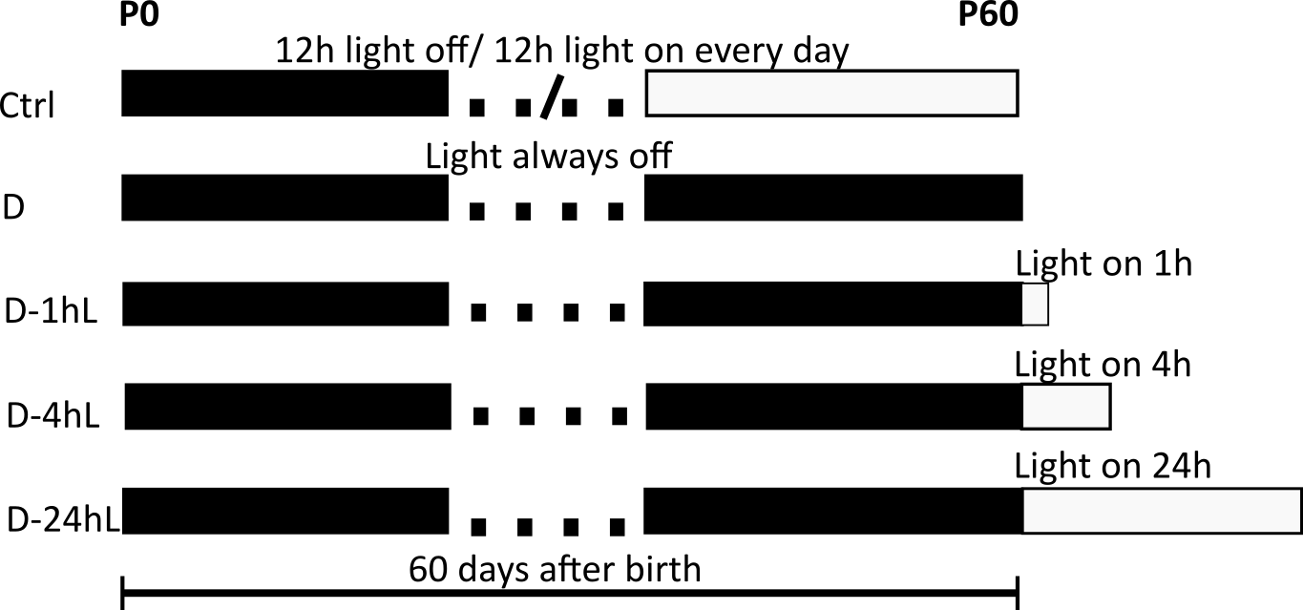

Experimental paradigm for the Light/Dark rearing panel. Control mice (Ctrl) were reared in normal condition of 12 hours light/dark cycles. Dark reared mice (D) were reared in the dark from birth until P60. D-1hL mice were re-exposed to light for 1 hour before being sacrificed; D-4hL and D-24hL were D mice exposed to light for 4 hour and 24 hour respectively.

Figure S3.
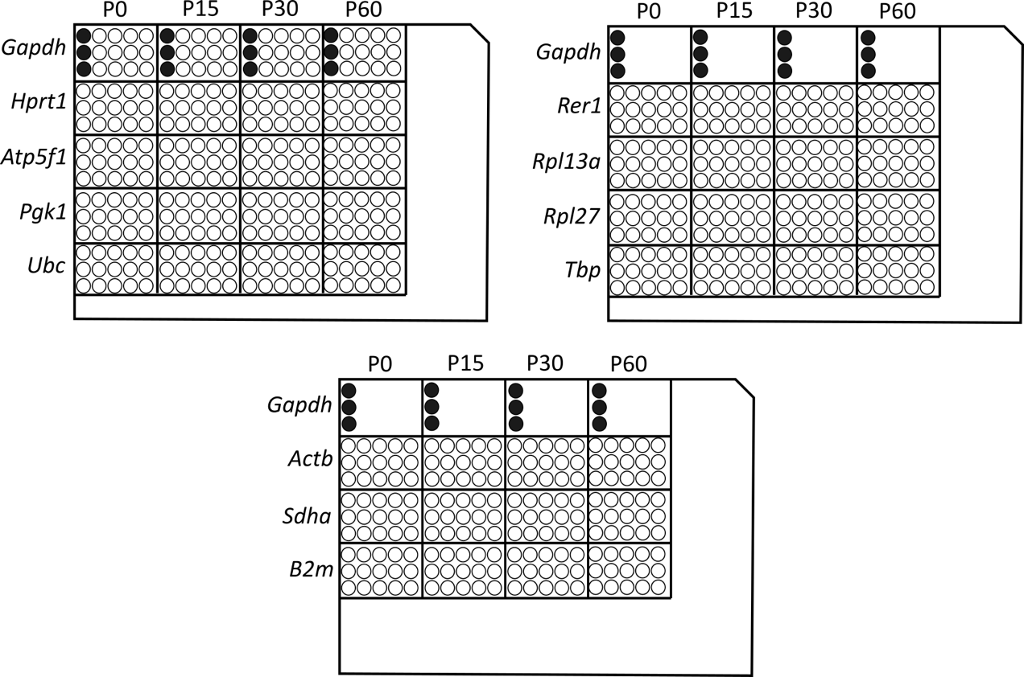

Experimental setup following sample maximization approach. An example of simplified layout for Developmental panel. One sample from each age group was used with Gapdh primers (black dots) to provide inter-run calibrators (IRC) for downstream correction.

Figure S4.
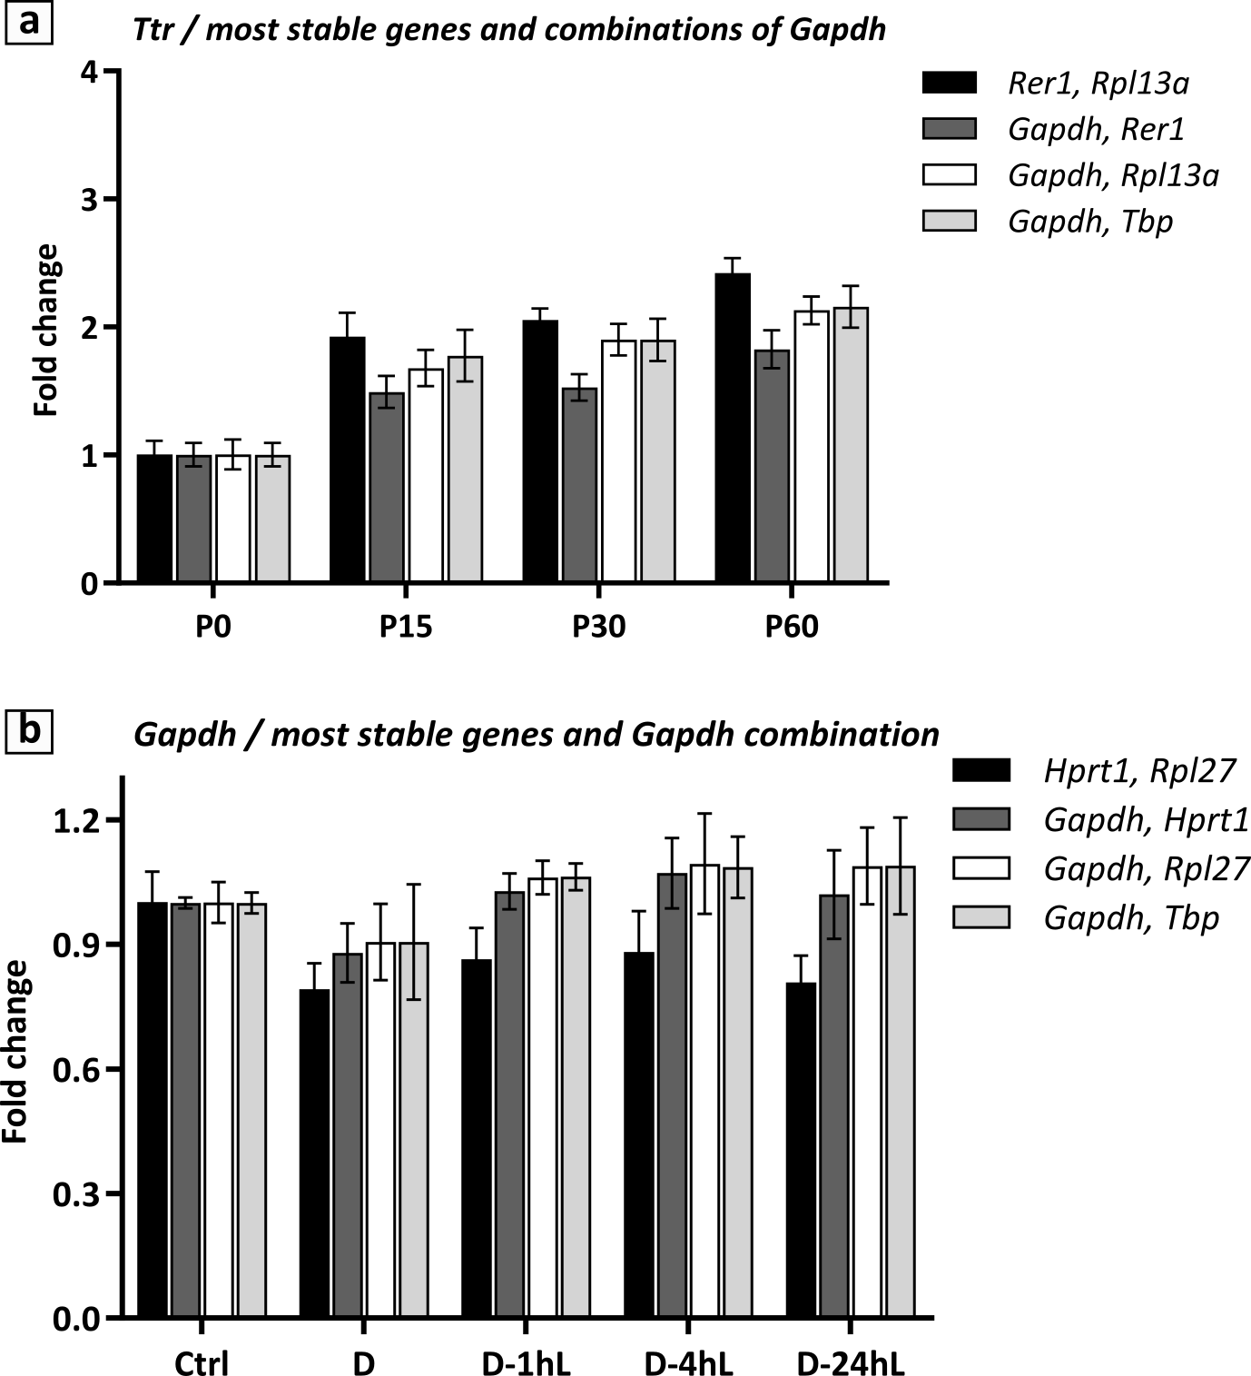
The effect of combining 1 more stable gene to Gapdh as normalisation factor (a) Ttr relative expression in the Developmental panel normalized to Rer1, Rpl13a versus different combination of Gapdh with more stable genes, as Rer1, Rpl13a, Tbp. (b) Otx2 relative expression in the Light/Dark rearing panel normalized to Hprt1, Rpl27 versus different combination of Gapdh with more stable genes, as Hprt1, Rpl27, Tbp. Data is presented as Mean ± SD.

