SUPPLEMENTARY MATERIAL FILE

Title
Particle size and cholesterol content of circulating HDL correlate with cardiovascular death in chronic heart failure
Author’s names and institutions
Teis A; Cediel G; Amigó N; Julve J; Aranyó J; Andrés J; Puig-Jové C; Castelblanco E; Gual-Capllonch F; Ferrer-Sistach E; Vallejo N; Juncà G; López-Ayerbe J; De Antonio M; Domingo M; Santiago-Vacas E; Codina P; Mauricio D; Lupón J; Alonso N; Bayes-Genis A
SUPPLEMENTARY MATERIAL
Supp. Figure 1.- Distribution of HDL-C/P ratio and HDL-Sz in the overall cohort
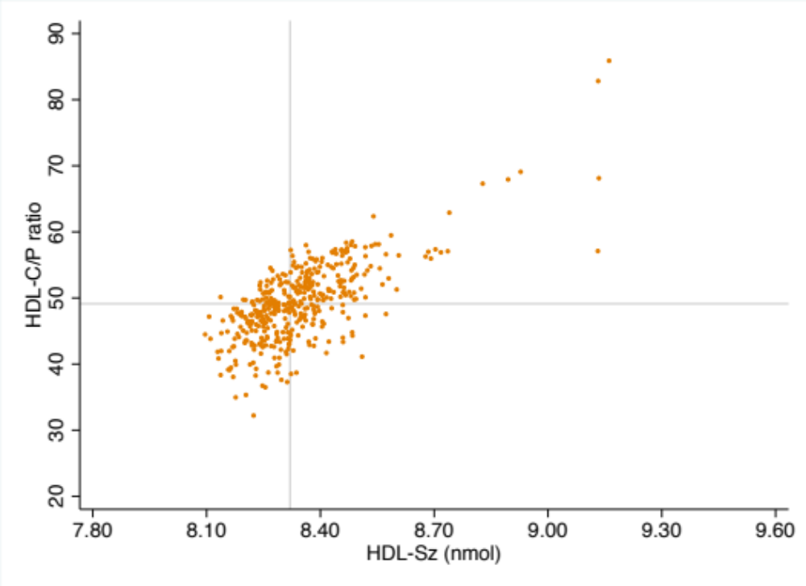

Figure S1 legend: HDL-C/P ratio: Content of Cholesterol per HDL particle. HDL-Sz: Mean normalized HDL particle size. Nm: nanometers

Supp. Table S1.- Univariable and multivariable Cox Regression Analysis of the associations between HDL-Sz and HDL-C/P ratio with cardiovascular death according to NYHA functional classification.
 | HDL-Sz |  | HDL-C/P ratio
 | HR (95% CI) | P value | HR (95% CI) | P value
NYHA functional class I-II
Unadjusted | 1.28 (1.05-1.56) | 0.016 | 1.05 (1.01-1.08) | 0.005
Model 1 | 1.21 (0.97-1.51) | 0.087 | 1.03 (0.99-1.01) | 0.119
Model 2 | 1.15 (0.93-1.43) | 0.199 | 1.03 (0.97-1.09) | 0.280
NYHA functional class III-IV
Unadjusted | 1.34 (1.05-1.70) | 0.020 | 1.07 (1.01-1.13) | 0.028
Model 1 | 1.38 (1.07 – 1.78) | 0.012 | 1.06 (1.00-1.13) | 0.044
Model 2 | 1.38 (1.07-1.78) | 0.012 | 1.09 (1.02-1.15) | 0.006

Hazard ratios for HDL-Sz reflect 1 SD change in a given measure.
Model 1 Adjusted for age, sex, BMI, diabetes, arterial hypertension, vasculopathy, ischemic etiology, eGFR, Hemoglobin, NT-ProBNP, LDL-P and treatment with ACEi/ARB, Betablockers, statins and ICD.
Model 2 Adjusted for Model 1 plus glycoprotein (Gly)-A, Gly-B and Gly-F.

