Predictors of brain infarction in adult patients on extracorporeal membrane oxygenation: an observational cohort study
Riccardo Iacobelli* ¹, Alexander Fletcher-Sandersjöö ^{2,3}, Caroline Lindblad ³, Boris Keselman ^{3,4}, Eric P Thelin ^{3,4}, Lars Mikael Broman ^{1,5}

¹ ECMO Centre Karolinska, Department of Pediatric Perioperative Medicine and Intensive Care, Karolinska University Hospital, Stockholm, Sweden
² Department of Neurosurgery, Karolinska University Hospital, Stockholm, Sweden
³ Department of Clinical Neuroscience, Karolinska Institutet, Stockholm, Sweden
⁴ Department of Neurovascular diseases, Karolinska University Hospital, Stockholm, Sweden
⁵ Department of Physiology and Pharmacology, Karolinska Institutet, Stockholm, Sweden.
Supplementary tables: 1-4
Supplementary figure: 1

Corresponding author:
Riccardo Iacobelli
+46 734041109
email: riccardo.iacobelli@stud.ki.se / riccardo.iacobelli@gmail.com
ORCID: 0000-0001-7536-3795
ECMO Centre Karolinska, Karolinska University Hospital, 171 76, Stockholm, Sweden
Supplementary table 1. Univariate regression analysis predicting brain infarction during Extracorporeal membrane oxygenation. Patients who did not undergo a CT scan during treatment have been excluded.
Variable | BI (n=41) | No BI (n=144) | p-value
Pre-cannulation data
Age, years | 49 (38 – 58) | 55 (36 – 62) | 0.435
Male sex | 26 (62%) | 94 (65%) | 0.612
Weight (kg) | 82 (± 23), (2 missing, 5%) | 81 (± 18), (6 missing, 4%) | 0.763
Smoker | 6 (14%) | 28 (19%) | 0.531
CCI | 2 (0 – 3) | 2 (1 – 3) | 0.527
SAPS-3 | 84 (± 14), (8 missing, 19%) | 80 (± 14), (28 missing, 19%) | 0.329
GCS | 13 (4 – 15), (8 missing, 19%) | 13 (9 – 15), (29 missing, 20%) | 0.352
SOFA total | 14 (10 – 16), (11 missing, 26%) | 14 (11 – 16), (36 missing, 25%) | 0.570
SOFA coagulation | 0 (0 – 2), (9 missing, 21%) | 1 (0 – 2), (31 missing, 22%) | 0.445
Cardiac arrest | 14 (33%) | 26 (18%) | 0.062
pH | 7.22 (7.09 – 7.33), (3 missing, 7%) | 7.23 (7.14 – 7.32), (6 missing, 4%) | 0.878
PaCO2 (kPa) | 6.92 (5.34 – 8.99), (1 missing, 2%) | 7.18 (5.9 – 9.18), (7 missing, 5%) | 0.594
PaO2 (kPa) | 7.45 (6.30 – 8.45), (3 missing, 7%) | 7.55 (6.5 – 9.75), (6 missing, 4%) | 0.964
p-lactate | 4.00 (1.85 – 7.5), (5 missing, 12%) | 3.4 (1.8 – 7.5), (13 missing, 9%) | 0.456
ECMO data
VA ECMO | 35 (83%) | 77 (53%) | 0.027
Atrial fibrillation/flutter | 12 (29%) | 44 (31%) | 0.874
Extracranial thrombosis | 3 (7%) | 17 (12%) | 0.419
Extracranial bleeding | 25 (60%) | 88 (61%) | 0.766
ECMO circuit change | 12 (29%) | 49 (34%) | 0.568
Conversion of modality | 12 (29%) | 28 (19%) | 0.309
Normally distributed continuous data are presented as mean (±1SD), non-parametric continuous data as median (interquartile range) and categorical data as count (proportion).
Bold text in the p value column indicates a statistically significant correlation (p < 0.05)
Abbreviations: ABG= Arterial Blood Gas; BI = Brain Infarction; CCI = Charlson comorbidity index; ECMO = extracorporeal membrane oxygenation; GCS = Glasgow Coma Scale; SAPS-3 = Simplified Acute Physiology Score III; SOFA = Sequential Organ Failure Assessment; VA = venoarterial

Supplementary table 2: Multivariable regression analysis predicting brain infarction diagnosis during Extracorporeal membrane oxygenation (ECMO). Final results from the step-down multivariable logistic regression analysis that included VA ECMO and pre-cannulation cardiac arrest. Patients who did not undergo a CT scan during ECMO treatment have been excluded.
Variable | Univariate p-value | ﻿Nagelkerke's R² | Multivariable p-value | OR (95% CI)
VA ECMO | 0.027 | 0.043 | 0.027 | 2.37 (1.105 – 5.097)
Bold text in the p value column indicates a statistically significant correlation (p < 0.05)
Abbreviations: VA = venoarterial

Supplementary table 3. Univariate regression analysis predicting brain infarction during venovenous (VV) Extracorporeal membrane oxygenation.
Variable | BI (n=7) | No BI (n=101) | p-value
Pre-cannulation data
Age (years) | 55 (45 – 60) | 51 (35 – 62) | 0.680
Male sex | 4 (57%) | 67 (66%) | 0.677
Weight (kg) | 87 (± 39), (1 missing, 14%) | 80 (± 18), (2 missing, 2%) | 0.461
Smoker | 1 (14%) | 20 (20%) | 0.669
CCI | 2 (1.5 – 3) | 2 (0.5 – 3) | 0.445
SAPS-3 | 75 (± 8.7), (2 missing, 29%) | 74 (± 12), (18 missing, 18%) | 0.822
GCS | 13 (12 – 15), (2 missing, 29%) | 13 (12 – 15), (19 missing, 16%) | 0.792
SOFA total | 9 (8 – 13), (2 missing, 29%) | 11 (9 – 14), (23 missing, 23%) | 0.499
SOFA coagulation | 0 (0 – 0), (2 missing, 29%) | 0 (0 – 2), (18 missing, 18%) | 0.355
Cardiac arrest | 1 (14%) | 5 (5%) | 0.322
pH | 7.25 (7.09 – 7.305), (1 missing, 14%) | 7.28 (7.19 – 7.35), (6 missing, 6%) | 0.090
PaCO2 (kPa) | 9.17 (7.83 – 11.65), (0 missing, 0%) | 7.16 (6.32 – 9), (6 missing, 6%) | 0.074
PaO2 (kPa) | 7.64 (7.15 – 8.9), (0 missing, 0%) | 7.5 (6.46 – 8.65), (6 missing, 6%) | 0.145
p-lactate | 4.3 (2.08 – 7.5), (1 missing, 14%) | 1.9 (1.25 – 2.9), (10 missing, 10%) | 0.012
ECMO data
Atrial fibrillation/flutter | 1 (14%) | 21 (21%) | 0.682
Extracranial thrombosis | 1 (14%) | 5 (5%) | 0.322
Extracranial bleeding | 2 (29%) | 45 (45%) | 0.417
ECMO circuit change | 1 (14%) | 16 (16%) | 0.913
Normally distributed continuous data are presented as mean (±1SD), non-parametric continuous data as median (interquartile range) and categorical data as count (proportion).
Bold text in the p value column indicates a statistically significant correlation (p < 0.05).
Abbreviations: ABG = Arterial Blood Gas; BI = Brain Infarction; CCI = Charlson comorbidity index; ECMO = extracorporeal membrane oxygenation; GCS = Glasgow Coma Scale; SAPS-3 = Simplified Acute Physiology Score III; SOFA = Sequential Organ Failure Assessment

Supplementary table 4. Multivariable regression analysis predicting brain infarction during Extracorporeal membrane oxygenation (ECMO). Final results from the step-down multivariable logistic regression analysis that included pre-cannulation serum pH, PaCO₂ and lactate.
Variable | Univariate p-value | ﻿Nagelkerke's R² | Multivariable p-value | OR (95% CI)
Pre-cannulation serum lactate | 0.012 | 0.116 | 0.038 | 1.451 (1.02 – 2.065)

Bold text in the p value column indicates a statistically significant correlation (p < 0.05)

Supplementary table 5. Patient characteristics sorted by ECMO modality.
Variable | VA ECMO (n=167) | VV ECMO (n=108)
Age, years | 49 (35 – 62) | 48 (35 – 62)
Male sex | 100 (60%) | 71 (66%)
Weight (kg) | 83.6 (± 19) | 80.7 (± 19.8),
Smoking | 27 (16%) | 21 (19%)
CCI | 1.9 (± 1.8) | 1.9 (± 1.6)
SAPS-3 | 81.4 (± 14.3) | 74 (± 11.4)
GCS | 10.7 (± 4.8) | 12.4 (± 3.6)
SOFA total | 14.2 (± 3.6) | 11.4 (± 3.4)
SOFA coagulation | 1.4 (± 1.3) | 0.9 (± 1.1)
Pre-ECMO cardiac arrest | 47 (28%) | 6 (5.6%)
ABG analysis
pH | 7.18 (± 0.17) | 7.27 (± 0.12)
PaCO2 (kPa) | 8.4 (± 3.2) | 8 (± 2.5)
PaO2 (kPa) | 9 (± 8) | 8.5 (± 7)
p-lactate | 6 (± 5) | 2.55 (± 1.9)
Atrial fibrillation/flutter | 45 (27%) | 22 (20%)
Extracranial thrombosis | 18 (11%) | 6 (5.6%)
Extracranial bleeding | 101 (60%) | 47 (44%)
ECMO circuit change | 54 (32%) | 17 (16%)
Brain infarction | 34 (20.3%) | 7 (6.5%)
Normally distributed continuous data are presented as mean (±1SD), non-parametric continuous data as median (interquartile range) and categorical data as count (proportion).
Abbreviations: ABG = Arterial Blood Gas; BI = Brain Infarction; CCI = Charlson comorbidity index; ECMO = extracorporeal membrane oxygenation; GCS = Glasgow Coma Scale; SAPS-3 = Simplified Acute Physiology Score III; SOFA = Sequential Organ Failure Assessment

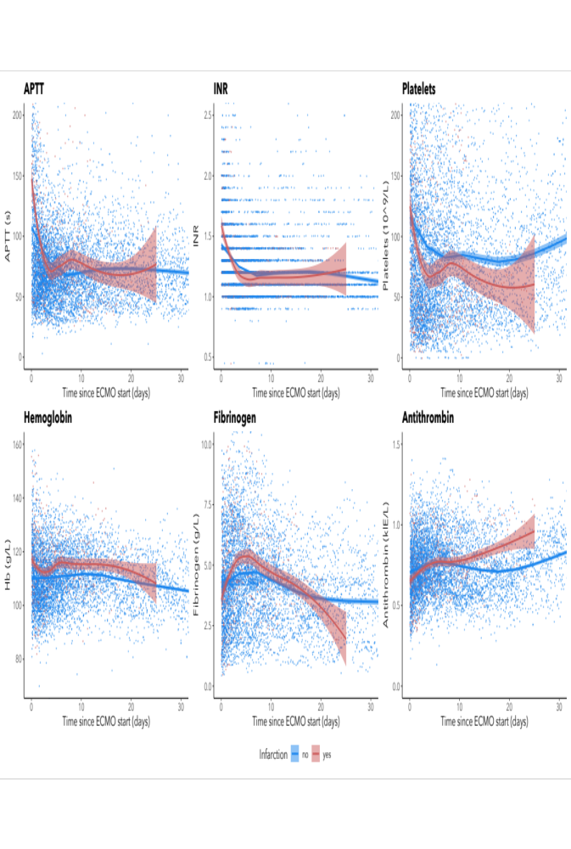
Supplementary figure 1. Scatterplots of activated partial thromboplastin time (APTT), international normalized ratio (INR), platelets, hemoglobin, fibrinogen and antithrombin depicted longitudinally and subdivided according to brain infarction status. Samples were collected during the first month of treatment or until BI detection. The red line represents patients that suffered brain infarction on ECMO, the blue line represents patients with no signs of infarction. The smoothened line indicates a LOWESS curve and the shaded area surrounding it indicates 95% confidence intervals.

