Supplementary Information

Effects of silicon doping on low-friction and high-hardness diamond-like carbon coating via filtered cathodic vacuum arc deposition

Jae-Il Kimª, Young-Jun Jangª, Jisoo Kim^{b,c,*}, Jongkuk Kim^{a,*}

ªDepartment of Extreme Environmental Coatings, Surface Technology Division, Korea Institute of Materials Science (KIMS), 797 Changwondae-ro, Seongsan-gu, Changwon-si, Gyeongnam-do, 51508, Republic of Korea
^{b}Department of Precision Mechanical Engineering, Kyungpook National University, 2559 Gyeongsang-daero, Sangju, Gyeongsangbuk-do, 37224, Republic of Korea.
^{c}Department of Advanced Science and Technology Convergence, Kyungpook National University, 2559 Gyeongsang-daero, Sangju, Gyeongsangbuk-do, 37224, Republic of Korea.

†Corresponding Authors:
Dr. Jisoo Kim
Department of Precision Mechanical Engineering & Department of Advanced Science and Technology Convergence, Kyungpook National University, 2559 Gyeongsang-daero, Sangju, Gyeongsangbuk-do, 37224, Republic of Korea.
Tel: +82-54-530-1279; Fax: +82-54-530-1278
E-mail: js.kim@knu.ac.kr
ORCID: 0000-0001-9540-2800

Dr. Jongkuk Kim
Department of Extreme Environmental Coatings, Surface Technology Division, Korea Institute of Materials Science, 797, Changwon-daero, Seongsan-gu, Changwon-si, Gyeongsangnam-do 51508, Republic of Korea.
Tel: +82-55-294-9500; Fax: +82-55-280-3333
E-mail: kjongk@kims.re.kr

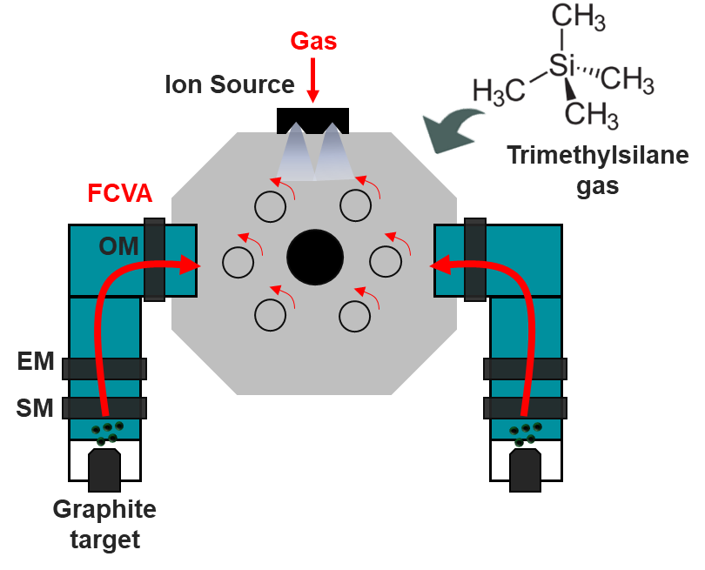
Figure S1. Schematic diagram of the experimental set up for the hybrid deposition based on filtered cathodic vacuum arc (FCVA)

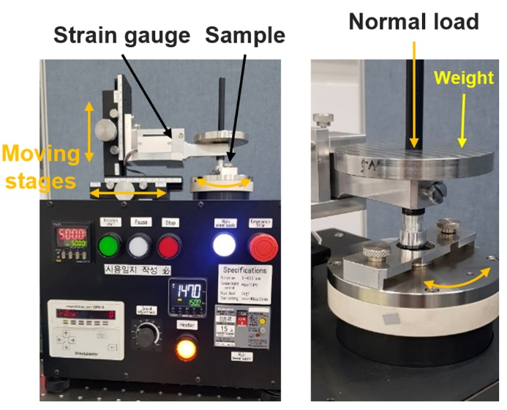
Figure S2. Experimental set up for the ball-on-disk tribotests

Figure S3. (a) O-1s and (b) Si-2p XPS spectra of Si-doped DLC coatings produced with the TMS flow rate of 7 sccm, and the (c) corresponding fraction of carbon, oxygen, and silicon before and after the ball-on-disk tribotest

Table S1. Detailed experimental conditions for the deposition of the pure tetrahedral amorphous carbon (ta-C) and Si-doped diamond-like carbon coating (Si-DLC)
Coating layer | TMS flow rate  [sccm] | Deposition rate  [nm/min] | Coating time  [min] | Working pressure  [Pa] | Thickness  [μm]
DLC layer  (bias : -150 V) | 0.0 | 3.70 | 270 | 1.07 × 10⁻² | ~1
DLC layer  (bias : -150 V) | 3.0 | 6.72 | 150 | 1.87 × 10⁻² | ~1
DLC layer  (bias : -150 V) | 4.6 | 8.33 | 120 | 2.93 × 10⁻² | ~1
DLC layer  (bias : -150 V) | 5.4 | 9.14 | 110 | 3.73 × 10⁻² | ~1
DLC layer  (bias : -150 V) | 7.0 | 10.76 | 95 | 6.80 × 10⁻² | ~1
DLC layer  (bias : -150 V) | 12.0 | 15.83 | 60 | 2.00 × 10⁻¹ | ~1
Etching  (bias: -75V) | Ar gas  40 | 1.05 | 60 | - | -

Table S2. Chemical composition (%) of the SUJ2 steel ball
Fe | C | Si | Mn | P | S | Cr | Mo
Bal. | 0.95–1.10 | 0.15–0.35 | ≤0.50 | ≤0.025 | ≤0.025 | 1.30 | ≤0.080

