Supplementary Information

Hunting territories and land use overlap in sedentarised Baka Pygmy communities in southeastern Cameroon

Julia E. Fa, Guillermo Ros Brull, Eva Ávila Martin, Robert Okale, François Fouda, Miguel Ángel Fárfan, Bradley Cain, Rohan Fisher, Lauren Coad and Stephan M. Funk

3 Tables and 3 Figures

Table S1. Population censuses carried in the ten study Baka villages, southeastern Cameroon.
 |  | Houses |  |  | Inhabitants per Household
Village | Location | Total | Occupied |  | Mean | SD | Min | Max | Total
Abing-Nkolemboula | N 02°42'20''/E013°19'43'' | 14 | 12 |  | 4.92 | 3.75 | 1 | 13 | 59
Adjap-Mintom | N 02°40'16"/E 013°15'13" | 20 | 15 |  | 3.6 | 2.32 | 1 | 8 | 54
Akom | N 02°37'28''/E 013°19'11'' | 37 | 24 |  | 4.63 | 3.16 | 1 | 17 | 93
Akonetyé | N 02°42'03''/E 013°00'08'' | 32 | 23 |  | 5.05 | 2.5 | 1 | 11 | 111
Assok | N 02°39'21''/E 013°17'12'' | 36 | 23 |  | 3.3 | 2.87 | 1 | 12 | 106
Belle-Ville | N 02°35'23''/E 013°21'48'' | 11 | 10 |  | 4.1 | 2.18 | 1 | 8 | 76
Bemba II | N 02°44'44,5''/ E 013°21'13'' | 20 | 14 |  | 4.43 | 2.38 | 1 | 8 | 41
Doum | N 02°40'16"/ E 013°15'13" | 30 | 24 |  | 4.54 | 2.41 | 1 | 13 | 62
Meyos-Mintom | N 02°43'30''/E 013°20'50'' | 7 | 5 |  | 5 | 3.32 | 2 | 9 | 109
Odoumou | E 02°39'32''/E 013°39'20'' | 30 | 22 |  | 4.23 | 2.93 | 1 | 11 | 25
Grand Total |  | 237 | 172 |  | 4.33 | 2.77 | 1 | 17 | 736

Table S2. Details of participatory workshops undertaken in the 10 Baka villages to map hunting territories.

Village | Date | Start time | End time | Duration (h) | Children | Women | Men | Non-Baka | Total participants
Adjap-Mintom | 20/21 Sept. 2018 | 07:30 | 12:50 | 5.33 | 6 | 11 | 13 | 2 |  | 32
Abing- Nkolemboula | 18/19 Dec. 2017 | 08:10 | 12:45 | 4.58 | 23 | 15 | 6 | 0 |  | 44
Akom | 14/15 Dec. 2017 | 08:10 | 13:30 | 5.33 | 16 | 22 | 41 | 8 |  | 87
Akonetyé | 24/25 Sept. 2018 | 08:20 | 14:15 | 5.92 | 13 | 11 | 17 | 5 |  | 46
Assok | 14/15 Dec. 2017 | 08:10 | 13:30 | 5.33 | 6 | 11 | 9 | 2 |  | 28
Belle Ville | 06/07 Dec. 2017 | 07:30 | 12:50 | 5.33 | 15 | 13 | 9 | 4 |  | 41
Bemba II | 21/22 Dec. 2017 | 08:10 | 13:30 | 5.33 | 23 | 17 | 16 | 4 |  | 60
Doum | 11/12 Dec. 2017 | 08:10 | 14:15 | 6.08 | 19 | 21 | 14 | 5 |  | 59
Meyos-Mintom | 14/15 Oct. 2018 | 08:10 | 13:30 | 5.33 | 5 | 6 | 8 | 10 |  | 29
Odoumou | 31 Oct./20 Dec. 2018 | 08:10 | 12:45 | 4.58 | 13 | 8 | 17 | 6 |  | 44

Table S3. Percentage overlap of hunting territories obtained from participatory mapping workshops in the ten study Baka villages, southeastern Cameroon. The reference villages are listed in the column; for example, 71% of Adjap-Mintom´s territory is also claimed by Akonetyé but only 55% of Akonetyé’s territory is claimed by Adjap-Mintom.

 | Adjap-Mintom | Akonetyé | Akom | Assok | Bemba II | Bell-Ville | Doum | Meyos-Mintom | Abing-Nkolemboula | Odoumou
Adjap-Mintom |  | 71 | 7.5 | 3 | 0 | 0 | 21 | 0 | 0 | 0
Akonetyé | 55 |  | 2 | 0 | 0 | 0 | 2 | 0 | 0 | 0
Akom | 8 | 3 |  | 81 | 0 | 2 | 79 | 0 | 0 | 38
Assok | 0 | 0 | 41 |  | 0 | 16 | 28 | 0 | 0 | 21
Bemba II | 0 | 0 | 0 | 0 |  | 0 | 0 | 46 | 10 | 0
Bell-Ville | 0 | 0 | 25 | 17 | 0 |  | 0 | 17 | 31 | 5
Doum | 14 | 2 | 48 | 47 | 0 | 0 |  | 0 | 0 | 27
Meyos-Mintom | 0 | 0 | 63 | 0 | 0 | 100 | 0 |  | 91 | 0
Abing-Nkolemboula | 0 | 0 | 24 | 0 | 6 | 0 | 0 | 56 |  | 0
Odoumou | 0 | 0 | 63 | 72 | 0 | 17 | 56 | 0 | 0

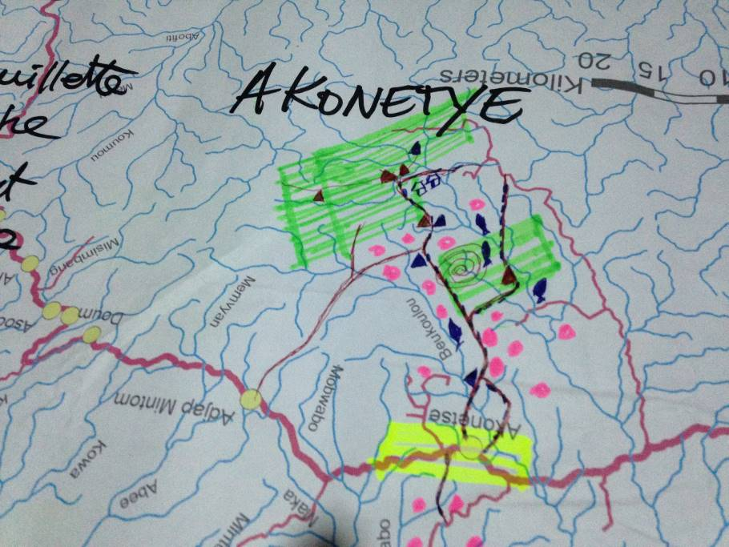

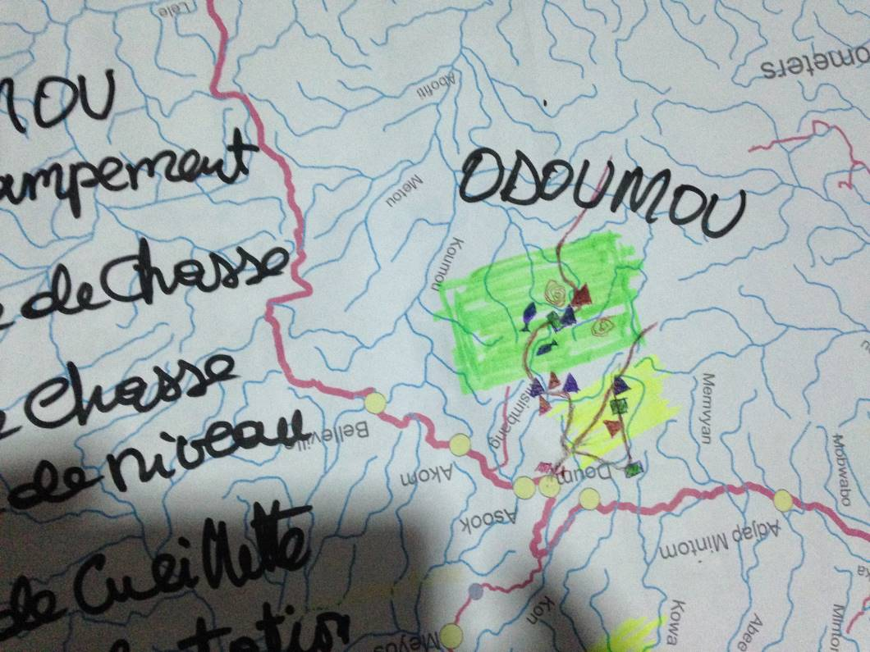

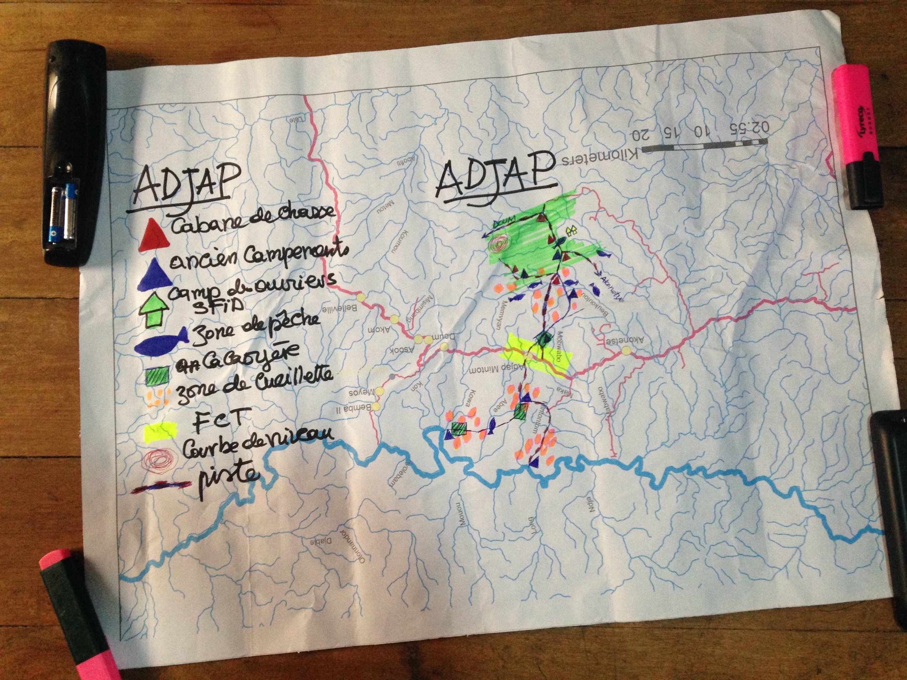

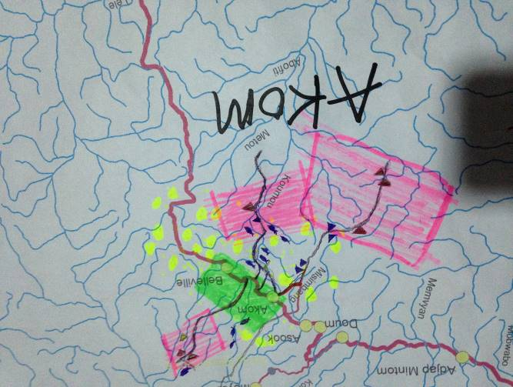

Figure S1: Examples of participatory maps resulting from workshops.

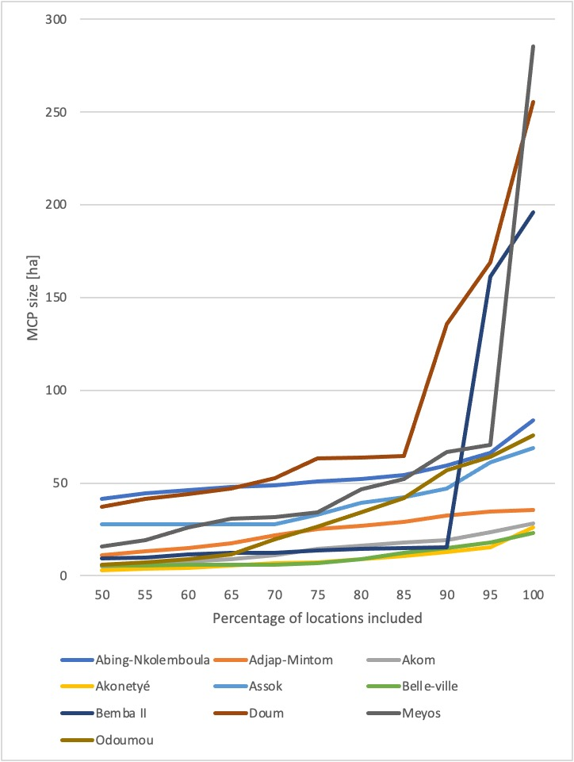

Figure S2: MCP size in relation to the proportion of localization data included in the MCP calculation.

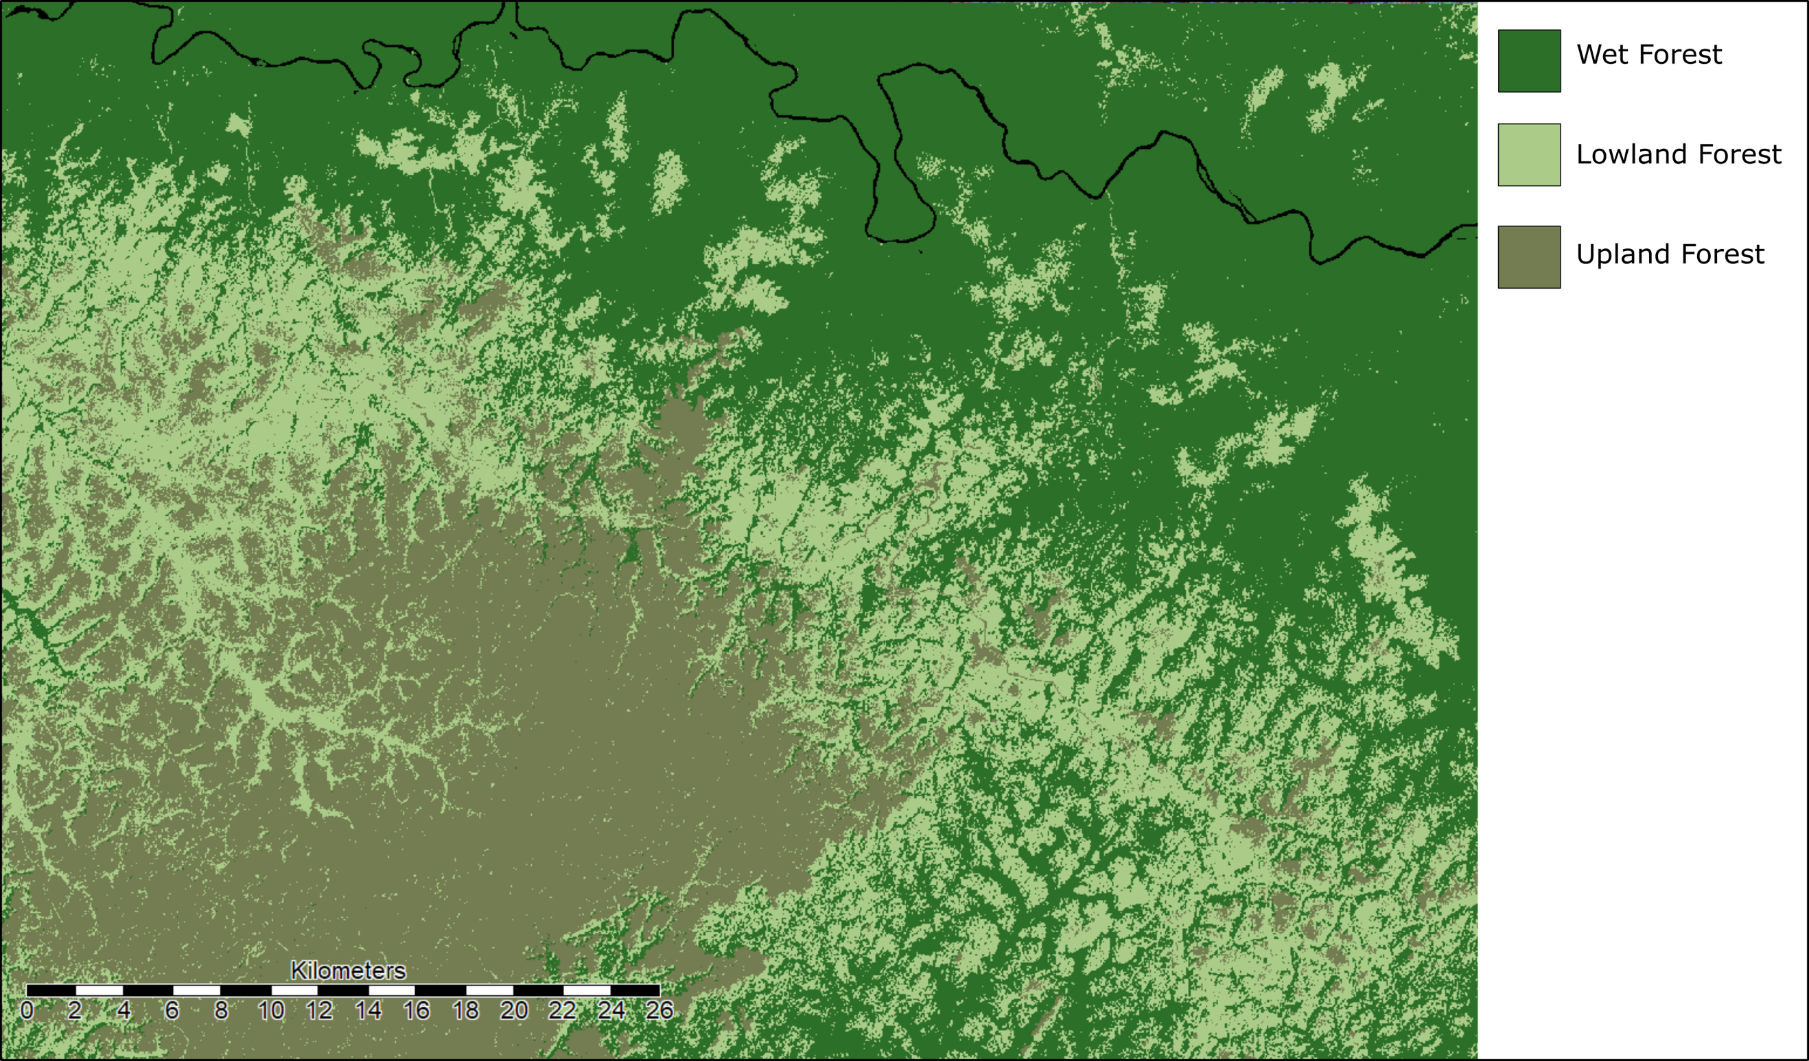

Figure S3: Forest classification map of the study area to attribute hunting areas with a habitat type. Three broad classes were used to identify primary forest cover types; wet (swamp) forest, lowland forest and upland forest. We classified forest cover using elevation data and satellite imagery as the base input data; elevation data was obtained from the global Shuttle Radar Topographic Mission (SRTM) available globally as spatially explicit raster data at 30 m resolution, accessed and downloaded via the Remote Pixel satellite data web portal¹. European Space Agency Sentinel-2 satellite imagery was downloaded at a 20 m resolution from the Sentinel-hub web resource². An unsupervised classification was then conducted with SAGA-GIS geoscientific analyses software³.
References

- Remote Pixel. Remote Pixel - Satellite Imagery Search. https://remotepixel.ca/ (2018).
- European Space Agency. Sentinel online. https://sentinel.esa.int/web/sentinel/missions/sentinel-2 (2020).
- System for Automated Geoscientific Analyses (SAGA). SAGA - System for Automated Geoscientific Analyses. http://www.saga-gis.org/en/index.html (2020).

