Supplementary Data
for
Identification of ebselen and its analogues as potent covalent inhibitors of papain-like protease from SARS-CoV-2

Ewelina Węglarz-Tomczak¹, Jakub M. Tomczak², Michał Talma³, Małgorzata Burda-Grabowska^{3,4}, Mirosław Giurg⁴, Stanley Brul¹

¹Swammerdam Institute for Life Sciences, Faculty of Science, University of Amsterdam, the Netherlands
²Department of Computer Science, Vrije Universiteit Amsterdam, the Netherlands
³Department of Bioorganic Chemistry, Faculty of Chemistry, Wroclaw University of Science and Technology, Poland
⁴Department of Organic and Medicinal Chemistry, Faculty of Chemistry, Wroclaw University of Science and Technology, Wrocław, Poland

Corresponding authors:
ewelina.weglarz.tomczak@gmail.com and s.brul@uva.nl

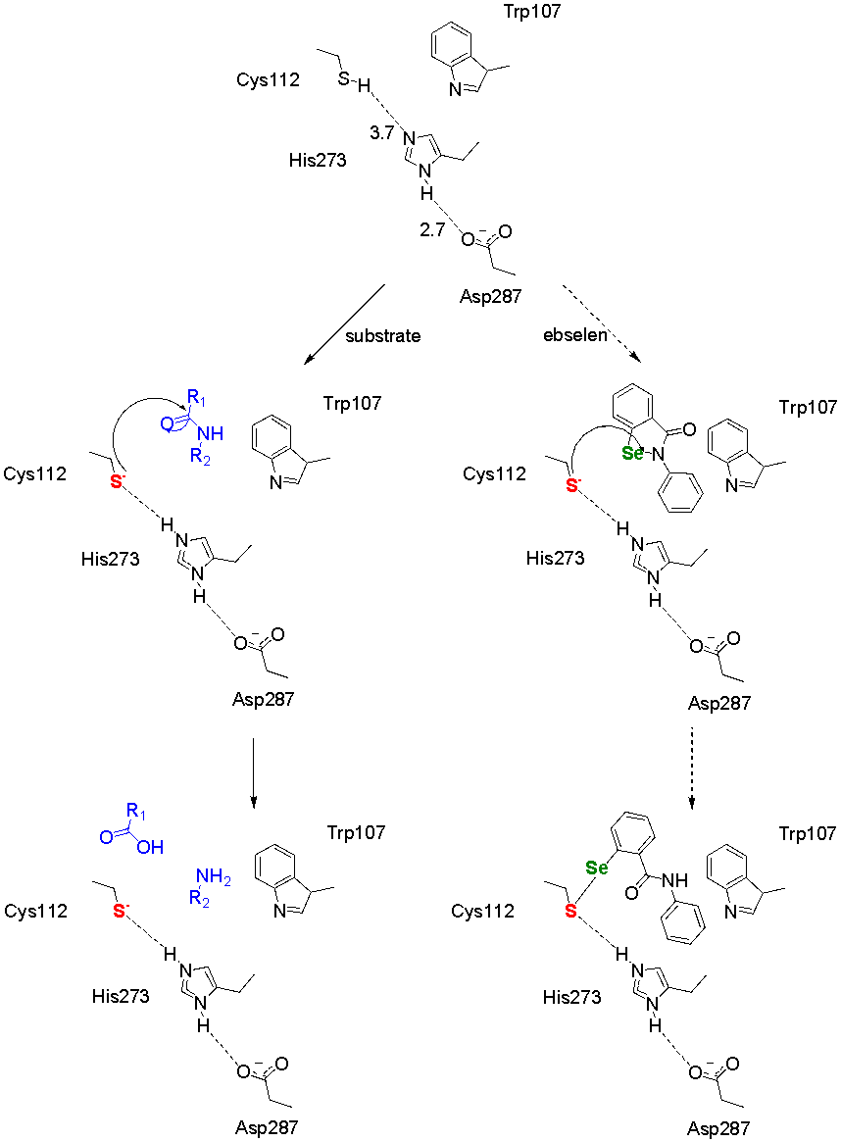
Fig. 1. Analysis of the active site, mechanism of the catalysis (left) and possible inhibition by ebselen (right) of coronaviruses PL^{pro} based on the active site of PL^{pro}SARS [1].

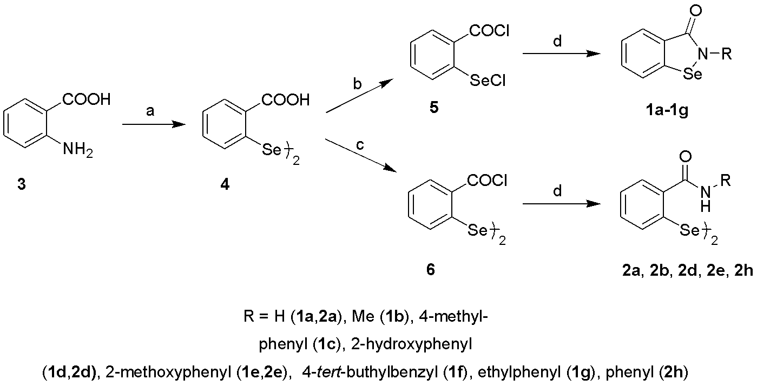
Fig. 2. Synthesis of the benzisoselenazol-3(2H)-ones 1a–1g and bis(2-carbamoyl)phenyl diselenides 2a, 2b, 2d, 2e, 2h. Reagents and conditions: a) i) HCl, H₂O ii) NaNO₂ -7–7°C, iii) Na₂Se₂,-5–+5°C, next rt 20h, iv) HCl; gentle reflux, and rt for 20h; b) 7 eqv. SOCl₂, DMF, benzene, reflux, 3.5h; c) 3.5eqv SOCl₂, DMF, benzene, reflux; d) RNH₂, Et₃N, MeCN, or RNH₂, MeCN [2].

Synthesis
The compounds considered in this paper were fully characterized in the previous studies [2-8]. Their purity and homogeneity were confirmed by HRMS and ⁷⁷Se NMR.

1,2-Benzisoselenazol-3(2H)-one (1a)
⁷⁷Se NMR (115 MHz, DMSO-d₆): δ 808.35 ppm. HRMS (TOF MS ESI): m/z for C₇H₅NOSe+H⁺ calculated: 199.9615; found: 199.9606.
2-Methyl-1,2-benzisoselenazol-3(2H)-one (1b)
⁷⁷Se NMR (115 MHz, DMSO-d₆): δ 877.08 ppm. HRMS (TOF MS ESI): m/z for C₈H₇N₂OSe+H⁺ calculated: 213.9771; found: 213.9762.
2-(4-Methylphenyl)-1,2-benzisoselenazol-3(2H)-one (1c)
⁷⁷Se NMR (115 MHz, DMSO-d₆): δ 925.64 ppm. HRMS (TOF MS ESI): m/z for C14H11NOSe+Na+ calculated: 311.9904; found: 311.9906.
2-(2-Hydroxyphenyl)-1,2-benzisoselenazol-3(2H)-one (1d)
⁷⁷Se NMR (115 MHz, DMSO-d₆): δ 930.02 ppm. HRMS (TOF MS ESI): m/z for C₁₃H₉NO₂Se+H⁺ calculated: 291.9877; found: 291.9984.
2-(2-Methoxyphenyl)-1,2-benzisoselenazol-3(2H)-one (1e)
⁷⁷Se NMR (115 MHz, DMSO-d₆): δ 946.31 ppm. HRMS (TOF MS ESI): m/z for C₁₄H₁₁NO₂Se+H⁺ calculated: 306.0034; found: 306.0041.
2-(4-t-Butylbenzyl)-1,2-benzisoselenazol-3(2H)-one (1f)
⁷⁷Se NMR (115 MHz, DMSO-d₆): δ 867.86 ppm. HRMS (TOF MS ESI): m/z for C₁₈H₁₉NOSe+H⁺ calculated: 346.0711; found: 346.0701.
2-Phenylethyl-1,2-benzisoselenazol-3(2H)-one (1g)
⁷⁷Se NMR (115 MHz, DMSO-d₆): δ 875.57 ppm. HRMS (TOF MS ESI): m/z for C₁₅H₁₃NOSe+H⁺ calculated: 304.0241; found: 304.0337.
Bis[2-(2-hydroxyphenylcarbamoyl)phenyl] diselenide (2d)
⁷⁷Se NMR (115 MHz, DMSO-d₆): δ 458.63 ppm. HRMS (TOF MS ESI): m/z for C₂₆H₂₀N₂O₄Se₂+Na. calculated: 606.9657; found: 606.9700.
Bis[2-(2-methoxyphenylcarbamoyl)phenyl] diselenide (2e)
⁷⁷Se NMR (115 MHz, DMSO-d₆): δ 455.29 ppm. HRMS (TOF MS ESI): m/z for C₂₈H₂₄N₂O₄Se₂+Na⁺ calculated: 634.9970; found: 634.9996.
Bis(2-phenylcarbamoyl)phenyl diselenide (2h)
⁷⁷Se NMR (115MHz, DMSO-d6): δ 439.78ppm. HRMS (TOF MS ESI): m/z for C26H20N2O2Se2+Na+calculated: 574.9752; found: 574.9752.

Approximate Bayesian Computation for estimating kinetic constants
The full description of the Approximate Bayesian Computation (ABC) for estimating kinetic constants in the Michaelis-Menten model is available in the literature [9].
The goal of the method is to find values of kinetic constants k_{cat} and K_{M} that minimize the Euclidean distance between real measurements and signals generated by the Michaelis-Menten. The method consists of the following steps:
- Sample new values of parameters k_{cat} and K_{M}.
- Simulate data using the Michaelis-Menten model. This step requires applying a numerical method for solving ordinary differential equations (e.g., the Runge-Kutta methods).
- Calculating the distance between the real measurements and the generated data. If the distance is smaller than some assumed threshold, the values of parameters are accepted. Otherwise, the values of parameters are rejected.
- If the stopping criterion is not met (e.g., the number of repetitions), go to step 1. Otherwise stop the procedure and calculate mean and standard deviation of all accepted values of k_{cat} and K_{M}.

References
- Báez-Santos M., St. John S. E. & Mesecar A. D. The SARS-coronavirus papain-like protease: Structure, function and inhibition by designed antiviral compounds. Antiviral Res. 115, 21–38 (2015).
- Weglarz-Tomczak, E. et al. Identification of methionine aminopeptidase 2 as a molecular target of the organoselenium drug ebselen and its derivatives/analogues: Synthesis, inhibitory activity and molecular modeling study. Bioorg. Med. Chem. Lett. 26, 5254–5259 (2016).
- Młochowski, J., Kloc, K., Syper, L., Inglot, A. D. & Piasecki, E. Aromatic and azaaromatic diselenides, benzisoselenazolones and related compounds as immunomodulators active in humans: synthesis and properties, Liebigs Ann. Chem. 12, 1239-1244 (1993).
- Młochowski, J. et al. Synthesis and properties of 2‐carboxyalkyl‐1, 2‐benzisoselenazol‐3 (2H)‐ones and related organoselenium compounds as nitric oxide synthase inhibitors and cytokine inducers, Liebiegs Ann. Chem., 1751-1755, 11 (1996).
- Chang, T.-C., Huang, M.-L., Hsu, W.-L., Hwang, J.-M. & Hsu, L.-Y. Synthesis and biological evaluation of ebselen and its acyclic derivatives, Chem. Pharm. Bull., 51, 1413 (2003).
- Welter, A., Fischer, H., Christiaens, L.; Wendel, A.; Etschenberg, E. DE 3513070 (1986).
- Welter, A., Leyck, S. & Etschenberg, E. DE 3407511 (1985).
- Balkrishna, S. J., Bhakuni, B. S., Chopra, D. & Kumar, S. Cu-catalyzed efficient synthetic methodology for ebselen and related Se− N heterocycles. Org. Lett., 12, 5394-5397 (2010).
- Tomczak, J.M. & Węglarz-Tomczak, E. Estimating kinetic constants in the Michaelis-Menten model from one enzymatic assay using Approximate Bayesian Computation. FEBS Lett. 593, 2742-2750 (2019).

