Structure based pharmacophore modeling, virtual screening, molecular docking and ADMET approaches for identification of natural anti-cancer agents targeting XIAP protein

Firoz A. Dain Md Opo ^{1,2}, Mohammed M. Rahman ^{3, *}, Foysal Ahammad ⁴, Istiak Ahmed ⁵, Mohiuddin Ahmed Bhuiyan ², Abdullah M. Asiri ³

¹Department of Biomedical Science. College of Natural Sciences, Chosun University, Chosun, South Korea
²Department of Pharmacy, University of Asia Pacific, 74/A, Green Road, Farmgate, Dhaka-1215, Bangladesh.
³Department of Chemistry, Faculty of Science, King Abdulaziz University, Jeddah 21589, Saudi Arabia
⁴Department of Genetic Engineering and Biotechnology, Faculty of Biological Science and Technology, Jashore University of Science and Technology, Jashore, 7408, Bangladesh
⁵Department of Chemistry, Jahangirnagar University, Savar Upazila, Dhaka-1342, Bangladesh

*Corresponding author: mmrahman@kau.edu.sa (M.M. Rahman)

Table S1: Showing the interaction between XIAP (PDBID: 5OQW) and selected active antagonists.
PubChem CID | Interaction residues | 3D Interaction
46940575 | 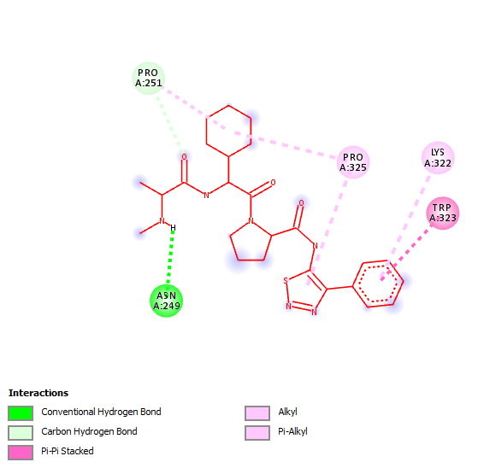 | 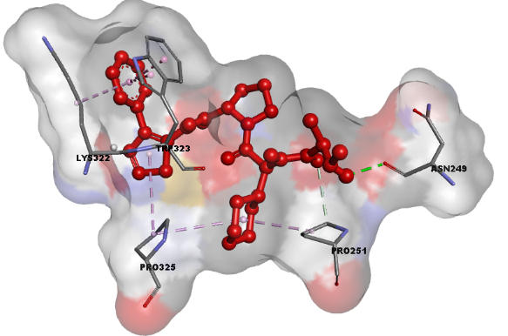
3218 | 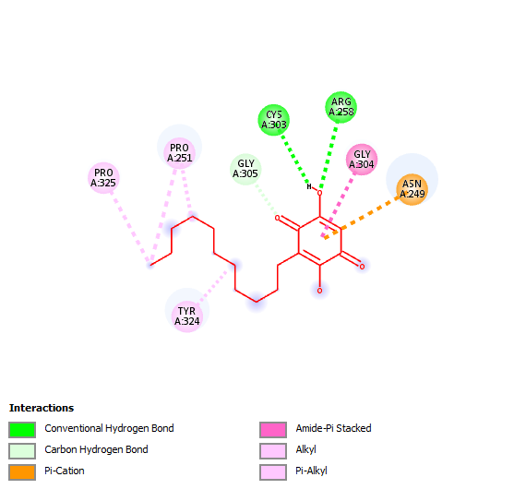 | 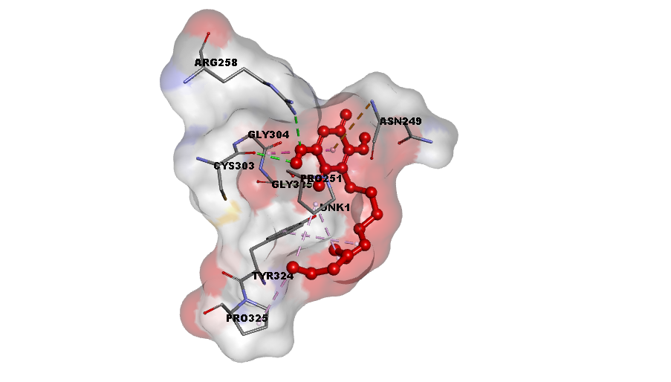
10281 | 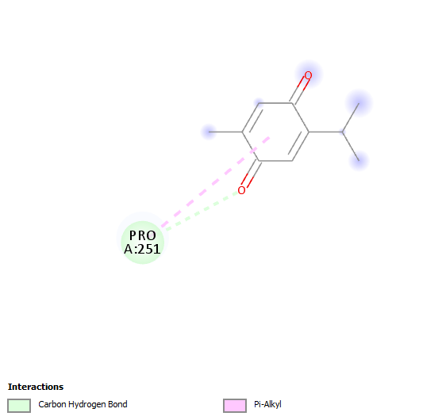 | 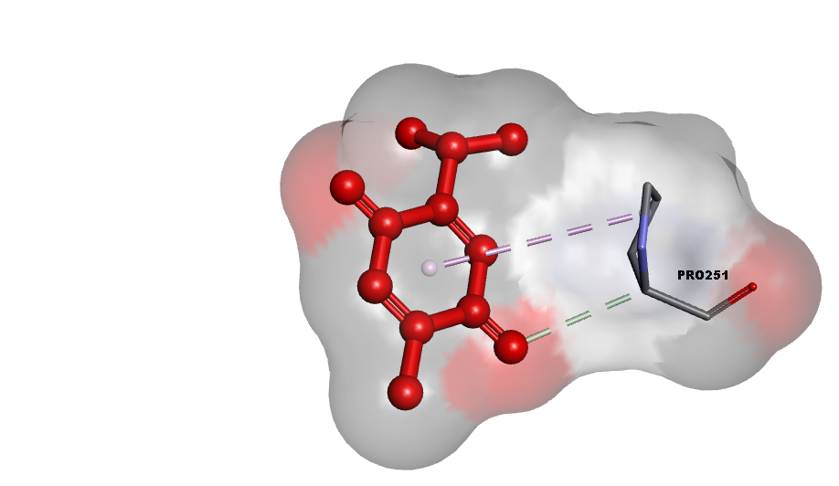
219100 | 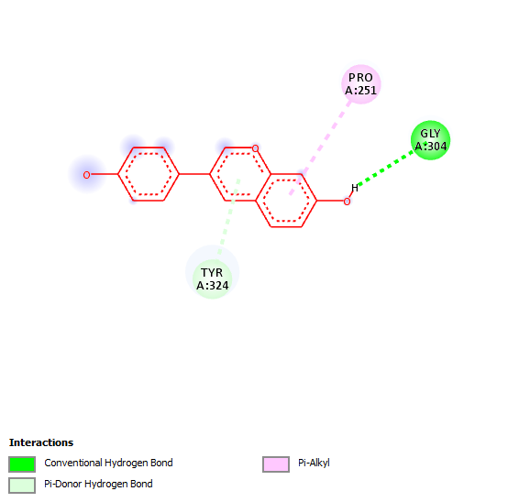 | 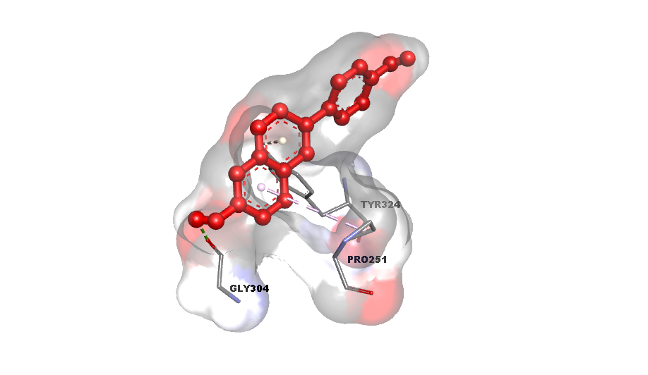
24737642 | 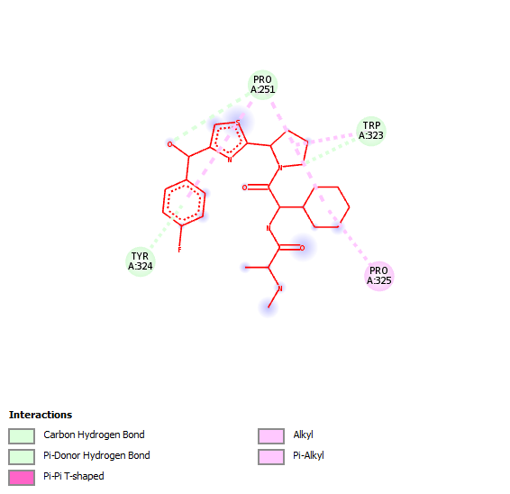 | 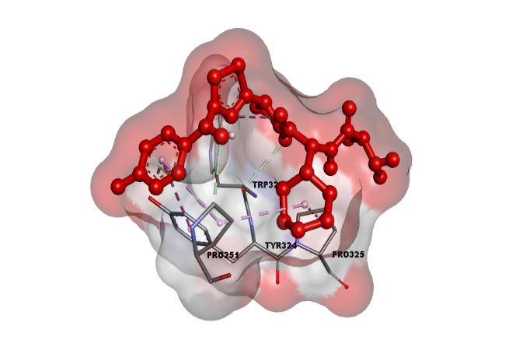
25022340 | 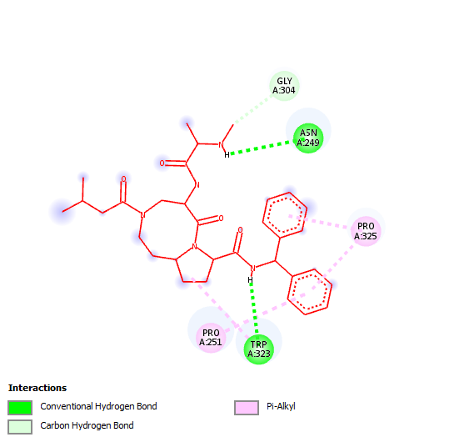 | 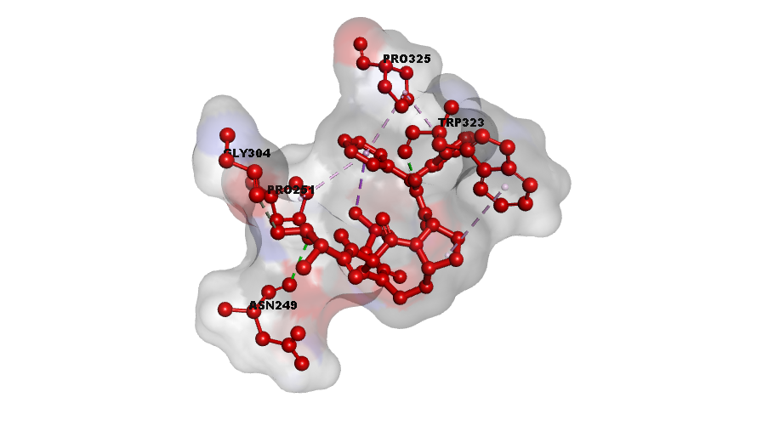
44182275 | 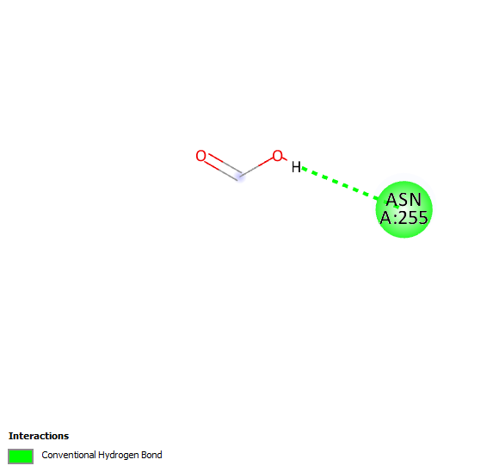 | 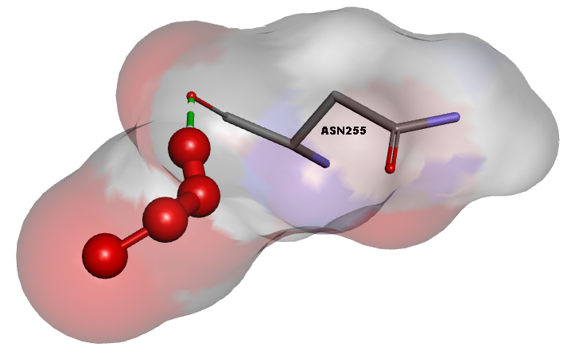
46781908 | 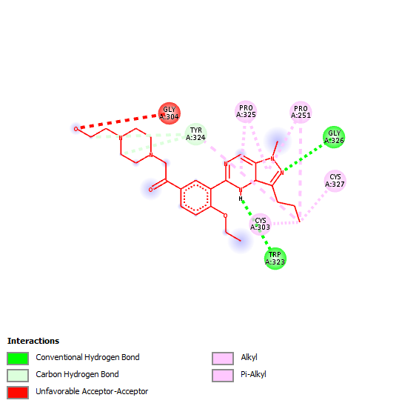 | 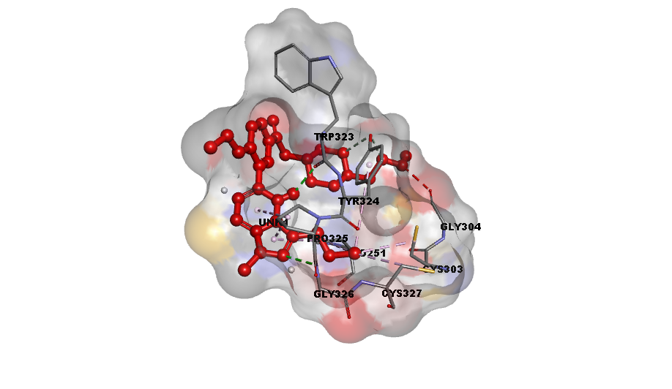
49836020 | 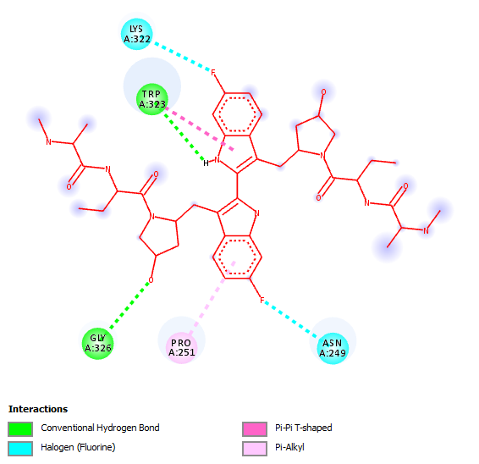 | 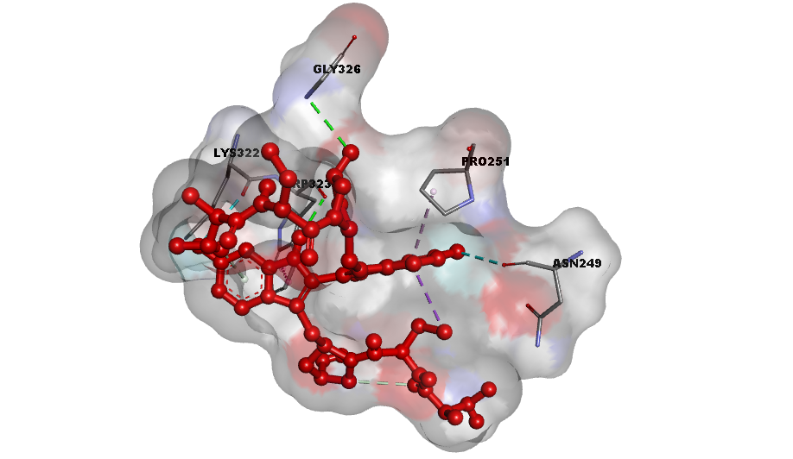
118169620 | 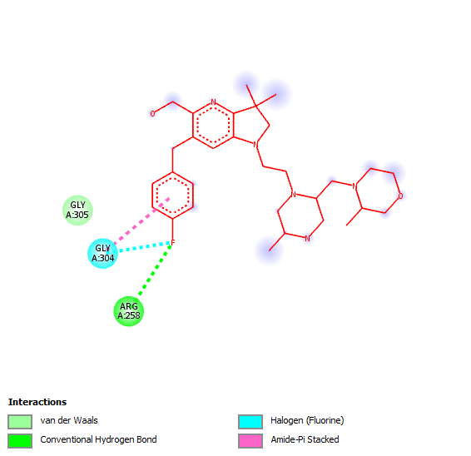 | 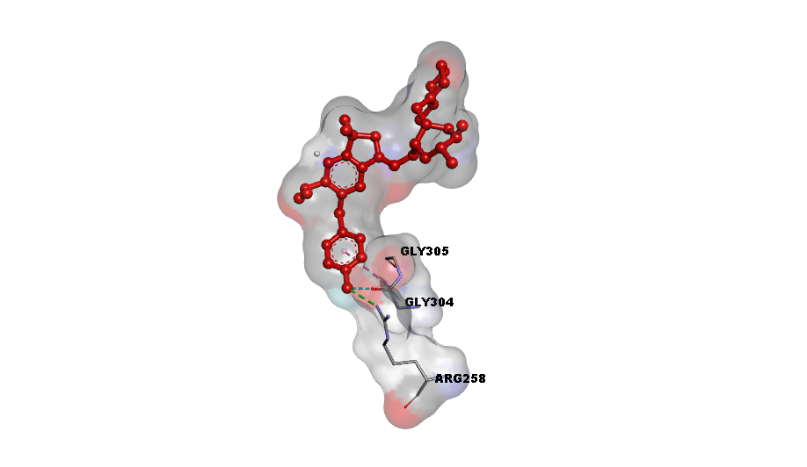

Table S2: Showing the docking score of selected 7 hit compounds with XIAP and Pharm-Fit Score found during pharmacophore-based screening process.
ZINC ID | Docking Score (kcal/mol) | Pharm-Fit Score
ZINC77257307 | -8.0 | 95.53
ZINC1070004335 | -7.8 | 94.75
ZINC247950187 | -7.6 | 95.70
ZINC107434573 | -6.9 | 95.72
ZINC14612168 | -6.4 | 94.91
ZINC253388756 | -5.5 | 94.89
ZINC253388755 | -5.2 | 94.62

