Supplementary Information for
Inflammaging markers characteristic of advanced age show similar levels with frailty and dependency

Ainhoa Alberro¹, Andrea Iribarren-Lopez¹, Matías Sáenz-Cuesta¹, Ander Matheu^{2,3,4}, Itziar Vergara^{5,6} and David Otaegui^{1,7}*

¹ Biodonostia Health Research Institute, Multiple Sclerosis Group, San Sebastian, Spain.
² Biodonostia Health Research Institute, Cellular Oncology Group, San Sebastian, Spain.
³ CIBER de Fragilidad y Envejecimiento Saludable (CIBERfes), Madrid, Spain.
⁴ IKERBASQUE, Basque Foundation for Science, Bilbao, Spain.
⁵ Biodonostia Health Research Institute, Primary Care Unit, San Sebastian, Spain.
⁶ Health Services Research on Chronic Patients Network (REDISSEC), Madrid, Spain.
⁷ Spanish Network of Multiple Sclerosis, Barcelona, Spain.

Table S1. Spearman correlations between frailty assessment tests and inflammatory markers.

 |  |  | Timed up-and-go (TUG) |  |  | Gait Speed (GS)
 |  | n | r | p |  | r | p
Cohort 1 | CRP | 111 | 0.12 | 0.23 |  | -0.01 | 0.91
 | TNF-α | 37 | 0.10 | 0.54 |  | -0.03 | 0.85
Cohort 2 | CRP | 74 | 0.11 | 0.36
 | TNF-α | 84 | 0.42 | <0.0001
 | IL-6 | 79 | 0.26 | 0.0227
 | Albumin | 85 | 0.04 | 0.73
Significant correlations are indicated in bold.

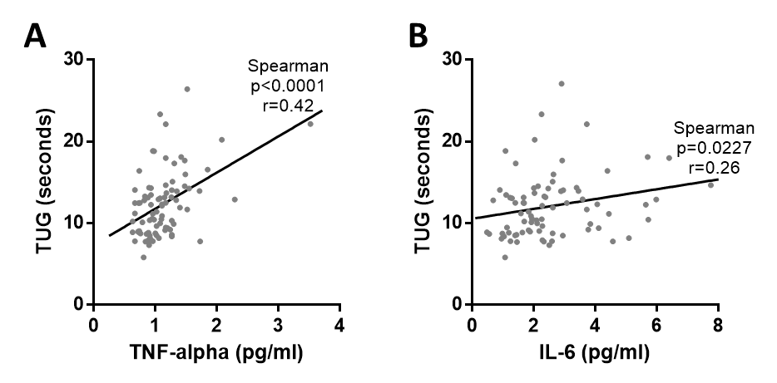
Figure S1. Significant correlations between frailty assessment tests and inflammatory markers. (A) Positive correlations between TNF-α and TUG (p<0.0001****, r=0.42 and 95% confidence interval 0.215 to 0.583) and (B) between IL-6 and TUG (p=0.0227*, r=0.26 and 95% confidence interval 0.030 to 0.457) were reported in Cohort 2.

