Supplementary Table S1. Natural cubic spline functions for weekly mean rainfall and temperature, and lag.

Model  no | Lag (df) | Rainfall (df) | Temperature (df) | QAIC (rainfall) | QAIC (temperature) | QAIC (rainfall & temperature)
1 | 3 | 3 | 3 | 1474.744* | 1496.242* | 1544.778*
2 | 4 | 3 | 3 | 1493.405 | 1543.736 | 1588.154
3 | 5 | 3 | 3 | 1499.362 | 1543.200 | 1584.064
4 | 3 | 4 | 3 | 1481.011 | 1496.242 | 1553.102
5 | 4 | 4 | 3 | 1507.072 | 1543.736 | 1603.645
6 | 5 | 4 | 3 | 1512.846 | 1543.200 | 1599.677
7 | 3 | 5 | 3 | 1487.595 | 1496.242 | 1553.114
8 | 4 | 5 | 3 | 1520.859 | 1543.736 | 1607.244
9 | 5 | 5 | 3 | 1525.261 | 1543.200 | 1601.280
10 | 3 | 3 | 4 | 1474.744 | 1496.954 | 1547.544
11 | 4 | 3 | 4 | 1493.405 | 1545.320 | 1593.432
12 | 5 | 3 | 4 | 1499.362 | 1545.976 | 1591.291
13 | 3 | 4 | 4 | 1481.011 | 1496.954 | 1560.095
14 | 4 | 4 | 4 | 1507.072 | 1545.320 | 1615.268
15 | 5 | 4 | 4 | 1512.846 | 1545.976 | 1613.226
16 | 3 | 5 | 4 | 1487.595 | 1496.954 | 1561.723
17 | 4 | 5 | 4 | 1520.859 | 1545.320 | 1622.134
18 | 5 | 5 | 4 | 1525.261 | 1545.976 | 1619.052
19 | 3 | 3 | 5 | 1474.744 | 1558.252 | 1605.070
20 | 4 | 3 | 5 | 1493.405 | 1601.826 | 1647.801
21 | 5 | 3 | 5 | 1499.362 | 1598.002 | 1641.562
22 | 3 | 4 | 5 | 1481.011 | 1558.252 | 1616.131
23 | 4 | 4 | 5 | 1507.072 | 1601.826 | 1666.718
24 | 5 | 4 | 5 | 1512.846 | 1598.002 | 1660.037
25 | 3 | 5 | 5 | 1487.595 | 1558.252 | 1616.731
26 | 4 | 5 | 5 | 1520.859 | 1601.826 | 1673.319
27 | 5 | 5 | 5 | 1525.261 | 1598.002 | 1664.834

Degrees of freedom (df) associated with cross-basis matrices in the weather-lag spaces, and values for the Quasi-Akaike Information Criterion (QAIC) for the alternative models for the association between rainfall, temperature and TB notifications from year 2011 to 2018.

Supplementary Figure S1. Sensitivity analysis.

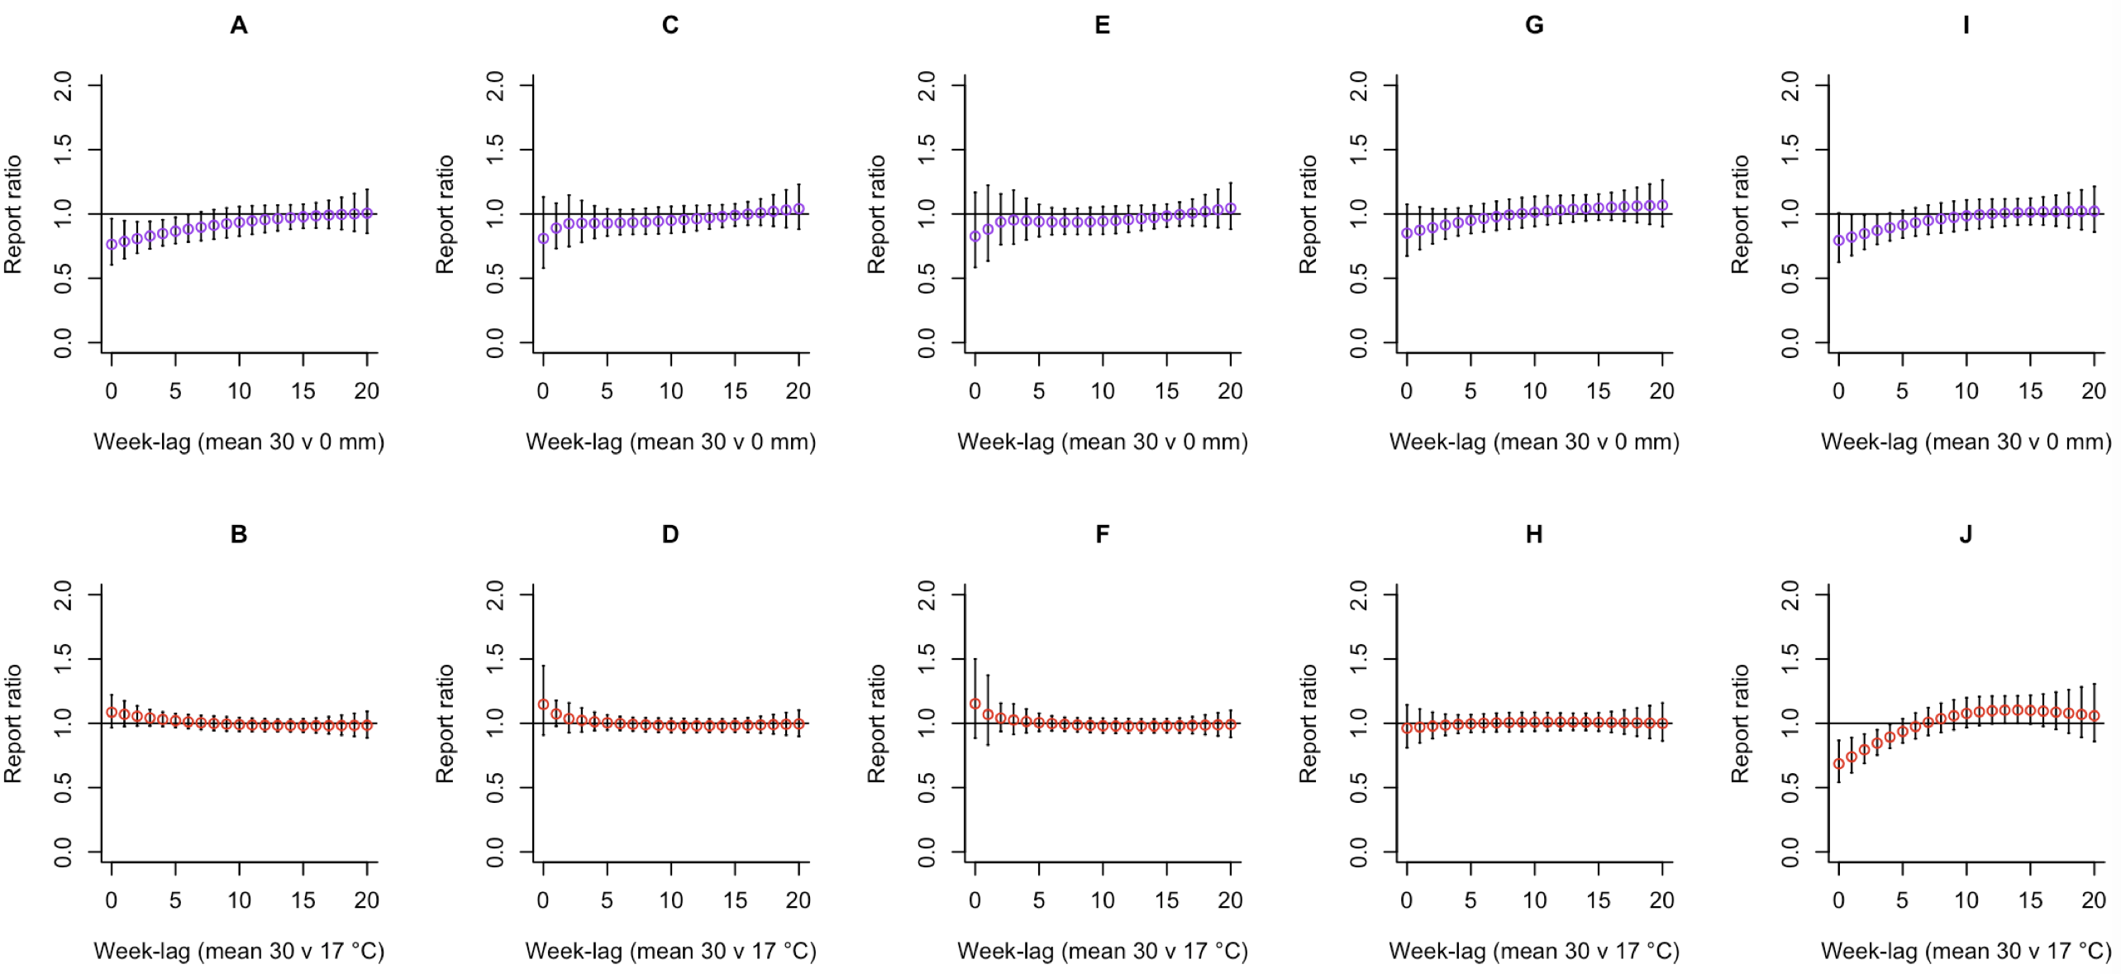
The effects on TB notifications of weekly average of 30 mm rainfall compared to 0 mm and weekly average of 30 °C temperature compared to 17 °C along the lags, modified by increasing the degrees of freedom (df) in the lag space from (df=3; model.no=1;A,B) to (df=4; model.no=2;C,D) to (df=5; model.no=3;E,F), in the rainfall space from (df=4; model.no=4;G) to (df=5; model.no=7;I), in the temperature space from (df=4; model.no=10;H) to (df=5; model.no=19;J)

Supplementary Figure S2. Model validation checks.

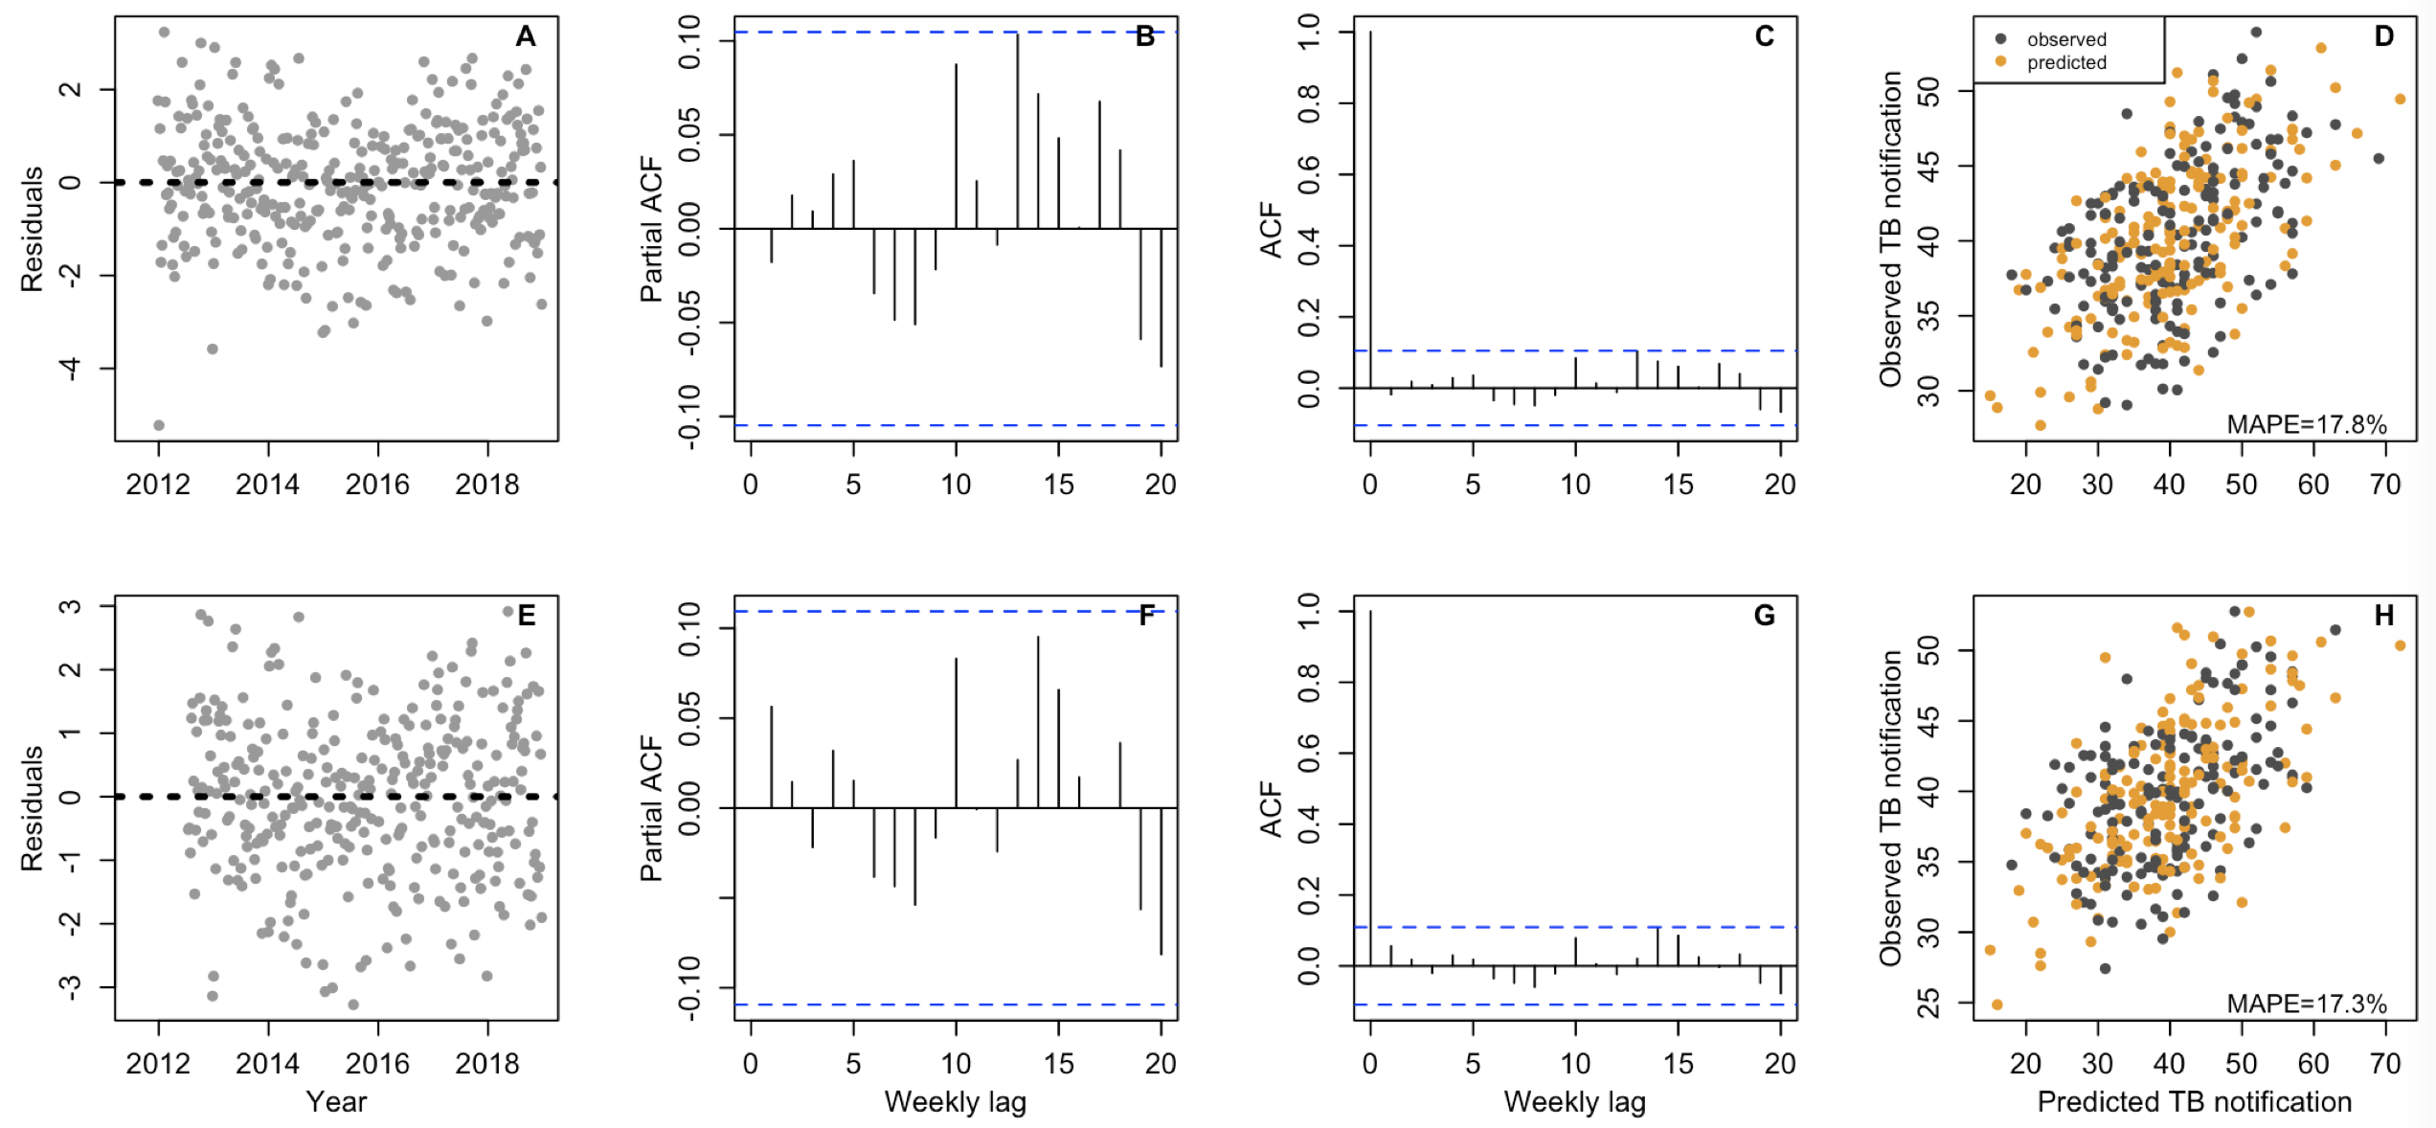

Deviance residuals overtime, partial autocorrelation (partial ACF), autocorrelation (ACF) and model prediction accuracy using mean absolute percentage error (MAPE) respectively, estimated by; adjusted model (additional residuals at lags 1, 2) of bi-dimensional association between rainfall-lag and TB notification rates (A,B,C,D), and adjusted model (additional residuals at lags 2, 13, 17) of bi-dimensional association between temperature-lag and TB notification rates (E,F,G,H).

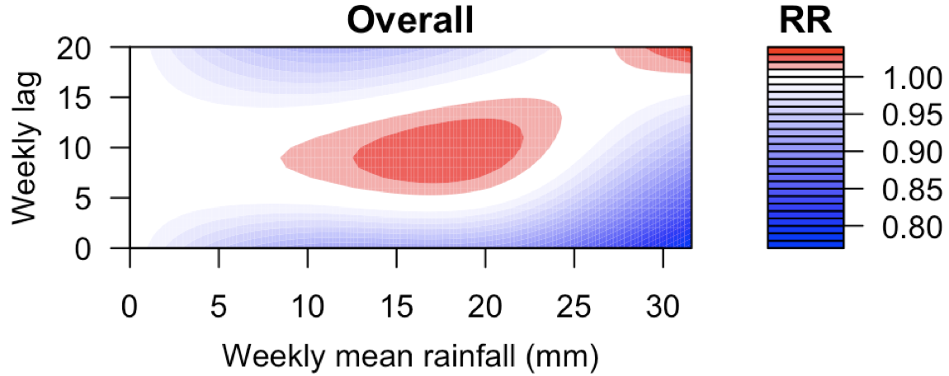 | 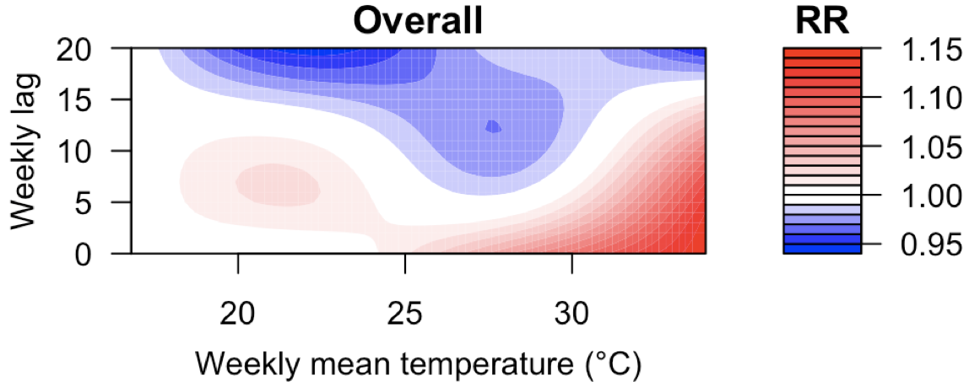
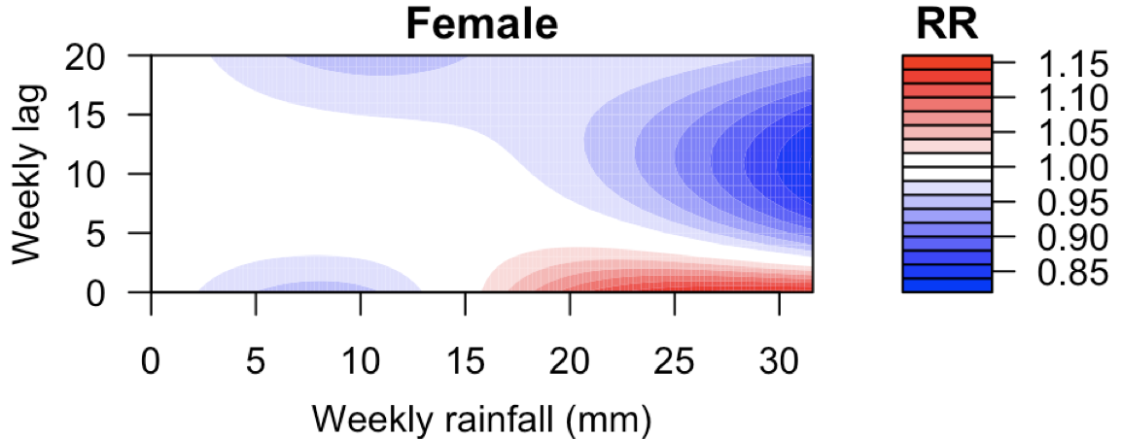 | 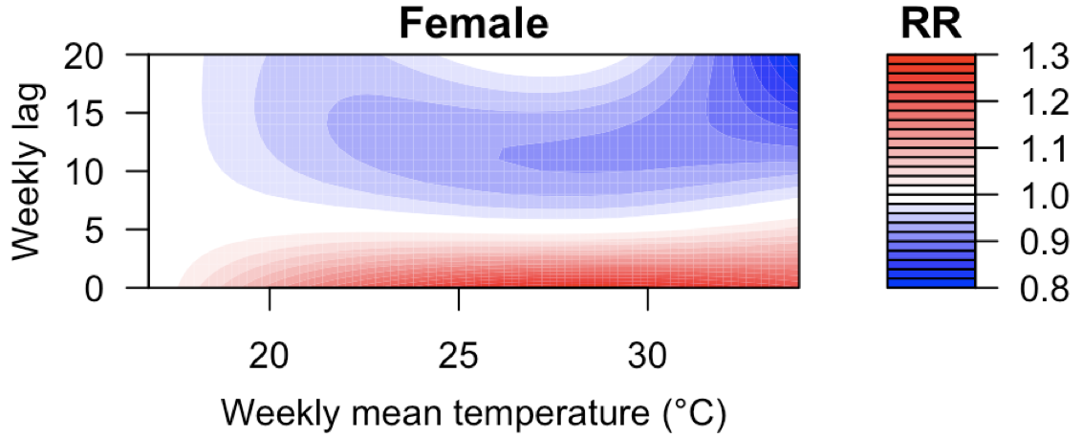
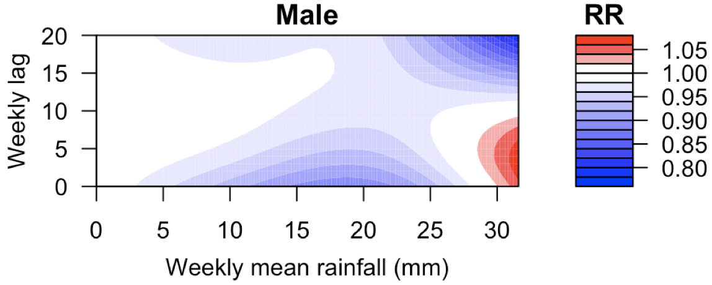 | 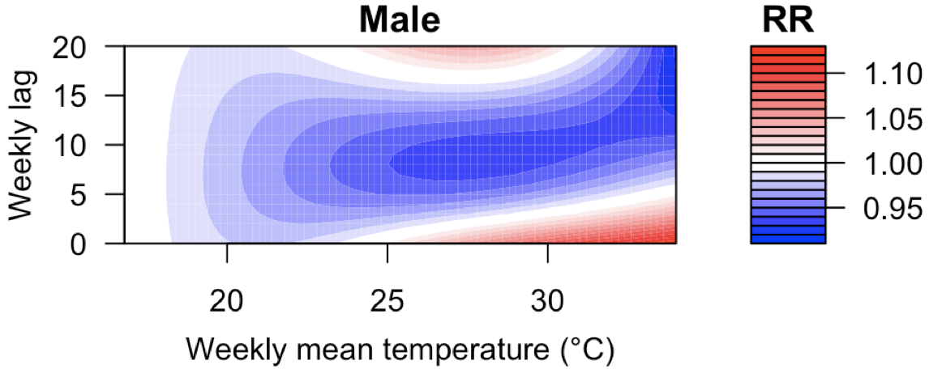
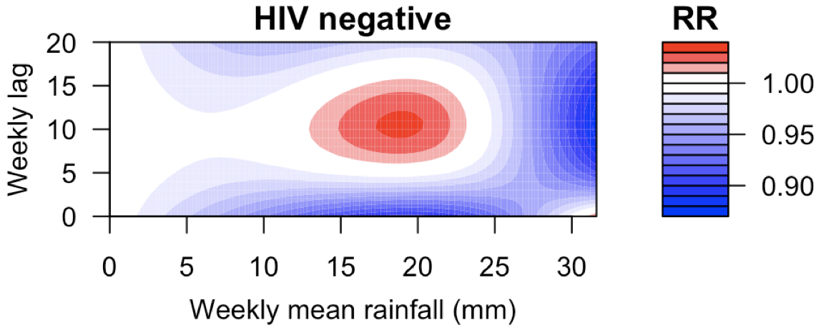 | 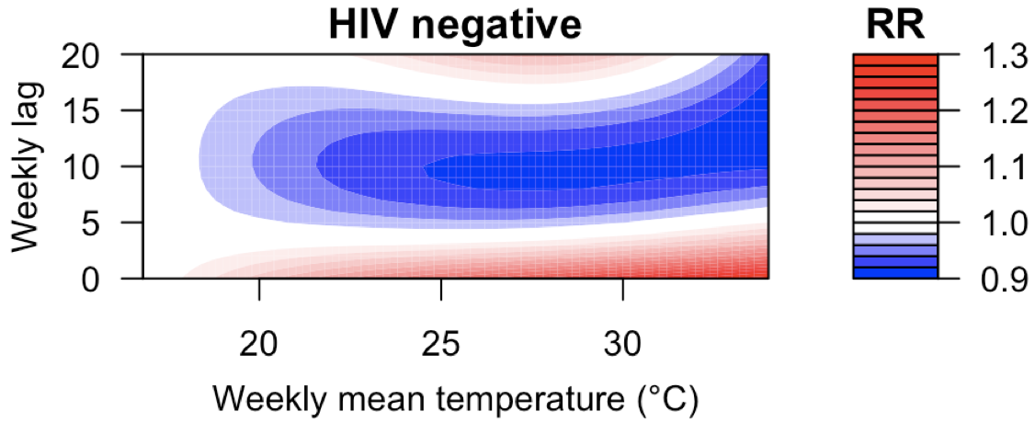
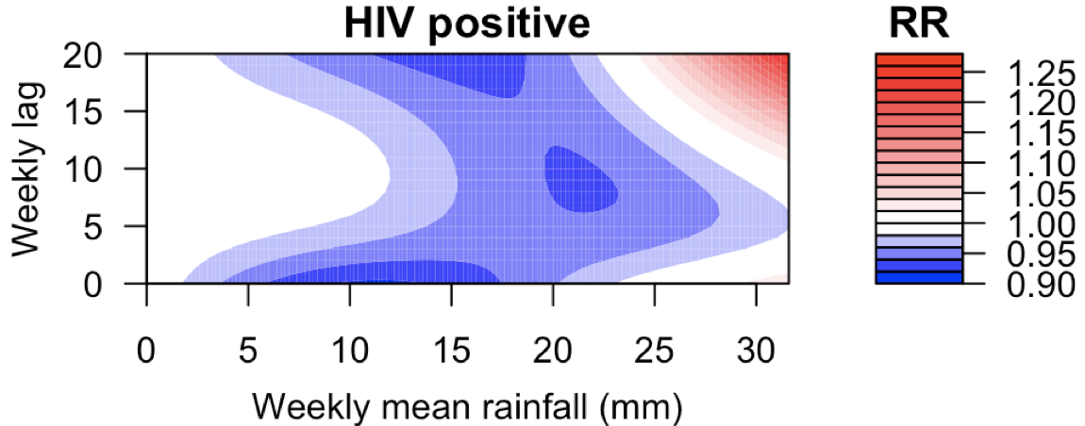 | 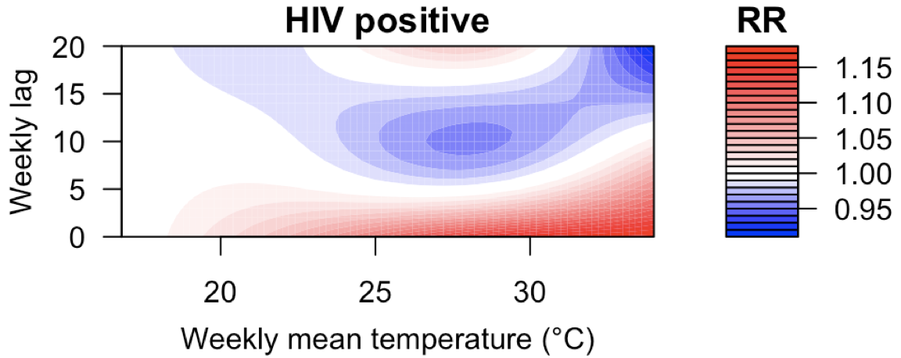
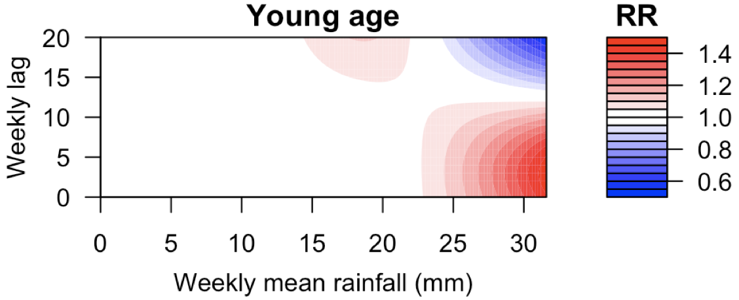 | 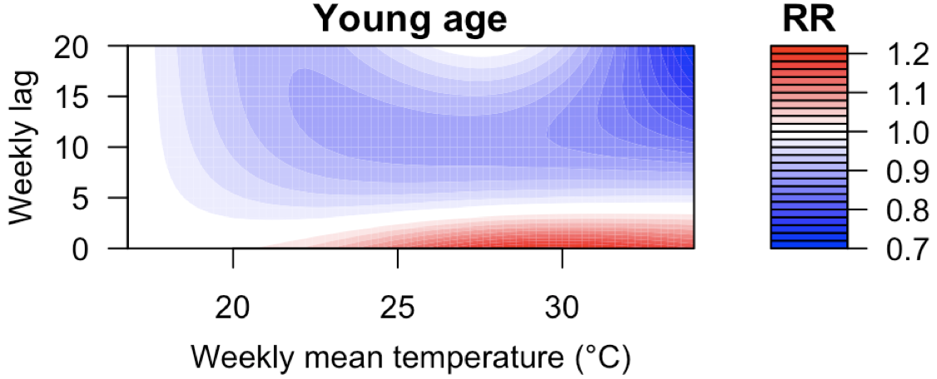
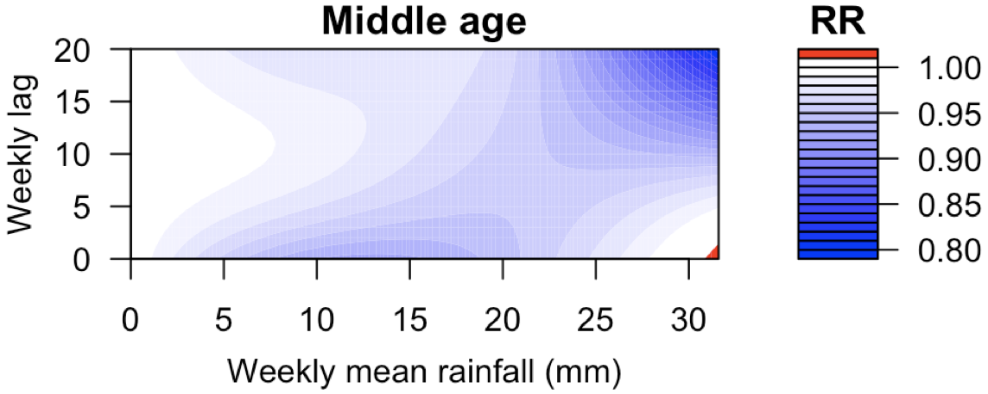 | 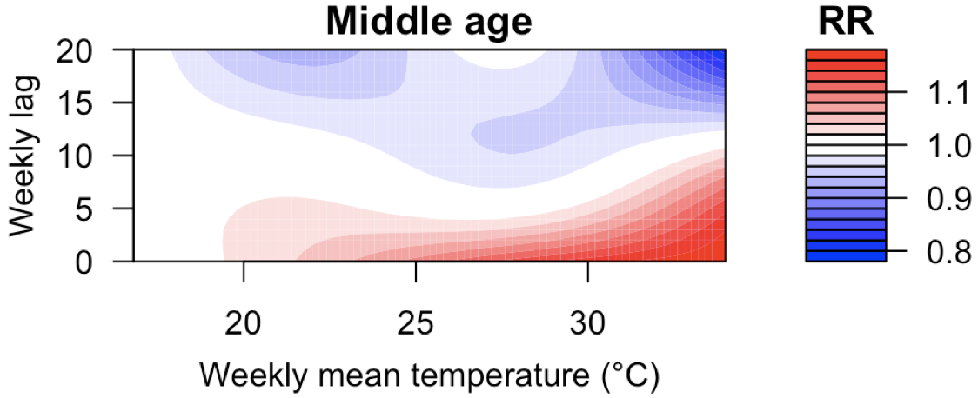
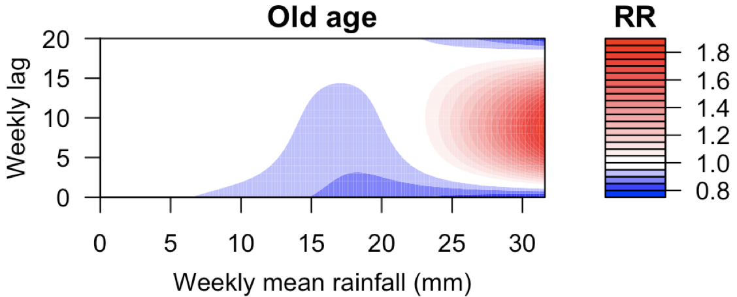 | 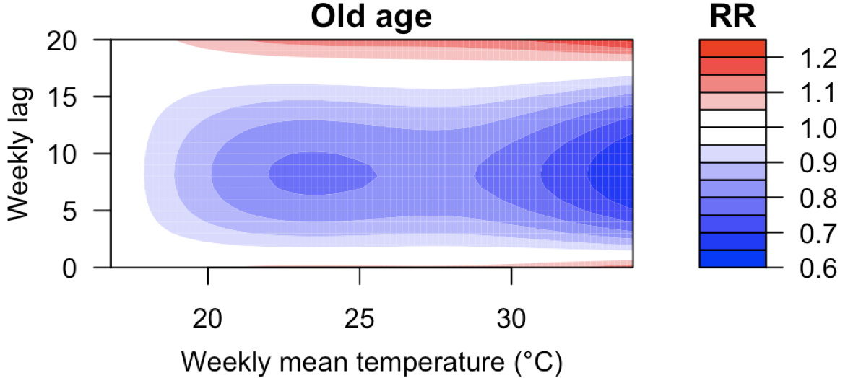
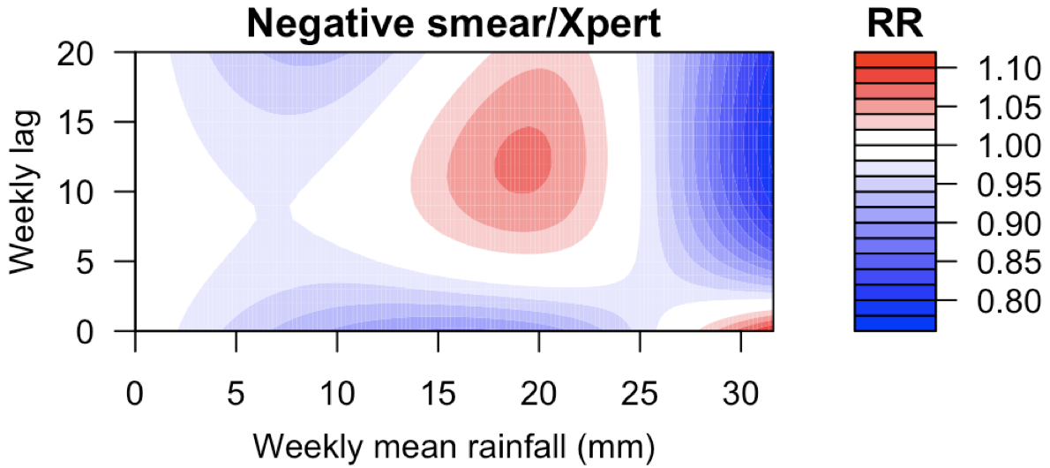 | 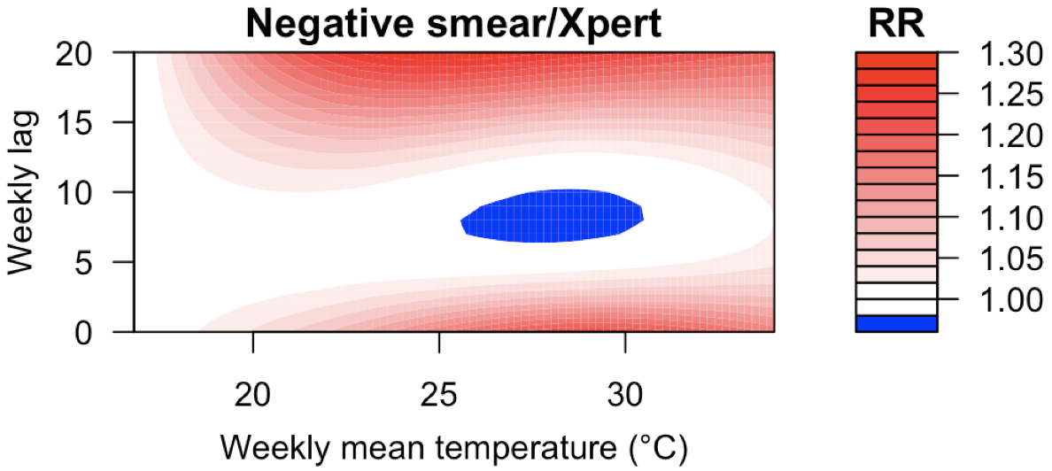
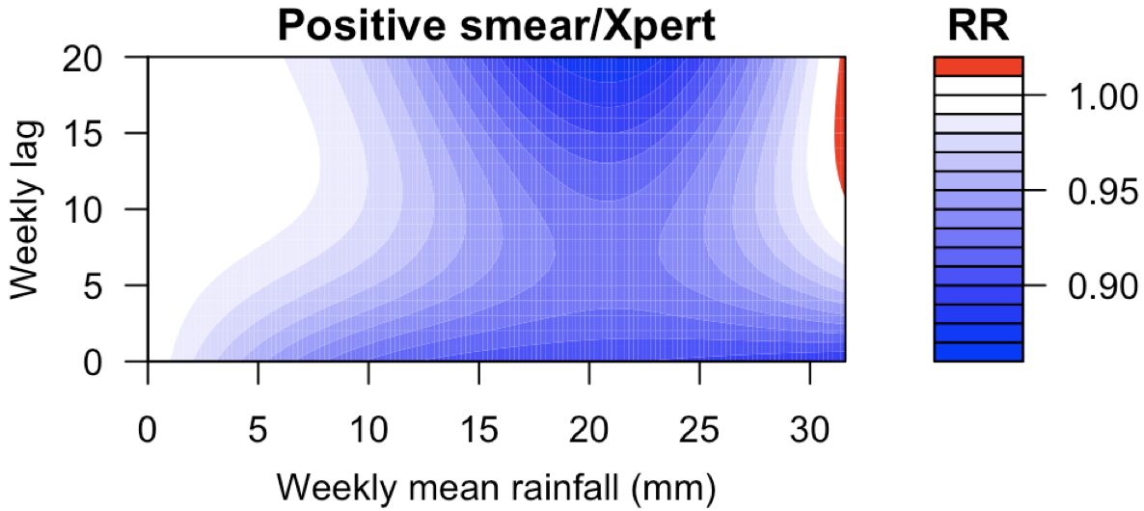 | 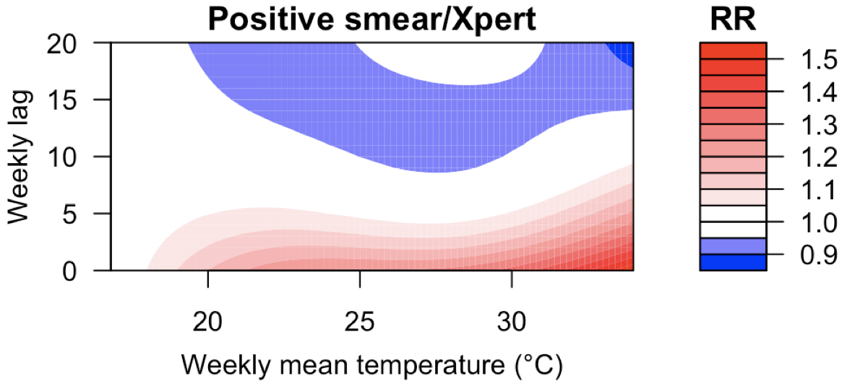
Supplementary Figure S3. Contour plots of the delayed impact of rainfall and temperature on the relative TB notification ratio (RR) stratified by covariates.

