Exploring the genetic architecture of feed efficiency traits in chickens

Jorge Augusto Petroli Marchesi¹,ª, Rafael Keith Ono^{2,b}, Mauricio Egidio Cantão², Adriana Mércia Guaratini Ibelli², Jane de Oliveira Peixoto², Gabriel Costa Monteiro Moreira³, Thaís Fernanda Godoy³, Luiz Lehmann Coutinho³, Danísio Prado Munari¹, Mônica Corrêa Ledur^{2,*}
¹Universidade Estadual Paulista “Júlio de Mesquita Filho”, Faculdade de Ciências Agrárias e Veterinárias, São Paulo 14884-900, Brazil.
²Embrapa Suínos e Aves, Concórdia, 89715-899 Brazil.
³Departamento de Zootecnia, Escola Superior de Agricultura “Luiz de Queiroz”, Universidade de São Paulo, Av. Pádua Dias 11, Piracicaba, São Paulo 13419-900, Brazil.
ªPresent address: Universidade de São Paulo, Departamento de Genética, Ribeirão Preto, 14049-900, Brazil.
^{b}Present address: Pamplona Alimentos S/A, Rio do Sul 89164-900, Brazil.

*monica.ledur@embrapa.br

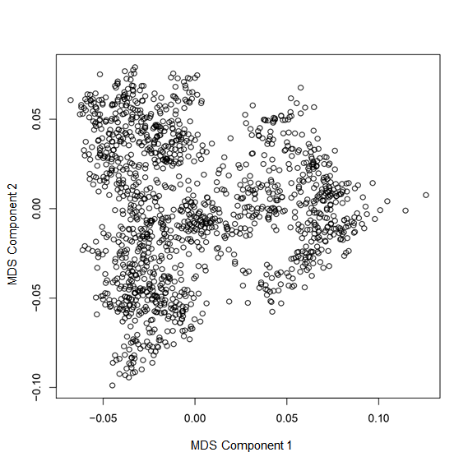
Supplementary Figure S1. Multi-dimensional scaling plot to examine for the presence of population stratification.

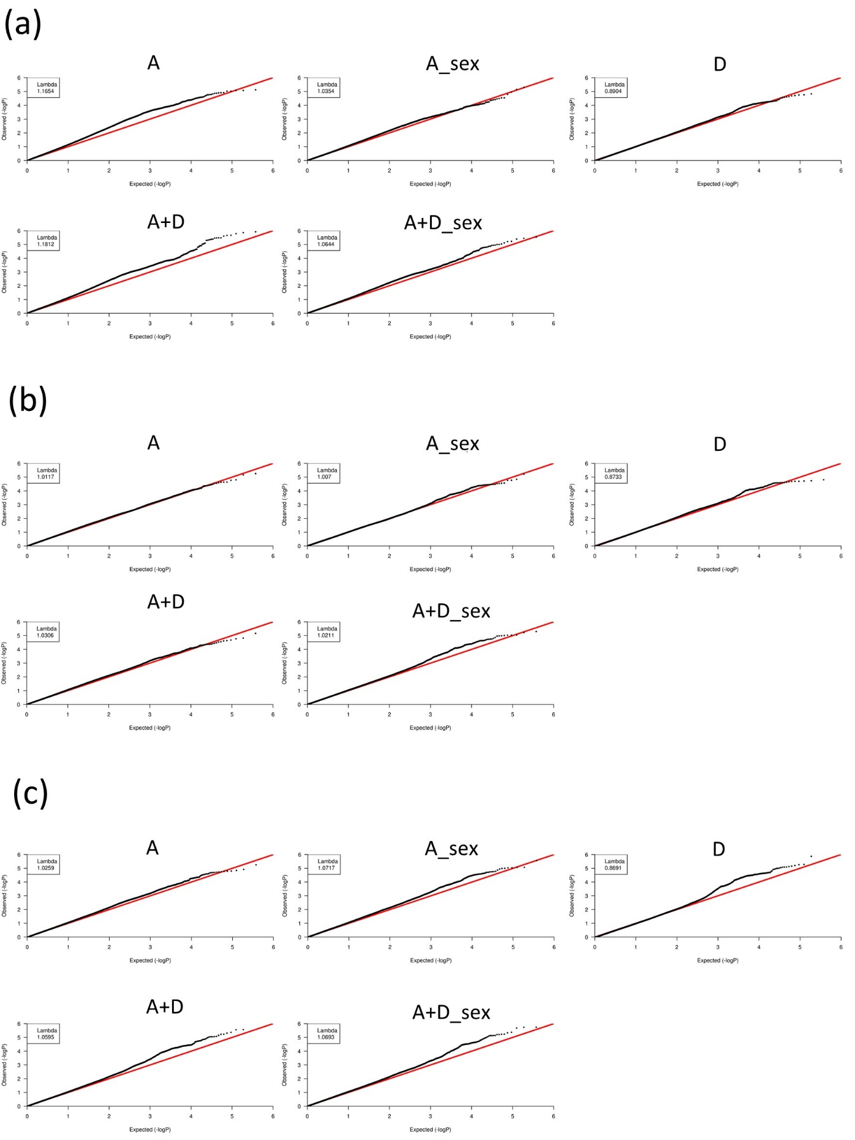Supplementary Figure S2. QQ plot for (a) Feed Intake, (b) Body Weight Gain and (c) Feed Conversion Ratio traits. The x-axis indicates the expected -log10-transformed P-values, and the y-axis shows the observed -log10-transformed P-values. The genomic inflation factors (Lambda) are shown on the top left in the QQ plots.

Chromosome | Chromosome size (Kb)* | Total SNPs | SNP density (n/Kb)
0* | - | 4,830 | -
1 | 196,200 | 65,260 | 0.333
2 | 149,560 | 40,202 | 0.269
3 | 111,300 | 38,197 | 0.343
4 | 91,280 | 27,603 | 0.302
5 | 59,830 | 19,662 | 0.329
6 | 35,470 | 15,209 | 0.429
7 | 36,950 | 14,604 | 0.395
8 | 29,960 | 11,237 | 0.375
9 | 24,090 | 11,889 | 0.494
10 | 20,440 | 12,341 | 0.604
11 | 20,220 | 9,586 | 0.474
12 | 19,950 | 9,991 | 0.501
13 | 18,410 | 7,554 | 0.410
14 | 15,600 | 8,426 | 0.540
15 | 12,760 | 6,712 | 0.526
16 | 652 | 243 | 0.373
17 | 10,960 | 6,409 | 0.585
18 | 11,050 | 6,446 | 0.583
19 | 9,980 | 6,327 | 0.634
20 | 14,110 | 6,830 | 0.484
21 | 6,860 | 6,128 | 0.893
22 | 4,730 | 2,658 | 0.562
23 | 5,790 | 4,462 | 0.771
24 | 6,280 | 5,203 | 0.829
25 | 2,910 | 1,540 | 0.529
26 | 5,310 | 4,091 | 0.770
27 | 5,660 | 3,706 | 0.655
28 | 4,970 | 3,049 | 0.613
LGE64 | 897 | 53 | 0.059
33 | 1,650 | 122 | 0.074
Z | 5,160 | 15,204 | 2.947
W | 82,310 | 2 | 2.430E-05
Total | - | 375,776 | -
Supplementary Table S1. Distribution of SNPs across the chromosomes. *Size of the sequenced genome. * Chromosome 0 represents SNPs with no position.

Trait | SNP effect | SNP | GGA | Position | P-value | Candidate gene
BWG | A | rs315753164 | 1 | 141362 | 2.37e-05 | ENSGALG00000033919
BWG | A | rs312763768 | 1 | 102001483 | 3.31e-05 | U6, ENSGALG00000037303
BWG | A | rs318236242 | 1 | 73597647 | 3.75e-05 | ENSGALG00000033533, ENSGALG00000029785
BWG | A | rs317758384 | 4 | 25972470 | 1.7e-05 | ENSGALG00000030400
BWG | A | rs16185141 | 22 | 3862615 | 2.3e-05 | ENSGALG00000030747
BWG | A | rs312461641 | 22 | 4214936 | 2.8e-05 | LRRTM4
BWG | A | rs316558717 | 5 | 38947151 | 5.51e-06 | LRRC74A
BWG | A | rs14992480 | 13 | 3320197 | 6.86e-06 | TLX2, NPM1
BWG | A_sex | rs312763768 | 1 | 102001483 | 2.92e-05 | U6, ENSGALG00000037303
BWG | A_sex | rs315164331 | 3 | 23675069 | 2.92e-05 | EML4
BWG | A_sex | rs317758384 | 4 | 25972470 | 1.69e-05 | ENSGALG00000030400
BWG | A_sex | rs314678192 | 4 | 29448998 | 3.39e-05 | ENSGALG00000009774
BWG | A_sex | rs317305197 | 6 | 29287944 | 1.43e-05 | SLC18A2, PDZD8, ENSGALG00000035332
BWG | A_sex | rs14593593 | 6 | 31618521 | 3.72e-05 | ENSGALG00000041779
BWG | A_sex | rs312461641 | 22 | 4214936 | 2.71e-05 | LRRTM4
BWG | A_sex | rs313819577 | Z | 79348753 | 3.51e-05 | ENSGALG00000034193, ZNF608
BWG | A_sex | rs317588919 | 6 | 28493301 | 7.2e-07 | ATRNL1
BWG | A+D | rs315753164 | 1 | 141362 | 1.51e-05 | ARSA
BWG | A+D | rs317758384 | 4 | 25972470 | 3.75e-05 | ENSGALG00000030400
BWG | A+D | rs316558717 | 5 | 38947151 | 2.44e-05 | LRRC74A
BWG | A+D | rs316626812 | 7 | 31398092 | 1.7e-05 | THASD7B, HNMT, ENSGALG00000033461
BWG | A+D | rs316312015 | 12 | 6465550 | 3.59e-05 | WNK2
BWG | A+D | rs312461641 | 22 | 4214936 | 3.31e-05 | LRRTM4
BWG | A+D_sex | rs316498242 | 1 | 27596741 | 1.05e-05 | ENSGALG00000027876
BWG | A+D_sex | rs316423051 | 6 | 29259327 | 3.39e-05 | PDZD8, ENSGALG00000035332
BWG | A+D_sex | rs14593593 | 6 | 31618521 | 3.72e-05 | ENSGALG00000041779
BWG | A+D_sex | rs315917442 | 12 | 1173714 | 3.15e-05 | ENSGALG00000046270
BWG | A+D_sex | rs13610024 | 12 | 6127578 | 3.47e-05 | WNT7A, PTPDC1, BARX1B, ENSGALG00000029394
BWG | A+D_sex | rs313819577 | Z | 79348753 | 1.36e-05 | ENSGALG00000034193, ZNF608
BWG | A+D_sex | rs318192494 | 2 | 62758807 | 9.74e-06 | ENSGALG00000028826, gga-mir-1759
BWG | A+D_sex | rs312928242 | 12 | 8058572 | 5.02e-06 | ERC2
BWG | D | rs13610024 | 12 | 6127578 | 1.83e-05 | WNT7A, PTPDC1, BARX1B, ENSGALG00000029394
BWG | D | rs13507290 | 18 | 3730848 | 3.68e-05 | ENSGALG00000046130
FCR | A | rs15236018 | 1 | 36283561 | 1.59e-05 | LGR5
FCR | A | rs316432031 | 1 | 36706251 | 2.09e-05 | TRHDE
FCR | A | rs16083084 | 2 | 102079332 | 2.97e-05 | PACAP
FCR | A | rs314925702 | 3 | 18959711 | 3.68e-05 | SLC30A10, EPRS
FCR | A | rs14517170 | 5 | 13417627 | 1.71e-05 | ENSGALG00000037138
FCR | A | rs15801622 | 6 | 24470217 | 1.2e-05 | SORCS3
FCR | A | rs316420511 | 6 | 28472992 | 1.92e-05 | ATRNL1
FCR | A | rs13853250 | 1 | 38041526 | 5.63e-06 | OSBPL8
FCR | A_sex | rs13853250 | 1 | 38041526 | 2.87e-05 | OSBPL8
FCR | A_sex | rs15801622 | 6 | 24470217 | 1.65e-05 | SORCS3
FCR | A_sex | rs80770142 | 6 | 31514161 | 2.62e-05 | BUB3, HMX2, HMX3
FCR | A_sex | rs316420511 | 6 | 28472992 | 2.75e-06 | ATRNL1
FCR | A_sex | rs14774125 | Z | 61776792 | 1.03e-05 | ENSGALG00000039484
FCR | A_sex | rs314388497 | 6 | 29216961 | 9.29e-06 | PDZD8
FCR | A_sex | rs15936523 | 8 | 26493993 | 8.54e-06 | FGGY
FCR | A_sex | rs314893988 | 8 | 25324177 | 8.69e-06 | PARS2
FCR | A+D | rs13853250 | 1 | 38041526 | 1.78e-05 | OSBPL8
FCR | A+D | rs317318235 | 2 | 30809117 | 2.73e-06 | RAPGEF5
FCR | A+D | rs314120370 | 2 | 7676565 | 3.61e-05 | DPP6
FCR | A+D | rs14325026 | 3 | 21872815 | 1.89e-05 | ATF3
FCR | A+D | rs314377290 | 4 | 35113081 | 1.06e-05 | FRAS1
FCR | A+D | rs317423687 | 4 | 49403944 | 3.67e-05 | TECRL
FCR | A+D | rs313312956 | 12 | 8077730 | 1.4e-05 | ERC2
FCR | A+D | rs318030379 | 12 | 7469711 | 1.82e-05 | CACNA2D3
FCR | A+D | rs316312015 | 12 | 6465550 | 3.59e-05 | WNK2
FCR | A+D | rs316219360 | 1 | 195411003 | 5.89e-06 | P2RY6
FCR | A+D | rs316420587 | 1 | 194786435 | 7.07e-06 | NUP98
FCR | A+D | rs14513380 | 5 | 9756115 | 5.8e-06 | TRIM66
FCR | A+D | rs314727166 | 11 | 3384475 | 4.86e-06 | ESRP2
FCR | A+D | rs318126183 | 4 | 46851357 | 1.16e-07 | ENSGALG00000011221
FCR | A+D_sex | rs314487130 | 1 | 194771508 | 1.07e-05 | RHOG, NUP98, PGAP2
FCR | A+D_sex | rs314384561 | 1 | 92883077 | 1.1e-05 | CHMP2B
FCR | A+D_sex | rs315679231 | 1 | 76160852 | 2.29e-05 | ENSGALG00000014252
FCR | A+D_sex | rs317473017 | 2 | 23862188 | 1.84e-05 | ENSGALG00000045286
FCR | A+D_sex | rs317318235 | 2 | 30809117 | 3.55e-05 | RAPGEF5
FCR | A+D_sex | rs318126183 | 4 | 46851357 | 2.24e-05 | ENSGALG00000011221
FCR | A+D_sex | rs314377290 | 4 | 35113081 | 2.95e-05 | FRAS1
FCR | A+D_sex | rs13578747 | 6 | 22818029 | 2.05e-05 | ENSGALG00000007803
FCR | A+D_sex | rs316420511 | 6 | 28472992 | 2.25e-05 | ATRNL1
FCR | A+D_sex | rs316423051 | 6 | 29259327 | 3.49e-05 | PDZD8, ENSGALG00000035332
FCR | A+D_sex | rs314727166 | 11 | 3384475 | 3.2e-05 | ESRP2
FCR | A+D_sex | rs315862526 | 12 | 6507595 | 3.09e-05 | WNK2
FCR | A+D_sex | rs314162123 | 12 | 7387912 | 3.58e-05 | CACNA2D3
FCR | A+D_sex | rs315665292 | 13 | 7370225 | 3.45e-05 | GABRB2
FCR | A+D_sex | rs314707646 | Z | 62642824 | 3.27e-05 | VCAN
FCR | A+D_sex | rs313801640 | Z | 6165654 | 3.58e-04 | ENSGALG00000038930
FCR | A+D_sex | rs313006651 | 4 | 5995991 | 4.61e-06 | DIAPH1
FCR | A+D_sex | rs13642049 | 4 | 5496189 | 5.77e-06 | ENSGALG00000035275
FCR | A+D_sex | rs15936573 | 8 | 26507284 | 7.19e-06 | FGGY
FCR | A+D_sex | rs313312956 | 12 | 8077730 | 7.29e-06 | ERC2
FCR | A+D_sex | rs312879906 | 2 | 76462592 | 2.08e-06 | ANKH
FCR | D | rs15508269 | 1 | 173254253 | 1.02e-05 | ENSGALG00000017062
FCR | D | rs314807128 | 1 | 173564445 | 2.59e-05 | ENSGALG00000045592
FCR | D | rs314384561 | 1 | 92883077 | 3.72e-05 | CHMP2B
FCR | D | rs314724704 | 4 | 48783835 | 1.71e-05 | ADGRL3, gga-mir-1730
FCR | D | rs317370088 | 4 | 49572846 | 2.03e-05 | SRP72
FCR | D | rs317232259 | 4 | 48470791 | 2.73e-05 | ADGRL3
FCR | D | rs314350934 | 8 | 4608621 | 1.18e-05 | ENSGALG00000033244
FCR | D | rs14720659 | 9 | 15018375 | 1.21e-05 | TNK2
FCR | D | rs317503850 | 10 | 9951482 | 2.98e-05 | SEMA6D, gga-mir-1744
FCR | D | rs80591054 | 10 | 10504571 | 3.68e-05 | GALK2, ENSGALG00000027088
FCR | D | rs318030379 | 12 | 7469711 | 1.11e-05 | CACNA2D3
FCR | D | rs313312956 | 12 | 8077730 | 2.14e-05 | ERC2
FCR | D | rs315061673 | 17 | 3999541 | 2.76e-05 | ASTN2
FCR | D | rs314784590 | 21 | 3147539 | 3.23e-05 | ENSGALG00000030881
FCR | D | rs314487130 | 1 | 194771508 | 5.27e-06 | RHOG, NUP98, PGAP2
FCR | D | rs316219360 | 1 | 195411003 | 6.28e-06 | P2RY6
FCR | D | rs14325026 | 3 | 21872815 | 9.55e-06 | ATF3
FCR | D | rs314377290 | 4 | 35113081 | 6.98e-06 | FRAS1
FCR | D | rs318126183 | 4 | 46851357 | 6.04e-08 | ENSGALG00000011221
FCR | D | rs314727166 | 11 | 3384475 | 1.35e-06 | ESRP2
FI | A | rs318002020 | 1 | 57397855 | 1.23e-05 | WEE2, SSBP1
FI | A | rs13647069 | 1 | 84905430 | 1.51e-05 | LNP1, TMEM45A
FI | A | rs315522090 | 1 | 87092827 | 1.62e-05 | BBX
FI | A | rs315107540 | 1 | 112553707 | 1.71e-05 | ENSGALG00000034279, gga-mir-6672
FI | A | rs315478611 | 2 | 130411613 | 2.56e-05 | RIMS2
FI | A | rs317133732 | 2 | 145557161 | 3.81e-05 | TRAPPC9
FI | A | rs315173296 | 3 | 18410439 | 2.33e-05 | DUSP10
FI | A | rs313104423 | 3 | 13412141 | 2.79e-05 | JAG1, gga-mir-1641
FI | A | rs315381456 | 4 | 59134409 | 3.05e-05 | UNC5C
FI | A | rs317066057 | 7 | 16224389 | 1.27e-05 | MTX2, ENSGALG00000040585
FI | A | rs16580134 | 7 | 7097519 | 1.34e-05 | PCNT
FI | A | rs313616546 | 7 | 9868631 | 1.73e-05 | HECW2
FI | A | rs313139484 | 7 | 9491599 | 1.94e-05 | SLC39A10, ENSGALG00000033329
FI | A | rs316277353 | 7 | 5216065 | 2.11e-05 | ENSGALG00000004045
FI | A | rs16580847 | 7 | 8812053 | 2.6e-05 | ENSGALG00000043345
FI | A | rs15005501 | 14 | 3180770 | 2.65e-05 | GRIFIN, ENSGALG00000033476, ENSGALG00000033476
FI | A | rs316814340 | 21 | 6343049 | 1.74e-05 | WNT4
FI | A | rs313589731 | 1 | 27315930 | 8.5e-06 | ENSGALG00000009485
FI | A | rs312763768 | 1 | 102001483 | 9.5e-06 | U6, ENSGALG00000037303
FI | A | rs316682850 | 7 | 11676924 | 8.46e-06 | CDK15
FI | A | rs317640967 | 21 | 5762426 | 7.63e-06 | DISP3, ENSGALG00000032291
FI | A_sex | rs313589731 | 1 | 27315930 | 1.11e-05 | ENSGALG00000009485
FI | A_sex | rs13647069 | 1 | 84905430 | 1.65e-05 | LNP1, TMEM45A
FI | A_sex | rs312763768 | 1 | 102001483 | 3.47e-05 | U6, ENSGALG00000037303
FI | A_sex | rs316682850 | 7 | 11676924 | 2.9e-05 | CDK15
FI | A_sex | rs317203573 | 7 | 19617860 | 3.86e-05 | SCN9A
FI | A_sex | rs317640967 | 21 | 5762426 | 7.08e-06 | DISP3, ENSGALG00000032291
FI | A_sex | rs317066057 | 7 | 16224389 | 7.16e-07 | MTX2, ENSGALG00000040585
FI | A+D | rs318002020 | 1 | 57397855 | 1.23e-05 | WEE2, SSBP1
FI | A+D | rs13647069 | 1 | 84905430 | 1.51e-05 | LNP1, TMEM45A
FI | A+D | rs313254797 | 1 | 108975541 | 2.17e-05 | RIPK4, TMPRSS2
FI | A+D | rs315478611 | 2 | 130411613 | 2.94e-05 | RIMS2
FI | A+D | rs14135909 | 2 | 8603904 | 3.07e-05 | MNX1, UBE3C
FI | A+D | rs314467892 | 2 | 9263356 | 3.42e-05 | PTPRN2
FI | A+D | rs315173296 | 3 | 18410439 | 2.33e-05 | DUSP10
FI | A+D | rs313104423 | 3 | 13412141 | 2.79e-05 | JAG1, gga-mir-1641
FI | A+D | rs314348687 | 3 | 102543692 | 2.7e-05 | APOB, LDAH
FI | A+D | rs315381456 | 4 | 59134409 | 3.05e-05 | UNC5C
FI | A+D | rs317066057 | 7 | 16224389 | 3.26e-05 | MTX2, ENSGALG00000040585
FI | A+D | rs316682850 | 7 | 11676924 | 3.65e-05 | CDK15
FI | A+D | rs315030186 | 10 | 7069502 | 3.8e-05 | ALDH1A2
FI | A+D | rs316645397 | 21 | 4741412 | 2.38e-05 | MINOS1, ENSGALG00000035240
FI | A+D | rs317640967 | 21 | 5762426 | 2.46e-05 | DISP3, ENSGALG00000032291
FI | A+D | rs14846017 | 1 | 77666765 | 2.19e-06 | CLCN1, CASP2
FI | A+D | rs315107540 | 1 | 112553707 | 4.22e-06 | ENSGALG00000034279, gga-mir-6672
FI | A+D | rs313589731 | 1 | 27315930 | 8.5e-06 | ENSGALG00000009485
FI | A+D | rs312763768 | 1 | 102001483 | 9.5e-06 | U6, ENSGALG00000037303
FI | A+D | rs14069483 | 14 | 1426739 | 3.28e-06 | TRRAP
FI | A+D | rs14845471 | 1 | 77114645 | 1.2e-06 | ZNF384
FI | A+D | rs15384208 | 1 | 110917887 | 1.63e-06 | ENSGALG00000016217
FI | A+D_sex | rs313589731 | 1 | 27315930 | 1.11e-05 | ENSGALG00000009485
FI | A+D_sex | rs13647069 | 1 | 84905430 | 1.65e-05 | LNP1, TMEM45A
FI | A+D_sex | rs15384208 | 1 | 110917887 | 1.89e-05 | ENSGALG00000016217
FI | A+D_sex | rs315792569 | 1 | 77116326 | 2.91e-06 | ZNF384
FI | A+D_sex | rs315107540 | 1 | 1,13E+08 | 3.21e-05 | ENSGALG00000034279, gga-mir-6672
FI | A+D_sex | rs312763768 | 1 | 1,02E+08 | 3.47e-05 | U6, ENSGALG00000037303
FI | A+D_sex | rs318207219 | 4 | 12888606 | 1.8e-05 | ATRX
FI | A+D_sex | rs312275094 | 7 | 17014397 | 1.75e-05 | SCRN3, SP9
FI | A+D_sex | rs16590934 | 7 | 16574481 | 2.77e-05 | LNPK
FI | A+D_sex | rs316611731 | 9 | 4698401 | 2.67e-05 | ENSGALG00000006395, ENSGALG00000037281
FI | A+D_sex | rs313486854 | 9 | 20701374 | 2.72e-05 | SERPINI1, PDCD10
FI | A+D_sex | rs14069483 | 14 | 1426739 | 3.42e-05 | TRRAP
FI | A+D_sex | rs80748129 | 17 | 4324086 | 3.02e-05 | ENSGALG00000034713, BRINP1
FI | A+D_sex | rs14846017 | 1 | 77666765 | 6.16e-06 | CLCN1, CASP2
FI | A+D_sex | rs317066057 | 7 | 16224389 | 5.94e-06 | MTX2, ENSGALG00000040585
FI | A+D_sex | rs314874196 | 21 | 362229 | 9.2e-06 | CAMTA1
FI | D | rs15384208 | 1 | 110917887 | 1.49e-05 | ENSGALG00000016217
FI | D | rs317581914 | 1 | 77211449 | 2.4e-05 | ENSGALG00000014477
FI | D | rs14135909 | 2 | 8603904 | 1.98e-05 | MNX1, UBE3C
FI | D | rs314467892 | 2 | 9263356 | 2.1e-05 | PTPRN2
FI | D | rs314542965 | 2 | 40493294 | 2.53e-05 | GPD1L, CMTM8
FI | D | rs14169972 | 2 | 41645269 | 2.88e-05 | ENSGALG00000039290, CAPN7
FI | D | rs314469380 | 2 | 39800595 | 3.71e-05 | ENSGALG00000011439, TGFBR2
FI | D | rs317479100 | 9 | 1607615 | 2.6e-05 | HS6ST1, ENSGALG00000031091
FI | D | rs317904365 | 14 | 1116038 | 3.04e-05 | TECPR1
FI | D | rs316747986 | 27 | 3697594 | 1.74e-05 | SNF8, UBE2Z, IGF2BP1
FI | D | rs14069483 | 14 | 1426739 | 5.11e-07 | TRRAP
Supplementary Table S2. SNPs associated with the three Feed Efficiency traits evaluated in broiler chickens using different SNP effects fit in the model, considering the 3 levels of significance: 5% genome-wide (2 x 10⁻⁶), moderate (1 x 10⁻⁵) and suggestive (4x10⁻⁵) associations.

