Human BM-MSC secretome enhances human granulosa cell proliferation and steroidogenesis and restores ovarian function in primary ovarian insufficiency mouse model

Hang-soo Park^{1ɸ}, Rishi Man Chugh^{2ɸ}, Abdeljabar El Andaloussi^{3ɸ}, Elie Hobeika⁴, Sahar Esfandyari², Amro Elsharoud², Mara Ulin², Natalia Garcia², Mahmood Bilal⁵, Ayman Al-Hendy¹*

¹Department of Obstetrics and Gynecology, University of Chicago, 5841 S. Maryland Ave. Chicago, IL 60637, USA
² Department of Surgery, University of Illinois at Chicago, Medical College, Chicago, Illinois 60612, USA
³ Department of Pathology, University of Illinois at Chicago, Medical College, Chicago, Illinois 60612, USA
⁴ Fertility Centers of Illinois, Glenview, Illinois 60026, USA
⁵ Rosalind Franklin University, North Chicago, Illinois 60064, USA

^{ɸ} These authors equally contributed to this study

* Corresponding author:
Ayman Al-Hendy, MD, PhD, FRCSC, FACOG, CCRP
Professor
Department of Obstetrics and Gynecology
University of Chicago
5841 S. Maryland Ave.
Chicago, IL 60637
E. mail: aalhendy@BSD.Uchicago.edu

Supplementary Figure 1
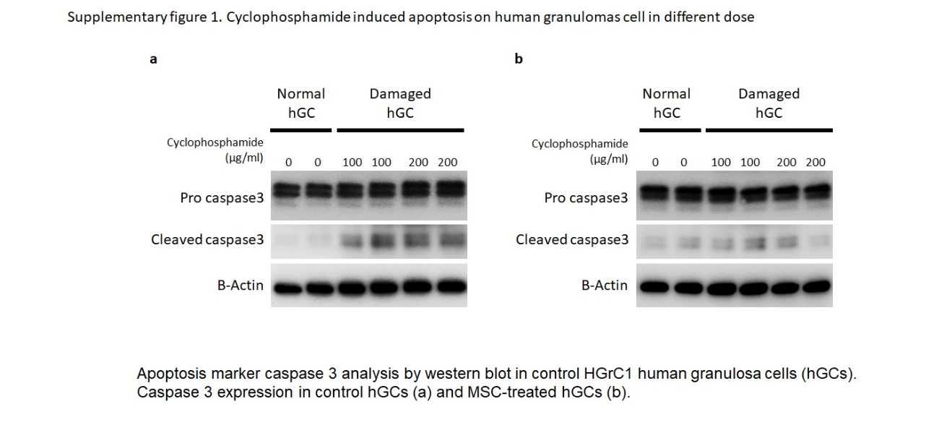

Supplementary Figure 2
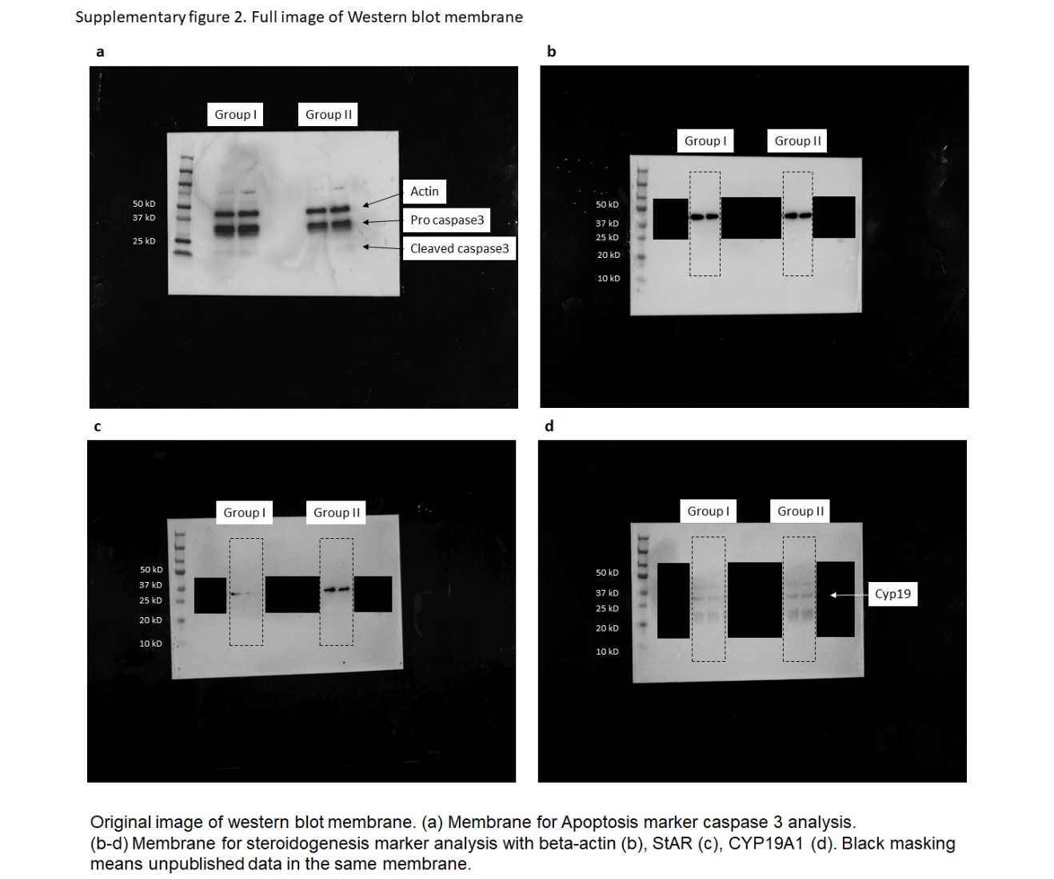
Supplementary Figure 3
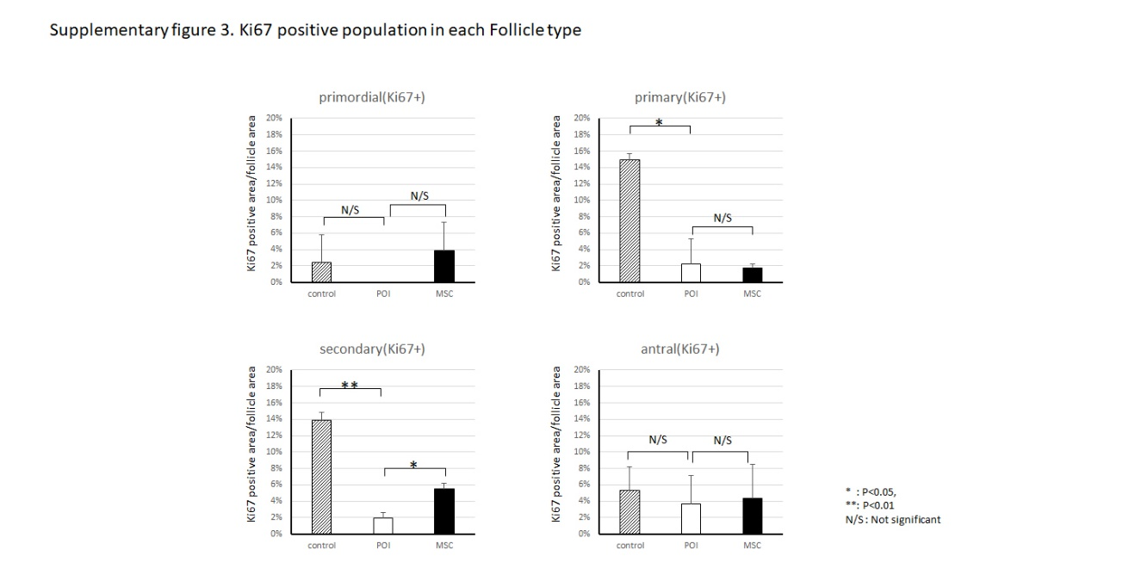

Supplementary Table 1. Characterization of the hMSC CM
 | Average | SD
Volume of hMSC CM (ml) | 5 ml
Number of MSCs for producing CM | 500,000 cells
Time for hMSC CM production | 24 hours
Total protein in 5 ml of hMSC CM  (including other protein or cytokines) | 20.0 μg | 5.52 μg
Exosomes in 5 ml of hMSC CM
Exosome diameter | 255 nm | 21.6 nm
Exosome mass (kDa) | 289,000 kDa | 24,200 kDa
Exosomal protein | 0.8 μg | 0.17 μg
Number of exosome particles | 1.67 × 10¹² | 3.54 × 10¹¹

