A novel highly quantitative and reproducible assay for the detection of anti-SARS-CoV-2 IgG and IgM antibodies
Kenta Noda, Kouki Matsuda, Shigehiro Yagishita, Kenji Maeda, Yutaro Akiyama, Junko Terada-Hirashima, Hiromichi Matsushita, Satoshi Iwata, Kazuto Yamashita, Yusuke Atarashi, Shunsuke Watanabe, Nobuyuki Ide, Tomokazu Yoshida, Norio Ohmagari, Hiroaki Mitsuya, Akinobu Hamada

Corresponding Authors
Akinobu Hamada, PhD.
Division of Molecular Pharmacology, National Cancer Center Research Institute, Tokyo, Japan
E-mail: akhamad@ncc.go.jp

Kenji Maeda, MD. PhD.
Department of Refractory Viral Infections, National Center for Global Health and Medicine (NCGM) Research Institute, Tokyo, Japan
E-mail: kmaeda@ri.ncgm.go.jp

Tomokazu Yoshida, Ph.D.
Central Research Laboratories, Sysmex Corporation, Hyogo, Japan
E-mail: Yoshida.Tomokazu@sysmex.co.jp

Supplemental Table 1. Evaluation of the sensitivity, specificity, and reproducibility of the novel assay
 | N-IgG |  | S-IgG |  | N-IgM |  | S-IgM
Sensitivity (%) | 100.0 |  | 98.3 |  | 71.7 |  | 93.3
Specificity (%) | 99.8 |  | 99.6 |  | 83.4 |  | 93.6
Reproducibility
Level¹ | L | H | L | H | L | H | L | H
n | 10 | 10 | 10 | 10 | 10 | 10 | 10 | 10
Mean (AU/mL) | 3.3 | 24.5 | 4.2 | 35.6 | 6.4 | 158.5 | 4.2 | 33.4
SD | 0.0 | 0.5 | 0.1 | 0.9 | 0.1 | 2.6 | 0.1 | 0.4
CV (%) | 1.4 | 2.1 | 3.3 | 2.5 | 2.1 | 1.7 | 1.2 | 1.2
¹L and H indicate low and high concentration controls.
Abbreviations: CV, coefficient of variation; SD, standard deviation.

Supplemental Table 2. Details of patient and sample information, and antibody titers
Patient ID | Age | Sex | Severity | Early stage sample collection | Convalescent sample collection | N-IgG [AU/mL] |  | S-IgG [AU/mL] |  | N-IgM [AU/mL] |  | S-IgM [AU/mL]
 |  |  |  | (Days from disease onset) | (Days from disease onset) | Early stage | Convalescent | Early stage | Convalescent | Early stage | Convalescent | Early stage | Convalescent
#1 | 65 | M | severe | 9 | 29 | 8.1 | 364.3 | 1.6 | 386.2 | 8.6 | 36.6 | 41.1 | 572.4
#2 | 46 | F | moderate | 6 | 32 | 0.4 | 29.1 | 0.2 | 52.2 | 2.7 | 2.6 | 10.5 | 18.5
#3 | 69 | F | moderate | NA | 35 | NA | 53.7 | NA | 59.2 | NA | 5.9 | NA | 54.7
#4 | 62 | M | moderate | 12 | 38 | 27.7 | 228.7 | 15.8 | 404.7 | 19.3 | 13.8 | 140.6 | 133.0
#5 | 53 | M | severe | 6 | 35 | 49.0 | 404.3 | 0.3 | 161.7 | 7.6 | 11.0 | 5.5 | 101.2
#6 | 55 | M | moderate | 10 | 37 | 123.7 | 162.0 | 30.9 | 51.5 | 80.5 | 41.4 | 155.9 | 159.2
#7 | 46 | M | moderate | NA | 42 | NA | 35.3 | NA | 37.8 | NA | 3.7 | NA | 21.4
#8 | 53 | M | moderate | 7 | 48 | 3.0 | 377.3 | 0.1 | 420.6 | 9.9 | 23.6 | 121.7 | 77.4
#9 | 61 | M | moderate | 13 | 66 | 128.1 | 99.2 | 17.7 | 233.6 | 16.3 | 4.6 | 89.1 | 105.1
#10 | 23 | F | moderate | NA | 37 | NA | 40.1 | NA | 24.5 | NA | 36.0 | NA | 38.0
#11 | 65 | F | moderate | 16 | 38 | 177.9 | 458.7 | 347.3 | 765.6 | 59.8 | 39.7 | 311.6 | 87.8
#12 | 48 | M | moderate | NA | 47 | NA | 12.3 | NA | 1.5 | NA | 2.2 | NA | 1.1
#13 | 31 | M | moderate | 8 | 33 | 13.3 | 301.3 | 0.2 | 60.6 | 25.3 | 116.1 | 9.2 | 178.8
#14 | 53 | M | moderate | 5 | 84 | 0.1 | 104.7 | 0.2 | 50.9 | 1.5 | 15.6 | 0.4 | 195.8
#15 | 46 | M | moderate | 8 | 50 | 0.1 | 282.3 | 0.1 | 91.7 | 1.2 | 10.5 | 1.9 | 10.6
#16 | 44 | M | moderate | NA | 34 | NA | 316.6 | NA | 62.2 | NA | 14.0 | NA | 113.8
#17 | 48 | F | moderate | 12 | 30 | 38.4 | 45.8 | 16.2 | 23.1 | 29.8 | 15.9 | 34.2 | 10.9
Patient ID | Age | Sex | Severity | Early stage sample collection | Convalescent sample collection | N-IgG [AU/mL] |  | S-IgG [AU/mL] |  | N-IgM [AU/mL] |  | S-IgM [AU/mL]
 |  |  |  | (Days from disease onset) | (Days from disease onset) | Early stage | Convalescent | Early stage | Convalescent | Early stage | Convalescent | Early stage | Convalescent
#18 | 53 | M | moderate | 7 | 30 | 2.9 | 166.6 | 2.8 | 356.2 | 3.2 | 194.0 | 0.8 | 300.1
#19 | 53 | M | severe | 3 | 95 | 0.1 | 28.7 | 0.1 | 21.6 | 0.9 | 3.2 | 0.3 | 3.8
#20 | 51 | M | severe | 8 | 52 | 12.1 | 918.4 | 1.2 | 154.2 | 3.6 | 23.4 | 7.0 | 54.6
#21 | 41 | M | moderate | 1 | 86 | 0.1 | 51.4 | 0.1 | 62.2 | 1.0 | 5.5 | 0.2 | 12.7
#22 | 46 | M | moderate | 5 | 65 | 24.1 | 78.4 | 9.9 | 183.4 | 9.3 | 8.6 | 92.8 | 23.8
#23 | 25 | M | moderate | 5 | 62 | 0.2 | 20.5 | 0.2 | 15.6 | 2.6 | 4.0 | 0.9 | 4.5
#24 | 49 | M | moderate | 11 | 63 | 72.8 | 71.0 | 23.4 | 94.4 | 4.6 | 1.9 | 71.7 | 15.4
#25 | 47 | F | moderate | 3 | 56 | 0.2 | 14.5 | 0.2 | 10.7 | 11.9 | 12.0 | 8.5 | 11.4
#26 | 34 | F | moderate | 10 | 42 | 58.0 | 101.9 | 10.4 | 51.3 | 14.1 | 5.5 | 81.9 | 28.0
#27 | 37 | M | severe | 10 | 58 | 17.1 | 75.2 | 3.6 | 380.8 | 8.8 | 21.2 | 50.6 | 111.7
#28 | 67 | M | severe | 10 | 56 | 499.0 | 266.8 | 2.4 | 302.8 | 264.5 | 51.1 | 38.6 | 44.8
#29 | 38 | M | moderate | NA | 61 | NA | 101.6 | NA | 38.4 | NA | 3.7 | NA | 47.5
#30 | 45 | M | moderate | NA | 56 | NA | 97.0 | NA | 28.2 | NA | 4.8 | NA | 69.0
#31 | 43 | M | moderate | NA | 68 | NA | 137.3 | NA | 150.0 | NA | 5.6 | NA | 15.8
#32 | 68 | M | moderate | NA | 25 | NA | 217.2 | NA | 274.0 | NA | 131.4 | NA | 287.1
#33 | 38 | M | moderate | NA | 65 | NA | 179.0 | NA | 200.5 | NA | 14.1 | NA | 10.5
#34 | 78 | M | critical | 13 | 32 | 2.6 | 140.6 | 1.4 | 216.4 | 10.2 | 23.7 | 50.4 | 196.1
#35 | 67 | M | critical | 18 | 34 | 106.9 | 159.2 | 6.3 | 112.5 | 18.4 | 16.2 | 461.7 | 778.7
Patient ID | Age | Sex | Severity | Early stage sample collection | Convalescent sample collection | N-IgG [AU/mL] |  | S-IgG [AU/mL] |  | N-IgM [AU/mL] |  | S-IgM [AU/mL]
 |  |  |  | (Days from disease onset) | (Days from disease onset) | Early stage | Convalescent | Early stage | Convalescent | Early stage | Convalescent | Early stage | Convalescent
#36 | 36 | M | critical | 7 | 36 | 304.9 | 270.4 | 164.7 | 127.3 | 58.4 | 16.7 | 125.8 | 19.1
#37 | 79 | F | severe | 14 | 32 | 241.0 | 139.2 | 337.1 | 242.6 | 62.8 | 26.5 | 487.9 | 171.8
#38 | 34 | M | severe | 6 | 57 | 0.8 | 127.0 | 0.2 | 117.5 | 5.9 | 127.4 | 3.1 | 98.0
#39 | 81 | M | severe | 9 | 31 | 0.3 | 105.6 | 0.3 | 279.1 | 3.4 | 19.1 | 2.8 | 162.0
#40 | 57 | M | critical | 12 | 36 | 0.7 | 106.8 | 0.1 | 433.8 | 7.0 | 43.9 | 15.4 | 72.7
#41 | 71 | M | moderate | 25 | 36 | 3.8 | 85.5 | 2.1 | 184.9 | 11.0 | 35.8 | 111.1 | 301.2
#42 | 53 | M | critical | 11 | 25 | 51.5 | 319.2 | 84.4 | 493.4 | 15.2 | 18.6 | 252.0 | 550.5
#43 | 34 | F | moderate | 8 | 40 | 0.4 | 164.3 | 0.3 | 119.0 | 17.8 | 55.3 | 9.7 | 378.1
#44 | 47 | M | severe | 10 | 34 | 6.6 | 127.9 | 2.2 | 488.5 | 5.7 | 26.7 | 30.0 | 170.9
#45 | 29 | F | moderate | 8 | 30 | 0.9 | 100.9 | 0.7 | 103.9 | 3.6 | 74.2 | 8.4 | 41.8
#46 | 71 | M | severe | 9 | 38 | 2.2 | 127.6 | 0.4 | 97.1 | 2.1 | 6.7 | 9.3 | 30.9
#47 | 44 | M | moderate | 5 | 28 | 0.5 | 254.1 | 0.7 | 309.3 | 2.1 | 36.5 | 3.6 | 500.1
#48 | 50 | M | severe | 13 | 24 | 250.1 | 309.1 | 185.4 | 489.4 | 118.1 | 44.9 | 304.9 | 167.7
#49 | 3 | M | moderate | 8 | 23 | 0.4 | 96.3 | 3.4 | 187.1 | 2.6 | 5.5 | 83.7 | 28.9
#50 | 48 | M | severe | 7 | 37 | 1.4 | 214.7 | 0.5 | 361.2 | 8.7 | 15.7 | 11.8 | 85.9
#51 | 79 | M | severe | 9 | 26 | 5.2 | 268.2 | 0.4 | 186.5 | 1.8 | 10.0 | 2.1 | 86.2
#52 | 57 | M | severe | 10 | 39 | 4.7 | 127.1 | 0.2 | 234.8 | 129.8 | 419.9 | 7.2 | 65.8
#53 | 71 | M | moderate | 13 | 35 | 188.8 | 283.2 | 90.0 | 720.4 | 42.8 | 51.5 | 335.6 | 148.2
Patient ID | Age | Sex | Severity | Early stage sample collection | Convalescent sample collection | N-IgG [AU/mL] |  | S-IgG [AU/mL] |  | N-IgM [AU/mL] |  | S-IgM [AU/mL]
 |  |  |  | (Days from disease onset) | (Days from disease onset) | Early stage | Convalescent | Early stage | Convalescent | Early stage | Convalescent | Early stage | Convalescent
#54 | 87 | M | moderate | 9 | 20 | 76.8 | 193.4 | 10.7 | 236.9 | 30.5 | 64.3 | 118.6 | 542.9
#55 | 22 | M | moderate | 5 | 33 | 87.1 | 108.8 | 1.1 | 24.1 | 12.5 | 5.6 | 9.8 | 7.3
#56 | 45 | M | severe | 11 | 30 | 2.5 | 270.6 | 0.3 | 258.0 | 49.6 | 259.8 | 12.3 | 316.0
#57 | 74 | M | severe | 13 | 26 | 88.7 | 358.1 | 5.2 | 149.1 | 129.5 | 1685.7 | 34.2 | 68.0
#58 | 70 | M | severe | 12 | 34 | 107.1 | 720.0 | 0.9 | 513.1 | 5.7 | 40.9 | 4.5 | 28.7
#59 | 85 | F | severe | 6 | 22 | 0.1 | 176.1 | 0.2 | 156.9 | 1.3 | 14.8 | 0.7 | 140.6
#60 | 85 | F | moderate | 6 | 28 | 0.3 | 88.2 | 0.3 | 101.1 | 2.9 | 387.8 | 1.9 | 99.0
*NA: not applicable
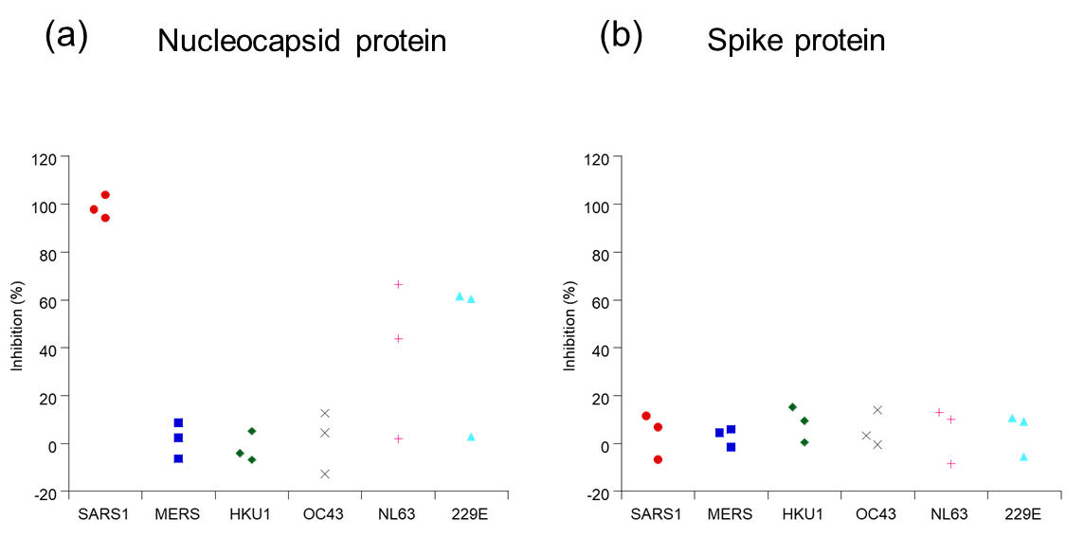
Supplemental Figure 1: Specificity of the SARS-CoV-2 antibody test. The inhibition rate with SARS-CoV-2 antigen was set at 100%, and crossover by other human coronavirus-derived antigens was assessed. Inhibition rate of nucleocapsid (a) and spike (b) proteins is shown. Common human coronaviruses: 229E and NL63 (alpha coronavirus), HKU1 and OC43 (beta coronavirus). MERS, Middle East respiratory syndrome; SARS1, severe acute respiratory syndrome.

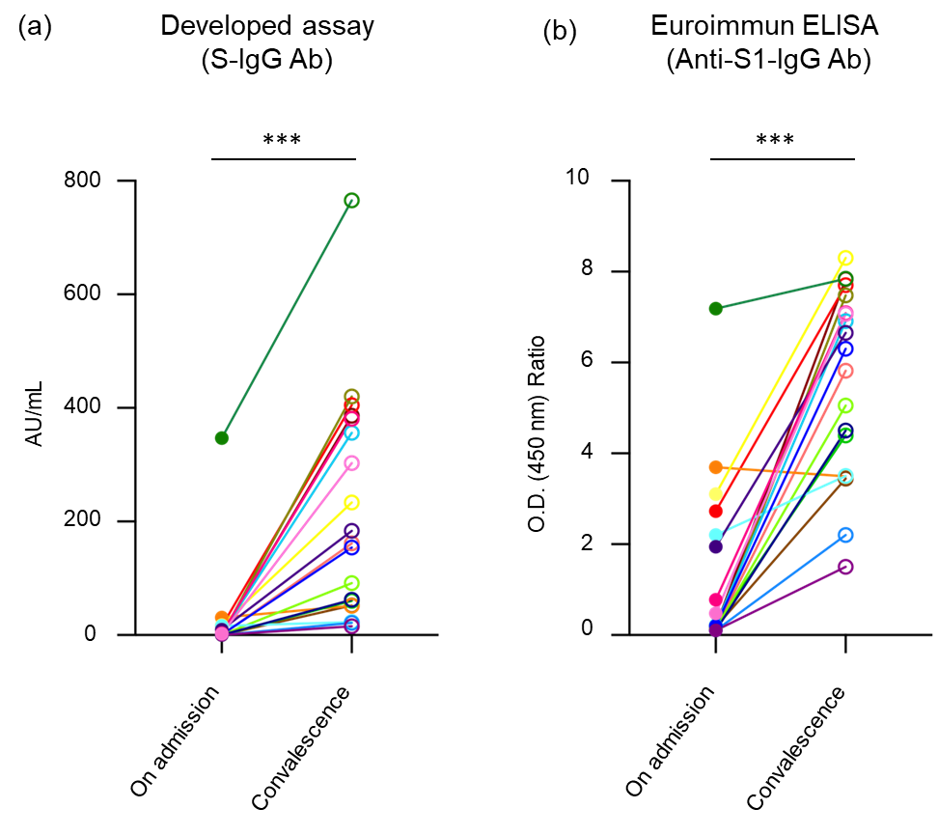

Supplemental Figure 2: Comparison between the high-sensitivity chemiluminescence enzyme immunoassay (HISCL) analysis system and a commercially available enzyme-linked immunosorbent assay (ELISA). The amounts of anti-SARS-CoV-2-IgG in the serum of 19 patients were measured with a commercial ELISA kit [Anti-SARS-CoV-2 ELISA (IgG) (EUROIMMUN AG, Luebeck, Germany)], and the data were compared with those of the novel HISCL analysis system. Values for each patient on admission and at a convalescence time point are connected by a line. Significant differences between SARS-CoV-2-IgG levels were determined upon using both assays (at the time of admission as well as convalescence) were observed. ***P > 0.001.

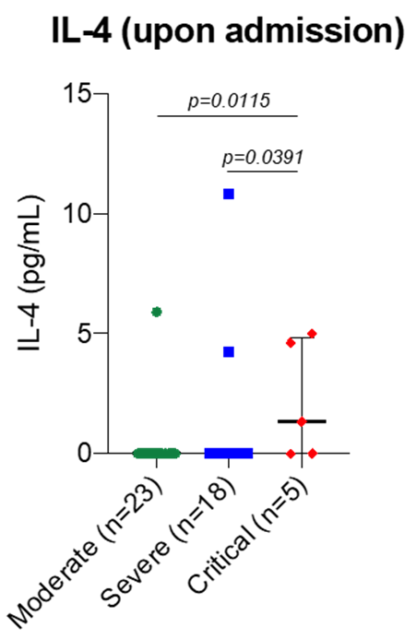

Supplemental Figure 3: Relationship between plasma IL-4 protein level and the severity status of patients.
The plasma IL-4 level in the blood of each patient on admission was measured and analyzed for the relationship with the severity status of patient.

