Plutonium dioxide particle imaging using a high-resolution alpha imager for radiation protection
Yuki Morishita^{1,*}, Shunsuke Kurosawa^{2,3}, Akihiro Yamaji^{2,3}, Masateru Hayashi⁴, Makoto Sasano⁴, Taisuke Makita⁴, and Tetsushi Azuma⁴

Supplementary Information

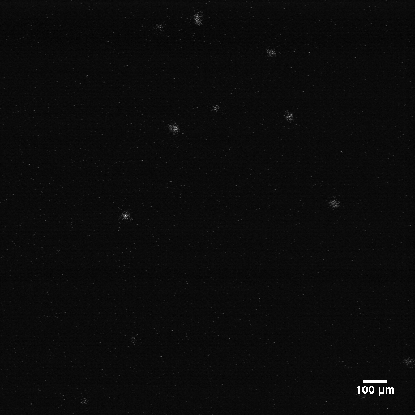
Figure 3 Supplementary Figure S1

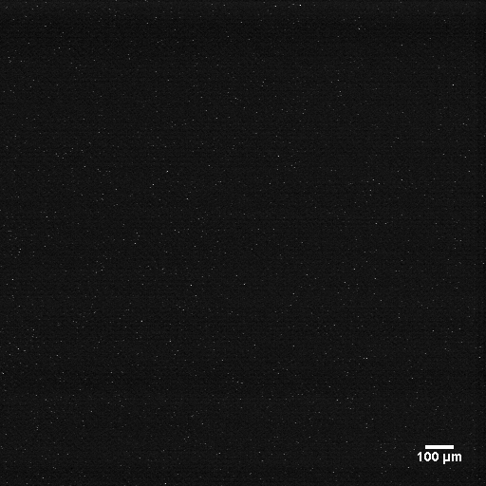
Figure 4 Supplementary Figure S2

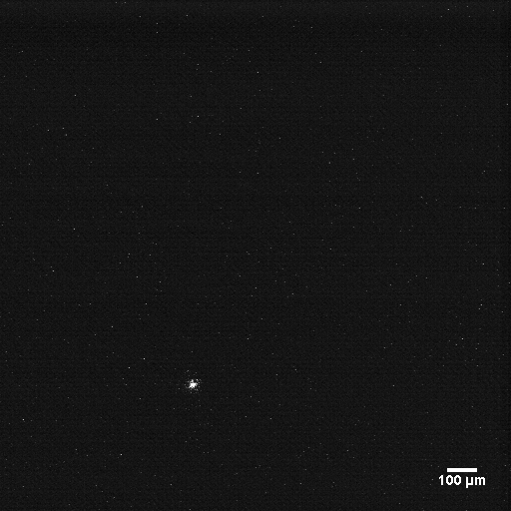
Figure 5 Supplementary Figure S3

