Supplementary Figure S1

Ex vivo characterization of Breg cells in patients with chronic Chagas disease
Magalí C. Girard¹, Gonzalo R. Acevedo¹, Micaela S. Ossowski¹, Marisa Fernández², Yolanda Hernández², Raúl Chadi³, Karina A. Gómez*¹.
¹Laboratorio de Inmunología de las Infecciones por Tripanosomátidos. Instituto de investigaciones en Ingeniería Genética y Biología Molecular “Dr. Hector N. Torres” (INGEBI-CONICET).
²Instituto Nacional de Parasitología “Dr. Mario Fatala Chabén”.
³Hospital Nacional de Agudos “Dr. Ignacio Pirovano”.

*email: gomez@dna.uba.ar.

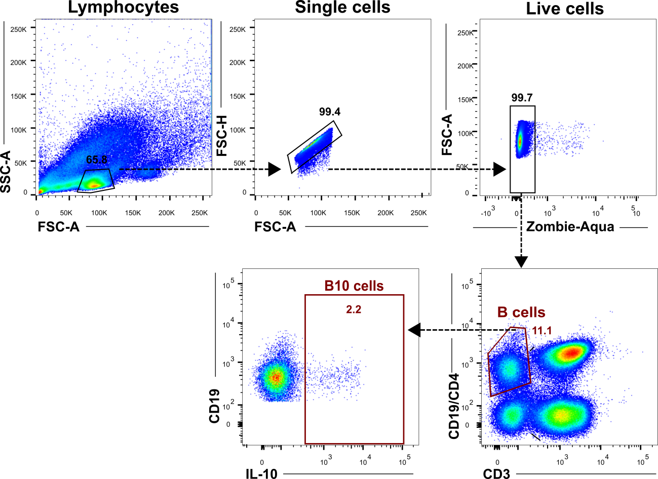
Supplementary Figure S1: General gating strategy used to define B and B10 lymphocyte populations to be studied in CCD patients and non-infected donors. Representative plots obtained by the manual gating of a sample by flow cytometry, based on the expression of CD3, CD4, CD19 and IL-10 markers. Cells were gated according to forward scatter/side scatter area (FSC-A/SSC-A) criteria to identify the total lymphocytes population. Non-single cell events and cells with compromised viability were excluded by gating on the FSC-A/FSC-H and Zombie Aqua channels, respectively. B-cells were gated using CD19 and CD3 markers (CD3⁻CD19⁺ population). Isotype controls were used to determine cut points for each marker. IL-10⁺ cells were gated according to subject- and condition-matched FMO control tubes. B and B10 cells were further sub-gated according to CD24, CD38 and CD27 markers to identify the phenotypical distribution ex vivo of these populations. Further gating analysis is shown in the corresponding figures. Manual data analysis was performed using the FlowJo software.

