Title:

Elevated levels of mitochondrial CoQ₁₀ induce ROS-mediated apoptosis in pancreatic cancer

Author Block: Tulin Dadali^{†1}, Anne R. Diers^{†1}, Shiva Kazerounian¹, Senthil K. Muthuswamy², Pallavi Awate¹, Ryan Ng¹, Saie Mogre¹, Carrie Spencer¹, Katerina Krumova¹, Hannah E. Rockwell¹, Justice McDaniel¹, Emily Y. Chen¹, Fei Gao¹, Karl T. Diedrich¹, Vijetha Vemulapalli¹, Leonardo O. Rodrigues¹, Viatcheslav R. Akmaev¹, Khampaseuth Thapa¹, Manuel Hidalgo², Arindam Bose², Vivek K. Vishnudas¹, A. James Moser², Elder Granger¹, Michael A. Kiebish¹, Stephane Gesta¹, Niven R. Narain¹, Rangaprasad Sarangarajan*¹
†Designates joint first authorship
¹BERG LLC, Framingham, MA, 01701, USA
²Department of Medicine, Cancer Research Institute, Beth Israel Deaconess Medical Center, Harvard Medical School, Boston, MA, 02215, USA.

Corresponding Author
Rangaprasad Sarangarajan, Ph.D.
500 Old Connecticut Path, Bldg B, 3rd Floor
Framingham, MA 01710
Email: Rangaprasad.Sarangarajan@BergHealth.com
Phone: 617-588-2164

Supplemental Figures and Table Legends
Supplemental Table 1. Cellular delivery of CoQ₁₀ by BPM31510 accumulates in the mitochondria of MIA PaCa-2 and PANC1 cells in a time-dependent manner. Cells were treated with BPM31510 (EC₅₀) for 24 or 48 h, washed, and lysed. Subcellular fractionation was carried out by sucrose gradient centrifugation. Total CoQ₁₀ levels were measured by LC MS/MS. The data represent the means + SEM of total protein (nmol/mg) from six independent experiments. The data were analysed by one-way ANOVA followed by Tukey’s post hoc test.
Supplemental Figure 1. Time-dependent substrate-specific driven H₂O₂ production using the Amplex® Red assay. (a) Dose and time effects of menadione on pyruvate-driven H₂O₂ production assessed by modified Amplex® Red assay in MIA PaCa-2 pancreatic cancer cells. The H₂O₂ standard curve is shown in the inset. The data represent three independent experiments. (b) Dose effects of menadione on pyruvate-mediated H₂O₂ generation at 90 min post treatment. (c-d) Kinetic graphs illustrating substrate-specific H₂O₂ generation with or without BPM31510 treatment assessed over 90 min in (c) MIA PaCa-2 and (d) PANC1 cells. UD = undetected.
Supplemental Figure 2. Tumour enrichment and substrate driven respiration. (a) Enrichment of epithelial cancer cells from immunocompromised mice with MIA PaCa-2 xenografts. Representative scatter plots showing the gating strategy of fibroblast specific (FSP-1), CD44 and CD31-positive stained cells. (b) Table reporting the percentage of CD44-positive cells plated for subsequent Seahorse assays. Cells plated to measure substrate-driven respiration were predominantly from the epithelial-derived cancer cell population. (c) Complex II-dependent and (d) Complex IV-dependent respiration assessed in tumours from control and BPM31510-treated mice. The data represent mean + SEM of n=6 saline-treated (control) and n=5 BPM31510-treated mice.
Supplemental Figure 3. PDO image processing source code for segmentation.
Supplemental Figure 4. Regression models to test for effect of treatment on PDO size. A linear regression model was built for day 3 (left panel) and day 7 (right panel) time points using the glm() function from the base R library. The dose was modelled as a binary variable: ‘Dose – no treatment’ and ‘Dose – any treatment’. The models indicate that the PDOs tend to be larger when there is no treatment and that the difference is statistically significant based on their p-value.

Supplemental Table 1

 | 24 h |  |  |  | 48 h
 | Untreated |  | EC₅₀ |  | Untreated |  | EC₅₀
 | Mean (nmol/mg) ± SEM | % of Total | Mean (nmol/mg) ± SEM | % of Total | Mean (nmol/mg) ± SEM | % of Total | Mean (nmol/mg) ± SEM | % of Total
Cytosol
MIA PaCa-2 | 0.11 ± 0.03 | 18.0% | 5.17 ± 0.54* | 9.7% | 0.19 ± 0.04 | 35.2% | 14.07 ± 2.54^{****,+++} | 8.5%
PANC1 | 0.09 ± 0.01 | 15.2% | 4.06 ± 0.31**** | 7.9% | 0.08 ± 0.01 | 12.0% | 7.01 ± 0.55^{****,++++} | 6.3%
Nucleus/Plasma membrane
MIA PaCa-2 | 0.18 ± 0.03 | 30.2% | 22.47 ± 2.97* | 42.0% | 0.14 ± 0.02 | 26.2% | 62.99 ± 12.19^{****,+++} | 38.2%
PANC1 | 0.21 ± 0.02 | 40.6% | 17.72 ± 2.03* | 34.7% | 0.31 ± 0.04 | 41.3% | 39.60 ± 8.79^{****,++} | 35.5%
Mitochondria
MIA PaCa-2 | 0.31 ± 0.13 | 51.8% | 25.90 ± 3.00* | 48.4% | 0.21 ± 0.01 | 38.7% | 87.83 ± 14.06^{****,++++} | 53.3%
PANC1 | 0.22 ± 0.21 | 44.1% | 29.34 ± 2.39** | 57.4% | 0.35 ± 0.04 | 46.7% | 64.80 ± 10.73^{****,+++} | 58.2%
**** p<0.0001 vs. untreated; +, p<0.05, ++ p<0.01, and +++ p<0.001 vs. 24 hr EC₅₀

Supplemental Figure 1
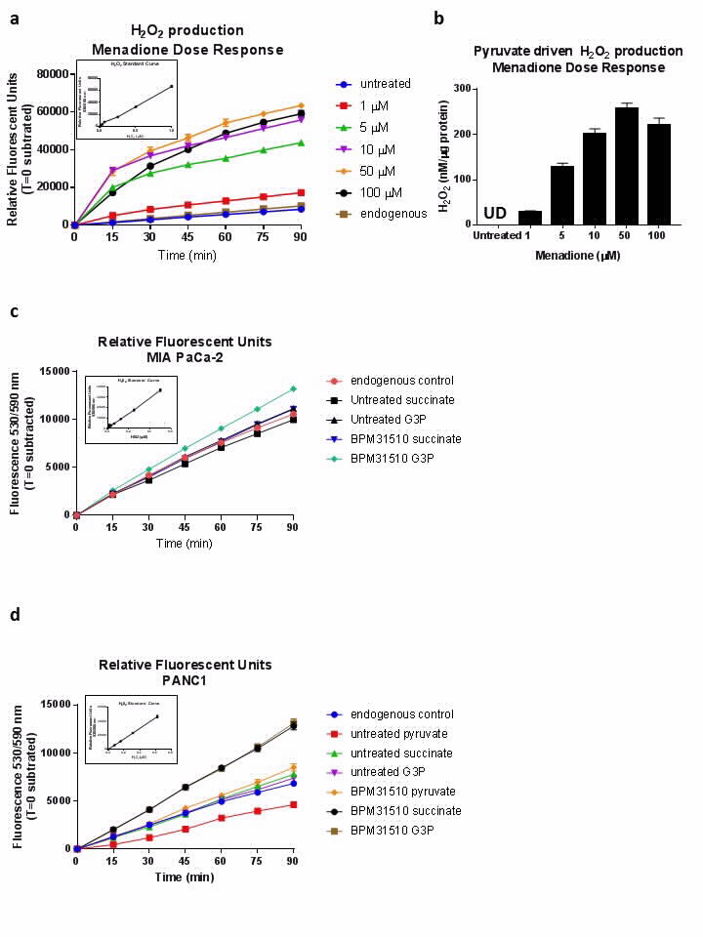
Supplemental Figure 2
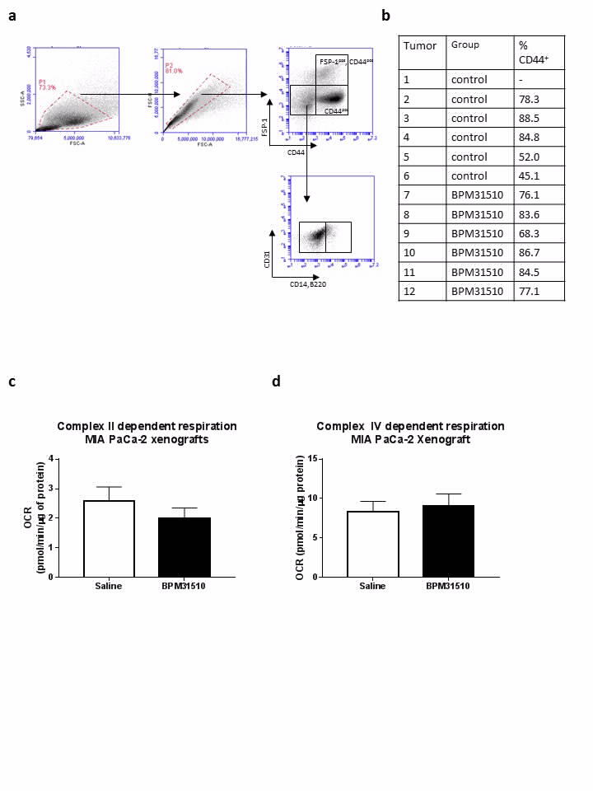

Supplemental Figure 3
The Python Script for the image segmentation portion of the source code is:
self._gray = cv2.cvtColor(self._img, cv2.COLOR_BGR2GRAY)
blurred = cv2.GaussianBlur(self._gray, (3, 3), 0)
edges = cv2.Canny(blurred, 25, 100, 7)
# blend edges together into objects
blurred_edges = cv2.GaussianBlur(edges, (7, 7), 0)
kernel = np.ones((6, 6), np.uint8)
blended_objects = cv2.morphologyEx(blurred_edges, cv2.MORPH_CLOSE, kernel, iterations=2)
# noise removal
kernel = np.ones((15, 15), np.uint8)
denoised_blends = cv2.morphologyEx(blended_objects, cv2.MORPH_OPEN, kernel, iterations=1)
filled_blends = fill_holes(denoised_blends)
fg_components = cv2.connectedComponentsWithStats(filled_blends, connectivity=self._connectivity)

Supplemental Figure 4
