Supplementary materials
A temporal hierarchical feedforward model explains both the time and the accuracy of object recognition
Hamed Heidari-Gorji^{1,2}, Reza Ebrahimpour^{1,2*}, Sajjad Zabbah^{2**},
¹ Faculty of Computer Engineering, Shahid Rajaee Teacher Training University, P.O. Box: 16785-163, Tehran, Iran.
² School of Cognitive Sciences, Institute for Research in Fundamental Sciences (IPM), P.O. Box: 19395-5746, Tehran, Iran.
*Corresponding author. Tel.: +9821 22294035; fax: +9821 22280352. E-mail address: ebrahimpour@ipm.ir, rebrahimpour@sru.ac.ir
**Co-Corresponding author. E-mail address: s.zabbah@ipm.ir,
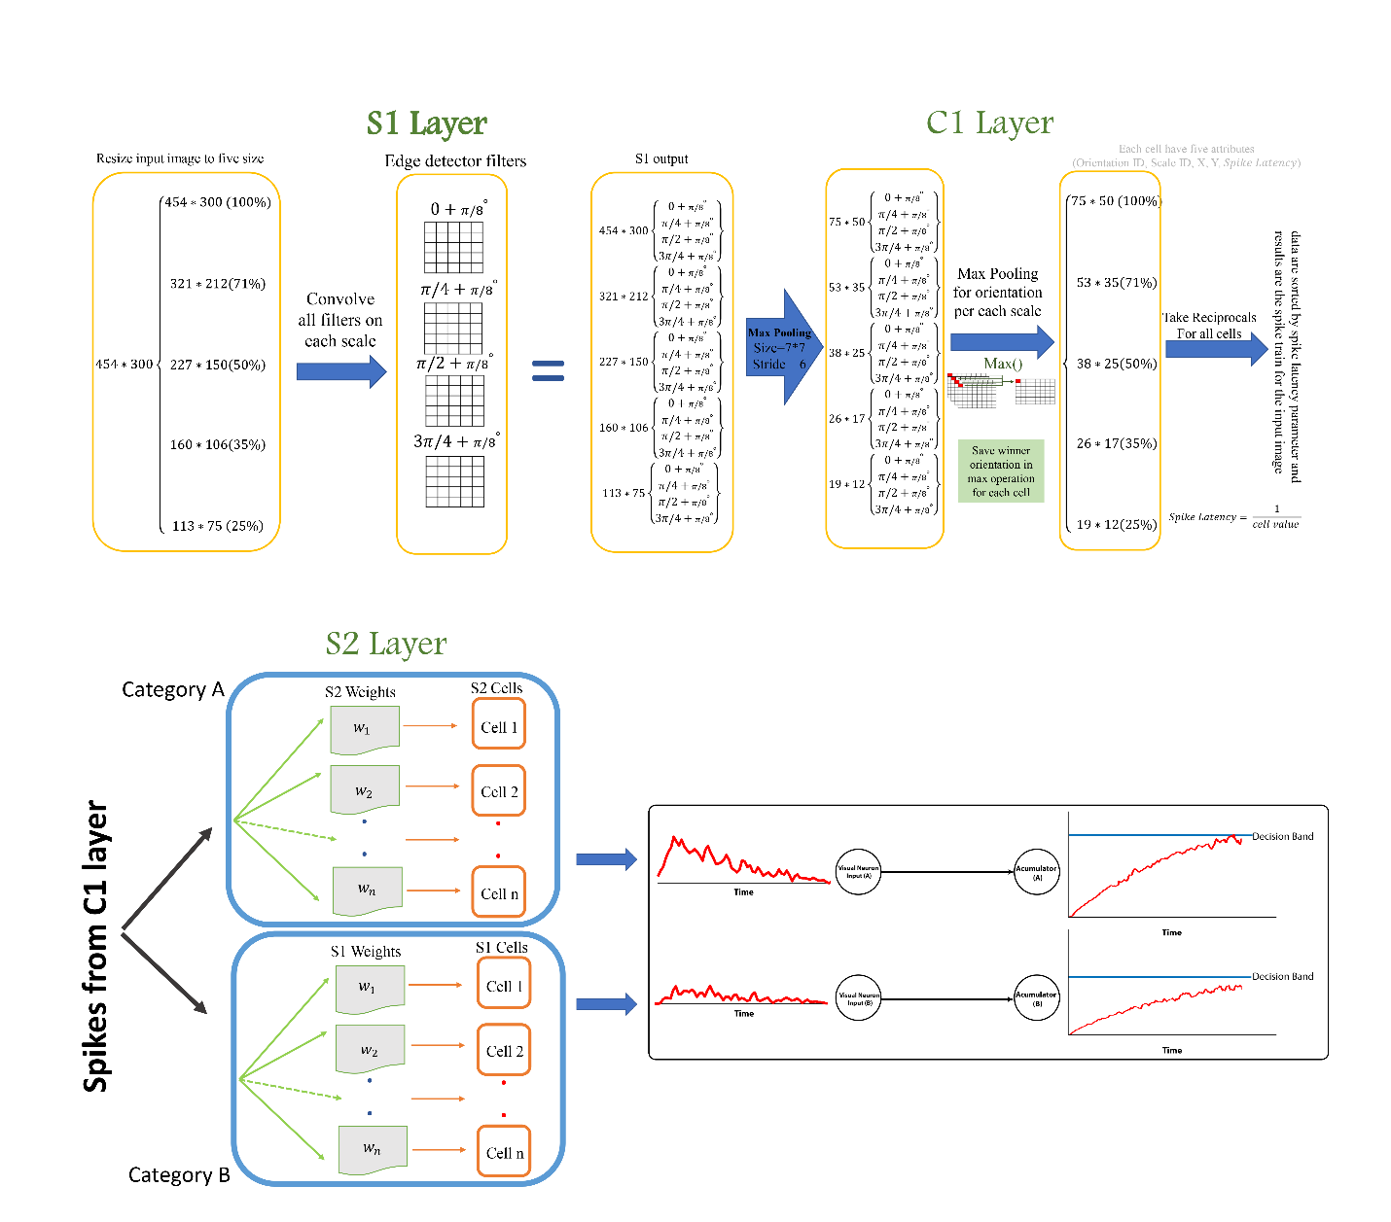
Figure S1. Detailed diagram of the proposed model.

Table S1. Optimized parameters for decision making layer of the model
Model time scale | Face threshold | House threshold | Non-decision time
0.32 | 27.38 | 68.73 | 445.92

