Microsatellite analysis reveals low genetic diversity in managed populations of the critically endangered gharial (Gavialis gangeticus) in India
Surya Prasad Sharma¹, Mirza Ghazanfarullah Ghazi¹, Suyash Katdare¹, Niladri Dasgupta¹, Samrat Mondol¹, Sandeep Kumar Gupta¹ and Syed Ainul Hussain^{1*}
¹ Wildlife Institute of India, P.O. Box # 18, Chandrabani, Dehra Dun, 248002, Uttarakhand, India.
*Corresponding author- Syed Ainul Hussain, E-mail: hussain@wii.gov.in

Table S1: List of microsatellite markers screened for population genetic study. * No amplification.
Locus | Repeats motif | Number of alleles | Allele Range(bp) | T_{a} (⁰C) | Species | Reference
G13_8 | tetra | 8 | 330-382 | 60 | Gavialis gangeticus | [1]
G13_5 | tetra | 3 | 256-264 | 56 | Gavialis gangeticus | [1]
G13_14 | tetra-di-tetra | 3 | 308-312 | 60 | Gavialis gangeticus | [1]
G13_2 | tetra | 2 | 290-294 | 60 | Gavialis gangeticus | [1]
G13_7 | tetra | 2 | 200-204 | 60 | Gavialis gangeticus | [1]
G13_16 | tetra-di | 2 | 255-265 | 60 | Gavialis gangeticus | [1]
Cj16 | di | 2 | 153-165 | 60 | Crocodylus johnstoni | [2]
G13_1 | tri-di | 1 | -- | 60 | Gavialis gangeticus | [1]
G13_6 | tetra | 1 | -- | 60 | Gavialis gangeticus | [1]
G13_11 | tetra-di | 1 | -- | 56 | Gavialis gangeticus | [1]
G13_15 | tetra | 1 | -- | 56 | Gavialis gangeticus | [1]
G13_18 | di-di | 1 | -- | 60 | Gavialis gangeticus | [1]
CpSSR12 | di | 1 | -- | 60 | Crocodylus palustris | [3]
4HDZ35 | di | 1 | -- | 60 | Crocodylus mindorensis | [4]
CUD68 | di | 1 | -- | 62 | Crocodylus acutus | [5]
4HDZ27 | di | 1 | -- | 60 | Crocodylus mindorensis | [4]
Cp309 | tetra | 1 | -- | 56 | Crocodylus porosus | [5]
TGE2 | di | 1 | -- | 56 | Alligator sinensis | [6]
CpSSR13* | di | -- | -- | -- | Crocodylus palustris | [3]
CpSSR14* | di | -- | -- | -- | Crocodylus palustris | [3]
CpP107* | tetra | -- | -- | -- | Crocodylus porosus | [5]
CpP121* | tetra | -- | -- | -- | Crocodylus porosus | [5]
CpP1401* | tetra | -- | -- | -- | Crocodylus porosus | [5]
4HDZ391* | di | -- | -- | -- | Crocodylus mindorensis | [4]
Amiu-102* | di | -- | -- | -- | Alligator mississippiensis | [7]
Amiu-202* | di | -- | -- | -- | Alligator mississippiensis | [8]
CpP1306* | tetra | -- | -- | -- | Crocodylus porosus | [5]

Table S2: Amplification success and error rates calculated for polymorphic loci. Amplification Success (AS); Quality Index per locus (QI); Allele Drop Out (ADO); False Allele (FA) and Null Allele (NA).
Populations | Chambal River |  |  |  |  | Girwa River
Locus | AS (%) | QI | ADO | FA | NA | AS (%) | QI | ADO | FA | NA
G13_7 | 93.65 | 0.88 | 0.07 | 0.02 | 0.02 | 98.86 | 0.88 | 0.11 | 0.03 | 0.00
Cj16 | 93.53 | 0.89 | 0.02 | 0.02 | 0.00 | 84.86 | 0.85 | 0.00 | 0.00 | 0.00
G13_2 | 97.63 | 0.90 | 0.03 | 0.03 | 0.00 | 95.73 | 0.91 | 0.03 | 0.03 | 0.00
G13_5 | 97.45 | 0.83 | 0.06 | 0.04 | 0.00 | Monomorphic
G13_8 | 95.87 | 0.82 | 0.02 | 0.10 | 0.00 | 97.14 | 0.93 | 0.01 | 0.03 | 0.05
G13_14 | 95.90 | 0.85 | 0.04 | 0.04 | 0.02 | 97.13 | 0.92 | 0.03 | 0.04 | 0.05
G13_16 | 98.62 | 0.86 | 0.06 | 0.03 | 0.00 | 98.56 | 0.87 | 0.08 | 0.09 | 0.00
Mean | 96.09 | 0.86 | 0.04 | 0.04 | 0.01 | 95.38 | 0.89 | 0.04 | 0.04 | 0.02
SE | 0.74 | 0.01 | 0.01 | 0.01 | 0.004 | 2.15 | 0.01 | 0.02 | 0.01 | 0.009

Table S3: The table information on nesting site, geographic coordinates and number of samples collected from each nesting site.

Population | Nesting site | Latitude | Longitude | Number of samples | Number of unique individual(s)
Chambal | Baroli | 26.10360 | 76.94320 | 44 | 32
Chambal | Dangbasai | 26.54073 | 77.75784 | 41 | 26
Chambal | Pali | 25.84446 | 76.56175 | 29 | 21
Chambal | Jaitpura | 26.79163 | 78.10700 | 8 | 6
Chambal | Kuthiyana | 26.70554 | 78.09555 | 17 | 11
Chambal | Barsala | 26.78505 | 78.17372 | 12 | 9
Chambal | Pureni | 26.75853 | 78.10860 | 6 | 5
Chambal | Shankarpura | 26.66739 | 78.07249 | 7 | 5
Chambal | Nadigaon | 26.14282 | 77.00317 | 27 | 16
Chambal | Din-ka-pura | 26.79148 | 78.72742 | 2 | 1
Chambal | Tigri | 26.69270 | 78.00359 | 15 | 14
Chambal | Rijentha | 26.23728 | 77.17841 | 2 | 1
Chambal | Bagadia | 26.75853 | 78.10860 | 4 | 4
Chambal | Bharrah | 26.40531 | 77.44702 | 4 | 4
Chambal | Radi | 26.23728 | 77.17841 | 4 | 1
Chambal | Reha | 26.82004 | 78.27239 | 10 | 6
Girwa | Pathrahna | 28.32706 | 81.18586 | 8 | 5
Girwa | Ambah | 28.31850 | 81.17061 | 8 | 7
Girwa | Bhawanipur | 28.33372 | 81.14678 | 100 | 54
Total |  |  |  | 348 | 228

Table S4: The table contains information regarding the type and origin of samples used in the current study. Unique: one sample per clutch; Sibling: more than one samples per clutch and Unknown: if the clutch information is not known.

Population | Chambal river |  |  | Girwa river
Sample Origin | Total sample size | Tissue  (tail scutes) | Hatchling chorioallantoic membranes | Total sample size | Tissue  (tail scutes) | Hatchling chorioallantoic membranes
Unique | 49 | 15 | 34 | -- | -- | --
Siblings | 56 | 3 | 53 | 82 | 07 | 75
No clutch information | 127 | 47 | 80 | 34 | 04 | 30
Total | 232 | 65 | 167 | 116 | 11 | 105

Fig. S1: Quality index per sample for the Girwa river. The samples with mean quality index ≥ 0.75 were used for analysis.

Fig. S2: Quality index per sample for the Chambal river. The samples with mean quality index ≥ 0.75 were used for analysis.

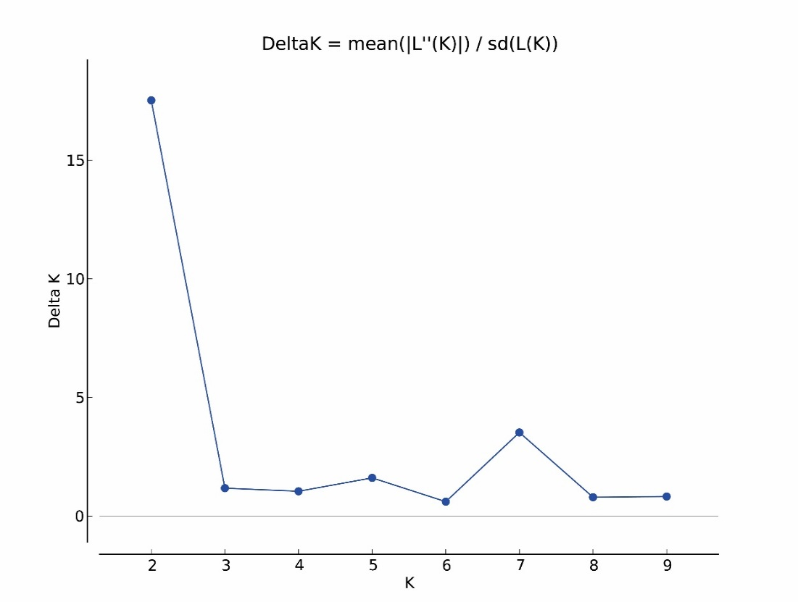
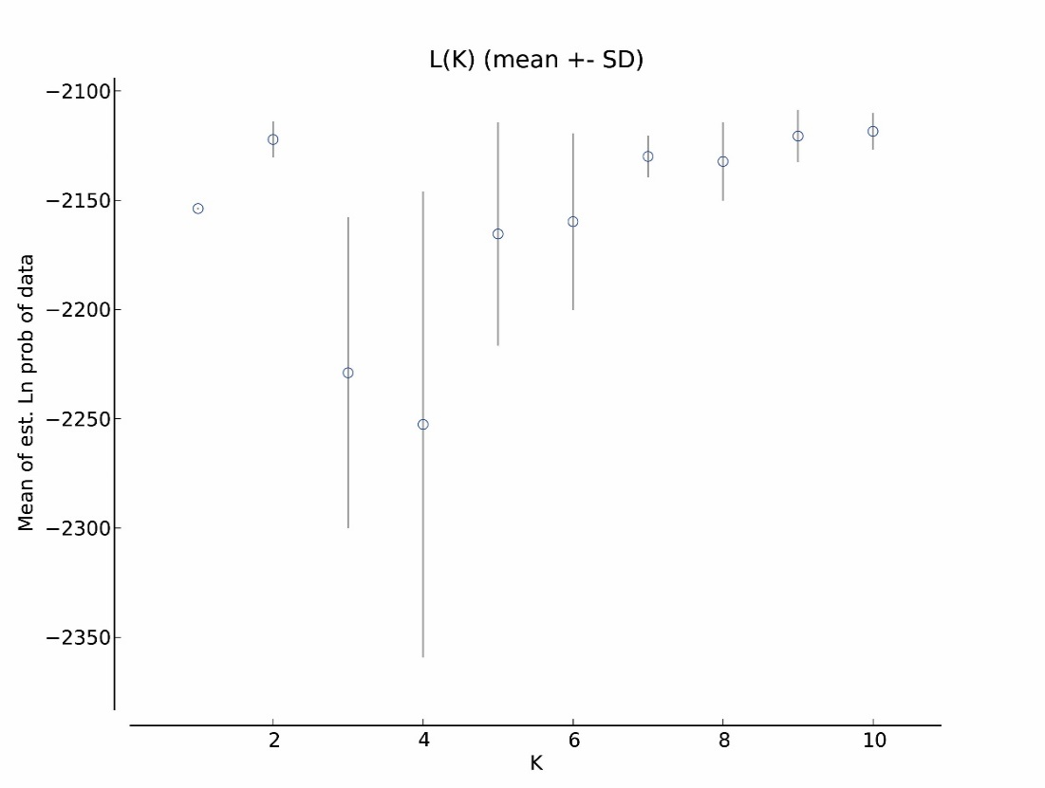
b)
a)
Fig. S3: The plot of a) the highest mean likelihood L(K) and b) Delta K using sampling location as a priori.

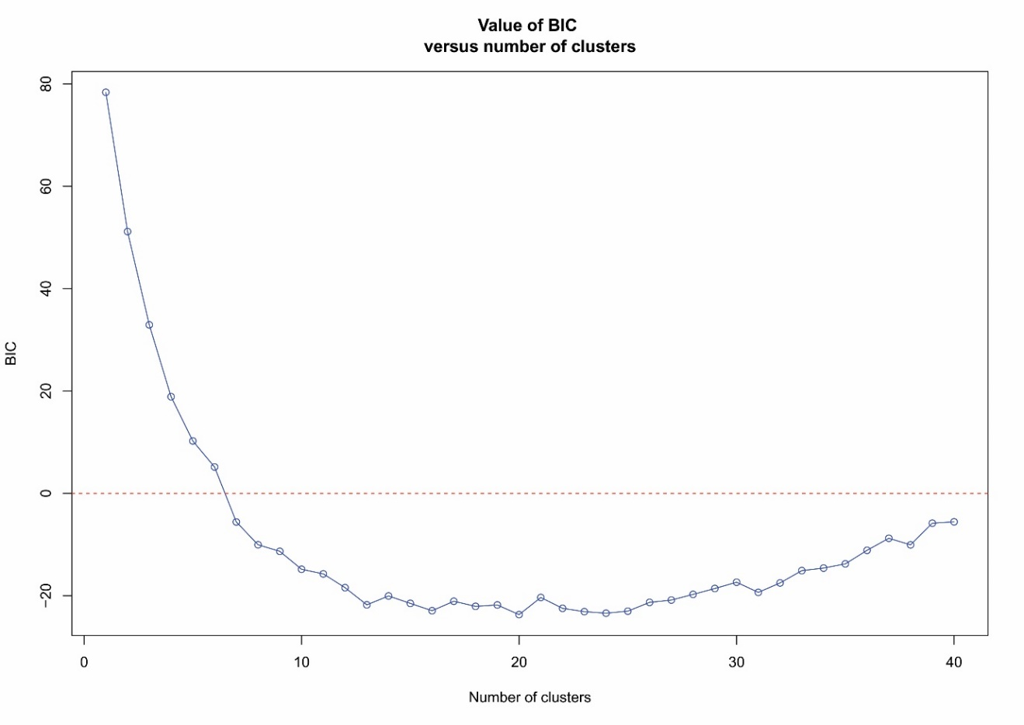
Fig. S4: The of the BIC against the number of clusters.

References:
1. Jogayya, K. N., Meganathan, P. R., Dubey, B. & Haque, I. Novel microsatellite DNA markers for Indian Gharial (Gavialis gangeticus). Conservation Genetics Resources 5, 787–790 (2013).
2. Fitzsimmons, N. N. et al. Microsatellite markers for Crocodylus: new genetic tools for population genetics, mating system studies and forensics. in Crocodilian Biology and Evolution (eds. Grigg, G. C., Seebacher, F. & Franklin, C. E.) 51–57 (Surrey Beatty & Sons, Chipping Norton, 2000).
3. Aggarwal, R. K., Lalremruata, A. & Dubey, B. Development of fourteen novel microsatellite markers of Crocodylus palustris, the Indian mugger, and their cross-species transferability in ten other crocodilians. Conservation Genetics Resources 7, 197–200 (2014).
4. Hinlo, M. R. P. et al. Population genetics implications for the conservation of the Philippine Crocodile Crocodylus mindorensis Schmidt, 1935 (Crocodylia: Crocodylidae). Journal of Threatened Taxa 6, 5513–5533 (2014).
5. Miles, L. G., Isberg, S. R., Moran, C., Hagen, C. & Glenn, T. C. 253 Novel polymorphic microsatellites for the saltwater crocodile (Crocodylus porosus). Conservation Genetics 10, 963–980 (2009).
6. Yu, D. et al. Analysis of genetic variation and bottleneck in a captive population of Siamese crocodile using novel microsatellite loci. Conservation Genetics Resources 3, 217–220 (2011).
7. Glenn, T. C. et al. Characterization of Microsatellite DNA Loci in American Alligators. Copeia 3, 591–601 (1998).
8. Davis, L. M. et al. Microsatellite DNA analyses support an east-west phylogeographic split of American alligator populations. Journal of Experimental Zoology 294, 352–372 (2002).

