All-Trans Retinoic Acid and Protein Kinase C α/β1 inhibitor combined treatment targets cancer stem cells and impair breast tumor progression
Damian Emilio Berardi^{1,2}, Lizeth Ariza Bareño¹, NataliaAmigo¹, Luciana Cañonero³, Maria de las Nieves Pelagatti¹, Andrea Nora Motter⁴, María Agustina Taruselli¹, María Inés Díaz Bessone^{1,6}, Stefano Martin Cirigliano^{1,5}, Alexis Edelstein⁴, María Giselle Peters^{1,7}, Miriam Diament¹, Alejandro Jorge Urtreger^{1,7} and Laura Beatriz Todaro^{1,7}.
¹ Universidad de Buenos Aires, Instituto de Oncología Ángel H. Roffo, Área Investigación, Buenos Aires, Argentina.
^{2.}Current address: The Ben May Department for Cancer Research, The Gordon Center for Integrative Sciences, The University of Chicago, Chicago, IL, USA.
³ Universidad de Buenos Aires, Facultad de Ciencias Exactas y Naturales, Departamento Química Biológica, CONICET- Universidad de Buenos Aires, Instituto de Química Biológica de la Facultad de Ciencias Exactas y Naturales (IQUIBICEN), Buenos Aires, Argentina
⁴ Unidad Operativa Centro de Contención Biológica de la Administración Nacional de Laboratorios e Institutos de Salud (UOCCB-ANLIS) “Dr. Carlos G. Malbrán”, Buenos Aires, Argentina.
⁵ Current address: Meyer Cancer Center, Weill Cornell Medicine, New York, NY, USA.
⁶ Current address: Universidad Nacional de San Martín, Instituto de Nanosistemas, Campus Miguelete, San Martín, Argentina.
⁷Member of the Scientific Research Career of the Consejo Nacional de Investigaciones Científicas y Técnicas (CONICET), Buenos Aires, Argentina.
Contact information:
- Damian Emilio Berardi E-mail: damianberardi@gmail.com
- Lizeth Ariza Bareño E-mail: LISA19111@hotmail.com
- Natalia Amigo E-mail: nlamigo82@gmail.com
- Luciana Cañonero E-mail: lucianacanonero@gmail.com
- Maria de las Nieves Pelagatti E-mail: marinipelagatti@yahoo.com.ar
- Andrea Nora Motter E-mail: andreamotter@gmail.com
- María Agustina Taruselli E-mail: ma.taruselli@gmail.com
- María Inés Díaz Bessone E-mail: ine.db84@gmail.com
- Stefano Martin Cirigliano E-mail: smcirigliano@gmail.com
- Alexis Edelstein E-mail: Aedel@anlis.gov.ar
- María Giselle Peters E-mail: mpeters@fmed.uba.ar
- Miriam Diament E-mail: miriam.diament@gmail.com
- Alejandro Jorge Urtreger E-mail: urtreger@yahoo.com.ar
- *Laura Beatriz Todaro E-mail: ltodaro@gmail.com / ltodaro@institutoroffo.uba.ar

SUPPLEMEMENTARY FIGURE

SUPPLEMENTARY FIGURE LEGEND
Supplementary Figure S1. HCC38 cell number was assessed 96 h after treatments with ATRA (0.25-1 µM) and/or Gö6976 (0.25-1 µM) or vehicle as control. Data represent the mean ± S.D. *p<0.05 vs. control, **p<0.01 vs. control, #p<0.05 vs. Gö6976, (ANOVA test). Three independent experiments were performed

SUPPLEMEMENTARY TABLE

Table S1. List of primers used for quantitative real time PCR.

Primer  (RT-qPCR) | Forward | Reverse
Human RARα | GGTCGGCGATGGTGAGGGT | TGGGCAAATACACTACGAACAACAG
Human RARβ | GATTTCTACACTGCGAGTCCGTC | GTGGAGATGGGGGGCTTG
Human RARγ | TCAAAGCTGCCTGCCTAGAT | GTCGGAGAAGGTCATGGTGT
Mouse RARα | GGCAAGTACACTACGAACAA | GCGAACTCCACAGTCTTAAT
Mouse RARβ | GTACGGCTCTGTTCTTTCTATAC | GTGGATGTACAGTGGTTTACTC
Mouse RARγ | TTCTAACTGGCTCCCTCTAC | GAAAGGCAGTGCTGAGATT
Human Nanog | ACCTTGGCTGCCGTCTCTGG | AGCAAAGCCTCCCAATCCCAAACA
Human Sox2 | GAGCTTTGCAGGAAGTTTGC | GCAAGAAGCCTCTCCTTGAA
Mouse Nanog | CACAGTTTGCCTAGTTCTGAGG | GCAAGAATAGTTCTCGGGATGAA
Mouse Sox2 | GCGGAGTGGAAACTTTTGTCC | GGGAAGCGTGTACTTATCCTTCT
Human/Mouse GAPDH | TGCACCACCAACTGCTTAGC | GGCATGGACTGTGGTCATGAG

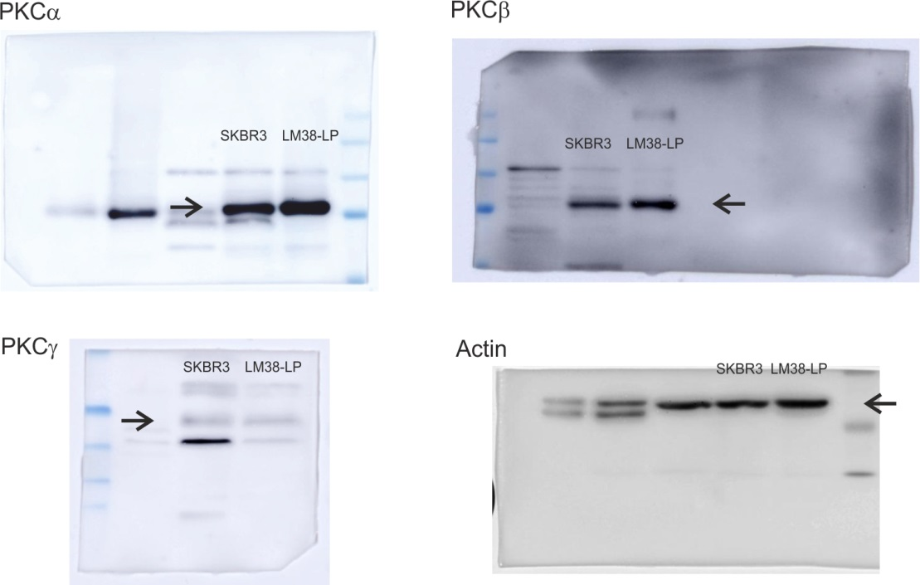
Figure 1a- Western Blots

Figure 3c- Western blots
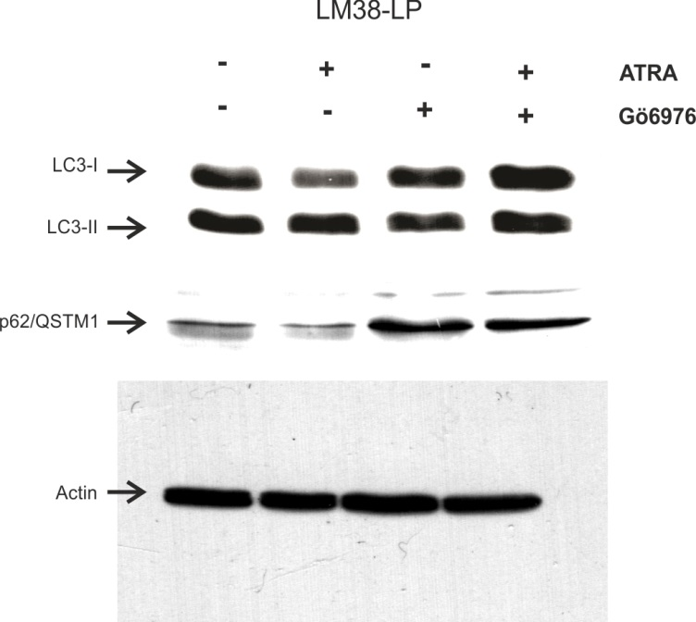
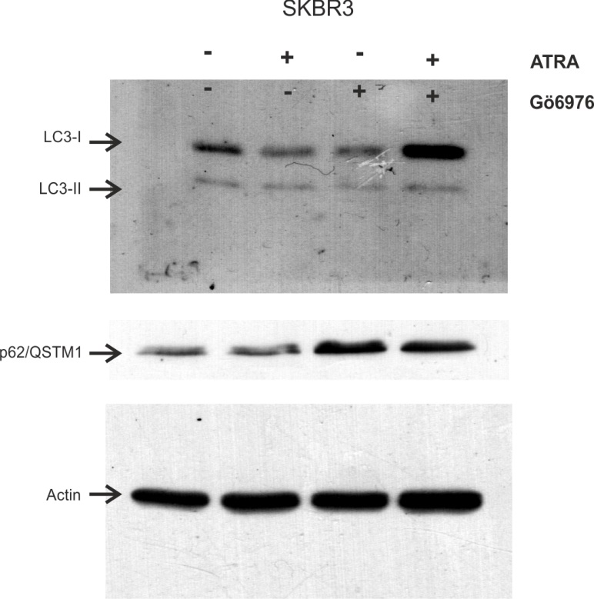

Figure 4b inset - zymography
