Supplementary Figure
Synergistic roles of Wnt Modulators R-spondin2 and R-spondin3 in Craniofacial Morphogenesis and Dental Development

Nora Alhazmi^{1,†}, Shannon H. Carroll^{2,3,4†}, Kenta Kawasaki^{2,3}, Katherine C. Woronowicz^{5,6}, Shawn A. Hallett^{2,4}, Claudio Macias Trevino^{2,4}, Edward B. Li^{2,4}, Roland Baron^{1,4}, Francesca Gori¹, Pamela C. Yelick⁷, Matthew P. Harris^{5,6}, and Eric C. Liao^{2,3,4,8*}

¹ Harvard School of Dental Medicine, Boston, Massachusetts, United States of America.
² Center for Regenerative Medicine, Massachusetts General Hospital, Boston, Massachusetts, United States of America.
³ Shriners Hospital for Children, Boston, Massachusetts, United States of America.
⁴ Department of Medicine, Harvard Medical School, Boston, Massachusetts, United States of America.
⁵ Department of Genetics, Harvard Medical School, Boston, Massachusetts, United States of America.
⁶ Department of Orthopedics, Boston Children’s Hospital, Boston, Massachusetts, United States of America.
⁷ Department of Orthodontics, Division of Craniofacial and Molecular Genetics, Tufts University School of Dental Medicine, Boston, Massachusetts, United States of America.
⁸ Division of Plastic and Reconstructive Surgery, Massachusetts General Hospital, Boston, Massachusetts, United States of America.

† These authors contributed equally to this work.

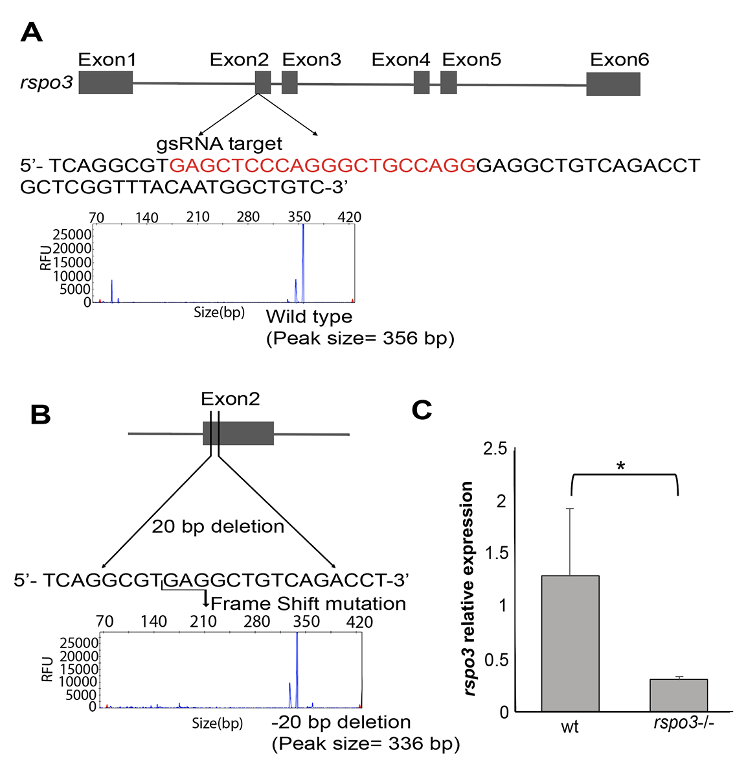

Supplemental Figure S1. Generation and characterization of CRISPR-Cas targeted rspo3 allele in zebrafish. A) Guided RNA target is designed in rspo3 exon 2 at the indicated sequence (red) for CRISPR-Cas mediated gene editing. Microsatellite genotyping presenting the wild-type allele with peak size=356 bp. B) Frame shift mutation is generated with -20 base pair deletion.
Microsatellite genotyping presenting the mutant allele with peak size = 336 bp. C) Characterization of rspo3-/- and rspo3+/- by RT-qPCR at 6 hpf. The mRNA levels are significantly reduced in rspo3-/-, likely consequence of mRNA nonsense mediated decay. *p ≤
0.05. rspo3 mRNA is reduced in rspo3-/- compared to wild-type. However, rspo3 mRNA levels are not statistically significant between rspo3+/- and wild-type. RFU: Relative fluorescence units.

