Figure S1. Model calibration to observed age- and sex-specific HIV prevalence reported in nationally representative South Africa surveys from 2002 to 2012 in an approximate Bayesian computation model selection procedure. The single best-fitting calibrated simulation was applied to the years 1990-2018 for each modeling scenario.

Figure S2. Simulated HIV incidence plots from 1990 to 2035 for the model calibration used in these analyses. Overall incidence is shown in black, incidence of vaccine-sensitive viral infections is in pink, and incidence of vaccine-resistant viral infections is in green. The top plot depicts a model scenario with no vaccine and no transmission advantage to the vaccine resistant virus. The bottom plot depicts a model scenario with sensitive and resistant viruses, a transmission advantage to the resistant virus, and behavioral risk compensation. The vertical dashed line marks the year of vaccine rollout in 2018 only for the model scenarios with vaccination (the bottom plot in the Figure). All scenarios had the same epidemic trajectory prior to 2018; after 2018 each scenario was repeated with 64 replicates and the plots show the mean and 95% credible intervals for each scenario. Vaccine scenarios included 70% vaccine coverage, 60% vaccine efficacy, and 83.3% resistant virus initial frequency at rollout.

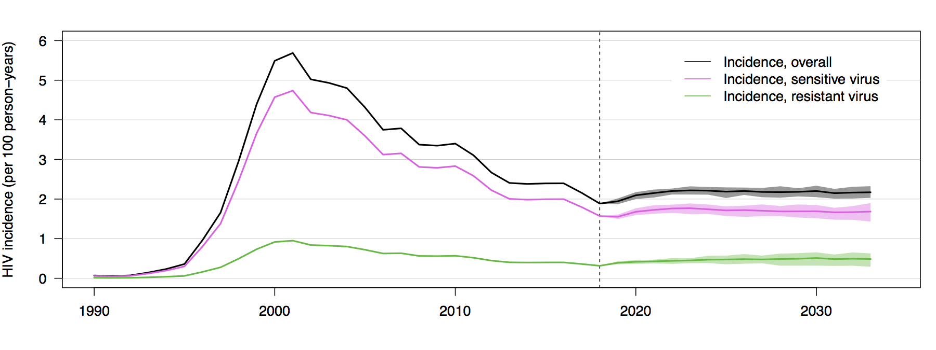
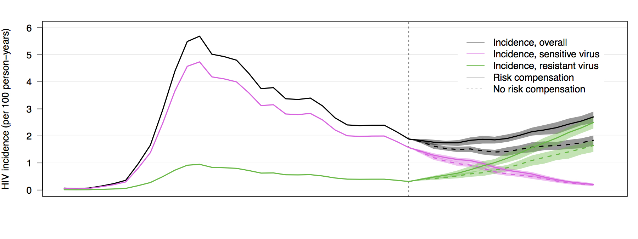
Figure S3. Frequencies of HIV lineages that are either sensitive or resistant to vaccine induced immune responses, following introduction of a partially effective vaccine (here shown as years from vaccine rollout). Each plot shows the mean and 95% credible interval of 64 replicates of each scenario. The scenarios vary in the proportion of vaccine sensitive virus at vaccine rollout (62.5%, 71.4%, 83.3%), variation in vaccine population coverage (50%, 70%, 90%), and, within each plot, the presence or absence of risk compensation (0% vs 30% reduction in condom use among vaccinated individuals). For all scenarios the overall vaccine efficacy at rollout was 50% (per-contact efficacy weighted by % sensitive virus).

Figure S4. HIV-1 prevalence following introduction of a partially effective vaccine in the year 2018. Each figure shows the mean and 95% credible interval of 64 replicates of each scenario. Scenarios include variation in the proportion of vaccine-sensitive virus at vaccine rollout (62.5%, 71.4%, and 83.3% compared to 100%) and variation in the reduction in condom use among vaccinated individuals (from 0% to 30% reduction).
Figure S5. HIV-1 incidence of vaccine-sensitive and vaccine-resistant viral strains following introduction of a partially effective vaccine in the year 2018. Scenarios include variation in the proportion of vaccine-sensitive virus at vaccine rollout (62.5%, 71.4%, and 83.3% compared to 100%) and variation in the relative reduction in condom use among vaccinated individuals (from 0% to 30% reduction). The mean and 95% credible interval of 64 replicates of each scenario are shown.
Figure S6. Percent of HIV-1 infections averted following 5, 10, and 15 years of continuous vaccine implementation. The mean and 95% credible interval of 64 replicates of each scenario are shown.
Figure S7. Incremental costs and infections averted following 15 years of continuous vaccine implementation. Health outcomes and costs are discounted at an annual rate of 3%. The mean and 90% credible interval of 64 replicates of each scenario are shown.
Figure S8. Incremental costs and disability-adjusted life-years (DALYs) averted following 15 years of continuous vaccine implementation. Health outcomes and costs are discounted at an annual rate of 3%. The mean and 90% credible intervals of 64 replicates of each scenario are shown.
Figure S9. Model-simulated proportion of condom-protected acts per time step and observed prevalence of condom use.

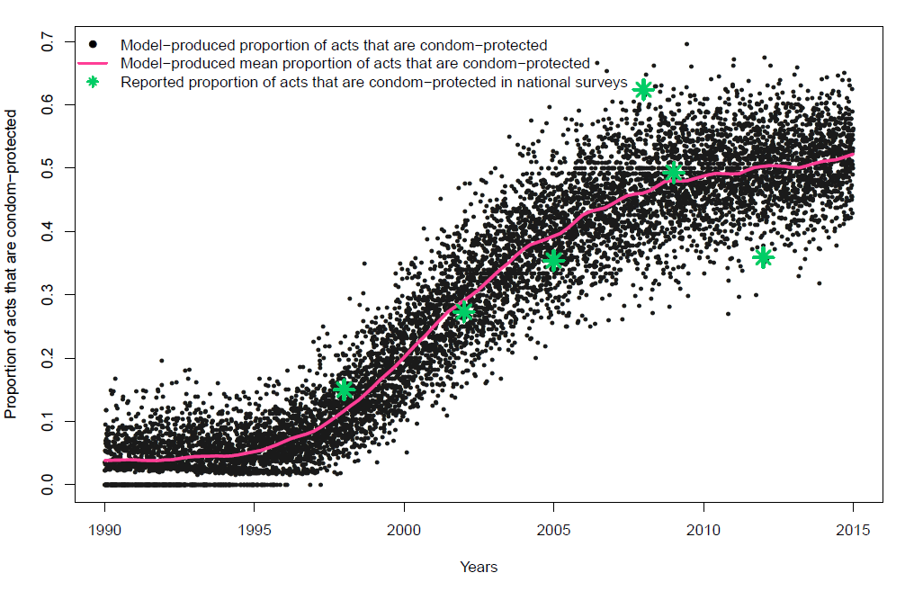

Figure S10. Intra-individual vaccine waning and boosting for per-contact vaccine efficacy at two years post-vaccination of 60%, 70%, and 80%

