Population pharmacokinetics and dose optimization of vancomycin in neonates

Soon Min Lee¹*, Seungwon Yang²*, Soyoung Kang³ and Min Jung Chang^{2,3}
¹Department of Pediatrics, Yonsei University College of Medicine, Seoul, Korea
²Department of Pharmacy and Yonsei Institute of Pharmaceutical Sciences, Yonsei University, Incheon, Republic of Korea
³Department of Pharmaceutical Medicine and Regulatory Science, Yonsei University, Incheon, Republic of Korea
* They did equal contribution to this work.

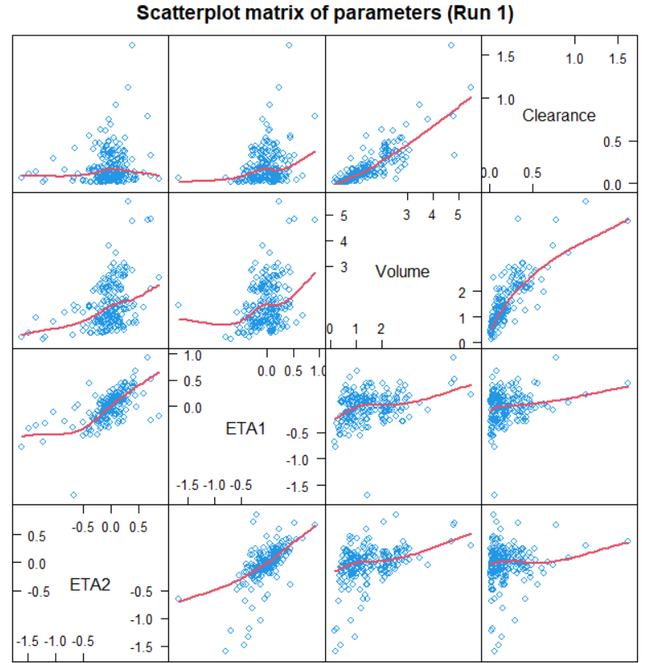
Figure S1. Scatterplot matrix of ETA
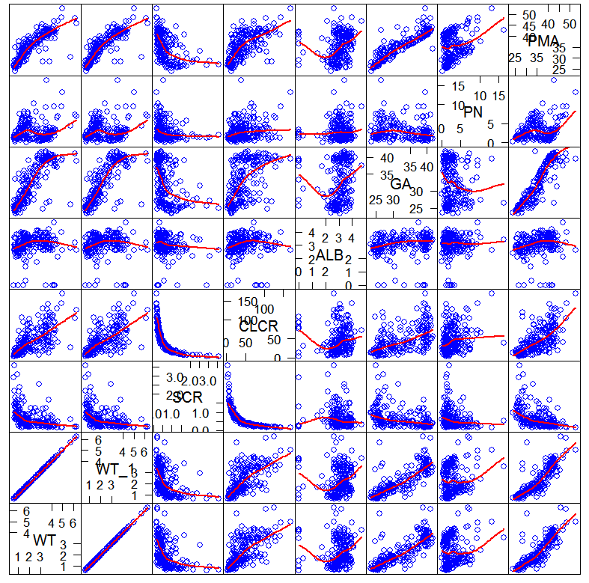
Figure S2. Scatterplot matrix of covariates
Figure 3. Scatterplot matrix of ETA

