Efficiency of nilotinib to target chronic phase-chronic myeloid leukaemia primary mature CD34- and immature CD34+ cells
Marc G Berger^{1,2,3,11} , Benjamin Lebecque^{1,2}, Thomas Tassin^{1,2}, Louis-Thomas Dannus^{1,2}, Juliette Berger^{1,2,3}, Mélanie Soucal^{1,2}, Agnès Guerci⁴, Pascale Cony-Makhoul⁵, Hyacinthe Johnson⁶, Gabriel Etienne⁷, Denis Guyotat⁸, Marie-Claude Gagnieu⁹, Bruno Pereira¹⁰, Sandrine Saugues^{2,3}, Olivier Tournilhac^{2,11}, Eric Hermet¹¹, and Céline Bourgne^{1,2}
¹Hématologie Biologique, CHU Clermont-Ferrand, Hôpital Estaing, 1 place Lucie et Raymond Aubrac, 63003 Clermont-Ferrand Cedex 1, France
²Equipe d’Accueil 7453 CHELTER, Université Clermont Auvergne, CHU Clermont-Ferrand, Hôpital Estaing, 1 place Lucie et Raymond Aubrac, 63003 Clermont-Ferrand Cedex 1, France
³CRB-Auvergne, CHU Clermont-Ferrand, Hôpital Estaing, 1 place Lucie et Raymond Aubrac, 63003 Clermont-Ferrand Cedex 1, France
⁴Hématologie Clinique, CHU Nancy, Hôpitaux de Brabois, Rue du Morvan, 54500 Vandoeuvre-lès-Nancy, France
⁵Hématologie Clinique, CH Annecy-Genevois, 1 Avenue de l’Hôpital, 74370 Metz-Tessy, France
⁶Institut d’Hématologie de Basse Normandie, CHU de Caen, Avenue de la Côte de Nacre, CS30001, 14033 Caen Cedex 9, France
⁷Hématologie Clinique, Institut Bergonié, 229 Cours de l’Argonne, 33076 Bordeaux Cedex, France
⁸Département d'Hématologie, Institut de Cancérologie Lucien Neuwirth, 108 Avenue Albert Raimond, 42270 Saint-Priest-en-Jarez, France
⁹Service de Biochimie et Biologie Moléculaire, UM Pharmacologie-Toxicologie, Groupement Hospitalier Sud,165, chemin du grand Revoyet, 69495 Pierre-Bénite, France
¹⁰CHU Clermont-Ferrand, Délégation à la Recherche Clinique et à l'Innovation, 63003, Clermont-Ferrand, France
¹¹Hématologie Clinique, CHU Clermont-Ferrand, Hôpital Estaing, 1 place Lucie et Raymond Aubrac, 63003 Clermont-Ferrand, France

Running Title: Flow cytometry evaluation of nilotinib uptake by CML cells
Correspondence: Dr Céline BOURGNE (PhD), Equipe d’Accueil 7453 CHELTER, Université Clermont Auvergne, Service Hématologie Biologique, CHU Estaing, 1 place Lucie et Raymond Aubrac, 63003 CLERMONT-FERRAND Cedex 1, France.
Tel: (33) 4 73 75 02 00. Fax: (33) 4 73 75 02 15. E-mail: cbourgne@chu-clermontferrand.fr
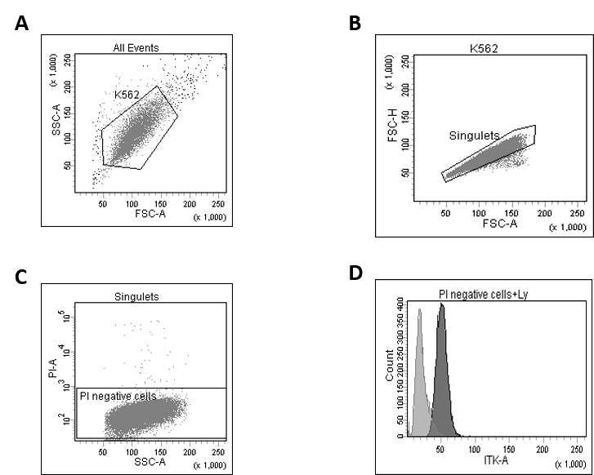

Supplementary Figure S1: Measurement of nilotinib uptake by K562 cells using flow cytometry
A flow cytometer equipped with a UV-laser was used to detect the fluorescence emitted by nilotinib. K562 cells were first gated using a FSC-SSC dot-plot (A). Then, singlets were selected (FSC-H vs FSC-A) (B) before selection of propidium iodide-negative (live) cells (C). The difference in the fluorescence mean intensity (linear scale) between control (untreated) and cells incubated with nilotinib was used to quantify the amount of intracellular nilotinib (D).

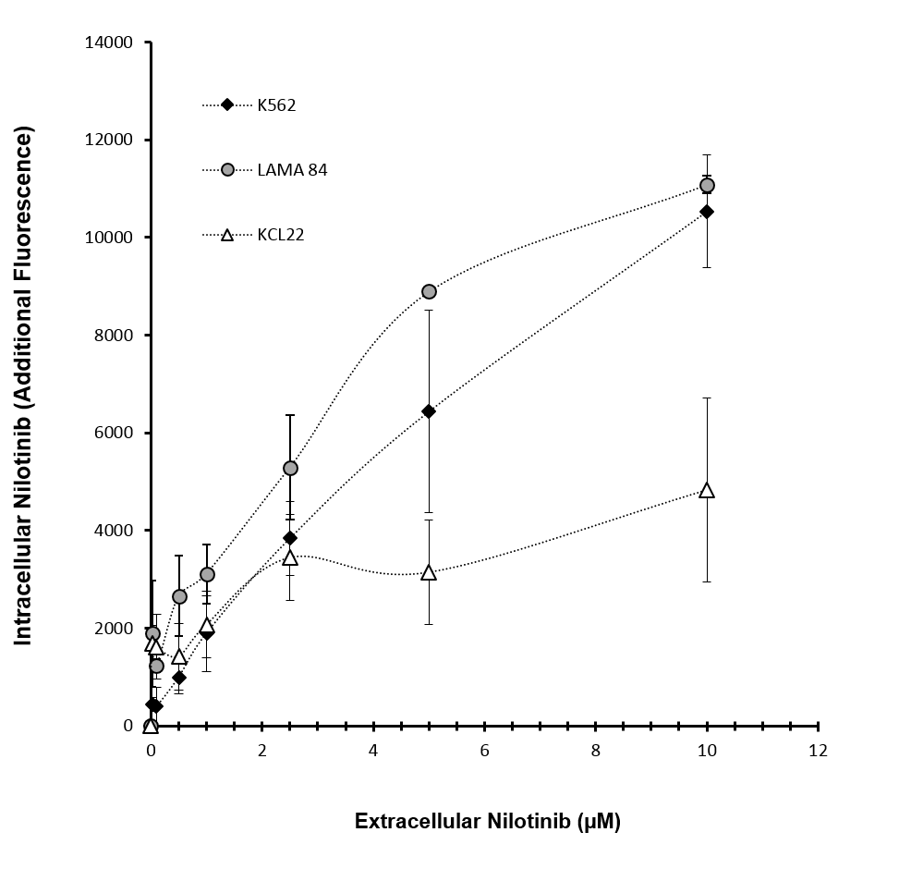
Supplementary Figure S2: Relationship between intra- and extra-cellular amount of nilotinib in CML cell lines.
Nilotinib accumulation was significantly different in the three CML-derived cell lines tested (K562, KCL22 and LAMA84). When incubated with low nilotinib concentrations (0.5 µM; extracellular nilotinib), nilotinib intracellular level was significantly higher in LAMA84 than in K562 cells (2.7x10³ ± 0.8 x10³ vs 1x10³ ± 0.3 x10³ AFU; p=0.05). Nilotinib intracellular concentration in KCL22 cells reached a plateau when cells were incubated with 2.5 μM of nilotinib, and in K562 and LAMA84 after incubation with 5 μM. Results are the mean ± standard deviation.
Supplementary Table 1: Patients characteristics
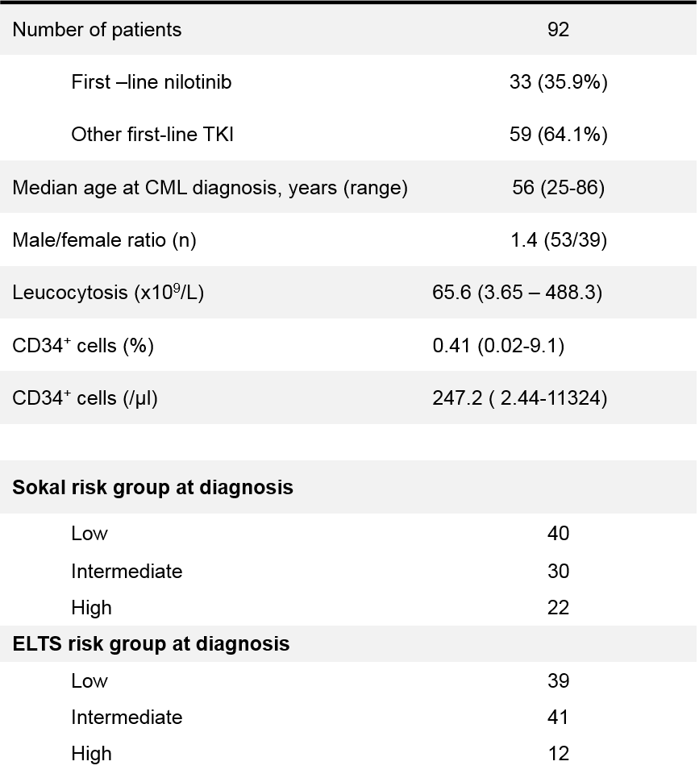

Supplementary Table 2 : Relationship between intra- and extra-cellular amount of nilotinib in primary CML cells.
 | 0 | 0.1 µM | 1 µM | 2.5 µM | 5 µM
Ly | 0 | 0.029±0.005 | 0.031±0.005 | 0.045±0.006 | 0.011±0.01
Mo | 0 | 0.099±0.02 | 0.13±0.02 | 0.17±0.02 | 0.33±0.03
PMN | 0 | 0.13±0.02 | 0.20±0.02 | 0.31±0.03 | 0.54±0.05

Nilotinib uptake by primary cells was evaluated by flow cytometry after 2 hours of incubation with 0.1, 1, 2.5 or 5µM of this TKI (n=60 patients). Lymphocytes (Ly), monocytes (Mo), and polymorphonuclear cells (PMN) were identified on the basis of their FSC/SSC parameters. Data are expressed as the mean ± standard deviation

Supplementary Table 3: Characteristics of patients who received nilotinib as first-line treatment



