Evaluation of multi-hazard map produced using MaxEnt machine learning technique
Narges Javidan¹, Ataollah Kavian¹, Hamid Reza Pourghasemi², Christian Conoscenti³, Zeinab Jafarian⁴, Jesús Rodrigo-Comino^{5,6}
¹Department of Watershed Management, Faculty of Natural Resources, Sari Agricultural Sciences and Natural Resources University (SANRU), Sari 48441-74111, Iran; narges.javidan20@gmail.com; a.kavian@sanru.ac.ir
²Department of Natural Resources and Environmental Engineering, College of Agriculture, Shiraz University, Shiraz 71441- 65186, Iran; hr.pourghasemi@shirazu.ac.ir
³Department of Earth and Marine Sciences (DISTEM), University of Palermo, Via Archirafi 22, 90123 Palermo, Italy; christian.conoscenti@unipa.it
⁴Department of Range Management, Sari Agricultural Sciences and Natural Resources University (SANRU), Sari 48441-74111, Iran; z.jafarian@sanru.ac.ir
⁵Department of Physical Geography, University of Trier, 54296 Trier, Germany
⁶Soil Erosion and Degradation Research Group, Department of Geography, Valencia University, Blasco Ibàñez, 28, 46010 Valencia, Spain. jesus.rodrigo@uv.es

Corresponding authors: Ataollah Kavian (a.kavian@sanru.ac.ir) and Jesús Rodrigo-Comino (jesus-rodrigo@uv.es)

Suppl. 1. Maps displaying the flood, gully and landslide conditioning factors: a) DEM (m), b) Slope percent c) Slope aspect, d) Land use, e) Profile curvature, f) Plan curvature, g) Soil texture, h) Topographic Position Index (TPI) i) Topographic Wetness Index (TWI), j) Distance to streams (m), k) Drainage density (km/km²), l) Annual mean rainfall (mm), m) Stream Power Index, n) Relative Slope Position, o) Terrain Ruggedness Index, p) Lithology, q) LS factor, r) Distance to road (m), s) Distance to faults (m).

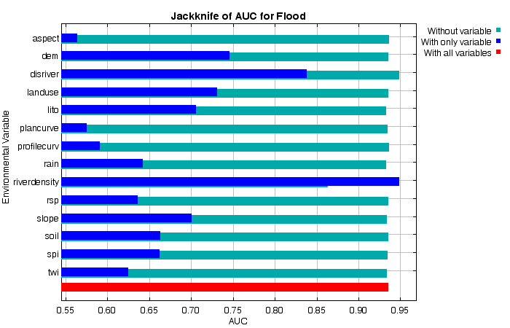
(a)
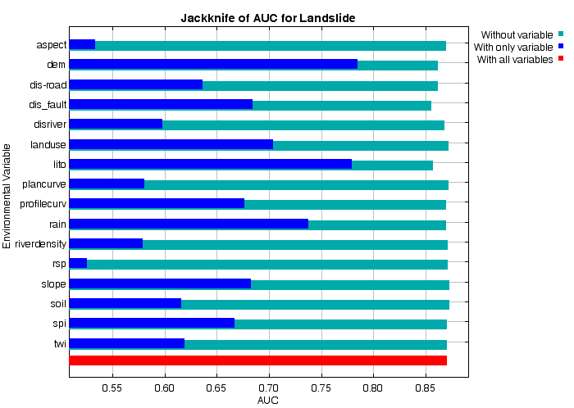
(b)

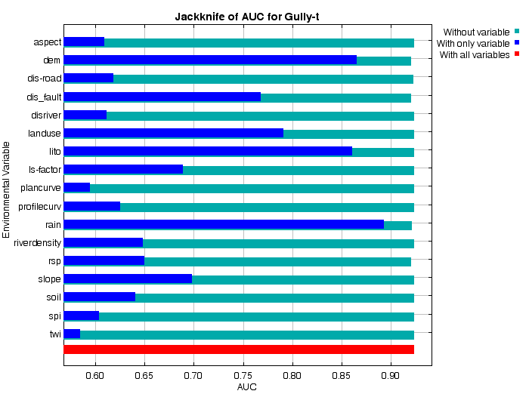
(c)

Suppl. 2. Factor importance analysis obtained from susceptibility model (a) Kappa-based Jackknife test for flood susceptibility, (b) Kappa-based Jackknife test for landslide susceptibility, and (c) Kappa-based Jackknife test for gully susceptibility.

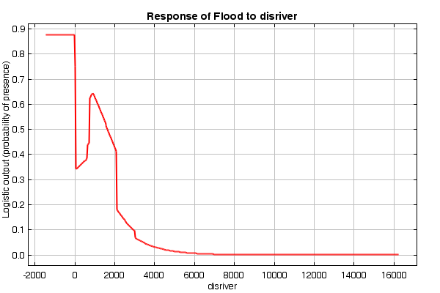
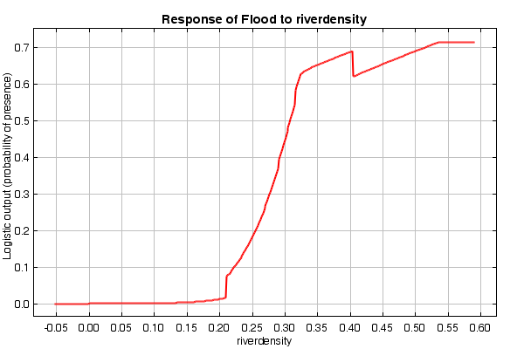
(b)
(b)
(a)
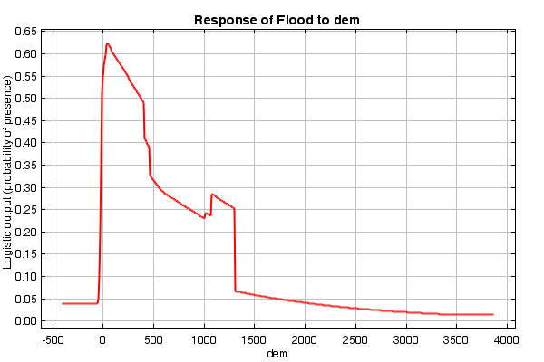
(c)

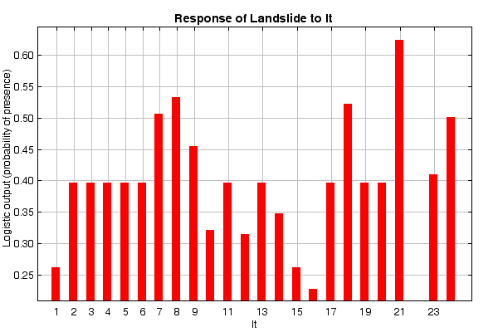
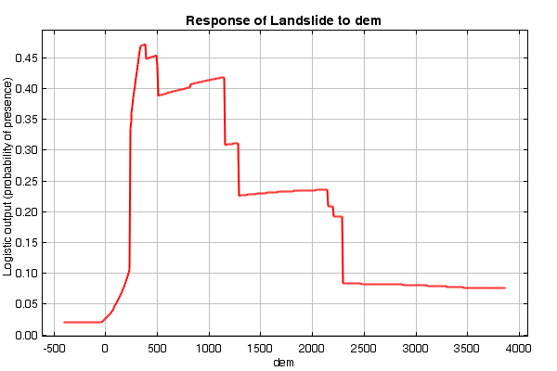
(f)
(e)
(f)
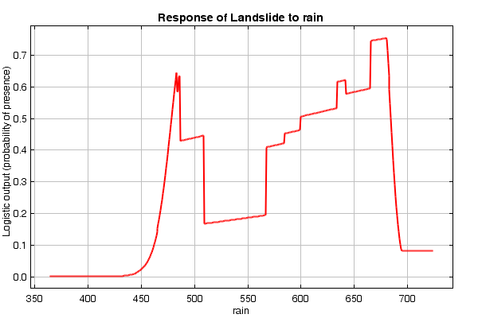
(g)

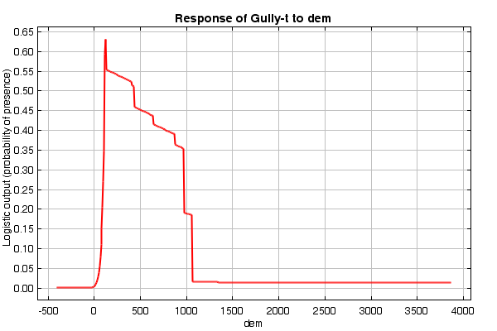
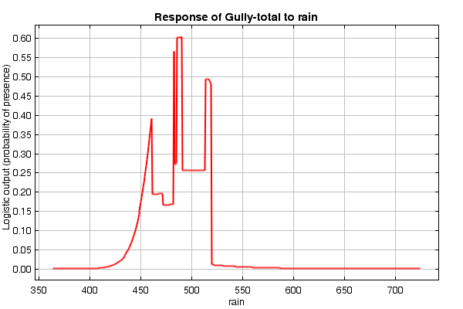
(i)
(i)
(h)
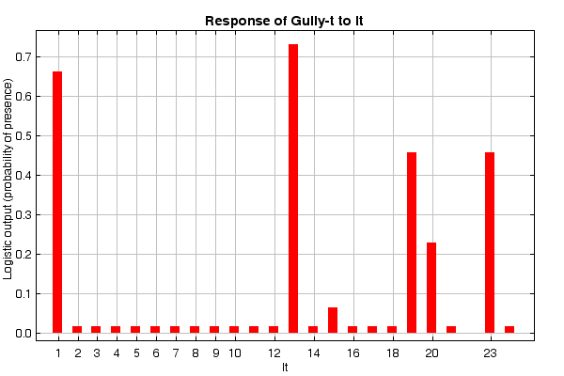
(j)
Suppl. 3. The response curves of one data set (S1) for some of important conditioning factors used for three hazards (a-b-c landslides, e-f-g flood, and h-i-j gully erosion) assessment

