An exploratory investigation on spatiotemporal parameters, margins of stability, and their interaction in bilateral vestibulopathy.
Nolan Herssens¹⁻³*, Wim Saeys^{2,4}, Luc Vereeck^{2,3}, Kenneth Meijer⁵, Raymond van de Berg^{6,7}, Vincent Van Rompaey^{8,9}, Christopher McCrum^{5§} & Ann Hallemans^{2,3§}.
Corresponding author: Nolan Herssens, Campus UZ Gent, Corneel Heymanslaan 10, Building B3, 9000, Ghent, Belgium. nolan.herssens@ugent.be, +32 4 74 22 29 62.

¹Department of Rehabilitation Sciences, Ghent University, Ghent, Belgium
² Department of Rehabilitation Sciences and Physiotherapy/Movant, Faculty of Medicine and Health Sciences, University of Antwerp, Belgium
³ Multidisciplinary Motor Centre Antwerp (M²OCEAN), University of Antwerp, Belgium.
⁴ RevArte Rehabilitation Hospital, Edegem, Antwerp.
⁵ Department of Nutrition and Movement Sciences, NUTRIM School of Nutrition and Translational Research in Metabolism, Maastricht University Medical Centre+, Maastricht, The Netherlands.
⁶ Division of Balance Disorders, Department of Otorhinolaryngology and Head and Neck Surgery, Faculty of Health Medicine and Life Sciences, School for Mental Health and Neuroscience, Maastricht University Medical Centre+, Maastricht, The Netherlands
⁷ Faculty of Physics, Tomsk State University, Tomsk, Russia.
⁸ Department of Otorhinolaryngology and Head & Neck Surgery, Antwerp University Hospital, Edegem, Belgium
⁹ Faculty of Medicine and Health Sciences, University of Antwerp, Belgium.

§ Christopher McCrum and Ann Hallemans should be considered joint senior author as they contributed equally to this manuscript.
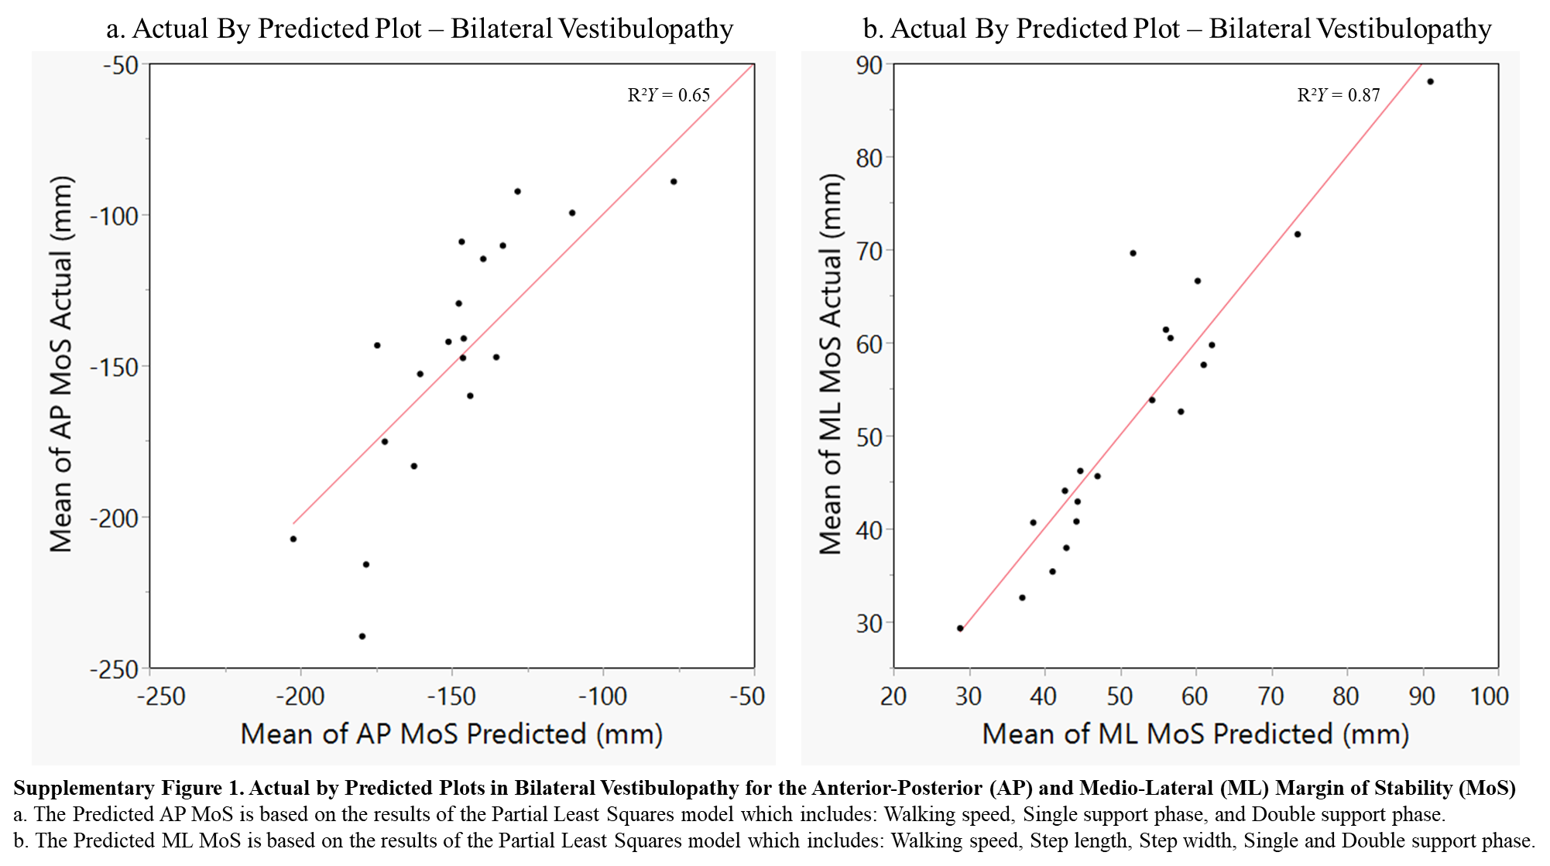

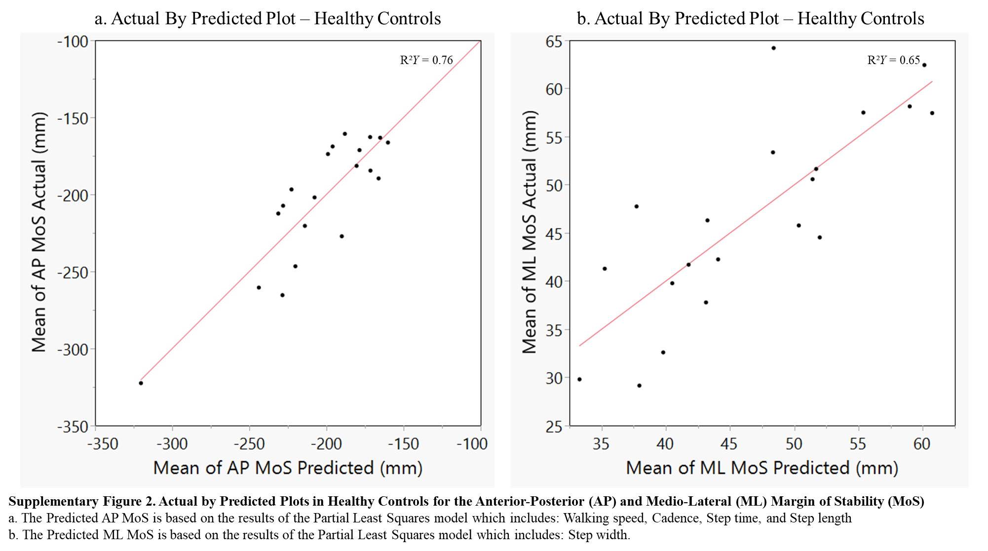

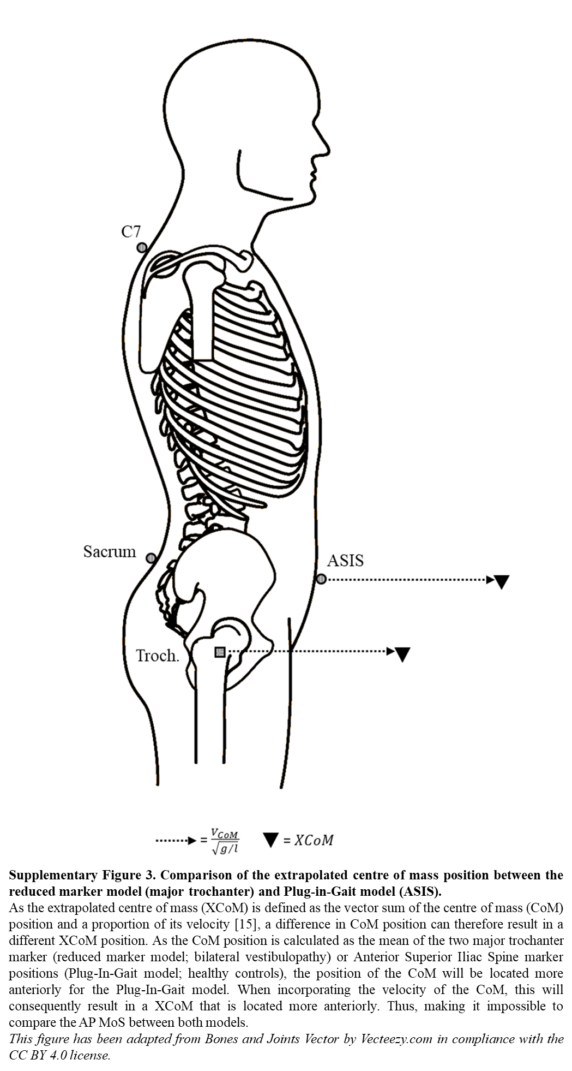
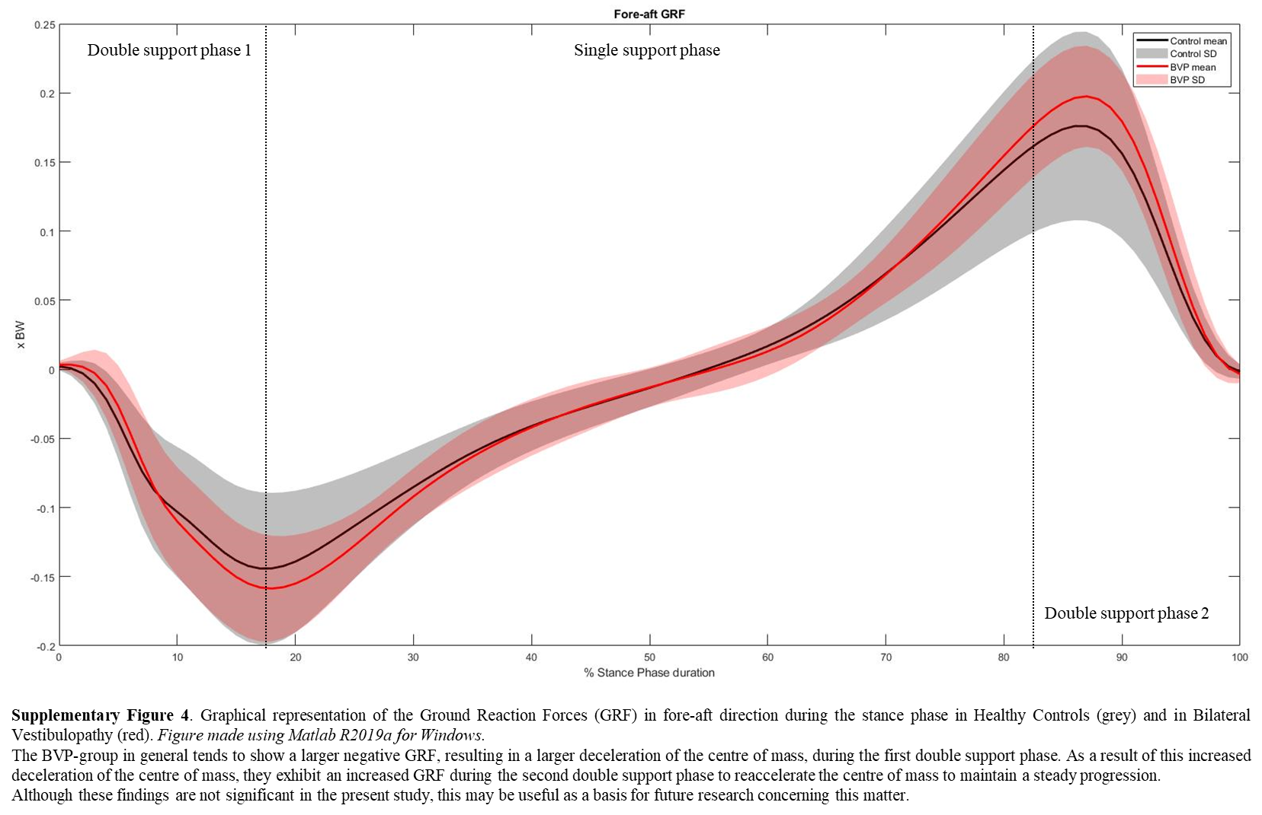
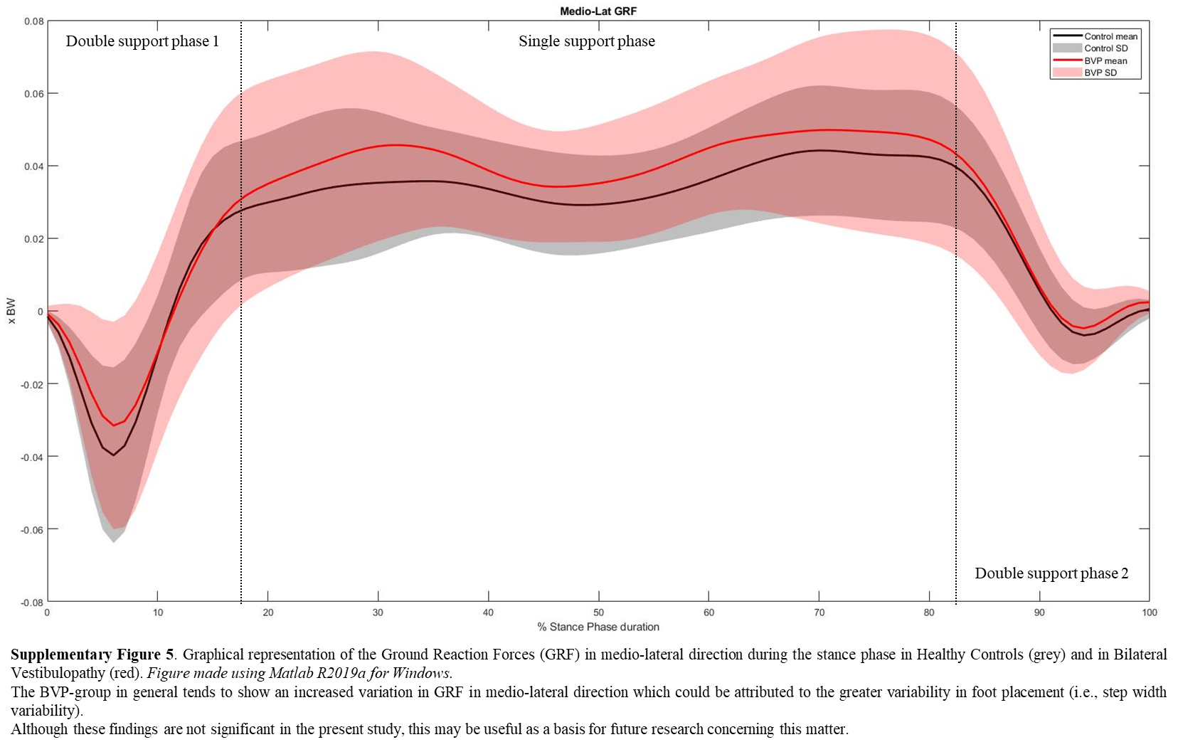
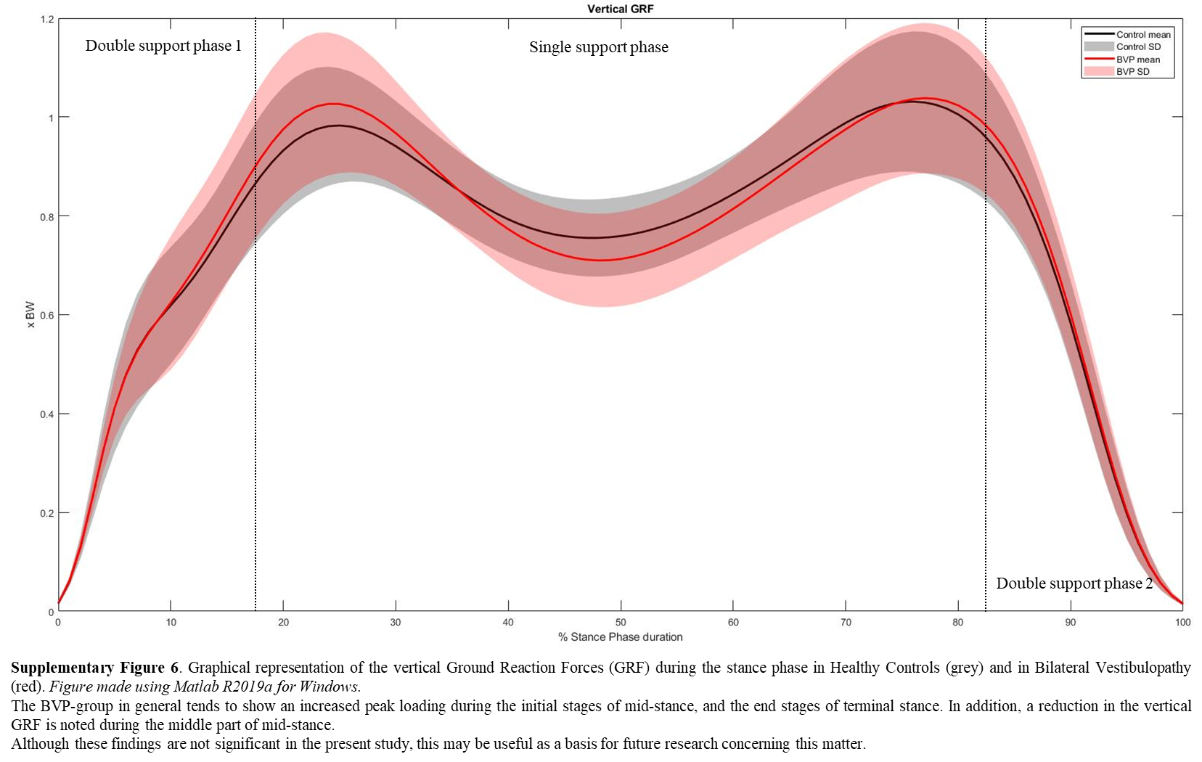

Supplementary Table 1. Patient characteristics with vestibulo-ocolar reflex function testing as documented by the diagnostic criteria for bilateral vestibulopathy.
Subject | Sex | Age (years) | Time since onset (years) | Etiology |  | Video Head Impulse Testing (gain) |  | Caloric Testing (deg/s) |  | Rotatory Chair Testing (gain)
 |  |  |  | Left | Right | Left lateral SCC | Right lateral SCC | Left | Right | Rotatory Chair Testing (gain)
BVP01 | Female | 56.24 | 17 | Menière’s Disease | Idiopathic | 0.14 | 0.16 | 0 | 0 | 0.01
BVP02 | Female | 74.05 | 5 | Idiopathic |  | 0.74 | 1.01 | 4 | 3 | 0.1
BVP03 | Male | 65.37 | 21 | Meningitis† |  | 0.45 | 0.56 | 4 | 5 | 0.1
BVP04 | Male | 59.72 | 20 | Unknown |  | 0.29 | 0.31 | 3 | 2 | 0.01
BVP05 | Male | 72.19 | 4 | Idiopathic |  | 0.27 | 0.40 | 0 | 3 | 0.05
BVP06 | Female | 58.09 | 4 | Meningitis† |  | 0.85 | 0.98 | 0 | 1 | 0.15
BVP07 | Male | 42.83 | 4 | Head trauma |  | 0.88 | 1.06 | 11 | 19 | 0.05
BVP08 | Male | 71.95 | 3 | Gentamicin† |  | 0.32 | 0.24 | 8 | 0 | 0.03
BVP09 | Female | 70.71 | 6 | Idiopathic |  | n.a. | n.a. | 0 | 0 | 0.02
BVP10 | Male | 62.66 | 10 | Head trauma |  | 0.12 | 0.04 | 0 | 0 | 0.04
BVP11 | Male | 56.51 | 3 | Idiopathic |  | 0.14 | 0.33 | 0 | 0 | 0.03
BVP12 | Male | 62.92 | 6 | Idiopathic | Menière’s Disease | 0.70 | 0.39 | 4 | 0 | 0.30
BVP13 | Male | 58.44 | 6 | Idiopathic |  | 0.26 | 0.15 | 2 | 0 | 0.02
BVP14 | Male | 55.65 | 7 | Idiopathic | Resection vestibular schwannoma | 0.84 | 0.38 | 0 | 0 | 0.19
BVP15 | Male | 50.53 | 14 | Idiopathic |  | 0.49 | 0.92 | 0 | 7 | 0.07
BVP16 | Male | 33.37 | 30 | Meningitis |  | 0.56 | 0.07 | 0 | 0 | 0.06
BVP17 | Male | 49.00 | 6 | Genetic† |  | n.a. | n.a. | 0 | 0 | 0.40
BVP18 | Male | 56.27 | 1 | Meningitis |  | 0.69 | 0.42 | 0 | 0 | 0.20
BVP19 | Female | 46.23 | 2 | DFNA9 |  | 0.89 | 0.78 | 0 | 0 | 0.05
BVP20 | Female | 63.31 | 20 | DFNA9 |  | 0.62 | 0.61 | 0 | 0 | 0.05
Note. SCC: Semi-circular canal; deg/s: degrees per second; A bilaterally reduced or absent angular VOR function has to be documented by: video Head Impulse Testing with a bilaterally pathological horizontal VOR gain <0.6 AND/OR a reduced caloric response (sum of bithermal maximal peak slow phase velocity on each side <6 deg/sec) AND/OR a reduced horizontal angular VOR gain <0.1 upon sinusoidal stimulation on a rotatory chair; †: probable etiology.

