Comparing survival outcomes for cervical cancer based on the 2014 and 2018 International Federation of Gynecology and Obstetrics staging systems

Wonkyo Shin, MD, PhD ¹, Tae Young Ham, BS ², Young Ran Park, MS ², Myong Cheol Lim, MD, PhD ^{1,3,4,5}, Young-Joo Won, MD, PhD ^{2,5*}

¹ Center for Gynecologic Cancer, National Cancer Center, Goyang, Korea
² Division of Cancer Registration and Surveillance, National Cancer Center, Goyang, Korea
³ Center for Clinical Trials, National Cancer Center, Goyang, Korea
⁴ Division of Tumor Immunology, National Cancer Center, Goyang, Korea
⁵ Department of Cancer Control & Population Health, Graduate School of Cancer Science and Policy, National Cancer Center, Goyang, Korea

*Correspondence to: Young-Joo Won, PhD
Division of Cancer Registration and Surveillance, National Cancer Center
323 Ilsan-ro, Ilsandong-gu, Goyang-si, 10408, Korea
E-mail: astra67@ncc.re.kr

Supplementary Figure S1. The survival curves for stage IIIC according to T classification
(p<0.001)
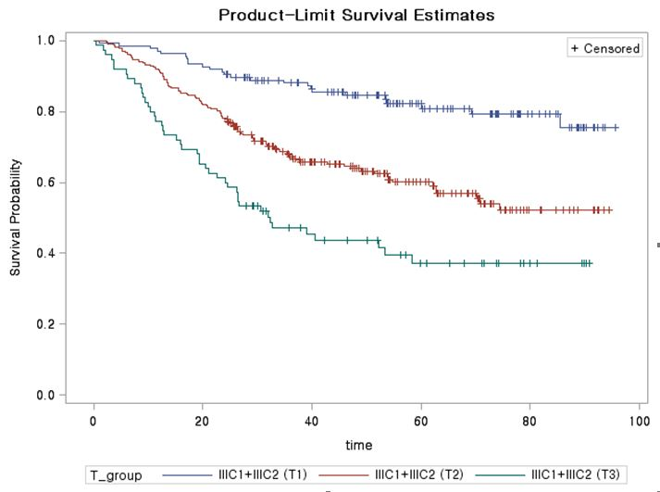
Supplementary table 1. Changes in cervical cancer staging between 2014 and 2018

Stage | FIGO 2014 |  | FIGO 2018
IB | Clinical lesions confined to the cervix, or preclinical lesions greater than stage IA. |  | Invasive carcinoma with measured deepest invasion ≥5 mm (greater than Stage IA), lesion limited to the cervix uteri
IB1 | Clinical lesions no greater than 4 cm in size. |  | Invasive carcinoma ≥5 mm depth of stromal invasion, and <2 cm in greatest dimension
IB2 | Clinical lesions > 4 cm in size. |  | Invasive carcinoma ≥2 cm and <4 cm in greatest dimension
IB3 | N/A |  | Invasive carcinoma ≥4 cm in greatest dimension
IIIC | N/A |  | Involvement of pelvic and/or para-aortic lymph nodes, irrespective of tumor size and extent (with r and p notations)
IIIC1 | N/A |  | Pelvic lymph node metastasis only
IIIC2 | N/A |  | Para-aortic lymph node metastasis

