MiRNA EXPRESSION PROFILING AND EMERGENCE OF NEW PROGNOSTIC SIGNATURE FOR ORAL SQUAMOUS CELL CARCINOMA
Christo Rajan^{a*}, VG Deepak Roshan^{a*}, Imran Khan^{b*}, Manasa VGª, Iris Himalª, Jayasree Kattoor^{c}, Shaji Thomas^{d}, Paturu Kondaiah^{b} and S Kannanª

SUPPLIMENTARY TABLES:
SupplementaryTable 1. Patient demographics
Demographics | n | %
Age
Young | 35 | 24.3
Old | 109 | 75.7
Gender
Male | 90 | 62.5
Female | 54 | 37.5
Site
Tongue | 83 | 57.6
Buccal Mucosa | 61 | 42.4
Habits
Alcohol | 2 | 1.4
Chewing | 29 | 20.1
Smoking | 4 | 2.8
Mixed | 77 | 53.5
No habits | 32 | 22.2
Tumor grade(cytology)
SCC | 7 | 4.9
WDSCC | 31 | 21.5
MDSCC | 93 | 64.6
PDSCC | 13 | 9
TNM Stage
I+ II (Early) | 40 | 27.8
III+IV (Late) | 104 | 72.2
Recurrence
Positive | 28 | 19.4
Negative | 116 | 80.6
Peri Neural Invasion(PNI)*
Positive | 13 | 26.5
Negative | 36 | 73.4
Tumor Depth*
<1mm | 12 | 25.3
1-1.9 mm | 30 | 63.8
2-4 mm | 5 | 10.6
Survival status
Overall >5 years | 56 | 38.9
>3 years | 95 | 66
Disease free > 5 years | 40 | 27.8
> 3 years | 71 | 49.3
*Cases with missing data not shown
SCC: Squamous Cell Carcinoma; WDSCC: Well Differentiated SCC; MDSCC: Moderately Differentiated SCC; PDSCC: Poorly Differentiated SCC

Supplementary Table 2. Pathways predicted for significant miRNAs using DIANA miR-path for a) up-regulated mRNA list and b) down regulated miRNAs.

KEGG pathway up-miRs | p-value | Target genes
Glycosphingolipid biosynthesis - lacto and neolacto series | <0.001 | 3
ECM-receptor interaction | <0.001 | 6
Fatty acid metabolism | <0.001 | 3
Endocytosis | <0.001 | 17
TGF-beta signalling pathway | <0.001 | 7
Axon guidance | <0.001 | 9
Steroid biosynthesis | 0.01 | 1
ErbB signaling pathway | 0.02 | 6
Valine, leucine and isoleucine degradation | 0.02 | 2
a.

b.
KEGG pathway down-miRs | p-value | target genes
PI3K-Akt signaling pathway | <0.001 | 53
Focal adhesion | <0.001 | 36
Transcriptional misregulation in cancer | <0.001 | 34
Pathways in cancer | <0.001 | 52
Dopaminergic synapse | <0.001 | 24
Lysine degradation | <0.001 | 10
Glutamatergic synapse | <0.001 | 22
Endocrine and other factor-regulated calcium reabsorption | <0.001 | 13
Small cell lung cancer | <0.001 | 17
Ubiquitin mediated proteolysis | <0.001 | 24
MAPK signaling pathway | <0.001 | 38
Gap junction | <0.001 | 14
ErbB signaling pathway | <0.001 | 16
Prostate cancer | <0.001 | 15
Serotonergic synapse | <0.001 | 19
Wnt signaling pathway | <0.001 | 25
GnRH signaling pathway | <0.001 | 16

Supplementary Table 3: Details of oral cancer datasets from GEO.
Dataset | Tissue | n | Tumors | Normals | Country | Platform | Reference
GSE28100 | Tongue | 20 | 17 | 3 | USA | Agilent V3 | Jung et al.,2012
GSE31277 | OSCC | 32 | 16 | 16 | Brazil | Illumina | Severino et al.,2013
GSE34496 | OSCC | 76 | 50 | 26 | USA | Affimetrix | unpublished

Supplementary Table 4. Receiver Operating Characteristic (ROC) test statistic for enumeration of disease predictive power

Supplementary Table 5: Relationship between the clinic-biological variables and survival endpoints in oral cancer patients
Factors |  | Univariate Analysis |  |  | Multivariate Analysis
Disease Free Survival
 |  | Good | Poor | Log-Rank p-Value | Coefficient | P-Value | Hazard Ratio
Sex | Male  Female | 50  27 | 30  26 | 0.085 | 0.631 | 0.056 | 1.880
T-Stat | 1  2  3  4 | 13  43  12  18 | 7  16  11  20 | 0.370 | 0.373 | 0.248 | 1.452
N-Stat | Not Involved  Involved | 37  49 | 16  35 | 0.500 | -0.096 | 0.802 | 0.908
Composite Stage | 1  2  3  4 | 10  18  37  21 | 3  8  23  20 | 0.354 | 0.059 | 0.902 | 1.061
miR196a/miR204 Ratio | < 0.750  > 0.750 | 24  37 | 25  12 | 0.003 | -0.970 | 0.007 | 0.379
Overall Survival
 |  | Alive | Dead | Log-Rank p-Value | Coefficient | P-Value | Hazard Ratio
Sex | Male  Female | 57  31 | 33  23 | 0.442 | 0.227 | 0.513 | 1.254
T-Stat | 1  2  3  4 | 16  43  12  17 | 5  16  12  21 | 0.003 | 0.446 | 0.158 | 1.562
N-Stat | Not Involved  Involved | 40  48 | 17  37 | 0.124 | 0.413 | 0.434 | 1.511
Composite Stage | 1  2  3  4 | 12  20  36  20 | 2  6  25  21 | 0.045 | 0.009 | 0.985 | 1.009
miR196a/miR204 Ratio | < 0.750  > 0.750 | 30  35 | 21  14 | 0.092 | -0.658 | 0.062 | 0.518

Supplementary Table 6: List of Potential Targets for the Signature miRNAs in Oral Cancer
miRNA | Targets | Pearson Correlation | Sig (2-tailed)
miR-101-3p | PTGS2 | -.130 | .003
miR-101-3p | APP | -.314 | <.001
miR-101-3p | RAC1 | -.132 | .003
miR-1237-3p | FAM69C | -.251 | .001
miR-1237-3p | PACS2 | -.211 | .005
miR-1237-3p | SPOP | -.225 | .003
miR-155-5p | MYO10 | -.350 | <.001
miR-155-5p | KRAS | -.176 | <.001
miR-155-5p | FOXO3 | -.167 | <.001
miR-377-3p | CLN8 | -.165 | .001
miR-377-3p | MAP3K9 | -.248 | <.001
miR-377-3p | TMEM30B | -.246 | <.001
miR-190a-5p | PHLPP1 | -.108 | .019
miR-190a-5p | TATDN2 | -.104 | .025
miR-190a-5p | SERP1 | -.102 | .026
miR-424-5p | TGFBR3 | -.229 | <.001
miR-424-5p | MYB | -.295 | <.001
miR-424-5p | SMAD3 | -.250 | <.001
miR-411-5p | C15orf40 | -.202 | <.001
miR-411-5p | TARBP2 | -.193 | <.001
miR-411-5p | UQCRB | -.178 | <.001
miR-196a-5p | SPRR2C | -.181 | <.001
miR-196a-5p | ANXA1 | -.185 | <.001
miR-196a-5p | S100A9 | -.122 | .008
miR-196b-5p | TGFBR2 | -.232 | <.001
miR-196b-5p | ETS2 | -.100 | .029
miR-196b-5p | IGDCC4 | -.199 | <.001
miR-204-5p | CDC42 | -.325 | <.001
miR-204-5p | RAB22A | -.262 | <.001
miR-204-5p | EZR | -.239 | <.001
miR-21-5p | TGFBR3 | -.289 | <.001
miR-21-5p | TIAM1 | -.269 | <.001
miR-21-5p | ANKRD46 | -.229 | <.001
miR-144-3p | PPIC | -.135 | .003
miR-144-3p | COASY | -.149 | .001
miR-144-3p | DAB2 | -.111 | .015
miR-376a-3p | PARD6B | -.260 | <.001
miR-376a-3p | PRKCH | -.151 | .003
miR-376a-3p | INA | -.147 | .003

SUPPLIMENTARY FIGURES:
Supplementary Figure 1. Supervised hierarchical clustering using signature miRNAs differentiating samples site-wise into distinct Tongue and Buccal mucosa clusters with cut off Fold Change > 1.5 and p.value < 0.01. In the heatmap, samples are labelled with prefix ‘t’ for Tongue and ‘b’ for Buccal Mucosa
e
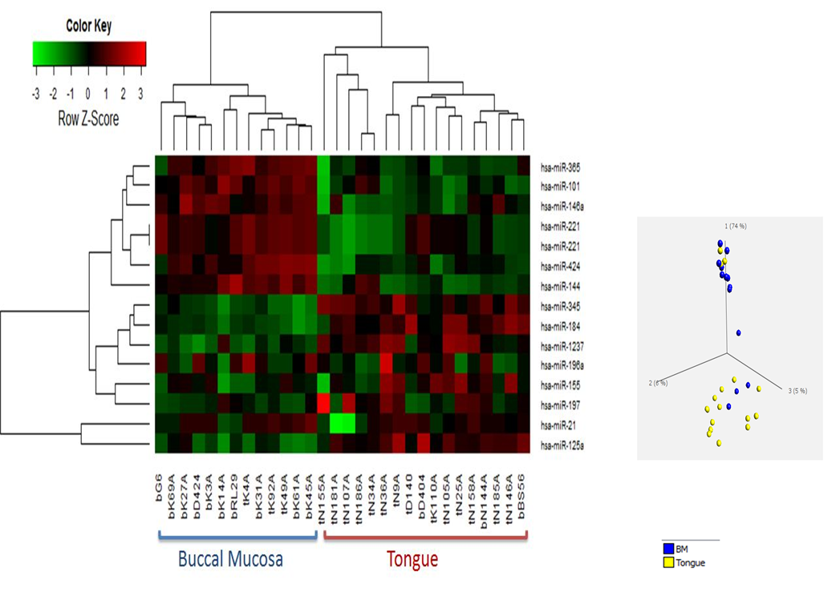

Supplementary Figure 2. Oral Squamous Cell Carcinoma pathological prognostic factors. a) Peri-Neural Invasion and b) Tumor depth.
e

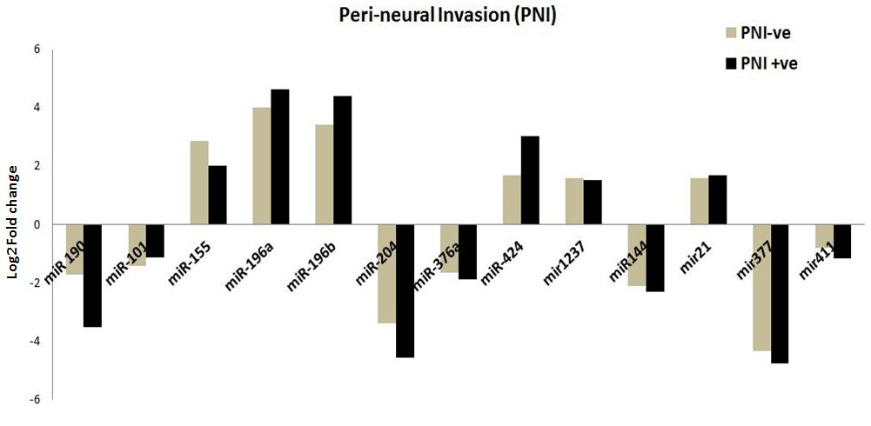
a.

b.
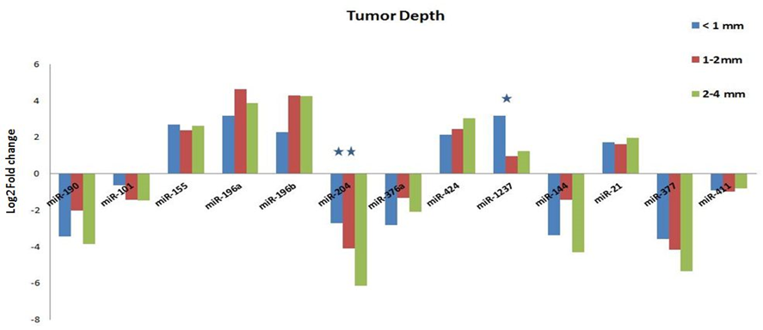

Supplementary Figure 3. Kaplan Meier curve showing Overall and Disease free survival in OSCC patients with respect to expression of a) miR-196a, b)miR-204

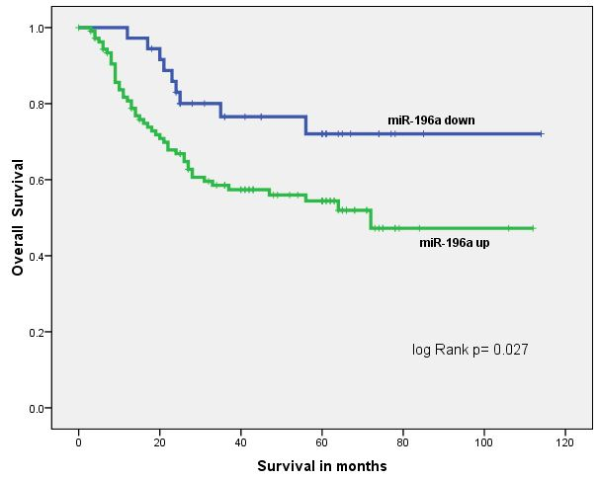
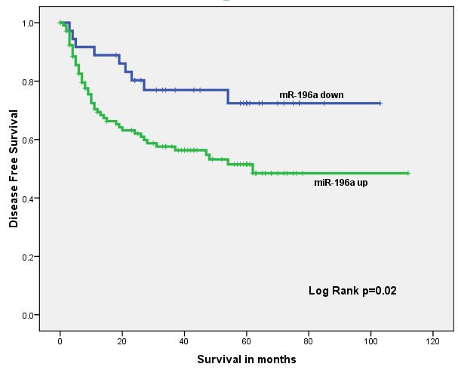
a.

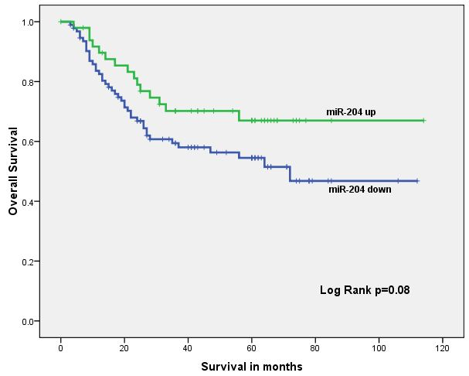
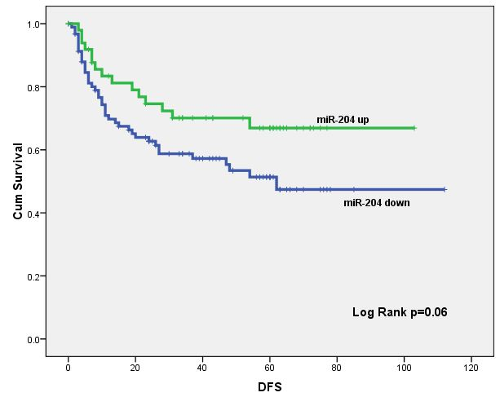
b.

Supplementary Figure 4. (a) Expression ratio of miR-196a/miR-204 and its association with
Overall and Disease-free survival (b) ROC demonstrates the predictory power of miR196a/miR-
204expression ratio

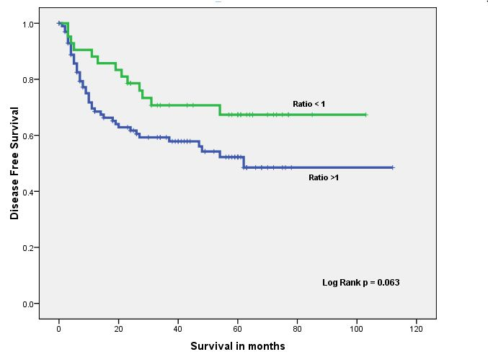
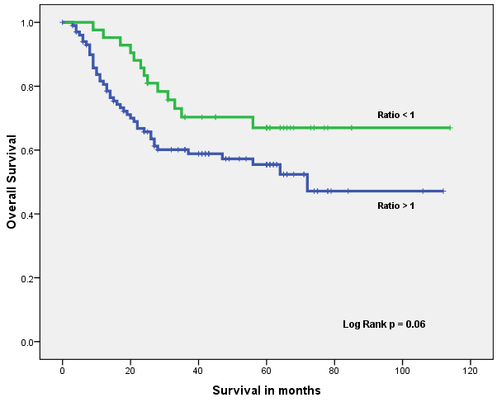
a.

b.

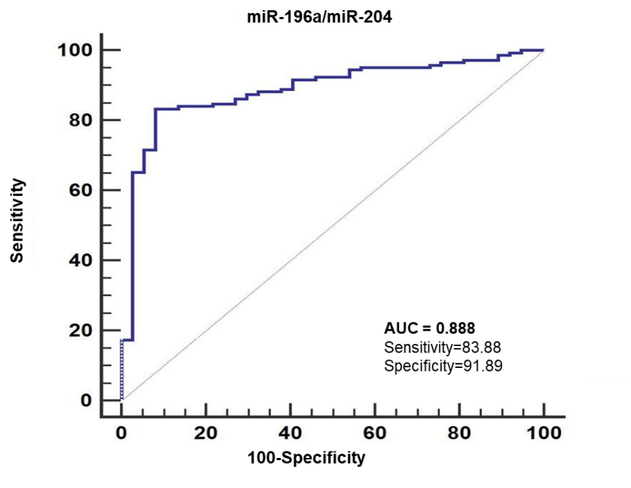

Supplementary Figure 5: MiR-196a/miR-204 target multiple genes in Hippo signaling pathway. Yellow boxes represent target genes of any one of the miRNA, orange boxes represent target genes of more than one miRNAs and green boxes indicates that the genes are not the targets of these miRNA in this context. Figure developed from the output of DIANA miRPath.
