Insights into Acinetobacter baumannii fatty acid synthesis 3-oxacyl-ACP reductases

Emily M. Crossª, Felise G. Adams^{b}, Jack K. Waters^{b}, David Aragão^{c,d}, Bart A. Eijkelkamp^{b}, Jade K. Forwoodª

Supplementary Figure 1: Identification of A. baumannii SDRs with conserved ACP docking residues. A multiple sequence alignment of representative A. baumannii SDRs that encode the typical catalytic motif ([ST]x₁₂Yx₃K) against FabG sequences with known 3-oxoacyl ACP reductive capacity (E. coli [K-12 FabG; NP_415611.1] and P. aeruginosa [PAO1 FabG; NP_251657.1]). Black shading represents positively charged residues at the conserved Arg-129 and Arg-172 position which facilitate ACP interaction (E. coli K-12 numbering). Conserved catalytic residues are coloured in blue, asterisk and colon symbols represent residues that are fully conserved and have similar physiochemical properties, respectively. Pink shading represents sequences that encode hydrophobic residues at the correct position. The numbers indicate the position of the last amino acids in the displayed sequences.
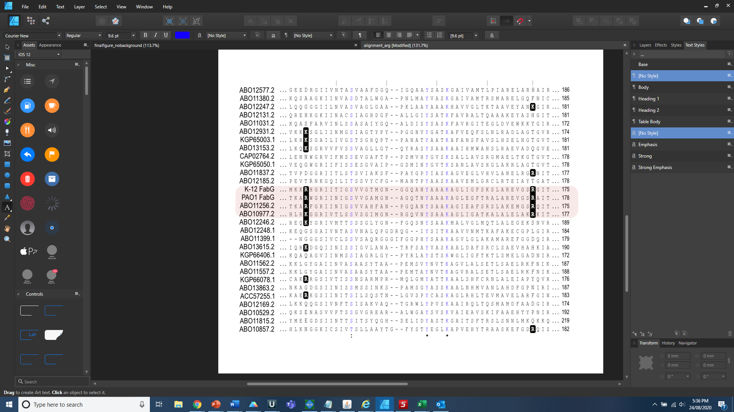

Supplementary Table 1. Strains used in the study
Name | Genotype or description | Reference / source
A. baumannii ATCC 17978 | Non international type clone; meninges isolate | ATCC
∆AbHMwfabG | ATCC 17978 with kanamycin cassette insertion disruption in A1S_2061 | This study

Supplementary Table 2. Oligonucleotides used in the study
Name | Sequence (5' - 3')
A1S_2061 UFR F | CATTCTTCAGAAGCAAGC
A1S_2061 UFR R | GCGATTGTGTAGGCTGGAGCTGGACCCAAATGGAAGCGGAC
A1S_2061 DFR F | GTCCATATGAATATCCTCCTTCAGGCGAAGGTAAACCCAG
A1S_2061 DFR R | GCCCTCTCCTGCAAGAAATC
Kan F | GCGATTGTGTAGGCTGGAGCTG
Kan R | GTCCATATGAATATCCTCCTT
A1S_2061 NOL F | CCACAGAAGCACCATCAGTC
A1S_2061 NOL R | GGCTTAGTCGCTGCGACCACA

Supplementary Table 3. Tetramer interface interactions for FabG
PDB 6UDS: A/B interface interactions
Hydrogen Bonds |  |  |  | Salt bridges
Chain A |  | Chain B | Distance (Å) | Chain A |  | Chain B | Distance (Å)
GLN173 [OE1] | <--> | ARG208 [NE] | 3.13
GLN173 [NE2] | <--> | LEU206 [O] | 3.27
PHE183 [O] | <--> | TYR229 [OH] | 3.22
LEU206 [O] | <--> | GLN173 [NE2] | 2.94
ARG208 [O] | <--> | TYR229 [OH] | 2.72
ARG208 [NE] | <--> | GLN173 [OE1] | 2.94
ARG208 [NH2] | <--> | GLY228 [O] | 3.01
GLY228 [O] | <--> | ARG208 [NH2] | 3.11
TYR229 [O] | <--> | GLY239 [N] | 2.85
TYR229 [OH] | <--> | ARG208 [O] | 2.69
GLY239 [N] | <--> | TYR229 [O] | 2.83
ALA244[O] | <--> | VAL234 [N] | 3.32
A/C interface interactions
Hydrogen Bonds |  |  |  | Salt Bridges
Chain A |  | Chain C | Distance (Å) | Chain A |  | Chain C | Distance (Å)
LEU95 [N] | <--> | GLU168 [OE1] | 2.91 | GLU100 [OE1] | <--> | LYS112 [NZ] | 2.75
LEU95 [O] | <--> | LYS119 [NZ] | 2.74 | GLU100 [OE1] | <--> | ARG116 [NH2] | 2.83
LEU96 [O] | <--> | LYS119 [NZ] | 2.84 | ASP104 [OD1] | <--> | LYS112 [NZ] | 2.77
MET98 [O] | <--> | TYR115 [OH] | 2.84 | LYS112 [NZ] | <--> | GLU100 [OE1] | 2.92
MET98 [O] | <--> | LYS119 [NZ] | 3.29 | LYS112 [NZ] | <--> | ASP104 [OD1] | 2.68
GLU100 [OE1] | <--> | LYS112 [NZ] | 2.75 | ARG116 [NE] | <--> | GLU100 [OE2] | 2.87
GLU100 [OE1] | <--> | ARG116 [NH2] | 2.83
GLU100 [OE2] | <--> | ARG116 [NE] | 2.84
ASP104 [OD1] | <--> | LYS112 [NZ] | 2.77
LYS112 [NZ] | <--> | GLU100 [OE1] | 2.92
LYS112 [NZ] | <--> | ASP104 [OD1] | 2.68
TYR115 [OH] | <--> | MET98 [O] | 2.69
ARG116 [NE] | <--> | GLU100 [OE2] | 2.87
ARG116 [NH2] | <--> | GLU100 [OE1] | 2.90
LYS119 [NZ] | <--> | LEU95 [O] | 2.92
LYS119 [NZ] | <--> | LEU96 [O] | 2.73
ALA141 [O] | <--> | ARG163 [NH2] | 2.98
ALA144 [O] | <--> | LYS167 [NZ] | 2.48
GLY147 [N] | <--> | GLU168 [OE2] | 2.65
ARG163 [NH2] | <--> | ALA141 [O] | 3.20
GLU168 [OE1] | <--> | LEU95 [N] | 2.79
GLU168 [OE2] | <--> | GLY147 [N] | 2.72

PDB: 6NRP A/B interface interactions
Hydrogen Bonds |  |  |  | Salt bridges
Chain A |  | Chain B | Distance (Å) | Chain A |  | Chain B | Distance (Å)
LYS173 [NZ] | <--> | GLN206 [OE1] | 2.75 | GLU225 [OE2] | <--> | Lys219 [NZ] | 3.37
ARG207 [O] | <--> | TYR228 [OH] | 2.70
GLU213 [OE2] | <--> | SER227 [OG] | 2.65
GLU225 [OE1] | <--> | SER216 [OG] | 2.84
SER227 [OG] | <--> | GLU213 [OE2] | 2.60
TYR228 [O] | <--> | GLY238 [N] | 2.93
TYR228 [OH] | <--> | ARG207 [O] | 2.72
ARG231 [NH1] | <--> | GLY239 [O] | 2.90
GLN232 [NE2] | <--> | ILE241 [O] | 2.82
GLY238 [N] | <--> | TYR228 [O] | 2.82
GLY239 [O] | <--> | ARG231 [NH1] | 2.93
ILE241 [O] | <--> | GLN232 [NE2] | 2.78
A/C interface interactions
Hydrogen Bonds |  |  |  | Salt Bridges
Chain A |  | Chain C | Distance (Å) | Chain A |  | Chain C | Distance (Å)
ARG64 [NH1] | <--> | ASP105 [OD2] | 2.87 | ARG64 [NH1] | <--> | ASP101 [OD1] | 3.89
ARG64 [NH2] | <--> | ASP105 [OD1] | 2.90 | ARG64 [NH1] | <--> | ASP105 [OD2] | 2.87
PHE96 [N] | <--> | GLU170 [OE1] | 2.94 | ASP101 [OD2] | <--> | ARG64 [NH1] | 3.36
LEU99 [O] | <--> | TYR116 [OH] | 3.08 | ASP105 [OD2] | <--> | ARG64 [NH1] | 2.89
LEU99 [O] | <--> | LYS120 [NZ] | 2.80
ASP101 [OD1] | <--> | TYR116 [OH] | 3.06
ASP105 [OD1] | <--> | ARG64 [NH2] | 2.95
ASP105 [OD2] | <--> | ARG64 [NH1] | 2.89
ASP113 [OD1] | <--> | TRP104 [NE1] | 3.28
TYR116 [OH] | <--> | LEU99 [O] | 3.24
TYR116 [OH] | <--> | ASP101 [OD1] | 2.80
LYS120 [NZ] | <--> | LEU99 [O] | 2.84
ILE144 [O] | <--> | LYS165 [NZ] | 3.03
MET145 [O] | <--> | ARG231 [NE] | 3.04
MET145 [O] | <--> | ARG231 [NH2] | 2.93
ARG148 [NE] | <--> | LEU169 [O] | 3.19
GLY149 [N] | <--> | GLU170 [OE2] | 2.83
LYS165 [NZ] | <--> | ILE144 [O] | 3.24
GLU170 [OE1] | <--> | PHE96 [N] | 2.93
GLU170 [OE2] | <--> | GLY149 [N] | 2.75
ARG231 [NE] | <--> | MET145 [O] | 2.99
ARG231 [NH2] | <--> | MET145 [O] | 2.84
Supplementary Table 4 Tetramer interface interactions for AbSDR

PDB: 6UUT A/B interface interactions
Hydrogen Bonds |  |  |  | Salt bridges
Chain A |  | Chain B | Distance (Å) | Chain A |  | Chain B | Distance (Å)
SER112 [OG] | <--> | SER331 [OG] | 2.77 | GLU113 [OE2] | <--> | ARG335 [NH1] | 3.94
SER112 [OG] | <--> | SER331 [OG] | 2.77 | LYS149 [NZ] | <--> | ASP338 [OD2] | 2.60
SER112 [OG] | <--> | GLU334 [OE1] | 2.64 | ARG335 [NH1] | <--> | GLU113 [OE2] | 3.35
TYR119 [OH] | <--> | MET317 [O] | 2.49 | ASP338 [OD2] | <--> | LYS149 [NZ] | 2.69
ASN123 [ND2] | <--> | LEU314 [O] | 2.74
ARG127 [NH2] | <--> | ASN316 [OD1] | 2.88
LYS149 [NZ] | <--> | ASP338 [OD2] | 2.60
SER163 [OG] | <--> | ASN364 [N] | 2.95
SER163 [OG] | <--> | ASN364 [O] | 3.26
LYS166 [NZ] | <--> | ALA362 [O] | 2.99
LYS166 [NZ] | <--> | GLY363 [O] | 2.97
GLU167 [OE1] | <--> | GLY366 [N] | 2.84
GLU167 [OE2] | <--> | LEU314 [N] | 2.65
LEU314 [N] | <--> | GLU167 [OE2] | 2.66
LEU314 [O] | <--> | ASN123 [ND2] | 2.85
ASN316 [OD1] | <--> | ARG127 [NH2] | 2.71
MET317 [O] | <--> | TYR119 [OH] | 2.59
SER331 [OG] | <--> | SER112 [OG] | 2.63
SER331 [OG] | <--> | SER112 [OG] | 2.63
GLU334 [OE1] | <--> | SER112 [OG] | 2.49
ASP338 [OD2] | <--> | LYS149 [NZ] | 2.69
ALA362 [O] | <--> | LYS166 [NZ] | 3.12
GLY363 [O] | <--> | LYS166 [NZ] | 2.97
ASN364 [N] | <--> | SER163 [OG] | 2.92
ASN364 [O] | <--> | SER163 [OG] | 3.26
GLY366 [N] | <--> | GLU167 [OE1] | 2.81
ARG454 [NH1] | <--> | ALA463 [O] | 2.97
LEU460 [O] | <--> | GLY462 [N] | 3.34
GLY462 [N] | <--> | LEU460 [O] | 3.33
ALA463 [N] | <--> | ALA463 [OXT] | 2.89
ALA463 [O] | <--> | ARG454 [NH1] | 2.87
ALA463 [OXT] | <--> | ALA463 [N] | 2.80
Supplementary Table 5 Dimer interface interactions for HMwFabG

 | ATCC 17978 (µg.ml⁻¹) | ΔHmwFabG (µg.ml⁻¹)
Gentamicin | 2 | 2
Streptomycin | 128 | 128
Chloramphenicol | 256 | 128
Colistin | 4 | 4
Supplementary Table 6. Antibiotic minimal inhibitory concentrations

