Ultrasound-triggered Herceptin Liposomes for Breast Cancer Therapy
Amal Elamir,ª Saniha Ajith,ª Nour Al Sawaftah,ª Waad Abuwatfa,ª Debasmita Mukhopadhyay,ª Vinod Paul,ª Mohammad H. Al-Sayah,^{b} Nahid Awad,ª and Ghaleb A. Husseini^{a,}*

ªDepartment of Chemical Engineering, American University of Sharjah, Sharjah, United Arab Emirates
^{b}Department of Biology, Chemistry and Environmental Sciences, American University of Sharjah, PO. Box 26666, Sharjah. UAE
*corresponding author, email: ghusseini@aus.edu

Supplementary material
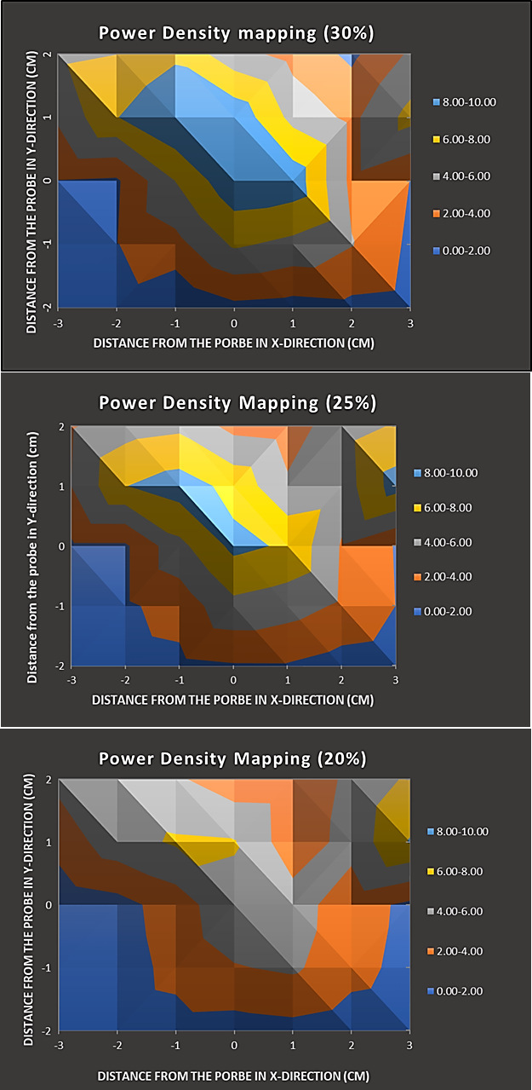
Figure 1. Power densities values measured with the hydrophone at various distances from the probe at 30%, 25% and 20% amplitude.

Table 1. Heat map summarizing p-values for the MDA-MB-231 cell line
 | Untreated | Untreated +LFUS |  | DOX |  | DOX+LFUS | Control-DOX | Control-DOX +LFUS | TRA-DOX | TRA-DOX+LFUS
Untreated | 1 | 9.58E-01 |  | 7.64E-10 |  | 4.17E-10 | 2.01E-07 | 5.76E-08 | 2.68E-04 | 2.54E-10
Untreated +LFUS | 9.58E-01 | 1 |  | 7.64E-10 |  | 4.17E-10 | 2.01E-07 | 5.76E-08 | 2.68E-04 | 2.54E-10
DOX | 7.64E-10 | 7.64E-10 |  | 1 |  | 1.55E-03 | 6.25E-07 | 2.03E-06 | 1.71E-04 | 1.03E-07
DOX+LFUS | 4.17E-10 | 4.17E-10 |  | 1.55E-03 |  | 1 | 4.33E-07 | 1.23E-06 | 1.33E-04 | 4.81E-08
Control-DOX | 2.01E-07 | 2.01E-07 |  | 6.25E-07 |  | 4.33E-07 | 1 | 1.60E-04 | 1.24E-01 | 8.44E-05
Control-DOX +LFUS | 5.76E-08 | 5.76E-08 |  | 2.03E-06 |  | 1.23E-06 | 1.60E-04 | 1 | 5.48E-03 | 9.42E-02
TRA-DOX | 2.68E-04 | 2.68E-04 |  | 1.71E-04 |  | 1.33E-04 | 1.24E-01 | 5.48E-03 | 1 | 6.78E-03
TRA-DOX+LFUS | 2.54E-10 | 2.54E-10 |  | 1.03E-07 |  | 4.81E-08 | 8.44E-05 | 9.42E-02 | 6.78E-03 | 1
p =1 | p > 0.05 |  | 0.01< p <0.05 |  | 0.001 < p < 0.01 |  | p < 0.001

Table 2. Heat map summarizing p-values for the SKBR3 cell line
 | Untreated |  | Untreated +LFUS |  | DOX |  | DOX+LFUS | Control-DOX | Control-DOX +LFUS | TRA-DOX | TRA-DOX+LFUS
Untreated | 1 |  | 5.80E-01 |  | 2.90E-09 |  | 6.51E-08 | 6.98E-05 | 2.20E-07 | 4.48E-06 | 2.46E-10
Untreated +LFUS | 5.80E-01 |  | 1 |  | 2.90E-09 |  | 6.51E-08 | 6.98E-05 | 2.20E-07 | 4.48E-06 | 2.46E-10
DOX | 2.90E-09 |  | 2.90E-09 |  | 1 |  | 3.88E-03 | 3.13E-04 | 2.76E-04 | 6.03E-04 | 9.19E-05
DOX+LFUS | 6.51E-08 |  | 6.51E-08 |  | 3.88E-03 |  | 1 | 1.93E-04 | 1.55E-04 | 2.89E-04 | 1.59E-04
Control-DOX | 6.98E-05 |  | 6.98E-05 |  | 3.13E-04 |  | 1.93E-04 | 1 | 2.22E-03 | 1.23E-02 | 7.37E-04
Control-DOX +LFUS | 2.20E-07 |  | 2.20E-07 |  | 2.76E-04 |  | 1.55E-04 | 2.22E-03 | 1 | 4.12E-02 | 4.55E-03
sTRA-DOX | 4.48E-06 |  | 4.48E-06 |  | 6.03E-04 |  | 2.89E-04 | 1.23E-02 | 4.12E-02 | 1 | 3.18E-03
TRA-DOX+LFUS | 2.46E-10 |  | 2.46E-10 |  | 9.19E-05 |  | 1.59E-04 | 7.37E-04 | 4.55E-03 | 3.18E-03 | 1
p =1 |  | p > 0.05 |  | 0.01< p <0.05 |  | 0.001 < p < 0.01 |  | p < 0.001

