Stability and individual variability of social attachment in imprinting
Bastien S. Lemaire^{1*}, Daniele Rucco¹, Mathilde Josserand^{1,2}, Giorgio Vallortigara¹, Elisabetta Versace^{3,1,4*}

¹ Center for Mind and Brain Sciences, University of Trento, Italy
² Ecole Normale Supérieure Lyon, France
³ School of Biological and Chemical Sciences, Queen Mary University of London, United Kingdom
⁴Alan Turing Institute, United Kingdom

Authors for correspondence:* bastien.lemaire@unitn.it; e.versace@qmul.ac.uk

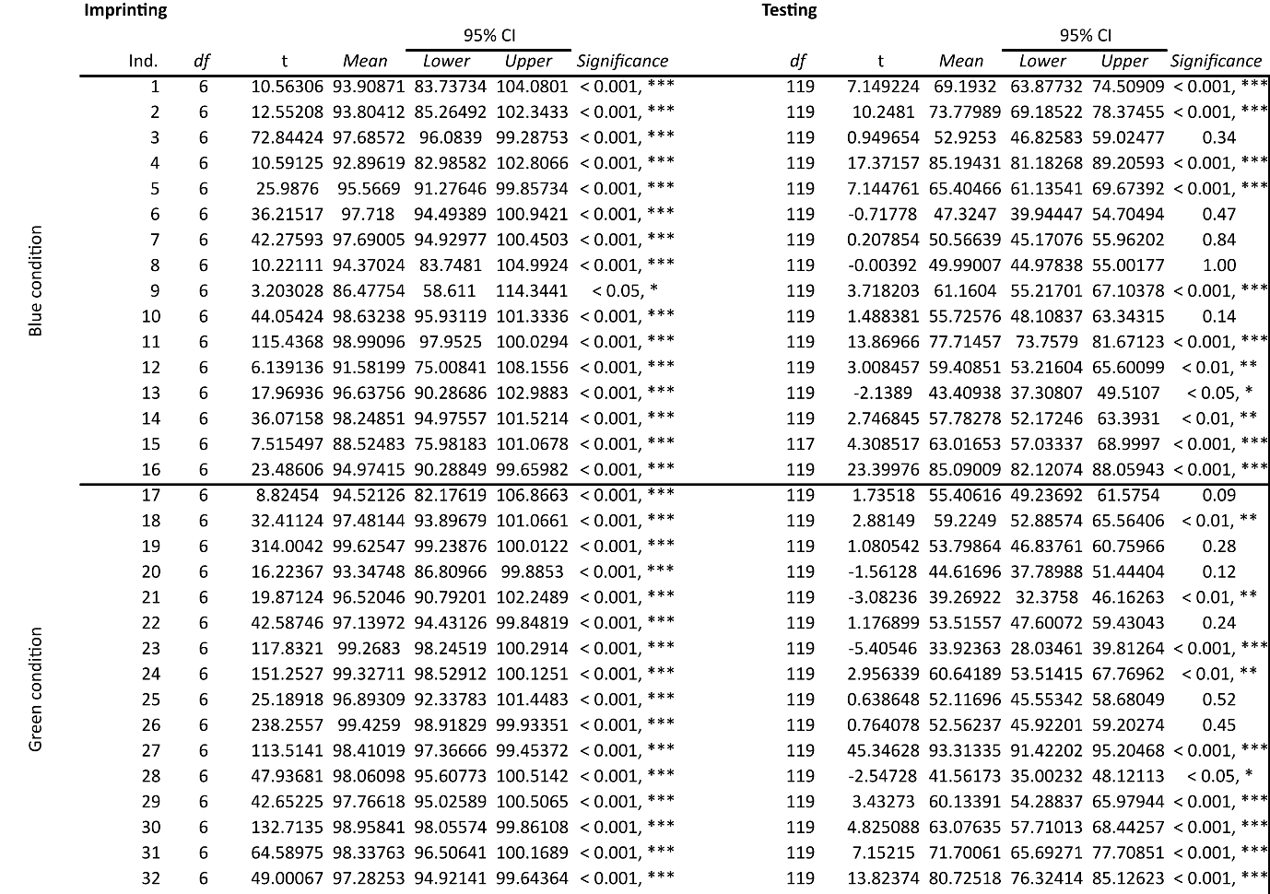
Table 1: Table showing the results of the t-tests on the preference for the imprinting stimulus against chance-level (50%) for each individual of the first experiment.

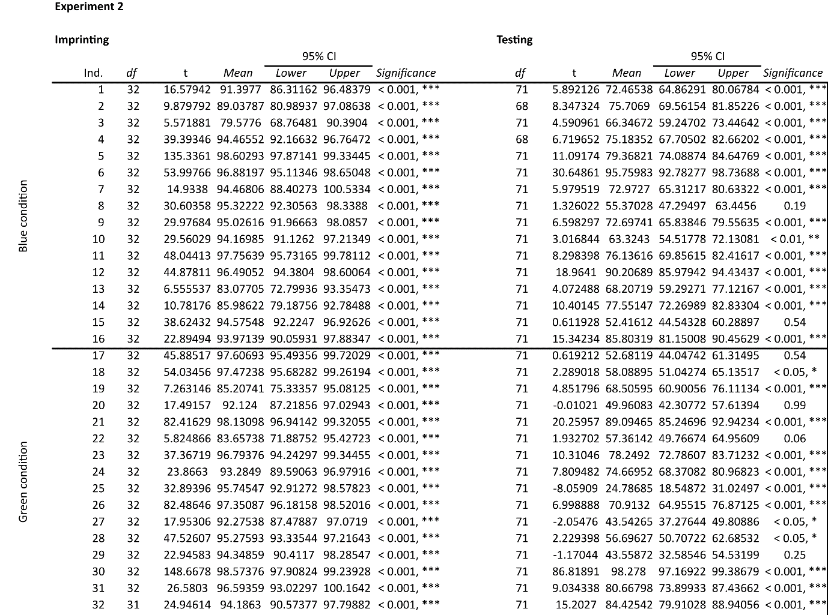
Table 2: Table showing the results of the t-tests on the preference for the imprinting stimulus against chance-level (50%) for each individual of the second experiment.

Table 3: Table showing the results of the t-tests on the preference for the primary imprinting stimulus against chance-level (50%) for each individual of the third experiment.
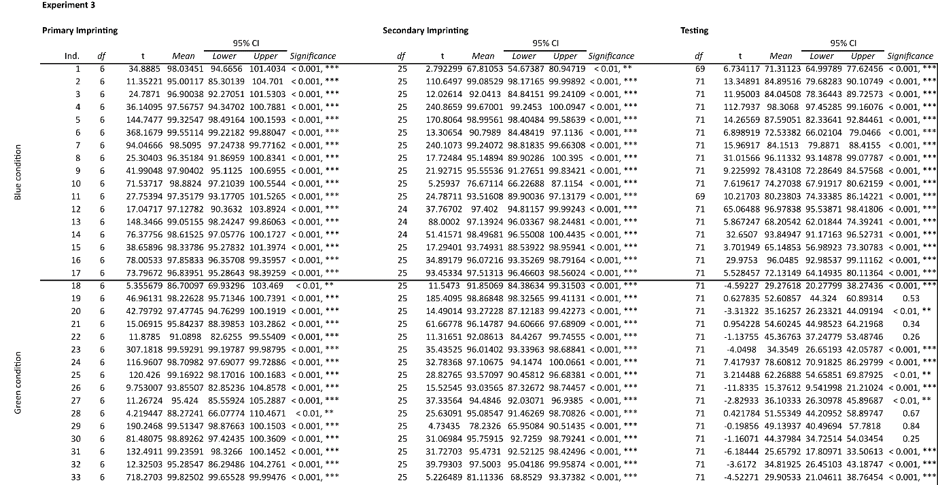

Table 4: Table showing the results of the t-tests on the preference for the primary imprinting stimulus against chance-level (50%) for each individual of the fourth experiment.
