Supplementary information

Deep brain electrical neurofeedback allows Parkinson patients to control pathological oscillations and quicken movements

Authors: Oliver Bichsel^{1,2,3,4}, Lennart H. Stieglitz^{3,4}, Markus F. Oertel^{3,4}, Christian R. Baumann^{2,4}, Roger Gassert*¹, Lukas L. Imbach*^{,2,4,5} (*co-senior authors)
- Rehabilitation Engineering Laboratory, Department of Health Sciences and Technology, ETH Zurich, Switzerland
- Department of Neurology, University Hospital Zurich, University of Zurich, Switzerland
- Department of Neurosurgery, University Hospital Zurich, University of Zurich, Switzerland
- Clinical Neuroscience Centre, University Hospital Zurich, University of Zurich, Switzerland
- Swiss Epilepsy Center, Klinik Lengg, Switzerland

Corresponding Author: Oliver Bichsel, MD, MSc; oliver.bichsel@hest.ethz.ch

Supplementary Figure 1: Neurofeedback experiment. The neurofeedback experiment consisted of three parts: the pre-neurofeedback, the neurofeedback and the transfer part. There was an additional part two days later: the 2 d transfer run. In the flow-chart, the blocks that were followed by a period of 15 s of behavioural assessment are indicated by ’15 s pro-/supination’.

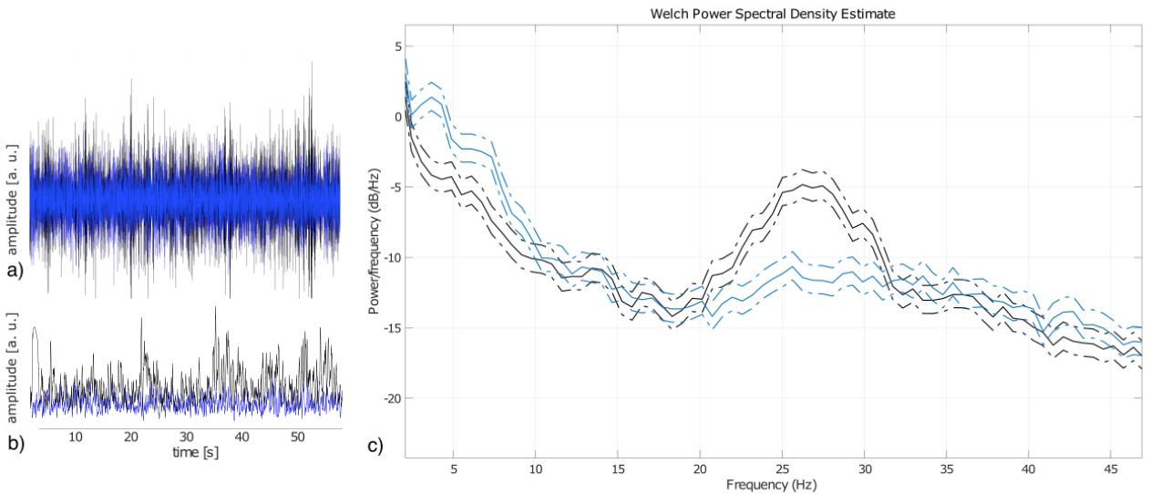
Supplementary Figure 2: Representative beta-activity recording during neurofeedback. These sample recordings show instantaneous beta-reduction in a patient during downregulation (blue, lower amplitude) as compared to rest (black, higher amplitude) in NF3. a) Beta-peak-filtered signal, b) 1’000 point moving average (200 ms), c) Welch power spectral density estimate with an oscillatory power reduction specific to the beta-peak (around 26 Hz) during downregulation.

Supplementary Figure 3: Representative motor behaviour. Filtered gyroscopic data (6th order Butterworth, bandpass [0.25, 4] Hz) from the palm of a sample patient during a 15 s pro- and supination task following the NF3 and the short-term transfer blocks (blue). The first 12 s were extracted for further analysis (red).

