On species delimitation, hybridization and population structure of cassava whitefly in Africa

Elfekih S^{1,a}, Tay WT^{2a†}, Polaszek A³, Gordon KHJ², Kunz D⁴, Macfadyen S², Walsh TK², Vyskočilová S⁵, Colvin J⁵, De Barro PJ⁶

- CSIRO, Australian Centre for Disease Preparedness, Geelong, VIC, Australia
- CSIRO, Black Mountain Laboratories, ACT, Australia
- Department of Life Sciences, Natural History Museum, London, UK
- The Gurdon Institute, University of Cambridge, Tennis Court Road, Cambridge CB2 1QN, UK
- Natural Resources Institute, University of Greenwich, Kent, UK
- CSIRO, Ecosciences Precinct, Brisbane, Australia
a. These authors contributed equally

E-mail: Samia.elfekih@csiro.au
Weetek.tay@csiro.au
A.Polaszek@nhm.ac.uk
Karl.gordon@csiro.au
dk603@cam.ac.uk
Sarina.Macfadyen@csiro.au
Tom.Walsh@csiro.au
s.vyskocilova@gmail.com
J.Colvin@greenwich.ac.uk
Paul.debarro@csiro.au

Correspondence: weetek.tay@csiro.au Tel: +61-2-6246 4286

Suppl. Fig. 1: Sequence alignment summary of 14 SSA4-related sequences (8-21) from GenBank. SSA4 sequences of Wosula et al.¹ are boxed in red. Sequences 1-4 are MEAM1 and MED partial mtCOI gene assembled from high-throughput sequencing (HTS) method^{2,3}. SSA1 (sequence 5) and SSA2 (sequence 6) partial mtCOI gene as assembled from HTS method based on a single individual (see Kunz et al.⁴). SSA3 COI gene (sequence 7) as obtained from HTS of a single individual from University of Greenwich Natural Resources Institute laboratory stock (full data not shown). Wosula et al.¹ reported SSA4 sequences were 8-10, and Berry et al.⁵ reported SSA4 sequences were 11-21. Red circles are indels. In three ‘putative SSA4’ sequences (8, 9, 10 of Wosula et al.¹) and two SSA4 sequences (18 (Cam Ayos 2 WO3), 19 (Cam Ayos 1 WO2) of Berry et al.⁵), no indels were observed. Nine of the 11 Berry et al.⁵, SSA 4-equivalence sequences (labelled as ‘Sub-Saharan III’) showed indels. All SSA4 sequences of Wosula et al.¹ and Berry et al. ⁵ shared ≥99% nucleotide identity. The reference SSA4 sequence used by Wosula et al.¹ is sequence 11. Single nucleotide polymorphisms detected in sequence alignments were colour highlighted.
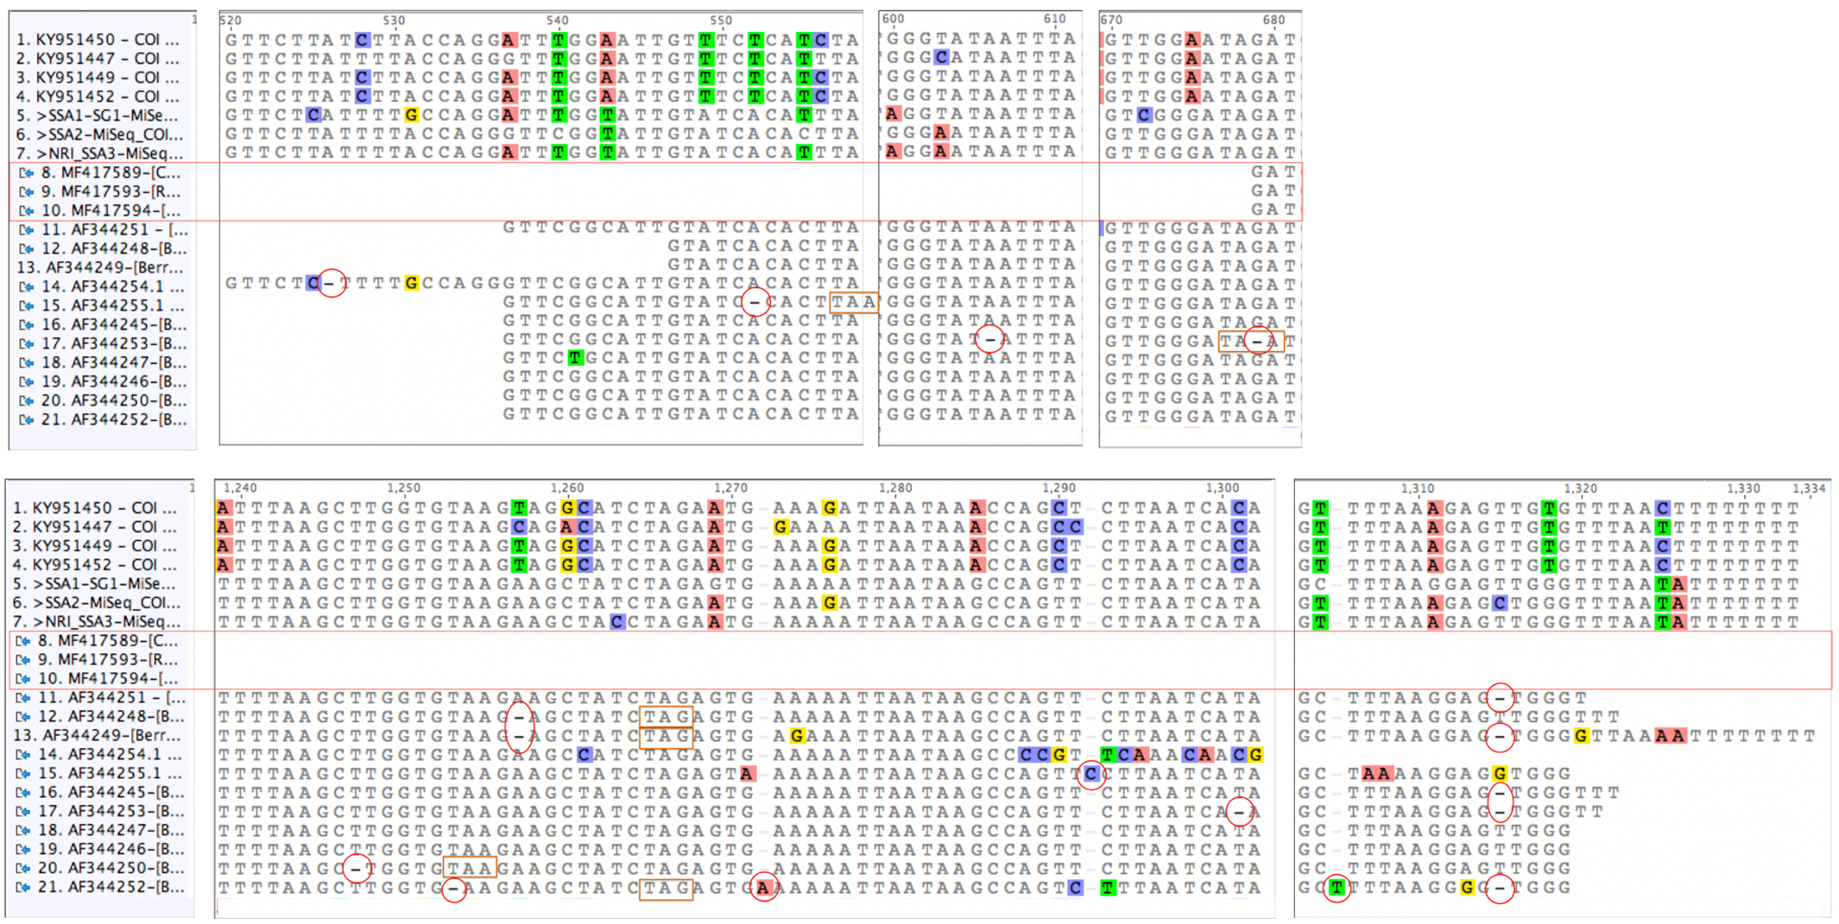
Note: Frameshift mutations leading to premature stop codons (‘TAA’ or ‘TAG’; indicated by rectangle boxes) in Berry et al.⁵ seqeunces are indicated. No premature stop codons were detected in the remaining five SSA4 sequences (i.e., AF344245, AF244246, AF244247, AF344251, AF344254) reported by Berry et al.⁵ despite presence of various INDELs (see main text).

Suppl. Fig 2: Schematic representation of partial mtCOI gene sequence alignments between sub-groups (SG) of the African cassava Bemisia whitefly SSA1 species. Numbers of nucleotide substitutions present within each alignment are indicated. Note that in: [A] three transition substitutions were observed between SSA1 individuals determined to belong to SG3 and SG5 (p-dist: 0.56%); [B] two tansition substitutions (p-dist: 0.37%) were observed between individuals in SG2; [C] three transitions and one transversion (p-dist: 0.75%)were observed between individuals that belonged to SG1; and [D] seven transition substitutions and one transversion substitution (p-dist: 1.5%) were observed between SG1 and SG2 individuals, for which mating experiments have failed to support these as being genetically distinct⁶.

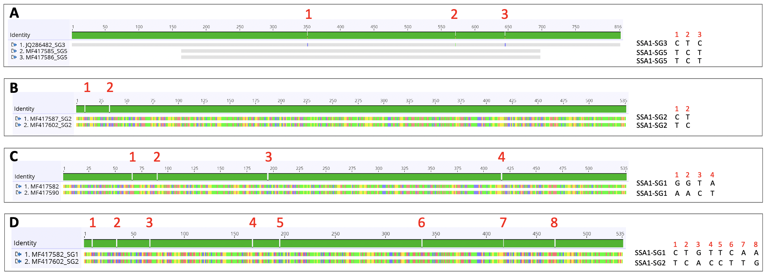

Suppl. Fig 3: Admixture plots (K= 2-4) and their respective cross-validation (CV) error estimates based on 14,358 geome-wide SNPs of 62 sub-Saharan African Bemisia cassava whitefly SSA1 and SSA2 cryptic species. CV error estimates indicated K=3 as the most optimal admixture plot, with the SSA2 and SSA1 indivdiuals maching their respective mtCOI halpotypes for species delimitation, and the SSA1 individuals showing NW (i.e., SSA-WA, SSA-ECA) and SE (i.e., SSA-CA. SSA-ESA) divide. Refere to the main text for detailed explanation.
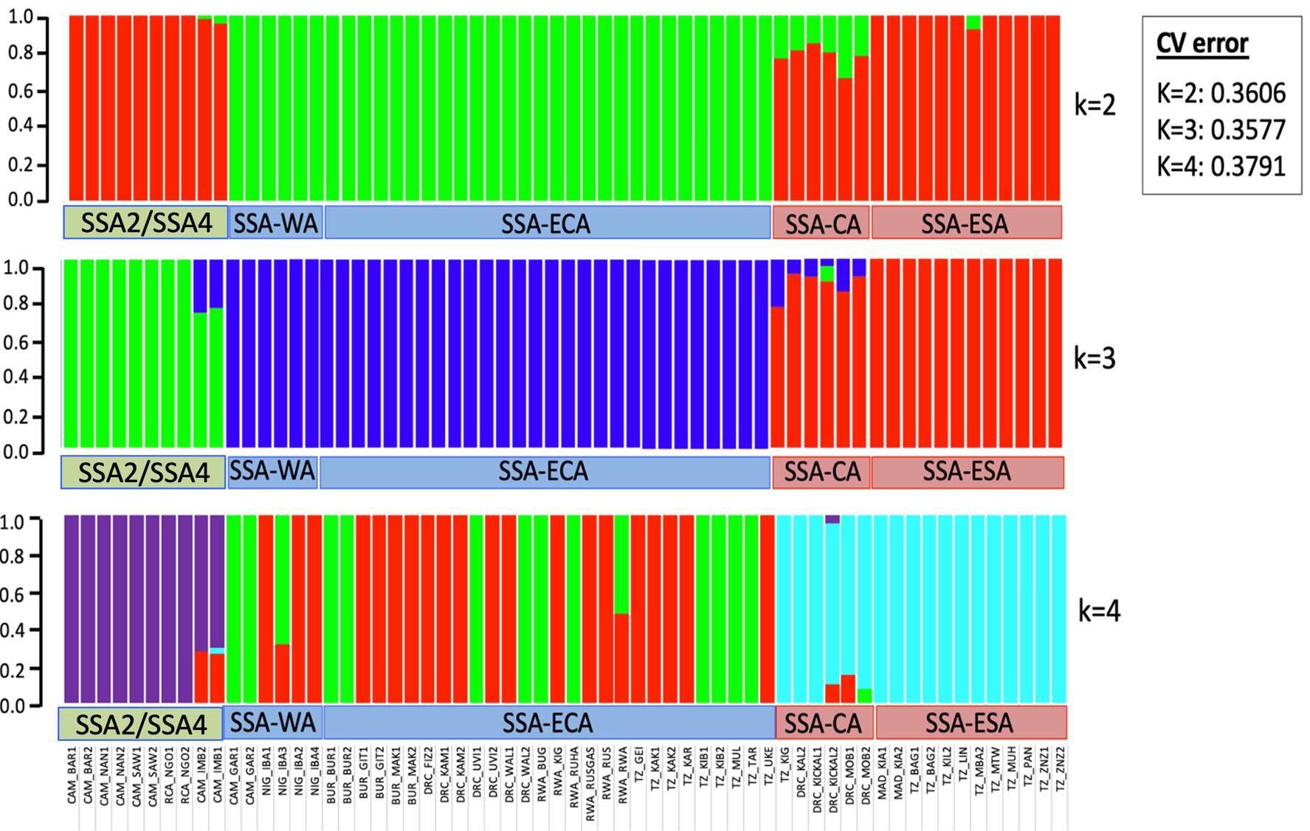
Literature cited
- Wosula EN, et al. Unravelling the Genetic Diversity among Cassava Bemisia tabaci Whiteflies Using NextRAD Sequencing. Genome Biology and Evolution 9: 2958-2973. doi: 10.1093/gbe/evx219 (2017)
- Tay WT, Elfekih S, Court L, Gordon KH, De Barro PJ. Complete mitochondrial DNA genome of Bemisia tabaci cryptic pest species complex Asia I (Hemiptera: Aleyrodidae). Mitochondrial DNA A DNA Mapp Seq Anal. 27(2):972-973 (2016).
- Tay WT, et al. Novel molecular approach to define pest species status and tritrophic interactions from historical Bemisia specimens. Scientific Reports 7: 429. Doi: 10.1038/s41598-017-00528-7 (2017).
- Kunz D, et al. Take out the rubbish - Removing NUMTs and pseudogenes from the Bemisia tabaci cryptic species mtCOI database. bioRxiv 724765; doi: https://doi.org/10.1101/724765 (2019).
- Berry SD, et al. Molecular evidence for five distinct Bemisia tabaci (Homoptera : Aleyrodidae) geographic haplotypes associated with cassava plants in sub-Saharan Africa. Annals of the Entomological Society of America 97: 852-859. doi: Doi 10.1603/0013-8746(2004)097[0852:Meffdb]2.0.Co;2 (2004).
- Mugerwa, H. et al. Whole-genome single nucleotide polymorphism and mating compatibility studies reveal the presence of distinct species in sub-Saharan Africa Bemisia tabaci whiteflies. Insect Science, doi:10.1111/1744-7917.12881 (2020).

