Supplementary Figure 5. We found a Bacteroidetes species, similar to the bee gut-associated Apibacter sp., in Cx. fuscocephala samples. Apibacter spp. were recently isolated from bee guts and are thought to be facultatively associated to multiple bee species [1, 2]. Initial phylogenetic analysis of partial 16s rRNA sequences suggested that the bacteria found in our Cx. fuscocephala samples clustered within the same clade as, but separated from, the bee-associated Apibacter spp. and another group of similar Bacteroidetes found in termites. Their ribosomal RNAs can be found only in Cx. fuscocephala samples collected from all three sites, but not in the other two mosquito species, suggesting that this species specifically associated to the Culex sp.
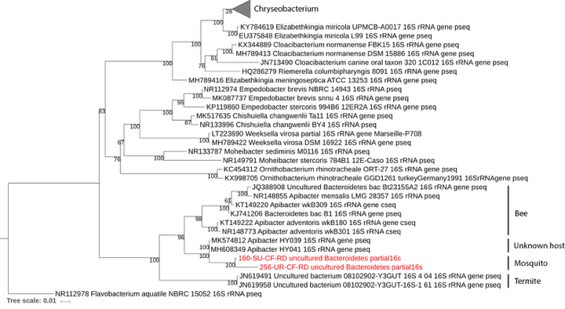

1. Kwong WK, Moran NA. Apibacter adventoris gen. nov., sp. nov., a member of the phylum Bacteroidetes isolated from honey bees. Int J Syst Evol Microbiol. 2016;66: 1323–1329. doi:10.1099/ijsem.0.000882
2. Praet J, Aerts M, Brandt ED, Meeus I, Smagghe G, Vandamme P. Apibacter mensalis sp. nov.: a rare member of the bumblebee gut microbiota. Int J Syst Evol Microbiol. 2016;66: 1645–1651. doi:10.1099/ijsem.0.000921

