Supplementary Figure 6. We found ribosomal RNA of a digenean trematode in this study. Initial analysis suggested that this trematode species is related to Lecithodendrium linstowi, one of the most prevalent and abundant trematodes of bats [1]. The first intermediate mollusk host of L. linstowi was recently identified but the second intermediate insect host remains unknown [1]. The presence of a digenean trematode species similar to L. linstowi in Cx. fuscocephala could point to the possibility that culicines may represent the missing link in the life cycle of these digenean trematodes.
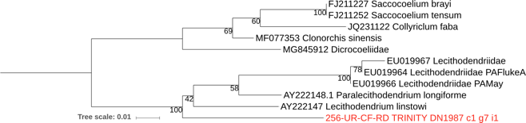

[1] Enabulele EE, Lawton SP, Walker AJ, Kirk RS. Molecular and morphological characterization of the cercariae of Lecithodendrium linstowi (Dollfus, 1931), a trematode of bats, and incrimination of the first intermediate snail host, Radix balthica. Parasitology. 2018;145: 307–312. doi:10.1017/S0031182017001640

